Supplementary Materials
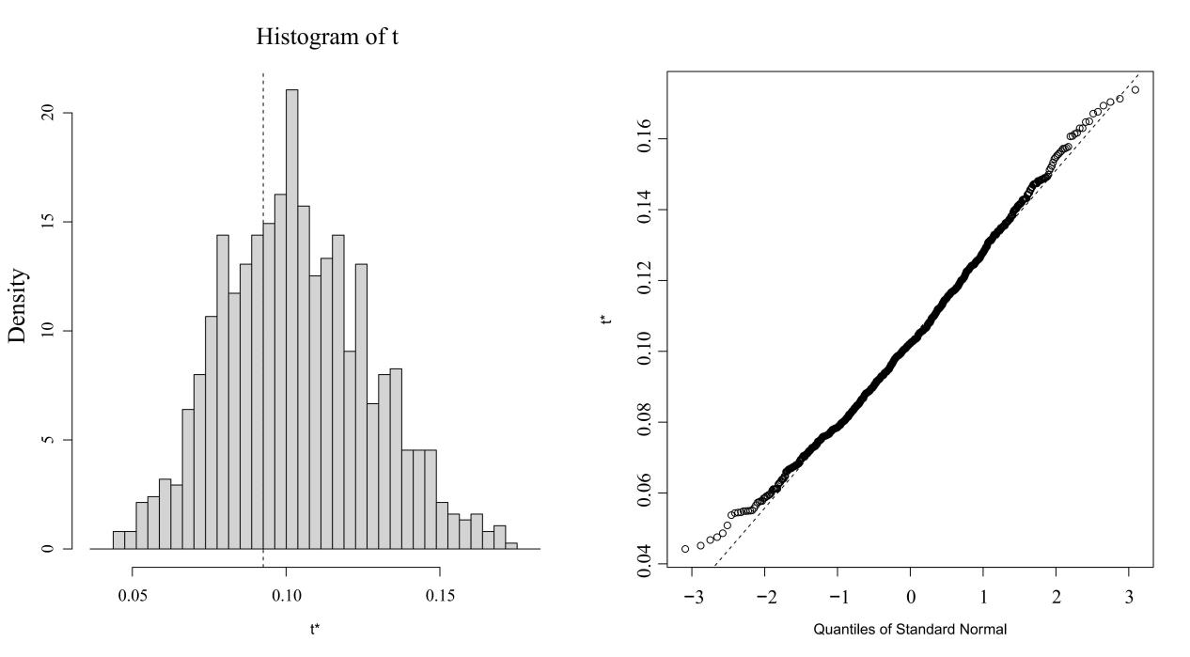
Supplementary Material: Figure 1. Bootstrap sampling tests the mean and standard deviation of samples
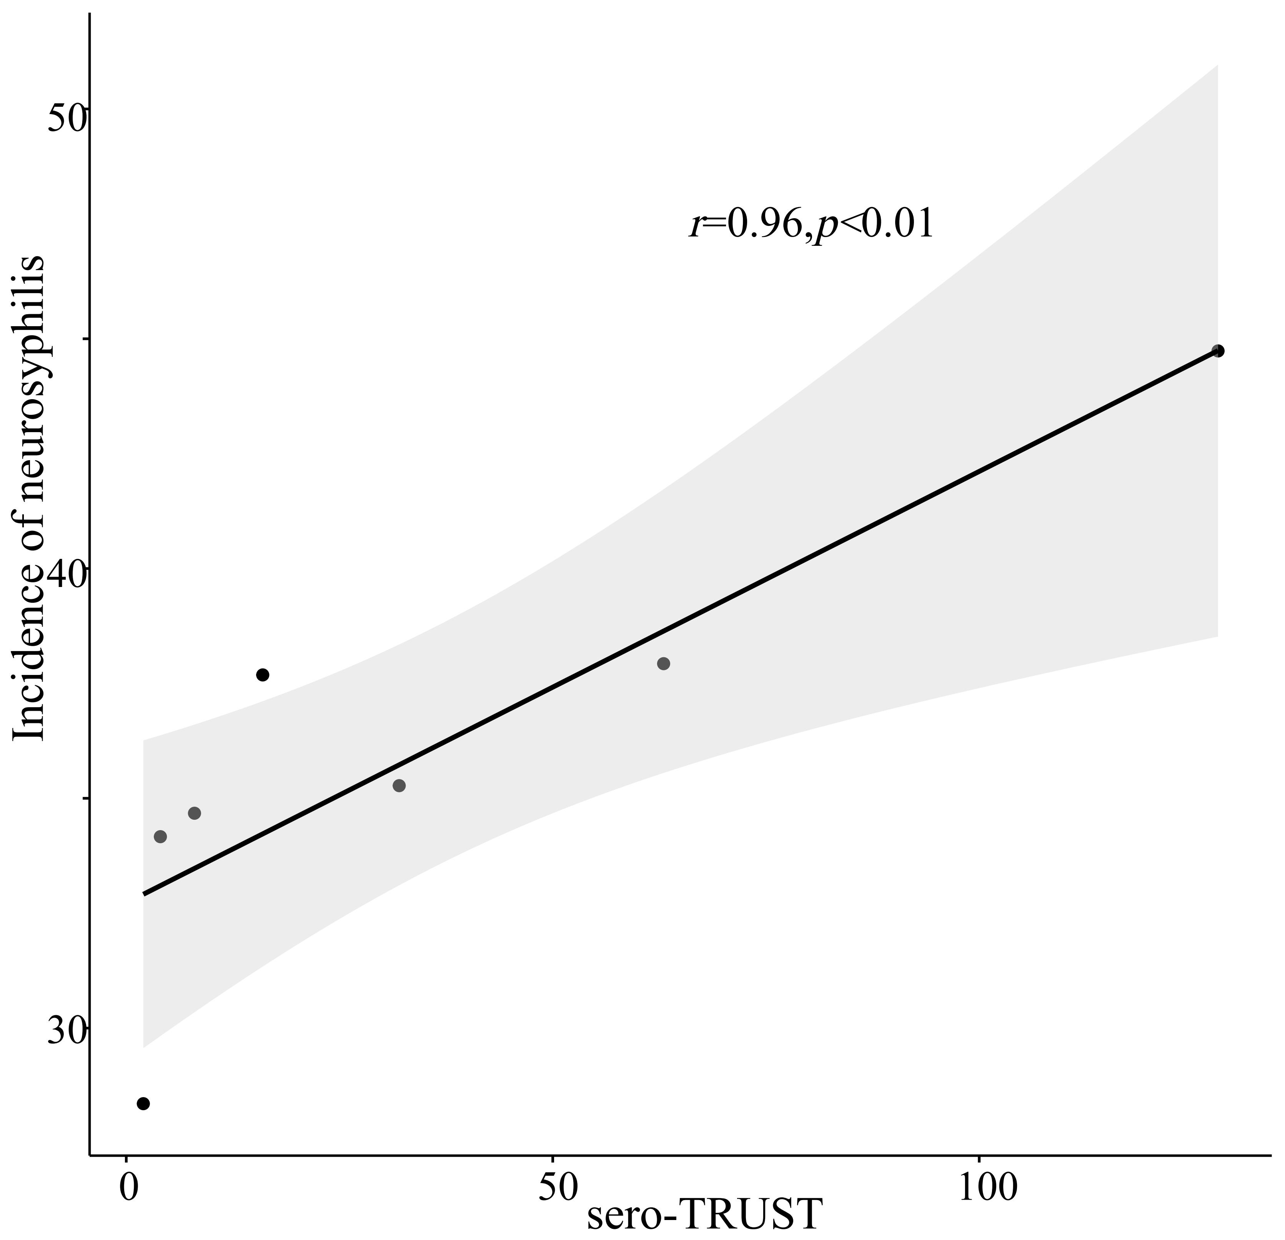
Supplementary Material: Figure 2. Spearman correlation coefficient chart between syphilis in blood antibody titers and neurosyphilis incidence.
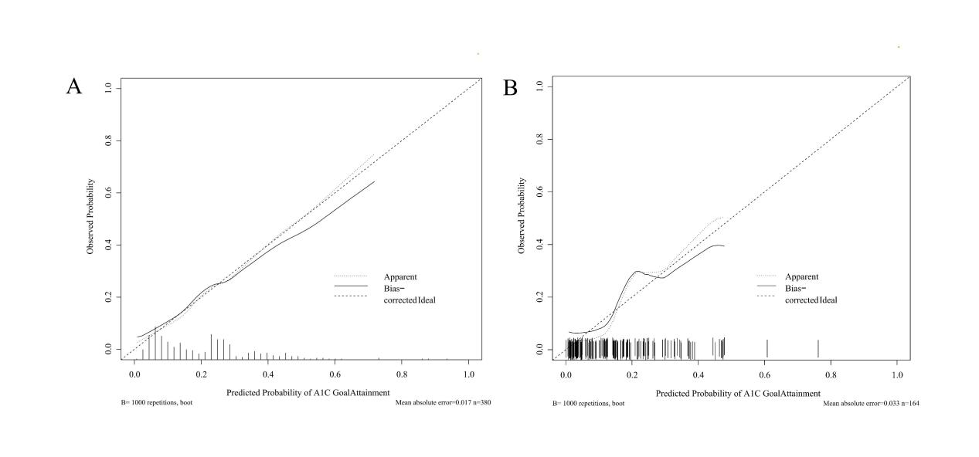
Supplementary Material: Figure 3. Calibration curve of PLWH ANS non-invasive model. (A) Train model of ANS calibration curve; (B) Test model of ANS calibration curve.
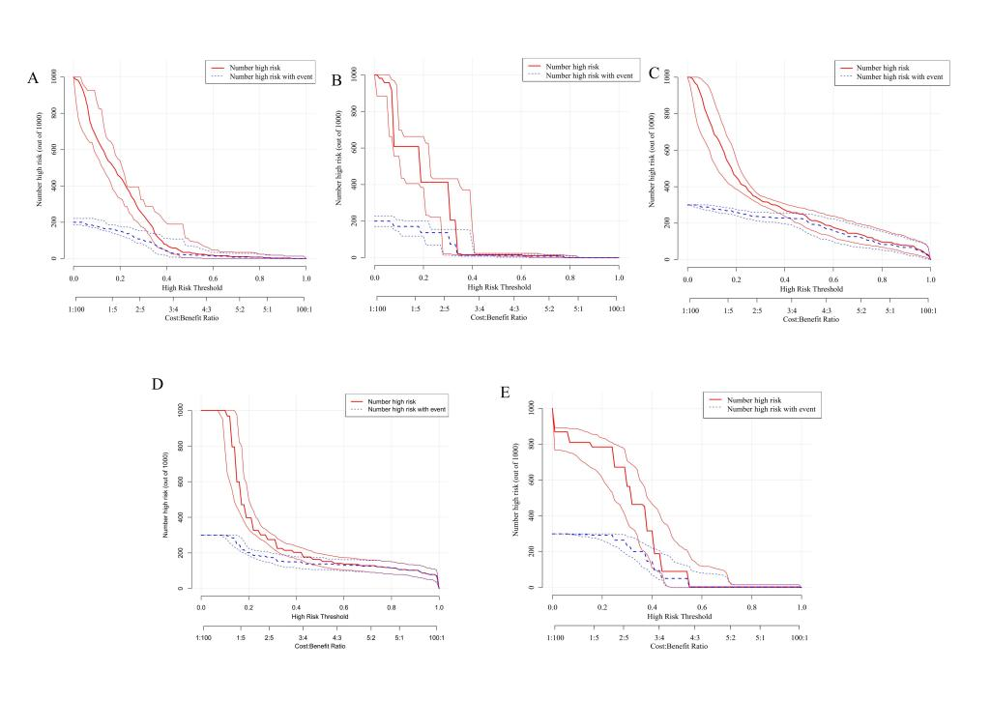
Supplementary Material: Figure 4. CIC of non-invasive diagnostic prediction model for PLWH ANS. (A) CIC curve of TRAIN-MODEL of ANS; (B) CIC curve of logistic model of ANS.(C) CIC curve of CSF-PRO of ANS; (D) CIC curve of CSF-WBC of ANS (E) CIC curve of sero-TRUST of ANS.

