Supplemented material
The protocol on the identification of the NOVC
After a blood culture tested positive, it was transferred onto blood agar plate and cultured for 24h. At the same time, the positive blood culture was smeared onto slide and observed under the microscope after Gram staining. Gram negative bacillus was observed. The colonies on blood agar were beta-hemolytic (supplemented fig. 1) and oxidase-positive. The isolate was confirmed as V. cholerae by matrix-assisted laser desorption ionization–time of flight mass spectrometry (MALDI-TOF MS) (Bruker; German). Furthermore, it was classified as NOVC via conventional serum agglutination by the Shanghai Municipal Center for Disease Control and Prevention (SCDC).
The patient’s diarrhea stool of was first enriched in alkaline peptone water (APW, pH 8.4-8.6) at 37°C for 6-8 hours, followed by subculture on CHROMagar™ Vibrio selective chromogenic medium.

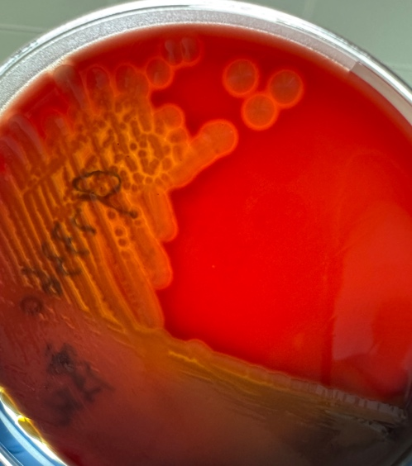
Supplementary Figure 1. Beta‐hemolytic colonies of vc973360 on blood agar plate

