Title: Tracking the Pandemic Through Molecular and Sequencing Tools: A Story of SARS-CoV-2 Over Five Years, Lessons Learned, and Further Directions

Authors: Saeed Khan, Hafsa Faruqui, Maria Zahid, Sharjeel Chaudhry, Zaira Rehman, Hamza Noor, Manaal Naushad
SUPPLEMENTARY FILE
[Uncropped image]
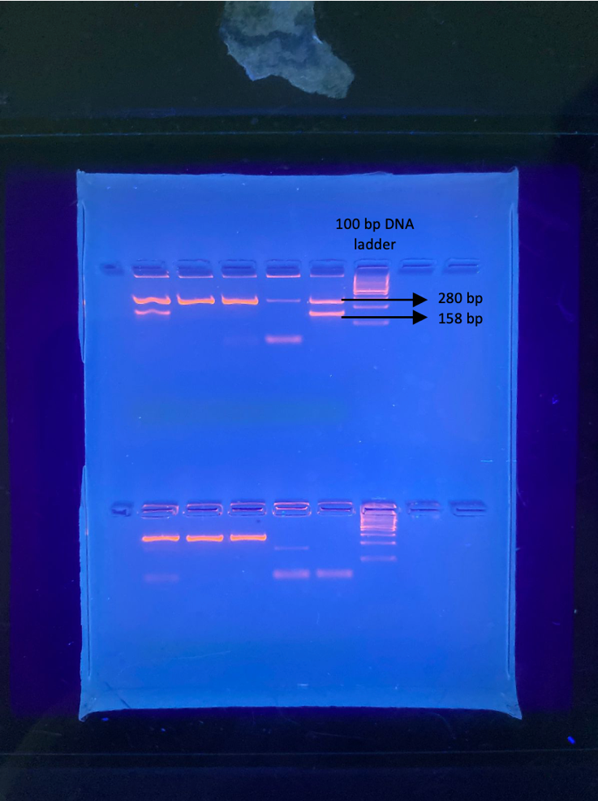
Figure 1A: 2% agarose gel electrophoresis showing bands of 280 bp and 158 bp for wildtype strains and a dropout of only 280 bp representing the 69/70 deletion. DNA marker ladder of 100 bp was run for reference size.
Supplementary Table 1: GISAID accession IDs of SARS-CoV-2 sequences submitted by PPHL-DUHS
PPHL-DUHS Accession IDs on GISAID
EPI_ISL_14441431
EPI_ISL_14441432
EPI_ISL_14441433
EPI_ISL_14441434
EPI_ISL_14441435
EPI_ISL_14441436
EPI_ISL_14441437
EPI_ISL_14441438
EPI_ISL_14441439
EPI_ISL_14441440
EPI_ISL_17445531
EPI_ISL_17445532
EPI_ISL_17445533
EPI_ISL_17445534
EPI_ISL_17445535
EPI_ISL_17445536
EPI_ISL_17445537
EPI_ISL_17445538
EPI_ISL_17445917
EPI_ISL_17445918
EPI_ISL_17445919
EPI_ISL_17445920
EPI_ISL_17445921
EPI_ISL_17445922
EPI_ISL_17445923
EPI_ISL_17445924
EPI_ISL_17445925
EPI_ISL_17445926
EPI_ISL_17445927
EPI_ISL_17445928
EPI_ISL_17445929
EPI_ISL_17445930
EPI_ISL_17474674
EPI_ISL_17474675
EPI_ISL_17474676
EPI_ISL_17474677
EPI_ISL_17474678
EPI_ISL_17474679
EPI_ISL_17474680
EPI_ISL_17474681
EPI_ISL_17474682
EPI_ISL_17474683
EPI_ISL_17474684
EPI_ISL_17474685
EPI_ISL_17474686
EPI_ISL_17474687
EPI_ISL_17474688
EPI_ISL_17474689
EPI_ISL_17474690
EPI_ISL_17474691
EPI_ISL_17474692
EPI_ISL_17474693
EPI_ISL_17474694
EPI_ISL_17474695
EPI_ISL_17474696
EPI_ISL_18788088
EPI_ISL_18788089
EPI_ISL_18788090
EPI_ISL_18788091
EPI_ISL_18788092
EPI_ISL_18788093
EPI_ISL_18788094
EPI_ISL_18831496
EPI_ISL_18831497
EPI_ISL_18831498
EPI_ISL_18831499
EPI_ISL_18831500
EPI_ISL_18831501
EPI_ISL_18831502
EPI_ISL_18831503
EPI_ISL_18831504
EPI_ISL_18831505
EPI_ISL_18831506
EPI_ISL_18831507
EPI_ISL_18831508
EPI_ISL_18831509
EPI_ISL_18831510
EPI_ISL_19882291
EPI_ISL_19882292
EPI_ISL_19882293
EPI_ISL_19882294
EPI_ISL_19882295
EPI_ISL_19882296
EPI_ISL_19882297
EPI_ISL_19882298
EPI_ISL_19882299
EPI_ISL_19882300
EPI_ISL_19882301
EPI_ISL_20055948
EPI_ISL_20055949
EPI_ISL_20055950
EPI_ISL_20055951
EPI_ISL_20055952
EPI_ISL_20055953
EPI_ISL_20055954
EPI_ISL_20055955
EPI_ISL_7861807
EPI_ISL_8170850
EPI_ISL_8170851
EPI_ISL_8170852
EPI_ISL_8170853
EPI_ISL_8170854
EPI_ISL_8170855
EPI_ISL_8170856
EPI_ISL_8170857
EPI_ISL_8317245
EPI_ISL_8317246
EPI_ISL_8317247
EPI_ISL_8329837
EPI_ISL_8329838
EPI_ISL_8329839
EPI_ISL_8329840
EPI_ISL_8329841
EPI_ISL_8329842
EPI_ISL_8329843
EPI_ISL_8329844
EPI_ISL_8329845
EPI_ISL_8329846
EPI_ISL_8329847
EPI_ISL_8329848
EPI_ISL_8329849
EPI_ISL_8329850
EPI_ISL_8486876
EPI_ISL_8487235

This table lists the GISAID accession IDs corresponding to SARS-CoV-2 whole-genome sequences generated by PPHL, DUHS. These sequences were collected and processed between June 2021 and June 2025 as part of ongoing genomic surveillance efforts in Sindh. Metadata associated with each sequence (e.g., collection date, location, and host) can be accessed via the GISAID EpiCoV database.

Supplementary Table 2: GISAID accession IDs of SARS-CoV-2 sequences used in phylogenetic analysis
Virus name | Accession ID
hCoV-19/Pakistan/DUHS09/2022 | EPI_ISL_14441431
hCoV-19/Pakistan/DUHS10/2022 | EPI_ISL_14441432
hCoV-19/Pakistan/DUHS11/2022 | EPI_ISL_14441433
hCoV-19/Pakistan/DUHS13/2022 | EPI_ISL_14441434
hCoV-19/Pakistan/DUHS24/2022 | EPI_ISL_14441435
hCoV-19/Pakistan/DUHS25/2022 | EPI_ISL_14441436
hCoV-19/Pakistan/DUHS26/2022 | EPI_ISL_14441437
hCoV-19/Pakistan/DUHS28/2022 | EPI_ISL_14441438
hCoV-19/Pakistan/DUHS30/2022 | EPI_ISL_14441439
hCoV-19/Pakistan/DUHS32/2022 | EPI_ISL_14441440
hCoV-19/Pakistan/DUHS-04/2022 | EPI_ISL_17445531
hCoV-19/Pakistan/DUHS-06/2022 | EPI_ISL_17445533
hCoV-19/Pakistan/DUHS-13/2022 | EPI_ISL_17445534
hCoV-19/Pakistan/DUHS-15/2022 | EPI_ISL_17445535
hCoV-19/Pakistan/DUHS-17/2022 | EPI_ISL_17445536
hCoV-19/Pakistan/DUHS-18/2023 | EPI_ISL_17445537
hCoV-19/Pakistan/DUHS-23/2023 | EPI_ISL_17445538
hCoV-19/Pakistan/DUHS-02/2022 | EPI_ISL_17445918
hCoV-19/Pakistan/DUHS-03/2022 | EPI_ISL_17445919
hCoV-19/Pakistan/DUHS-07/2022 | EPI_ISL_17445920
hCoV-19/Pakistan/DUHS-08/2022 | EPI_ISL_17445921
hCoV-19/Pakistan/DUHS-09/2022 | EPI_ISL_17445922
hCoV-19/Pakistan/DUHS-11/2022 | EPI_ISL_17445923
hCoV-19/Pakistan/DUHS-12/2022 | EPI_ISL_17445924
hCoV-19/Pakistan/DUHS-14/2022 | EPI_ISL_17445925
hCoV-19/Pakistan/DUHS-16/2022 | EPI_ISL_17445926
hCoV-19/Pakistan/DUHS-19/2023 | EPI_ISL_17445927
hCoV-19/Pakistan/DUHS-20/2023 | EPI_ISL_17445928
hCoV-19/Pakistan/DUHS-21/2023 | EPI_ISL_17445929
hCoV-19/Pakistan/DUHS-22/2023 | EPI_ISL_17445930
hCoV-19/Pakistan/BATCH-02-SAMPLE01/2023 | EPI_ISL_17474674
hCoV-19/Pakistan/BATCH-02-SAMPLE02/2023 | EPI_ISL_17474675
hCoV-19/Pakistan/BATCH-02-SAMPLE08/2023 | EPI_ISL_17474681
hCoV-19/Pakistan/BATCH-02-SAMPLE16/2023 | EPI_ISL_17474689
hCoV-19/Pakistan/BATCH-02-SAMPLE18/2023 | EPI_ISL_17474691
hCoV-19/Pakistan/BATCH-02-SAMPLE19/2023 | EPI_ISL_17474692
hCoV-19/Pakistan/DUHS-01/2024 | EPI_ISL_18788088
hCoV-19/Pakistan/DUHS-03/2023 | EPI_ISL_18788090
hCoV-19/Pakistan/DUHS-04/2023 | EPI_ISL_18788091
hCoV-19/Pakistan/DUHS-05/2023 | EPI_ISL_18788092
hCoV-19/Pakistan/DUHS-06/2023 | EPI_ISL_18788093
hCoV-19/Pakistan/DUHS-07/2024 | EPI_ISL_18788094
hCoV-19/Pakistan/DUHS-12/2024 | EPI_ISL_18831500
hCoV-19/Pakistan/DUHS-20/2024 | EPI_ISL_18831508
hCoV-19/Pakistan/DUHS-MN1/2021 | EPI_ISL_7861807
hCoV-19/Pakistan/DUHS01/2021 | EPI_ISL_8317245
hCoV-19/Pakistan/DUHS02/2021 | EPI_ISL_8317246
hCoV-19/Pakistan/DUHS05/2021 | EPI_ISL_8317247
hCoV-19/Pakistan/DUHS26/2021 | EPI_ISL_8486876
hCoV-19/Pakistan/DUHS29/2021 | EPI_ISL_8487235
hCoV-19/Pakistan/NIH-B135-S7/2021 | EPI_ISL_17814257
hCoV-19/Pakistan/NIH-B135-S9/2021 | EPI_ISL_17814259
hCoV-19/Pakistan/NIH-B142-S8/2021 | EPI_ISL_17973430
hCoV-19/Pakistan/NIH-B152-S13/2021 | EPI_ISL_18075449
hCoV-19/Pakistan/NIH-B152-S14/2021 | EPI_ISL_18075450
hCoV-19/Pakistan/NIH-B154-S8/2021 | EPI_ISL_18123234
hCoV-19/Pakistan/NIH-B154-S9/2021 | EPI_ISL_18123235
hCoV-19/Pakistan/NIH-AHF-S24/2023 | EPI_ISL_18445462
hCoV-19/Pakistan/UWARN-AKU-KHI-70395-S16/2024 | EPI_ISL_19192632
hCoV-19/Pakistan/NIH-B169-S31/2024 | EPI_ISL_19221081
hCoV-19/Saudi Arabia/KAUST489/2021 | EPI_ISL_16675001
hCoV-19/Saudi Arabia/KFSHRC_20S/2021 | EPI_ISL_17276067
hCoV-19/Saudi Arabia/KFSHRC_1O/2022 | EPI_ISL_17616339
hCoV-19/Saudi Arabia/KFSHRC_30AJ/2023 | EPI_ISL_19640595
hCoV-19/Saudi Arabia/KFSHRC_2AN/2024 | EPI_ISL_19642772
hCoV-19/India/MP-ICMR-NIRTH-S13/2020 | EPI_ISL_19624138
hCoV-19/India/DL-VRDL-AHRR-00062/2022 | EPI_ISL_19755601
hCoV-19/India/DL-VRDL-AHRR-00079/2022 | EPI_ISL_19769580
hCoV-19/India/GJ-INSACOG-GBRC-14511/2025 | EPI_ISL_20046871
hCoV-19/India/MP-INSACOG-GBRC-14515/2025 | EPI_ISL_20046875
hCoV-19/Henan/WIV-AY025/2020 | EPI_ISL_19765432
hCoV-19/Henan/WIV-AY666/2020 | EPI_ISL_19765445
hCoV-19/Hubei/WIV-YB0420_072/2020 | EPI_ISL_19765459
hCoV-19/Shanxi/SXJCCDC-JCCX25066/2025 | EPI_ISL_19917607
hCoV-19/Shanxi/SXJCCDC-JCCX25114/2025 | EPI_ISL_19917661
hCoV-19/Bangladesh/ideSHi-031310/2021 | EPI_ISL_18875527
hCoV-19/Bangladesh/ideSHi-2004226211/2020 | EPI_ISL_18875543
hCoV-19/Bangladesh/icddrb-HCWC-02040158/2023 | EPI_ISL_19406608
hCoV-19/Bangladesh/icddrb-HCWC-05020193/2024 | EPI_ISL_19406618
hCoV-19/Bangladesh/icddr-b-1250503020/2025 | EPI_ISL_19894988
hCoV-19/Australia/NSW-ICPMR-50518/2023 | EPI_ISL_18513410
hCoV-19/Australia/NSW-ICPMR-50608/2023 | EPI_ISL_18513500
hCoV-19/Australia/NSW-ICPMR-52522/2023 | EPI_ISL_18798760
hCoV-19/Australia/VIC-VIDRL-00013149/2023 | EPI_ISL_18880531
hCoV-19/Australia/QLD0x014175/2024 | EPI_ISL_19009767
hCoV-19/Iran/NIC-30/2022 | EPI_ISL_16464027
hCoV-19/Iran/NIC-34/2022 | EPI_ISL_16464031
hCoV-19/Iran/NIC-9es-35/2023 | EPI_ISL_17324873
hCoV-19/Iran/EF1016/2023 | EPI_ISL_18443026
hCoV-19/Iran/NIC-25Mehr-4/2023 | EPI_ISL_19508829
hCoV-19/USA/ND-NDDH-26187/2021 | EPI_ISL_19902720
hCoV-19/USA/ND-NDDH-26198/2021 | EPI_ISL_19902731
hCoV-19/USA/ND-NDDH-26216/2022 | EPI_ISL_19902776
hCoV-19/USA/NY-SUNY-080/2025 | EPI_ISL_19906130
hCoV-19/USA/NY-SUNY-081/2025 | EPI_ISL_19906131

This table provides the GISAID accession IDs of global and regional SARS-CoV-2 sequences included in the phylogenetic analysis. Sequences were selected based on lineage relevance, geographical representation (including India, China, Bangladesh, Iran, Saudi Arabia, USA, and Australia), and temporal overlap with samples collected during the study period. All sequences were downloaded from the GISAID EpiCoV database.

