Supplementary Materials
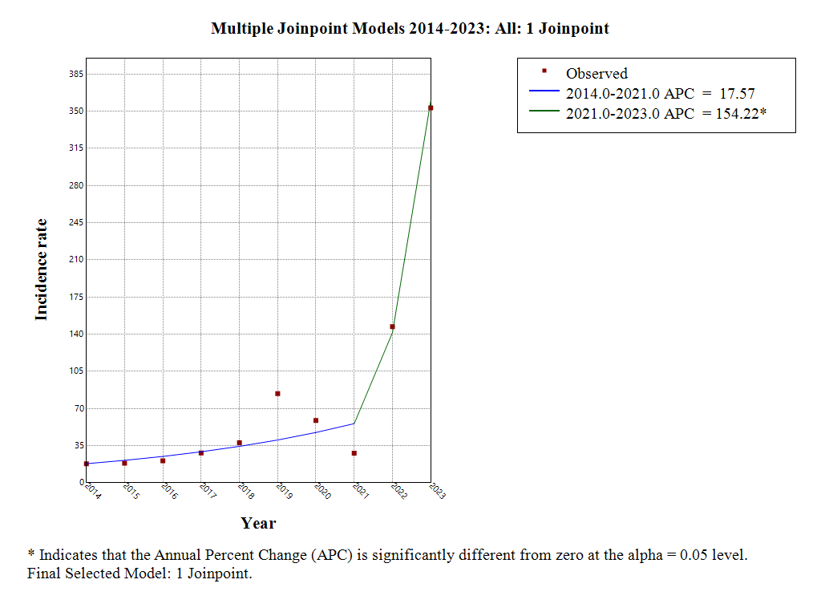
Annex 1.Joinpoint regression of seasonal influenza incidence in Jiangxi, 2014-2023
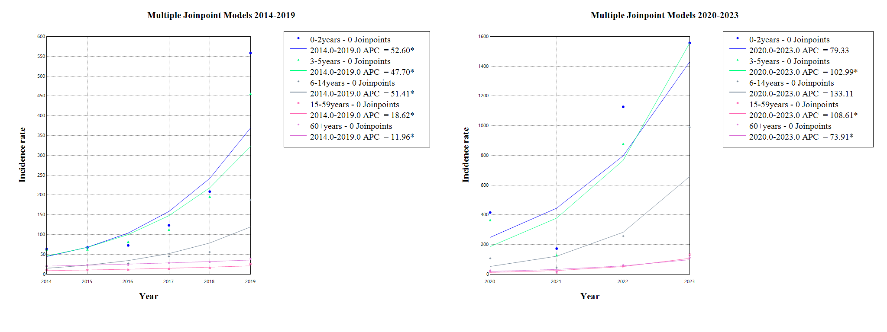

Annex 2.Joinpoint regression of seasonal influenza incidence in Jiangxi, 2014-2023

Table 1.APC model analysis results of seasonal influenza incidence in Jiangxi, 2014-2023

Age group | Period | APC(95 %CI) | P | AAPC(95 %CI) | P
0-3years | 2014-2019 | 52.6(13.2～106.1) | 0.004* | 52.6(13.2～106.1) | 0.004*
0-3years | 2020-2023 | 79.3(-5.9～238.0) | 0.095 | 79.3(-5.9～238.0) | 0.095
3-6years | 2014-2019 | 47.7（19.9～81.3） | <0.001* | 47.7（19.9～81.3） | <0.001*
3-6years | 2020-2023 | 103.0(2.2～302.7) | 0.040* | 103.0(2.2～302.7) | 0.040 *
6-15years | 2014-2019 | 51.4(12.9～102.7) | 0.006* | 51.4(12.9～102.7) | 0.006*
6-15years | 2020-2023 | 133.1(-4.5～470.8) | 0.072 | 133.1(-4.5～470.8) | 0.072
15-60years | 2014-2019 | 18.6(9.4～28.3) | <0.001* | 18.6(9.4～28.3) | <0.001*
15-60years | 2020-2023 | 108.6(29.0～235.1) | <0.001* | 108.6(29.0～235.1) | <0.001*
65+years | 2014-2019 | 12.0(7.8～16.1) | <0.001* | 12.0(7.8～16.1) | <0.001*
65+years | 2020-2023 | 73.9(17.8～156.3) | <0.001* | 73.9(17.8～156.3) | <0.001*
All age groups | 2014-2023 | 17.57（-17.05~32.32） | 0.232 | 39.55（22.77~ 52.93） | <0.001
All age groups | 2014-2023 | 154.22（38.70~304.39） | <0.001 | - | -

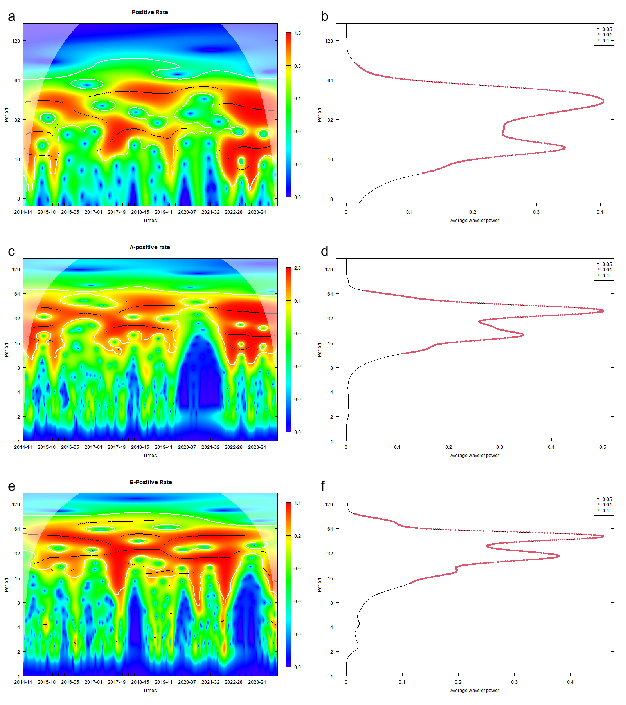
Annex 3.Wavelet power of the estimated incidence of seasonal influenza. (a) Wavelet power spectrum of the total positive.(b)The average power of the whole period of the total positive (c) Wavelet power spectrum of Type-A positive.(d)The average power of the whole period of the Type-A positive.(e) Wavelet power spectrum of Type-B positive.(f)The average power of the whole period of the Type-B positive

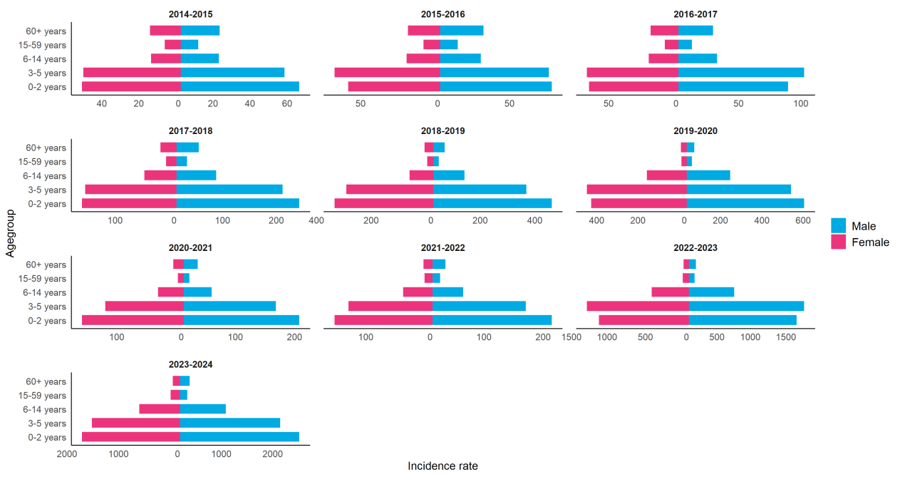
Annex 4.Gender pyramid of seasonal influenza incidence by surveillance year: distribution by age group

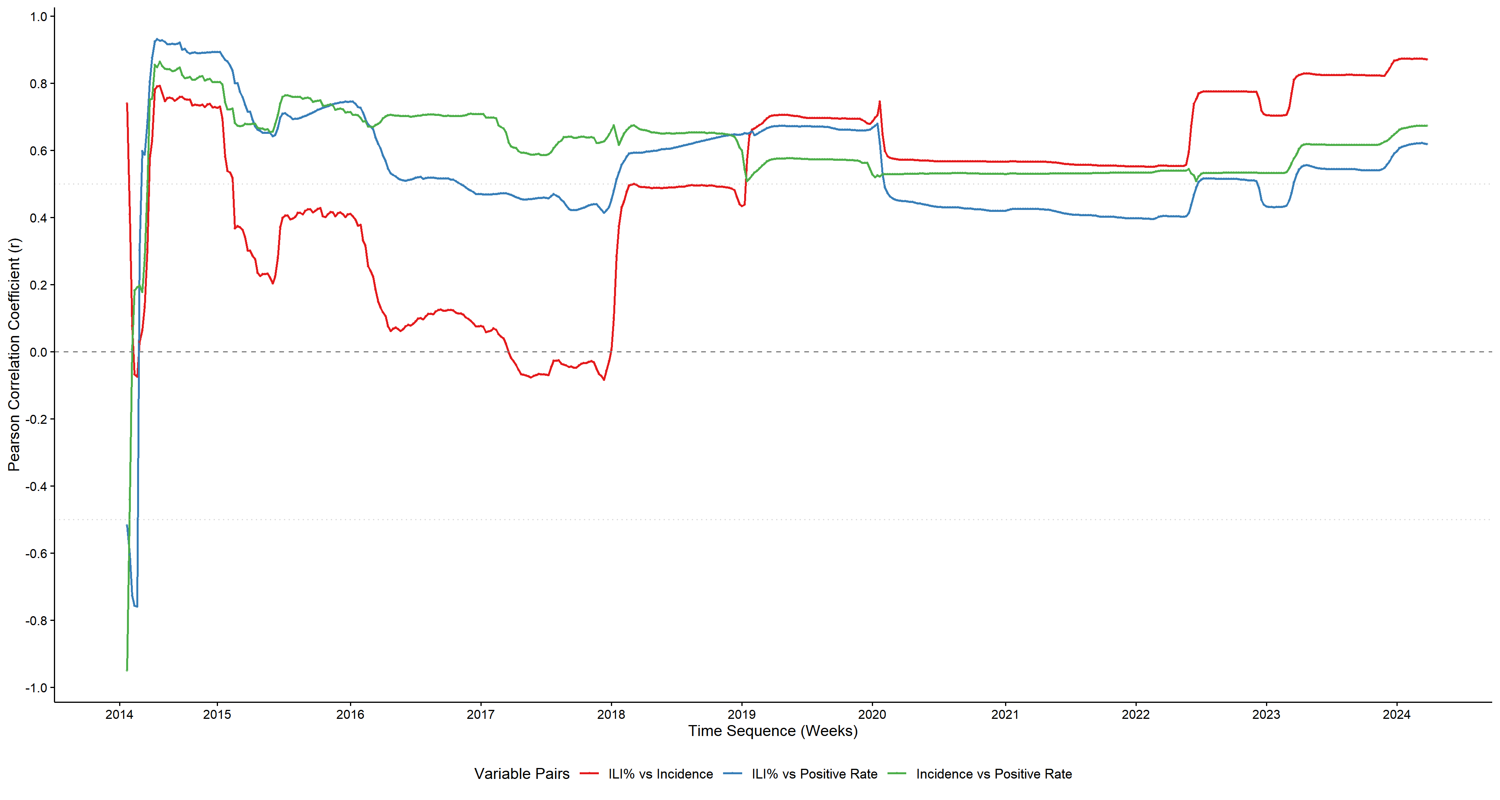
Annex 5. Rolling Correlation Analysis Chart for Three Surveillance Systems

