Additional file 1: Geographic location of two sites in the map of Bangladesh representing the collection sites of N. gonorrhoeae isolates in this analysis. The 2014 cross-sectional bio-behavioral study was conducted only in Dhaka. The SRHR study was conducted in both Dhaka and Jashore district. Both districts are marked in red color and specimen transportation route is presented with blue color.
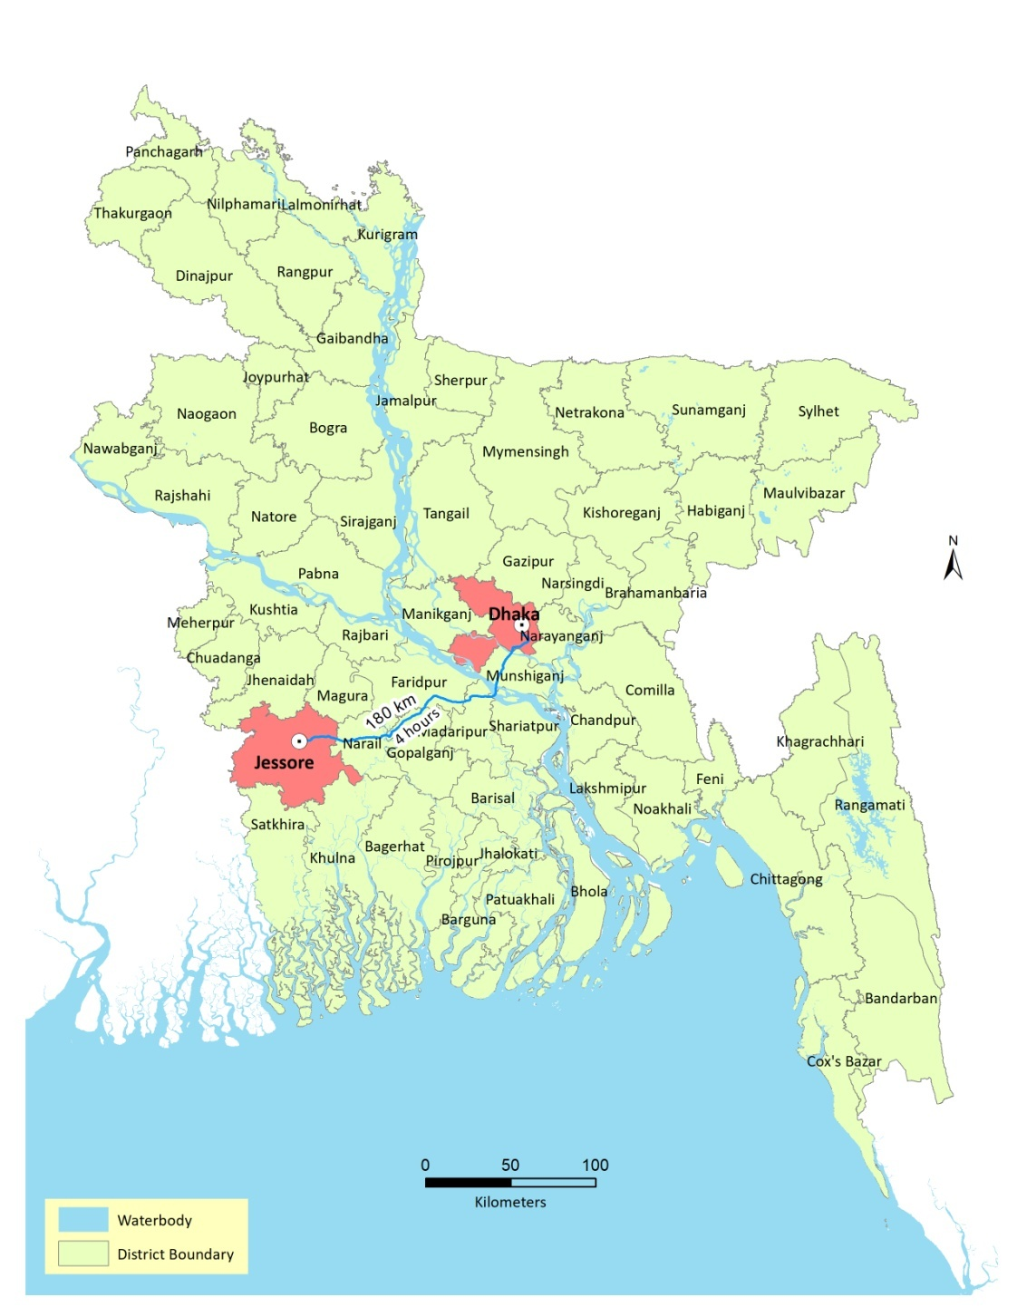
India
India
India
India
Myanmar
Bay of Bengal
Jashore

