Data Extraction tools
Data sheet 1: Individual information collecting tool from EMR for PLHIV in care
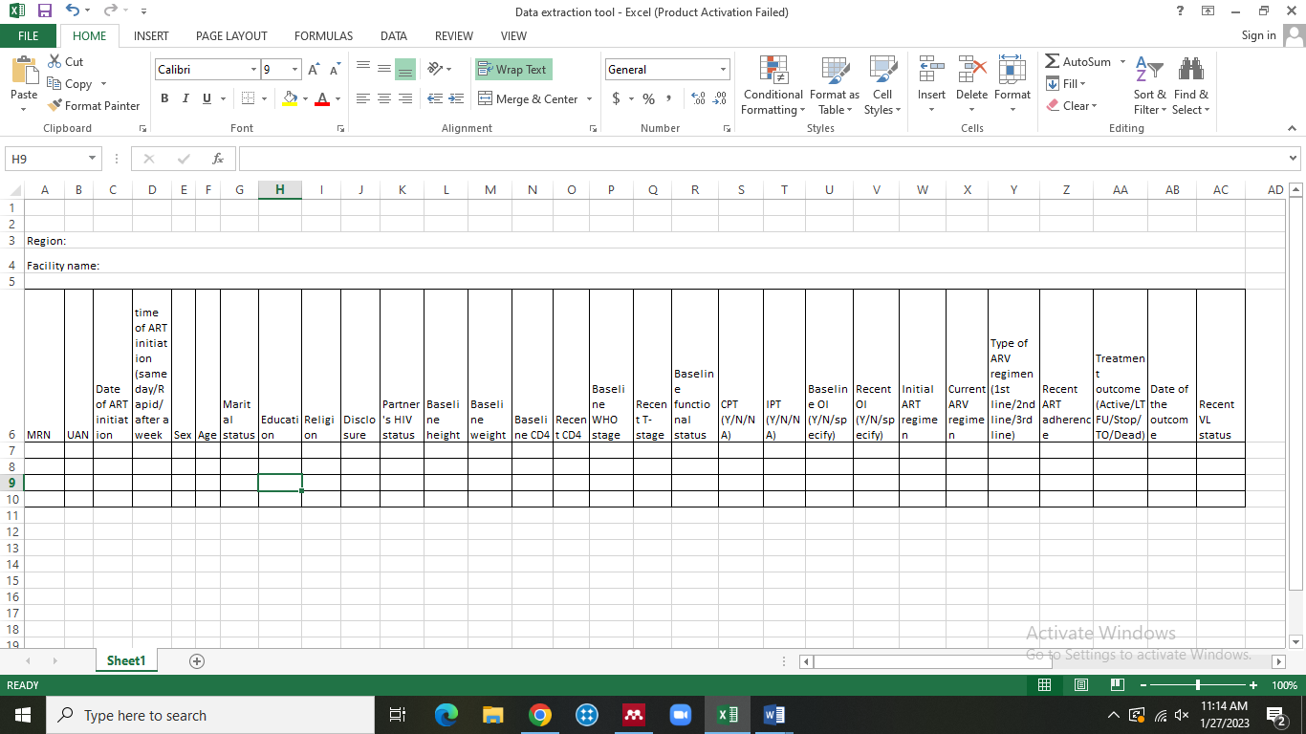

Data Sheet 2: Admissions, outcomes and length of hospital stay among PLHIV (2015/16-2023)
Reg. No* | MRN | Sex | Age | Reason for  admission |  |  | Date of admission  (DD/MM/YY) | ART related information ( if available) |  |  |  |  | Outcome:  1. discharge  2. death  3. transfer out/referral | Date of discharge/ death/ transfer out  (DD/MM/YY) | **Probable Cause of death
 |  |  |  |  |  |  |  | ART initiation status  Y/N | Place of ART initiation  - Within (write UAN  - outside | Date of ART initiation  (DD/MM/YY) | Clinical stage ART initiation | CD4 count at ART initiation (if available) | Outcome:  1. discharge  2. death  3. transfer out/referral | Date of discharge/ death/ transfer out  (DD/MM/YY) | **Probable Cause of death
 |  |  |  | Main diagnosis at admission | Other/additional OI | Other Comorbidities
* Registration number on the admission book
**Probable Cause of death – As stated by the physician during the time of death (if not stated capture the available diagnosis)
UAN – Unique ART number
Main reason for admission – Include admission related to accident and/or war

Data sheet 3: Information on admissions, bed occupancy and inpatient-deaths (2015/16-2023)
A. Background information
1. Hospital 2. Region 3. Zone

Year | Medical |  |  |  | Pediatrics |  |  |  | Surgical |  |  |  | Other*
 | No of beds | No of admission | No of death |  | No of beds | No of admission | No of death |  | No of beds | No of admission | No of death |  | No of beds | No of admission | No of death
 | No of beds | No of admission | AIDS related | Others | No of beds | No of admission | AIDS related | Others | No of beds | No of admission | AIDS related | Others | No of beds | No of admission | AIDS related | Others
2016
2017
2018
2019
2020
2021
2022
2023
* Gyn/Obs, delivery, Ophthalmology, dentistry, psychiatry, etc.

D. Data sheet 4: Information extracted from the card for PLHIV in care (2015/16-2023)
Unique identifier | Clinical diagnosis before death (up to 3 month)
Unique identifier | OI (Y/N) if yes specify | Other comorbidities (Y/N) If yes specify

NB: The unique identifier must be similar with the EMR number

