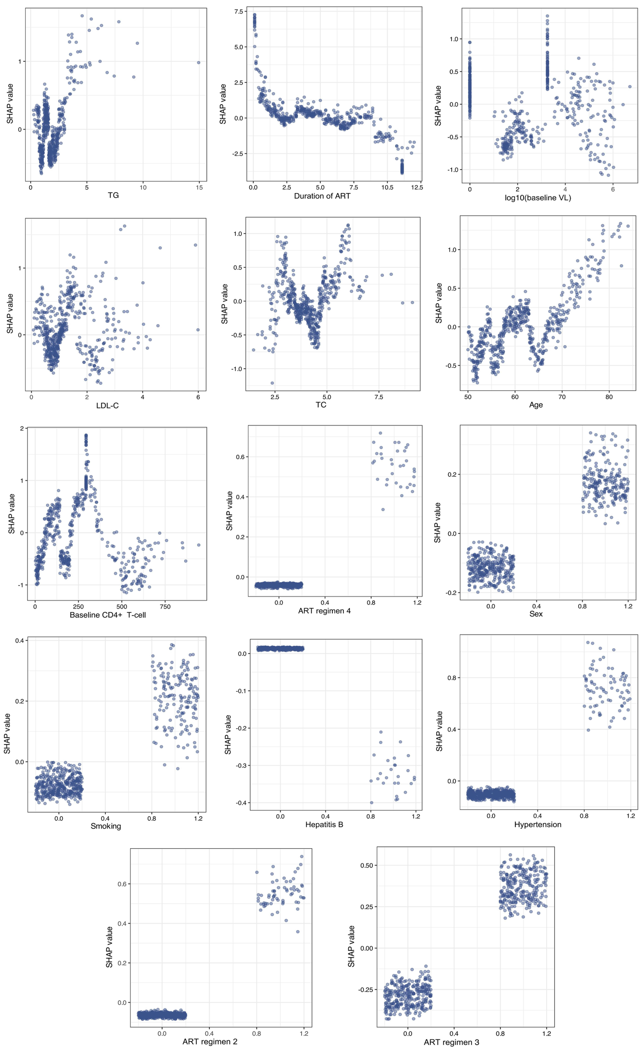
Figure S1. SHAP dependence plot for features. LDL-C, low-density lipoprotein-cholesterol; TG, triglycerides; TC, total cholesterol; ART regimen 2 = 3TC+AZT/D4T+NVP/EFV; ART regimen 3 = 3TC+LPV/r+TDF/AZT/D4T; ART regimen 4 = Other;ART, antiretroviral therapy; 3TC, Lamivudine; TDF, Tenofovir disoproxil fumarate; NVP, Nevirapine; AZT, Zidovudine ; D4T, Stavudine; LPV/r, Lopinavir/ritonavir; VL, viral load. Note: HIV transmission behavior 2 (“Injection Drug Use”) and HIV transmission behavior 3 (“Other”) are not displayed because their SHAP values were approximately zero across all samples.

