Table S1. Etiological results of 11 patients with M. col infection.
Patient | Sample Type | Platform | M.col Roads | Relative Abundance (%) | Detection Method |  |  | Drug Susceptibility
 |  |  |  |  | Smear | Culture | mNGS | Drug Susceptibility
1 | BALF | BGI | 51 | 45.2 | - | + | + | Yes
2 | Lung tissue | not stated | not stated | not stated | + | + | + | No
3 | Sputum | / | / | / | - | + (twice) | + | Yes
4 | BALF | Illumina | 4 | 0.6 | + | + | + | No
5 | Purulent discharge | not stated | not stated | not stated | + | + | + | No
6 | BALF | BGI | 1 | 0.35 | - | + | - | Yes
7 | BALF | BGI | 13 | 2.15 | + | / | + | No
8 | BALF | / | / | / | - | + | / | Yes
9 | BALF | BGI | 24 | 1.82 | - | + | + | Yes
10 | Sputum and BALF | BGI | 22 | 1.12 | + | / | + | No
11 | Purulent discharge | BGI | 15 | 0.14 | + | + | / | Yes
Abbreviations: BALF: bronchoalveolar lavage fluid; mNGS: metagenomic next-generation sequencing; BGI: formerly Beijing Genomics Institute.

Table S2. Treatment and prognosis of M. col pulmonary infection.
Patients | Anti-NTM Therapy | Treatment Course (Month) | Outcome
Patients | Anti-NTM Therapy | Treatment Course (Month) | Symptoms | Imaging | Etiology
1 | RIF 0.45g po qd +ETH 0.75g po qd +AZM 0.5g po qd+AMK 0.4g im qd | 7(Under treatment) | Imp | Imp | /
2 | MFX 0.4g po qd +ETH 0.75g po qd +CLR 0.5g po bid +AMK 0.4g im qd | 24 (Recover) | Imp | Imp | Imp
3 | ETH 0.75g po qd +INH 0.3g po qd +CLR 0.5g po bid +AMK 0.4g im qd | 3 (Under treatment) | Imp | / | /
4 | CDR 0.2g po bid +LEV 0.5g po qd | 12 (Recover) | Imp | Imp | Imp
5 | RIF 0.45g po qd +CLR 0.5g po bid +ETH 0.75g po qd +LNZ 0.6g po bid | 3 (Lost to follow-up) | Imp | / | /
6 | RIF 0.45g po qd +CLR 0.5g po bid +ETH 1.25g po qd | 14 (Recover) | Imp | Imp | Imp
7 | ETH 0.75g po qd +MFX 0.4g po qd + AMK 0.4g im qd+ AZM 0.5g po qd | 12 (Recover) | Imp | Imp | Imp
8 | RIF 0.6g po qd +CLR 0.5g po bid +ETH 0.75g po qd | 9 (Under treatment) | Imp | / | Imp
9 | RIB 0.6g po qwk +CLR 0.5g po bid +ETH 1g po qd +FOX 2g iv q8h | 4 days (Adverse Drug Reaction) | / | Imp | /
10 | RIF 0.45g po qd +CLR 0.5g po bid +ETH 0.75g po qd +AMK 0.4g im qd | 12 (Recover) | Imp | Imp | Imp
11 | RIF 0.45g po qd +CLR 0.5g po bid +ETH 0.75g po qd +AMK 0.4g im qd | 5 (Under treatment) | Imp | Imp | /
Abbreviations: RIF: Rifampin; AZM: Azithromycin; AMK: Amikacin; CLR: Clarithromycin; ETH: Ethambutol; MFX: Moxifloxacin; INH: isoniazid; CDR: Cefdinir; LEV: Levofloxacin; LNZ: Linezolid; RIB: Rifabutin; FOX: Cefoxitin; po: Per Os; iv: Intravenous; im: Intramuscular; qd: once daily; bid: twice daily; qwk: once per week; q8h: every 8 hours; Imp: improvement.

Figure S1. Mycobacterial Species Distribution and Clinical Characteristics of M. col Infections.
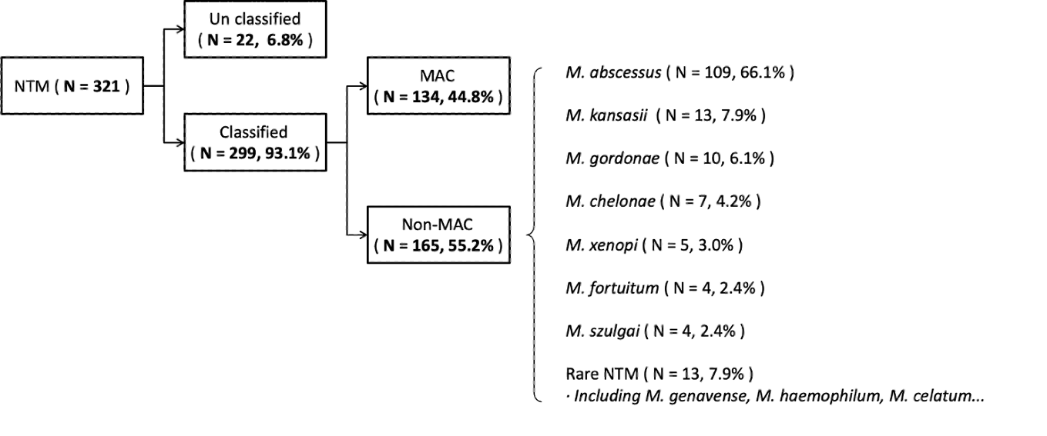
A

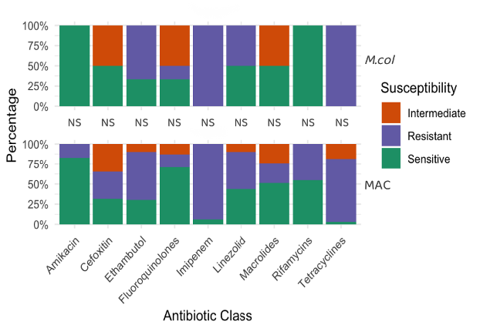
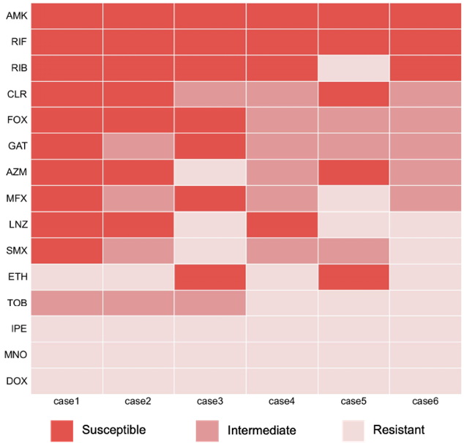
B C

(A): Species Distribution of the 321 NTM infection Cases. (B): Antibiotic susceptibility test of 6 patients with M. col infection. (C): Antibiotic susceptibility of 11 M. col infection patients and 38 MAC infection patients.
Abbreviations: NTM: nontuberculous mycobacteria; MAC: Mycobacterium avium complex; AMK: Amikacin, RIF: Rifampin; RIB: Rifabutin; CLR: Clarithromycin; FOX: Cefoxitin; GAT: Gatifloxacin; AZM: Azithromycin; MFX: Moxifloxacin; LNZ: Linezolid; SMX: Sulfamethoxazole; ETH: Ethambutol; TOB: Tobramycin; IPE: Imipenem; MNO: Minocycline; DOX: Doxycycline; NS: Non-Significant.

