Supplementary Table S1. Diagnostic performance of Abbott RealTime HCV assay by study site
 |  | Abbott RealTime  capillary DBS |  |  | Abbott RealTime  venous DBS
Site | Reference test and sample type | Sensitivity (%),  (95% CI) | Specificity (%),  (95% CI) |  | Sensitivity (%),  (95% CI) | Specificity (%),  (95% CI)
All sites | Abbott RealTime  plasma | 95.2  (92.9 – 96.8) | 95.6  (93.3 – 97.1) |  | 95.4  (93.1 – 97.0) | 96.0  (93.8 – 97.4)
Georgia | Abbott RealTime  plasma | 98.4  (94.2 – 99.5) | 94.6  (89.7 – 97.2) |  | 98.3  (94.2 – 99.5) | 95.3  (90.6 – 97.7)
Cameroon | Abbott RealTime  plasma | 94.7  (90 – 97.3) | 100  (96.2 – 100) |  | 94.7  (90 – 97.3) | 100  (96.2 – 100)
Greece | Abbott RealTime  plasma | 89.7  (82.1 – 94.3) | 95.9  (90.7 – 98.2) |  | 90.7  (83.3 – 95) | 95.9  (90.7 – 98.2)
Rwanda | Abbott RealTime  plasma | 97.8  (92.2 – 99.4) | 92.7  (86.2 – 96.2) |  | 97.7  (92.1 – 99.4) | 96.3  (90.9 – 98.6)
CI, confidence interval; DBS, dried blood spot; PSC, plasma separation card

Supplementary Table S2. Invalid rates with the Abbott RealTime HCV assay by study site
Assay and sample type | Georgia | Cameroon | Greece | Rwanda | All sites
Abbott RealTime
Venous DBS | 10/279 (3.58%) | 2/251 (0.80%) | 1/219 (0.45%) | 2/200 (1.0%) | 15/949 (1.58%)
Capillary DBS | 4/270 (1.48%) | 2/251 (0.80%) | 1/219 (0.45%) | 3/202 (1.49) | 10/946 (1.06%)
The table presents the number of eligible capillary and venous samples with available test results for inclusion in the analysis.
Supplementary Figure S1. Median (A) plasma viral load; median (B) capillary DBS viral load and median (C) Venous DBS viral load using the Abbott RealTime HCV assay by study site.
Pairwise Wilcoxon tests were used, and p-values were adjusted using the Bonferroni method to correct for multiple comparisons.
A
C
B
SITE | 25th percentile | Median | 75th percentile | SITE | 25th percentile | Median | 75th percentile | SITE | 25th percentile | Median | 75th percentile
Cameroon | 5.399835 | 5.964665 | 6.362244 | Cameroon | 5.563492 | 6.150038 | 6.631129 | Cameroon | 5.636618 | 6.179170 | 6.720419
Georgia | 5.494437 | 5.964707 | 6.427558 | Georgia | 5.331208 | 5.819155 | 6.226726 | Georgia | 5.367667 | 5.836904 | 6.253026
Greece | 4.791761 | 5.830553 | 6.291319 | Greece | 4.286679 | 5.169370 | 5.844000 | Greece | 3.883150 | 5.062187 | 5.749426
Rwanda | 5.741646 | 6.005026 | 6.462000 | Rwanda | 5.216355 | 5.677815 | 6.285885 | Rwanda | 5.316498 | 5.770748 | 6.281879
All sites | 5.405869 | 5.920752 | 6.409890 | All sites | 5.138547 | 5.802628 | 6.325609 | All sites | 5.152447 | 5.805192 | 6.335787

Supplementary information for Figure S 1A – Statistical information for median Plasma viral load across all sites.
Pairwise Wilcoxon tests were used, and p-values were adjusted using the Bonferroni method to correct for multiple comparisons.
.y. | group1 | group2 | n1 | n2 | statistic | p | p.adj | p.adj.signif
PL_ABBOTT_RES_VL | Cameroon | Georgia | 152 | 122 | 8567 | 0.543 | 1.000 | ns
PL_ABBOTT_RES_VL | Georgia | Greece | 122 | 97 | 6375 | 0.034 | 0.205 | ns
PL_ABBOTT_RES_VL | Georgia | Rwanda | 122 | 89 | 4952 | 0.389 | 1.000 | ns
PL_ABBOTT_RES_VL | Cameroon | Greece | 152 | 97 | 7507 | 0.100 | 0.600 | ns
PL_ABBOTT_RES_VL | Cameroon | Rwanda | 152 | 89 | 5806 | 0.164 | 0.984 | ns
PL_ABBOTT_RES_VL | Greece | Rwanda | 97 | 89 | 3113 | 0.014 | 0.083 | ns

Supplementary information for Figure S 1B – Statistical information for median capillary DBS viral load across all sites
Pairwise Wilcoxon tests were used, and p-values were adjusted using the Bonferroni method to correct for multiple comparisons.
.y. | group1 | group2 | n1 | n2 | statistic | p | p.adj | p.adj.signif
DBS_CAP_ABBOTT_RES_VL | Cameroon | Georgia | 144 | 128 | 11886 | 0.0000375 | 0.000225 | ***
DBS_CAP_ABBOTT_RES_VL | Georgia | Greece | 128 | 92 | 7787 | 0.0000457 | 0.000274 | ***
DBS_CAP_ABBOTT_RES_VL | Georgia | Rwanda | 128 | 96 | 6443 | 0.5340000 | 1.000000 | ns
DBS_CAP_ABBOTT_RES_VL | Cameroon | Greece | 144 | 92 | 10261 | 0.0000000 | 0.000000 | ****
DBS_CAP_ABBOTT_RES_VL | Cameroon | Rwanda | 144 | 96 | 9072 | 0.0000416 | 0.000250 | ***
DBS_CAP_ABBOTT_RES_VL | Greece | Rwanda | 92 | 96 | 3236 | 0.0020000 | 0.009000 | **

Supplementary information for Figure S 1C – Statistical information for median venous DBS viral load across all sites
Pairwise Wilcoxon tests were used, and p-values were adjusted using the Bonferroni method to correct for multiple comparisons.
.y. | group1 | group2 | n1 | n2 | statistic | p | p.adj | p.adj.signif
DBS_VEN_ABBOTT_RES_VL | Cameroon | Georgia | 144 | 126 | 11814 | 0.0000185 | 0.000111 | ***
DBS_VEN_ABBOTT_RES_VL | Georgia | Greece | 126 | 93 | 8226 | 0.0000003 | 0.000002 | ****
DBS_VEN_ABBOTT_RES_VL | Georgia | Rwanda | 126 | 94 | 6179 | 0.5830000 | 1.000000 | ns
DBS_VEN_ABBOTT_RES_VL | Cameroon | Greece | 144 | 93 | 10773 | 0.0000000 | 0.000000 | ****
DBS_VEN_ABBOTT_RES_VL | Cameroon | Rwanda | 144 | 94 | 8971 | 0.0000222 | 0.000133 | ***
DBS_VEN_ABBOTT_RES_VL | Greece | Rwanda | 93 | 94 | 2832 | 0.0000322 | 0.000193 | ***

Supplementary Figure S2. Turnaround testing times using the Abbott RealTime HCV assay for different sample types by study site; DBSc – capillary DBS, DBSv – venous DBS.
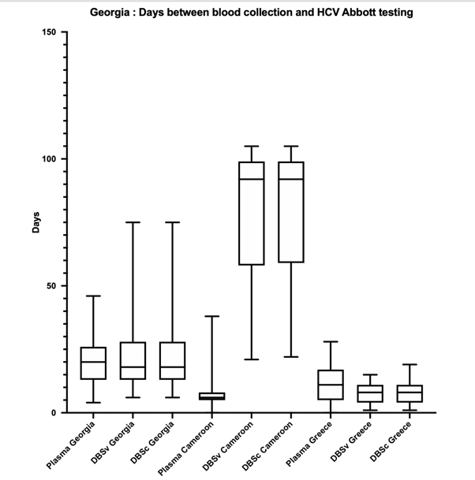

Supplementary Case Report Form S3
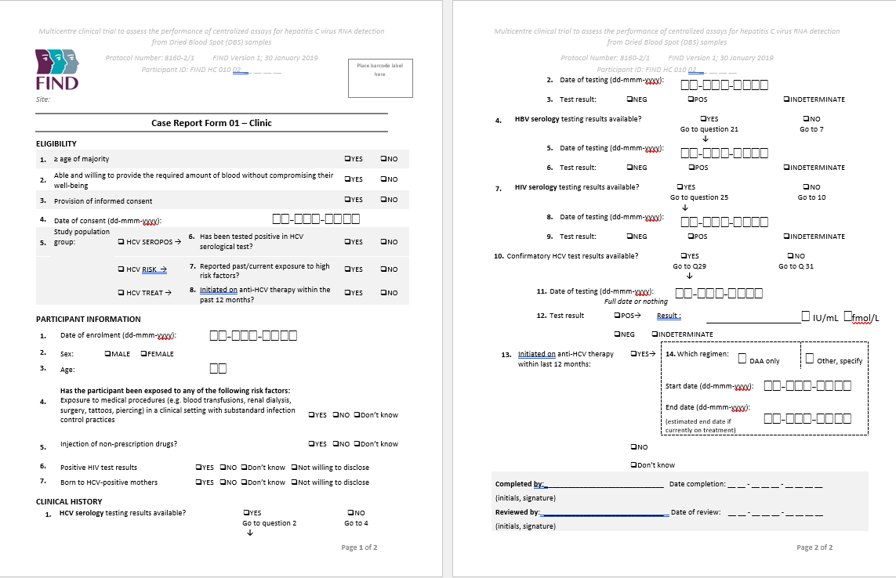

Supplementary Table S3
