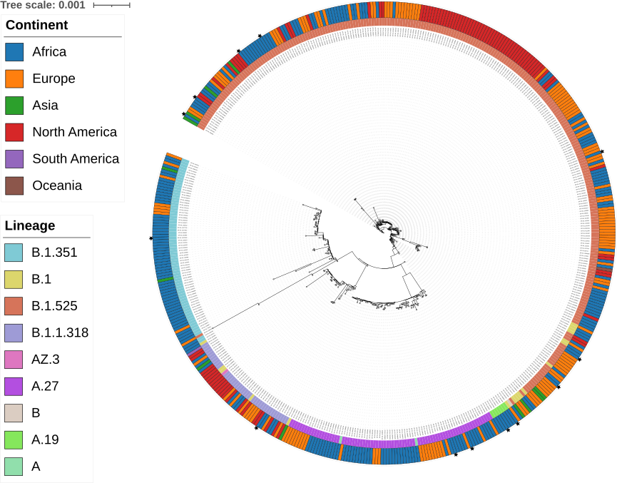
S1 figure. Maximum likelihood phylogenetic tree of the query sequences and related genomes worldwide.
Our study sequences are distributed in several distinct phylogenetic groups, demonstrating significant genetic diversity within our sample. Comparative analysis with international reference sequences reveals preferential phylogenetic associations with isolates from the African continent, as shown by the strong predominance of African sequences (in blue) in the tree, followed by notable representation from Europe (in orange) and North America (in red).

