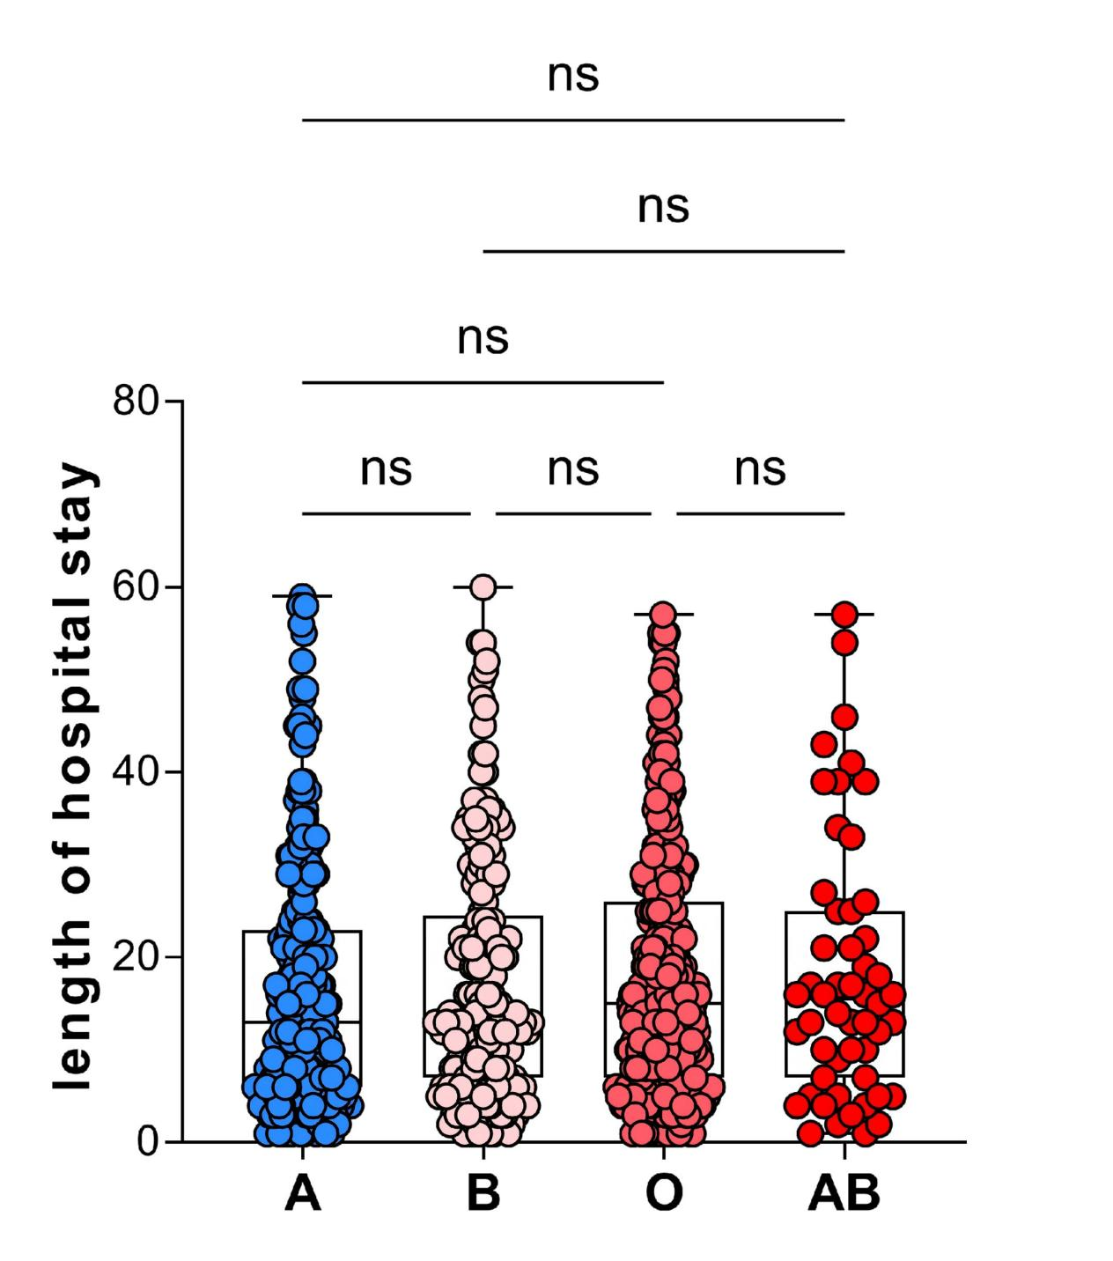
FingureS1. Length of Hospital Stay by Blood Types
Box plots with overlaid scatter points show the distribution of hospitalization days for COVID-19 patients. No statistically significant differences were observed between blood types.

