Supplementary materials 1

RESEARCH

Global burden and cross-country inequalities in rabies from 1990 to 2021: A systemic analysis of the Global Burden of Disease Study 2021

Items

Table S1: Incidence cases of rabies in 2021, and change trend of incidence cases were analyzed across GBD regions.
Table S2: The mortality cases of rabies in 2021, and change trend of incidence cases were analyzed across GBD regions.
Table S3: The DALY cases of rabies in 2021, and change trend of DALY cases were analyzed across GBD regions.
Table S4: The change trend of rabies in 204 countries and territories of GBD from 1990 to 2021.
Figure S1: The ASR of rabies showed notable differences in 204 countries and territories in 2021 year.
Figure S2: The ASR of rabies showed notable differences across age and gender distributions in 2021 year
Figure S3: Prediction of global disease burden of rabies from 2022–2035 years based on the BAPC model .
Table S5: Frontier analysis exploring ASDR of rabies across 204 countries and territories.
Table S6: Decomposition analysis of incidence cases for rabies globally and across five SDI regions from 1990 to 2021.

Table S1: Incidence cases of rabies in 2021, and change trend of incidence cases were analyzed across GBD regions.
Location | Rabies.  Incidence cases  (persons) .  (95% UI).  1990 year | Rabies.  Incidence cases  (persons) .  (95% UI).  2021 year | Rabies.  Percentage change (95% UI).  1990－2021. | Rabies.  EAPC (95% CI).  1990－2021. | Rabies.  AAPC (95% CI).  1990－2021.
Global | 22035.15(15731.80,28729.20) | 10180.67(6080.47,14293.43) | -53.80(-66.52,-40.38) | -2.80(-3.06,-2.55) | -390.610(-412.675,-368.545)
East Asia | 1103.41(647.46,1526.19) | 626.65(334.70,950.14) | -43.21(-61.52,-18.55) | 0.24(-1.75,2.26) | -14.327(-19.184,-9.471)
Southeast Asia | 1469.39(1095.44,1967.70) | 663.38(393.04,972.09) | -54.85(-70.69,-34.24) | -3.21(-3.60,-2.81) | -26.093(-26.709,-25.477)
Oceania | 0.69(0.20,2.24) | 1.56(0.41,4.45) | 126.57(16.98,333.25) | 2.58(2.43,2.72) | 0.029(0.028,0.029)
Central Asia | 13.36(7.36,25.21) | 9.14(5.91,13.73) | -31.59(-63.18,24.17) | -2.14(-2.79,-1.49) | -0.188(-0.250,-0.125)
Central Europe | 4.10(3.54,4.85) | 0.15(0.11,0.19) | -96.40(-97.28,-95.22) | -12.28(-13.48,-11.06) | -0.150(-0.165,-0.136)
Eastern Europe | 11.93(10.81,13.29) | 5.24(4.21,6.62) | -56.09(-64.25,-43.92) | -1.61(-2.52,-0.70) | -0.249(-0.295,-0.202)
High-income Asia Pacific | 1.03(0.86,1.19) | 0.38(0.28,0.46) | -62.66(-71.35,-55.68) | -2.31(-3.71,-0.88) | -0.024(-0.028,-0.020)
Australasia | 0.04(0.03,0.04) | 0.08(0.06,0.11) | 113.88(45.84,212.63) | 5.76(3.49,8.07) | 0.001(0.000,0.002)
Western Europe | 0.54(0.46,0.60) | 2.06(1.65,2.48) | 280.42(224.77,348.65) | 4.13(3.38,4.88) | 0.051(0.041,0.062)
Southern Latin America | 0.01(0.01,0.01) | 0.02(0.02,0.02) | 71.38(35.41,114.91) | 0.56(-1.18,2.33) | 0.000(0.000,0.001)
High-income North America | 1.64(1.54,1.75) | 6.57(5.76,7.40) | 300.71(255.45,343.68) | 3.47(2.96,3.98) | 0.154(0.133,0.176)
Caribbean | 0.43(0.24,0.75) | 0.65(0.32,1.25) | 49.93(-5.01,164.64) | 1.68(1.15,2.23) | 0.005(0.003,0.008)
Andean Latin America | 16.80(13.02,20.41) | 0.08(0.04,0.16) | -99.50(-99.80,-99.01) | -19.44(-21.96,-16.83) | -0.626(-0.712,-0.541)
Central Latin America | 65.08(59.51,70.74) | 0.11(0.09,0.13) | -99.83(-99.86,-99.80) | -17.98(-18.78,-17.17) | -2.090(-2.194,-1.987)
Tropical Latin America | 77.86(55.20,104.74) | 0.40(0.35,0.46) | -99.48(-99.64,-99.26) | -14.90(-16.45,-13.33) | -2.607(-2.732,-2.482)
North Africa and Middle East | 93.69(48.26,139.94) | 15.25(7.28,23.42) | -83.73(-89.56,-72.67) | -5.37(-5.86,-4.87) | -2.588(-2.647,-2.529)
South Asia | 15416.62(11333.56,19204.64) | 5188.67(3452.19,7083.06) | -66.34(-73.81,-55.46) | -4.08(-4.34,-3.81) | -339.643(-350.364,-328.921)
Central Sub-Saharan Africa | 16.57(3.47,50.92) | 21.61(4.27,60.09) | 30.43(-32.95,133.38) | 1.06(0.81,1.30) | 0.151(0.137,0.164)
Eastern Sub-Saharan Africa | 2478.32(1161.58,5343.51) | 1915.69(739.81,4223.91) | -22.70(-59.20,30.10) | -1.10(-1.34,-0.86) | -19.069(-19.997,-18.141)
Southern Sub-Saharan Africa | 28.92(16.10,44.39) | 29.49(17.22,46.51) | 1.97(-34.67,65.89) | 0.05(-0.45,0.55) | -0.005(-0.044,0.035)
Western Sub-Saharan Africa | 1234.73(567.02,2161.81) | 1693.49(673.58,2704.54) | 37.15(-26.10,121.00) | 1.28(1.05,1.52) | 14.411(13.441,15.382)
High-middle SDI | 353.77(217.69,479.06) | 244.26(136.48,364.56) | -30.96(-52.58,-5.44) | 0.18(-1.43,1.81) | -3.390(-4.723,-2.056)
High SDI | 10.72(7.34,13.95) | 17.15(12.39,22.61) | 59.97(25.34,106.96) | 2.38(1.43,3.33) | 0.201(0.157,0.244)
Low-middle SDI | 11413.97(8211.19,14549.77) | 3816.81(2453.04,5398.63) | -66.56(-74.07,-54.69) | -4.10(-4.35,-3.84) | -250.985(-258.265,-243.706)
Low SDI | 6660.40(4226.91,10636.52) | 4195.75(2074.40,7177.38) | -37.00(-61.41,-12.85) | -1.84(-2.04,-1.64) | -83.060(-86.273,-79.847)
Middle SDI | 3592.18(2636.35,4417.74) | 1903.98(1134.38,2794.94) | -47.00(-61.61,-26.94) | -1.83(-2.41,-1.24) | -55.849(-59.070,-52.627)
Notes: AAPC=Average Annual Percent Change. CI=Confidence interval. EAPC=Estimated annual percentage change. GBD=Global burden of disease. UI=Uncertainty interval. SDI=Socio-demographic index.

Table S2: The mortality cases of rabies in 2021, and change trend of incidence cases were analyzed across GBD regions
Location | Rabies.  Death cases  (persons)  (95% UI).  1990 year | Rabies.  Death cases  (persons)  (95% UI).  2021 year | Rabies.  Percentage change (95% UI).  1990－2021. | Rabies.  EAPC (95% CI).  1990－2021. | Rabies  AAPC (95% CI).  1990－2021.
Global | 21806.11(15577.30,28434.86) | 10084.21(6016.00,14171.86) | -53.76(-66.54,-40.54) | -2.77(-3.00,-2.53) | -381.648(-404.540,-358.757)
East Asia | 1091.38(642.00,1510.60) | 619.93(329.31,926.37) | -43.20(-61.54,-18.99) | 0.36(-1.70,2.46) | -15.438(-20.001,-10.875)
Southeast Asia | 1455.27(1088.37,1945.70) | 656.57(388.49,961.61) | -54.88(-70.68,-34.57) | -3.22(-3.61,-2.83) | -25.860(-26.742,-24.979)
Oceania | 0.68(0.20,2.19) | 1.54(0.42,4.41) | 127.16(17.13,330.38) | 2.57(2.41,2.72) | 0.028(0.027,0.029)
Central Asia | 13.24(7.31,25.02) | 9.08(5.86,13.83) | -31.40(-62.69,23.07) | -2.23(-2.91,-1.55) | -0.112(-0.194,-0.030)
Central Europe | 4.08(3.55,4.69) | 0.15(0.11,0.19) | -96.38(-97.26,-95.21) | -11.74(-13.33,-10.12) | -0.149(-0.169,-0.128)
Eastern Europe | 11.89(10.81,12.82) | 5.21(4.20,6.55) | -56.18(-64.18,-44.01) | -1.80(-2.83,-0.76) | -0.231(-0.342,-0.121)
High-income Asia Pacific | 1.03(0.86,1.19) | 0.38(0.28,0.46) | -62.64(-70.95,-55.67) | -2.14(-3.63,-0.62) | -0.025(-0.032,-0.018)
Australasia | 0.04(0.03,0.04) | 0.08(0.06,0.11) | 113.82(46.49,211.67) | 6.41(3.88,9.01) | 0.001(-0.000,0.002)
Western Europe | 0.54(0.46,0.60) | 2.05(1.66,2.45) | 278.78(227.46,340.70) | 4.41(3.53,5.29) | 0.053(0.045,0.062)
Southern Latin America | 0.01(0.01,0.01) | 0.02(0.02,0.02) | 71.55(35.99,115.99) | 0.44(-1.26,2.18) | 0.000(0.000,0.001)
High-income North America | 1.64(1.54,1.75) | 6.57(5.77,7.39) | 300.57(255.54,343.39) | 4.02(3.31,4.73) | 0.158(0.116,0.199)
Caribbean | 0.43(0.24,0.74) | 0.64(0.32,1.21) | 49.68(-5.17,160.19) | 1.72(1.25,2.19) | 0.006(0.002,0.010)
Andean Latin America | 16.64(13.05,20.21) | 0.08(0.04,0.16) | -99.50(-99.80,-99.03) | -19.34(-22.23,-16.35) | -0.545(-0.722,-0.367)
Central Latin America | 64.64(59.07,70.38) | 0.11(0.09,0.14) | -99.83(-99.86,-99.79) | -18.47(-19.67,-17.24) | -2.047(-2.146,-1.947)
Tropical Latin America | 77.18(54.32,104.32) | 0.40(0.35,0.46) | -99.48(-99.63,-99.25) | -15.07(-16.90,-13.20) | -2.599(-2.760,-2.439)
North Africa and Middle East | 92.71(47.91,139.22) | 15.11(7.20,22.98) | -83.70(-89.80,-73.10) | -5.38(-5.88,-4.88) | -2.546(-2.608,-2.483)
South Asia | 15258.92(11272.82,18973.84) | 5139.40(3417.34,7013.77) | -66.32(-73.77,-55.61) | -4.04(-4.28,-3.80) | -324.440(-337.098,-311.782)
Central Sub-Saharan Africa | 16.29(3.43,49.35) | 21.33(4.24,58.96) | 30.97(-31.29,132.16) | 1.11(0.87,1.35) | 0.148(0.134,0.163)
Eastern Sub-Saharan Africa | 2450.10(1146.00,5313.54) | 1900.41(731.68,4205.17) | -22.44(-59.11,29.81) | -1.08(-1.30,-0.85) | -18.422(-19.466,-17.378)
Southern Sub-Saharan Africa | 28.64(15.85,44.66) | 29.18(17.07,45.78) | 1.90(-34.96,70.09) | 0.09(-0.41,0.60) | -0.005(-0.043,0.034)
Western Sub-Saharan Africa | 1220.78(566.61,2099.74) | 1675.96(665.98,2664.32) | 37.29(-26.59,123.03) | 1.29(1.07,1.52) | 14.464(13.402,15.526)
High-middle SDI | 349.93(215.83,472.55) | 241.71(134.24,360.65) | -30.93(-52.80,-5.82) | 0.22(-1.41,1.86) | -3.861(-5.130,-2.591)
High SDI | 10.63(7.33,13.82) | 17.04(12.33,22.41) | 60.20(24.79,104.79) | 2.61(1.54,3.70) | 0.195(0.152,0.238)
Low-middle SDI | 11298.25(8121.18,14398.50) | 3779.68(2426.56,5357.79) | -66.55(-74.04,-54.87) | -4.06(-4.30,-3.83) | -241.831(-250.007,-233.656)
Low SDI | 6587.59(4206.06,10507.73) | 4158.57(2056.83,7142.11) | -36.87(-61.53,-12.74) | -1.79(-1.97,-1.61) | -78.981(-82.064,-75.899)
Middle SDI | 3555.64(2614.42,4367.65) | 1884.51(1123.87,2763.32) | -47.00(-61.72,-27.12) | -1.81(-2.38,-1.24) | -55.067(-57.570,-52.563)
Notes: AAPC=Average Annual Percent Change. CI=Confidence interval. EAPC=Estimated annual percentage change. GBD=Global burden of disease. UI=Uncertainty interval. SDI=Socio-demographic index.

Table S3: The DALY cases of rabies in 2021, and change trend of DALY cases were analyzed across GBD regions.
Location | Rabies.  DALYs cases.  (persons)  (95% UI).  1990 year. | Rabies.  DALYs cases.  (persons)  (95% UI).  2021 year. | Rabies.  Percentage change (95% UI).  1990－2021. | Rabies.  EAPC (95% CI).  1990－2021. | Rabies.  AAPC (95% CI).  1990－2021.
Global | 1368780.43(978542.27,1786736.75) | 569550.28(323361.74,828522.16) | -58.39(-71.94,-44.81) | -3.08(-3.33,-2.83) | -25979.438(-27353.585,-24605.291)
East Asia | 69478.83(40696.73,98020.93) | 26591.12(14377.31,39906.11) | -61.73(-74.52,-45.82) | -1.07(-3.06,0.97) | -1467.831(-1711.608,-1224.055)
Southeast Asia | 95996.78(74308.74,130899.54) | 36335.52(21329.06,54988.19) | -62.15(-77.43,-42.93) | -3.76(-4.15,-3.36) | -1915.647(-1940.824,-1890.470)
Oceania | 17.47(4.76,50.20) | 48.91(11.46,138.89) | 179.93(55.08,400.92) | 3.62(3.39,3.84) | 1.043(1.021,1.065)
Central Asia | 869.17(447.18,1745.50) | 508.47(303.71,844.10) | -41.50(-69.90,12.62) | -2.70(-3.33,-2.07) | -11.908(-16.014,-7.802)
Central Europe | 150.17(130.22,178.65) | 2.68(2.01,3.56) | -98.22(-98.67,-97.62) | -13.31(-15.11,-11.48) | -4.974(-5.755,-4.194)
Eastern Europe | 628.26(581.78,680.94) | 178.98(142.97,225.01) | -71.51(-76.67,-64.01) | -3.06(-4.19,-1.92) | -16.767(-21.500,-12.035)
High-income Asia Pacific | 44.80(39.18,49.38) | 5.11(4.18,5.98) | -88.60(-90.53,-86.92) | -5.92(-7.41,-4.41) | -1.442(-1.628,-1.256)
Australasia | 1.94(1.58,2.39) | 4.03(2.61,6.35) | 107.56(29.00,232.09) | 7.53(3.82,11.38) | 0.063(-0.025,0.150)
Western Europe | 18.20(15.35,20.38) | 47.16(40.29,53.20) | 159.09(127.90,191.19) | 3.47(2.53,4.42) | 0.776(0.201,1.351)
Southern Latin America | 0.59(0.50,0.70) | 0.41(0.35,0.49) | -30.50(-42.77,-14.53) | -2.29(-3.93,-0.63) | -0.009(-0.035,0.016)
High-income North America | 106.72(100.08,113.44) | 312.12(278.70,350.39) | 192.46(160.40,226.22) | 3.06(2.36,3.77) | 8.148(5.868,10.428)
Caribbean | 14.06(8.70,20.31) | 18.35(6.94,37.60) | 30.53(-38.38,167.93) | 2.00(1.14,2.87) | 0.067(-0.082,0.216)
Andean Latin America | 1060.10(810.35,1315.72) | 2.11(0.86,3.85) | -99.80(-99.91,-99.62) | -22.34(-25.41,-19.14) | -36.344(-42.582,-30.106)
Central Latin America | 4345.02(3927.21,4781.05) | 3.95(3.25,4.97) | -99.91(-99.93,-99.89) | -19.85(-21.05,-18.62) | -137.761(-144.085,-131.437)
Tropical Latin America | 5295.30(3611.35,7362.39) | 19.86(16.93,23.60) | -99.62(-99.75,-99.44) | -15.89(-17.73,-14.02) | -180.141(-190.776,-169.505)
North Africa and Middle East | 6374.97(3138.94,9863.16) | 847.39(393.30,1345.83) | -86.71(-92.01,-76.56) | -5.89(-6.42,-5.37) | -181.624(-185.464,-177.785)
South Asia | 928413.08(683556.56,1177412.37) | 257449.30(166294.78,365123.33) | -72.27(-79.12,-63.08) | -4.61(-4.90,-4.33) | -21644.034(-22578.427,-20709.642)
Central Sub-Saharan Africa | 1119.40(258.13,3559.08) | 1353.96(272.33,4062.37) | 20.95(-43.80,125.28) | 0.90(0.63,1.17) | 6.383(5.409,7.357)
Eastern Sub-Saharan Africa | 165399.57(77795.90,348595.50) | 124148.26(46424.88,272056.14) | -24.94(-63.78,29.47) | -1.13(-1.37,-0.90) | -1377.781(-1428.974,-1326.589)
Southern Sub-Saharan Africa | 1975.24(1141.10,3024.95) | 1847.47(1101.19,3052.96) | -6.47(-41.63,62.69) | -0.23(-0.71,0.25) | -5.914(-8.902,-2.925)
Western Sub-Saharan Africa | 87470.75(42004.84,146987.01) | 119825.13(47579.08,192226.93) | 36.99(-30.63,129.38) | 1.32(1.08,1.56) | 1028.003(948.198,1107.808)
High-middle SDI | 21212.48(13116.15,28991.81) | 10360.06(5839.22,15254.71) | -51.16(-67.44,-33.28) | -1.02(-2.57,0.55) | -377.340(-444.070,-310.611)
High SDI | 529.50(358.45,701.88) | 699.56(522.71,914.26) | 32.12(1.82,68.85) | 2.04(1.03,3.05) | 5.211(3.216,7.206)
Low-middle SDI | 691063.95(495899.78,899196.06) | 199814.84(122514.01,284866.02) | -71.09(-78.62,-59.97) | -4.48(-4.74,-4.22) | -15791.548(-16404.464,-15178.633)
Low SDI | 436598.55(280848.47,690531.54) | 269468.40(125691.24,465240.98) | -38.28(-65.31,-9.49) | -1.82(-2.02,-1.63) | -5406.149(-5653.629,-5158.669)
Middle SDI | 219108.49(165879.07,266668.41) | 89043.57(51202.69,131920.34) | -59.36(-72.40,-43.14) | -2.64(-3.20,-2.07) | -4287.508(-4423.150,-4151.866)

Notes: AAPC=Average Annual Percent Change. CI=Confidence interval. EAPC=Estimated annual percentage change. GBD=Global burden of disease. UI=Uncertainty interval. SDI=Socio-demographic index.

Table S4: The change trend of rabies in 204 countries and territories of GBD from 1990 to 2021.
Feature | Rank | Year | Index | Rate | Nations | Value (95%UI)
ascending | 1 | 1990-2021 | ASIR | Rate | Somalia | 0.002(0.002,0.002)
ascending | 2 | 1990-2021 | ASIR | Rate | South Sudan | 0.001(0.000,0.001)
ascending | 3 | 1990-2021 | ASIR | Rate | Belarus | 0.000(0.000,0.000)
ascending | 4 | 1990-2021 | ASIR | Rate | Barbados | 0.000(0.000,0.000)
ascending | 5 | 1990-2021 | ASIR | Rate | Norway | 0.000(0.000,0.000)
descending | 1 | 1990-2021 | ASIR | Rate | Nepal | -0.149(-0.150,-0.147)
descending | 2 | 1990-2021 | ASIR | Rate | Ethiopia | -0.090(-0.091,-0.089)
descending | 3 | 1990-2021 | ASIR | Rate | India | -0.044(-0.045,-0.043)
descending | 4 | 1990-2021 | ASIR | Rate | Bhutan | -0.037(-0.037,-0.036)
descending | 5 | 1990-2021 | ASIR | Rate | Pakistan | -0.035(-0.035,-0.035)
ascending | 1 | 1990-2021 | Incidence cases | Numbers | Nigeria | 7.704(7.152,8.255)
ascending | 2 | 1990-2021 | Incidence cases | Numbers | Somalia | 2.281(2.212,2.349)
ascending | 3 | 1990-2021 | Incidence cases | Numbers | Niger | 1.714(1.582,1.846)
ascending | 4 | 1990-2021 | Incidence cases | Numbers | Chad | 1.254(1.203,1.306)
ascending | 5 | 1990-2021 | Incidence cases | Numbers | Cameroon | 0.937(0.902,0.972)
descending | 1 | 1990-2021 | Incidence cases | Numbers | India | -285.624(-297.000,-274.249)
descending | 2 | 1990-2021 | Incidence cases | Numbers | Pakistan | -23.928(-24.421,-23.434)
descending | 3 | 1990-2021 | Incidence cases | Numbers | Ethiopia | -23.771(-24.479,-23.062)
descending | 4 | 1990-2021 | Incidence cases | Numbers | Nepal | -19.208(-19.611,-18.805)
descending | 5 | 1990-2021 | Incidence cases | Numbers | China | -15.601(-20.695,-10.507)
ascending | 1 | 1990-2021 | ASPR | Rate | United Kingdom | 0.001(0.001,0.002)
ascending | 2 | 1990-2021 | ASPR | Rate | Barbados | 0.000(0.000,0.000)
ascending | 3 | 1990-2021 | ASPR | Rate | Turkmenistan | 0.000(-0.000,0.000)
ascending | 4 | 1990-2021 | ASPR | Rate | Hungary | 0.000(0.000,0.000)
ascending | 5 | 1990-2021 | ASPR | Rate | Sweden | 0.000(0.000,0.000)
descending | 1 | 1990-2021 | ASPR | Rate | Nepal | -0.006(-0.008,-0.004)
descending | 2 | 1990-2021 | ASPR | Rate | Ethiopia | -0.003(-0.003,-0.003)
descending | 3 | 1990-2021 | ASPR | Rate | India | -0.002(-0.002,-0.002)
descending | 4 | 1990-2021 | ASPR | Rate | Bhutan | -0.001(-0.001,-0.001)
descending | 5 | 1990-2021 | ASPR | Rate | Pakistan | -0.001(-0.001,-0.001)
ascending | 1 | 1990-2021 | Prevalence cases | Numbers | Nigeria | 0.302(0.292,0.313)
ascending | 2 | 1990-2021 | Prevalence cases | Numbers | Somalia | 0.087(0.084,0.091)
ascending | 3 | 1990-2021 | Prevalence cases | Numbers | Niger | 0.068(0.064,0.072)
ascending | 4 | 1990-2021 | Prevalence cases | Numbers | Chad | 0.049(0.047,0.051)
ascending | 5 | 1990-2021 | Prevalence cases | Numbers | Cameroon | 0.037(0.036,0.037)
descending | 1 | 1990-2021 | Prevalence cases | Numbers | India | -10.871(-11.149,-10.593)
descending | 2 | 1990-2021 | Prevalence cases | Numbers | Ethiopia | -0.923(-0.943,-0.904)
descending | 3 | 1990-2021 | Prevalence cases | Numbers | Pakistan | -0.918(-0.932,-0.904)
descending | 4 | 1990-2021 | Prevalence cases | Numbers | Nepal | -0.738(-0.753,-0.723)
descending | 5 | 1990-2021 | Prevalence cases | Numbers | China | -0.431(-0.662,-0.200)
ascending | 1 | 1990-2021 | ASMR | Rate | Somalia | 0.002(0.002,0.002)
ascending | 2 | 1990-2021 | ASMR | Rate | South Sudan | 0.001(0.001,0.002)
ascending | 3 | 1990-2021 | ASMR | Rate | Belarus | 0.000(0.000,0.000)
ascending | 4 | 1990-2021 | ASMR | Rate | Barbados | 0.000(0.000,0.000)
ascending | 5 | 1990-2021 | ASMR | Rate | Norway | 0.000(0.000,0.000)
descending | 1 | 1990-2021 | ASMR | Rate | Nepal | -0.147(-0.149,-0.144)
descending | 2 | 1990-2021 | ASMR | Rate | Ethiopia | -0.088(-0.089,-0.087)
descending | 3 | 1990-2021 | ASMR | Rate | India | -0.043(-0.044,-0.042)
descending | 4 | 1990-2021 | ASMR | Rate | Bhutan | -0.036(-0.037,-0.035)
descending | 5 | 1990-2021 | ASMR | Rate | Pakistan | -0.034(-0.035,-0.034)
ascending | 1 | 1990-2021 | Death cases | Numbers | Nigeria | 7.495(6.902,8.088)
ascending | 2 | 1990-2021 | Death cases | Numbers | Somalia | 2.246(2.164,2.329)
ascending | 3 | 1990-2021 | Death cases | Numbers | Niger | 1.714(1.540,1.889)
ascending | 4 | 1990-2021 | Death cases | Numbers | Chad | 1.219(1.134,1.304)
ascending | 5 | 1990-2021 | Death cases | Numbers | Ghana | 0.952(0.781,1.122)
descending | 1 | 1990-2021 | Death cases | Numbers | India | -271.888(-286.382,-257.395)
descending | 2 | 1990-2021 | Death cases | Numbers | Pakistan | -23.461(-24.067,-22.855)
descending | 3 | 1990-2021 | Death cases | Numbers | Ethiopia | -23.002(-23.632,-22.373)
descending | 4 | 1990-2021 | Death cases | Numbers | Nepal | -19.239(-19.899,-18.579)
descending | 5 | 1990-2021 | Death cases | Numbers | China | -15.639(-20.196,-11.082)
ascending | 1 | 1990-2021 | Age-standardized DALY rate | Rate | South Sudan | 0.077(0.041,0.113)
ascending | 2 | 1990-2021 | Age-standardized DALY rate | Rate | Somalia | 0.072(0.048,0.096)
ascending | 3 | 1990-2021 | Age-standardized DALY rate | Rate | Kazakhstan | 0.011(-0.004,0.026)
ascending | 4 | 1990-2021 | Age-standardized DALY rate | Rate | Zimbabwe | 0.007(-0.004,0.018)
descending | 5 | 1990-2021 | Age-standardized DALY rate | Rate | Norway | 0.005(0.004,0.006)
descending | 1 | 1990-2021 | Age-standardized DALY rate | Rate | Nepal | -7.692(-7.779,-7.605)
descending | 2 | 1990-2021 | Age-standardized DALY rate | Rate | Ethiopia | -4.762(-4.827,-4.697)
descending | 3 | 1990-2021 | Age-standardized DALY rate | Rate | India | -2.240(-2.307,-2.174)
descending | 4 | 1990-2021 | Age-standardized DALY rate | Rate | Bhutan | -1.829(-1.892,-1.766)
descending | 5 | 1990-2021 | Age-standardized DALY rate | Rate | Myanmar | -1.778(-1.826,-1.730)
ascending | 1 | 1990-2021 | DALY number | Rate | Nigeria | 595.385(547.878,642.893)
ascending | 2 | 1990-2021 | DALY number | Rate | Somalia | 142.959(137.130,148.789)
ascending | 3 | 1990-2021 | DALY number | Rate | Niger | 114.555(102.167,126.942)
ascending | 4 | 1990-2021 | DALY number | Rate | Chad | 90.044(84.241,95.848)
descending | 5 | 1990-2021 | DALY number | Rate | Cameroon | 63.027(59.716,66.337)
descending | 1 | 1990-2021 | DALY number | Rate | India | -18061.046(-19004.040,-17118.053)
descending | 2 | 1990-2021 | DALY number | Rate | Ethiopia | -1582.256(-1632.501,-1532.011)
descending | 3 | 1990-2021 | DALY number | Rate | Pakistan | -1486.835(-1532.504,-1441.166)
descending | 4 | 1990-2021 | DALY number | Rate | China | -1472.906(-1716.681,-1229.130)
descending | 5 | 1990-2021 | DALY number | Rate | Nepal | -1358.715(-1402.531,-1314.899)
ascending | 1 | 1990-2021 | Age-standardized YLD rate | Rate | Somalia | 0.000(0.000,0.000)
ascending | 2 | 1990-2021 | Age-standardized YLD rate | Rate | South Sudan | 0.000(0.000,0.000)
ascending | 3 | 1990-2021 | Age-standardized YLD rate | Rate | Belarus | 0.000(0.000,0.000)
ascending | 4 | 1990-2021 | Age-standardized YLD rate | Rate | Barbados | 0.000(0.000,0.000)
descending | 5 | 1990-2021 | Age-standardized YLD rate | Rate | Kazakhstan | 0.000(0.000,0.000)
descending | 1 | 1990-2021 | Age-standardized YLD rate | Rate | Nepal | -0.001(-0.001,-0.001)
descending | 2 | 1990-2021 | Age-standardized YLD rate | Rate | Ethiopia | -0.000(-0.000,-0.000)
descending | 3 | 1990-2021 | Age-standardized YLD rate | Rate | India | -0.000(-0.000,-0.000)
descending | 4 | 1990-2021 | Age-standardized YLD rate | Rate | Bhutan | -0.000(-0.000,-0.000)
descending | 5 | 1990-2021 | Age-standardized YLD rate | Rate | Pakistan | -0.000(-0.000,-0.000)
ascending | 1 | 1990-2021 | YLD number | Rate | Nigeria | 0.040(0.039,0.041)
ascending | 2 | 1990-2021 | YLD number | Rate | Somalia | 0.012(0.011,0.012)
ascending | 3 | 1990-2021 | YLD number | Rate | Niger | 0.009(0.009,0.010)
ascending | 4 | 1990-2021 | YLD number | Rate | Chad | 0.006(0.006,0.007)
descending | 5 | 1990-2021 | YLD number | Rate | Cameroon | 0.005(0.005,0.005)
descending | 1 | 1990-2021 | YLD number | Rate | India | -1.450(-1.487,-1.413)
descending | 2 | 1990-2021 | YLD number | Rate | Ethiopia | -0.123(-0.126,-0.121)
descending | 3 | 1990-2021 | YLD number | Rate | Pakistan | -0.123(-0.124,-0.121)
descending | 4 | 1990-2021 | YLD number | Rate | Nepal | -0.098(-0.100,-0.096)
descending | 5 | 1990-2021 | YLD number | Rate | China | -0.057(-0.088,-0.027)
ascending | 1 | 1990-2021 | Age-standardized YLL rate | Rate | South Sudan | 0.077(0.041,0.114)
ascending | 2 | 1990-2021 | Age-standardized YLL rate | Rate | Somalia | 0.070(0.047,0.093)
ascending | 3 | 1990-2021 | Age-standardized YLL rate | Rate | Belarus | 0.005(0.003,0.007)
ascending | 4 | 1990-2021 | Age-standardized YLL rate | Rate | Norway | 0.004(0.003,0.005)
descending | 5 | 1990-2021 | Age-standardized YLL rate | Rate | United States of America | 0.003(0.002,0.004)
descending | 1 | 1990-2021 | Age-standardized YLL rate | Rate | Nepal | -7.691(-7.778,-7.605)
descending | 2 | 1990-2021 | Age-standardized YLL rate | Rate | Ethiopia | -4.762(-4.827,-4.697)
descending | 3 | 1990-2021 | Age-standardized YLL rate | Rate | India | -2.241(-2.307,-2.174)
descending | 4 | 1990-2021 | Age-standardized YLL rate | Rate | Bhutan | -1.938(-2.022,-1.854)
descending | 5 | 1990-2021 | Age-standardized YLL rate | Rate | Myanmar | -1.779(-1.827,-1.731)
ascending | 1 | 1990-2021 | YLL number | Rate | Nigeria | 600.280(552.529,648.032)
ascending | 2 | 1990-2021 | YLL number | Rate | Somalia | 142.949(137.120,148.778)
ascending | 3 | 1990-2021 | YLL number | Rate | Niger | 116.083(104.340,127.825)
ascending | 4 | 1990-2021 | YLL number | Rate | Chad | 89.480(83.616,95.344)
descending | 5 | 1990-2021 | YLL number | Rate | Cameroon | 62.609(59.049,66.168)
descending | 1 | 1990-2021 | YLL number | Rate | India | -18074.979(-19017.360,-17132.598)
descending | 2 | 1990-2021 | YLL number | Rate | Ethiopia | -1581.842(-1632.083,-1531.602)
descending | 3 | 1990-2021 | YLL number | Rate | Pakistan | -1504.103(-1549.828,-1458.377)
descending | 4 | 1990-2021 | YLL number | Rate | China | -1472.995(-1716.755,-1229.236)
descending | 5 | 1990-2021 | YLL number | Rate | Nepal | -1358.601(-1402.417,-1314.785)
High | 1 | 2021 | ASIR | Rate | Nepal | 1.71(0.92, 2.65)
High | 2 | 2021 | ASIR | Rate | Ethiopia | 1.05(0.31, 3.02)
High | 3 | 2021 | ASIR | Rate | Malawi | 0.77(0.37, 1.38)
High | 4 | 2021 | ASIR | Rate | Somalia | 0.63(0.12, 1.87)
High | 5 | 2021 | ASIR | Rate | Niger | 0.47(0.08, 1.29)
High | 1 | 2021 | Incidence cases | Numbers | Nigeria | 920(380, 1577)
High | 2 | 2021 | Incidence cases | Numbers | Kenya | 89(38, 157)
High | 3 | 2021 | Incidence cases | Numbers | Malawi | 82(34, 142)
High | 4 | 2021 | Incidence cases | Numbers | Uganda | 77(26, 153)
High | 5 | 2021 | Incidence cases | Numbers | Mali | 76(15, 192)
High | 1 | 2021 | ASPR | Rate | Nepal | 0.07(0.04, 0.1)
High | 2 | 2021 | ASPR | Rate | Ethiopia | 0.04(0.01, 0.12)
High | 3 | 2021 | ASPR | Rate | Malawi | 0.03(0.01, 0.05)
High | 4 | 2021 | ASPR | Rate | Somalia | 0.02(0, 0.07)
High | 5 | 2021 | ASPR | Rate | Niger | 0.02(0, 0.05)
High | 1 | 2021 | Prevalence cases | Numbers | India | 156(98, 220)
High | 2 | 2021 | Prevalence cases | Numbers | Ethiopia | 40(12, 108)
High | 3 | 2021 | Prevalence cases | Numbers | Nigeria | 35(15, 61)
High | 4 | 2021 | Prevalence cases | Numbers | Pakistan | 24(15, 35)
High | 5 | 2021 | Prevalence cases | Numbers | China | 23(12, 36)
High | 1 | 2021 | ASMR | Rate | Nepal | 1.69(0.91, 2.62)
High | 2 | 2021 | ASMR | Rate | Ethiopia | 1.04(0.31, 3.02)
High | 3 | 2021 | ASMR | Rate | Malawi | 0.76(0.37, 1.38)
High | 4 | 2021 | ASMR | Rate | Somalia | 0.63(0.12, 1.85)
High | 5 | 2021 | ASMR | Rate | Niger | 0.47(0.08, 1.27)
High | 1 | 2021 | Death cases | Numbers | India | 4023(2530, 5677)
High | 2 | 2021 | Death cases | Numbers | Ethiopia | 1043(313, 2905)
High | 3 | 2021 | Death cases | Numbers | Nigeria | 909(382, 1544)
High | 4 | 2021 | Death cases | Numbers | Pakistan | 614(378, 914)
High | 5 | 2021 | Death cases | Numbers | China | 604(317, 912)
High | 1 | 2021 | Age-standardized DALY rate | Rate | Nepal | 81.66(45.5, 129.56)
High | 2 | 2021 | Age-standardized DALY rate | Rate | Ethiopia | 58.03(17.35, 163.64)
High | 3 | 2021 | Age-standardized DALY rate | Rate | Somalia | 31.78(5.94, 94.63)
High | 4 | 2021 | Age-standardized DALY rate | Rate | Niger | 26.73(4.2, 74.48)
High | 5 | 2021 | Age-standardized DALY rate | Rate | Malawi | 25.45(10.97, 44.04)
High | 1 | 2021 | DALY number | Numbers | India | 195116(118441, 280802)
High | 2 | 2021 | DALY number | Numbers | Ethiopia | 68521(20502, 183503)
High | 3 | 2021 | DALY number | Numbers | Nigeria | 67273(28399, 114458)
High | 4 | 2021 | DALY number | Numbers | Pakistan | 36566(22664, 55665)
High | 5 | 2021 | DALY number | Numbers | China | 25855(14027, 39256)
High | 1 | 2021 | Age-standardized YLD rate | Rate | Nepal | 0.01(0, 0.02)
High | 2 | 2021 | Age-standardized YLD rate | Rate | Ethiopia | 0.01(0, 0.02)
High | 3 | 2021 | Age-standardized YLD rate | Rate | Malawi | 0(0, 0.01)
High | 4 | 2021 | Age-standardized YLD rate | Rate | Somalia | 0(0, 0.01)
High | 5 | 2021 | Age-standardized YLD rate | Rate | Niger | 0(0, 0.01)
High | 1 | 2021 | YLD number | Numbers | India | 21(11, 35)
High | 2 | 2021 | YLD number | Numbers | Ethiopia | 5(1, 14)
High | 3 | 2021 | YLD number | Numbers | Nigeria | 5(2, 9)
High | 4 | 2021 | YLD number | Numbers | Pakistan | 3(2, 5)
High | 5 | 2021 | YLD number | Numbers | China | 3(1, 6)
High | 1 | 2021 | Age-standardized YLL rate | Rate | Nepal | 81.65(45.49, 129.54)
High | 2 | 2021 | Age-standardized YLL rate | Rate | Ethiopia | 58.03(17.35, 163.62)
High | 3 | 2021 | Age-standardized YLL rate | Rate | Somalia | 31.77(5.94, 94.62)
High | 4 | 2021 | Age-standardized YLL rate | Rate | Niger | 26.73(4.2, 74.47)
High | 5 | 2021 | Age-standardized YLL rate | Rate | Malawi | 25.45(10.97, 44.03)
High | 1 | 2021 | YLL number | Numbers | India | 195095(118428, 280776)
High | 2 | 2021 | YLL number | Numbers | Ethiopia | 68515(20500, 183484)
High | 3 | 2021 | YLL number | Numbers | Nigeria | 67269(28397, 114449)
High | 4 | 2021 | YLL number | Numbers | Pakistan | 36563(22662, 55661)
High | 5 | 2021 | YLL number | Numbers | China | 25852(14025, 39251)

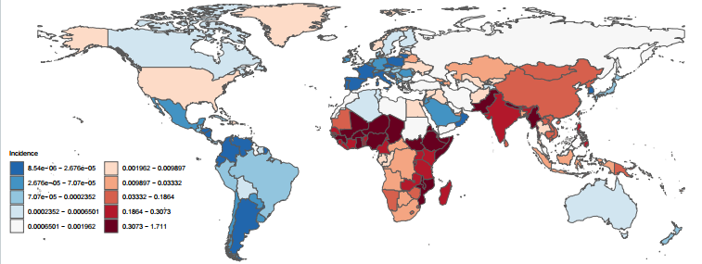
A
B
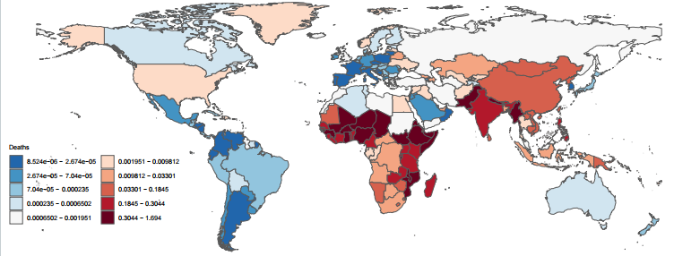
B
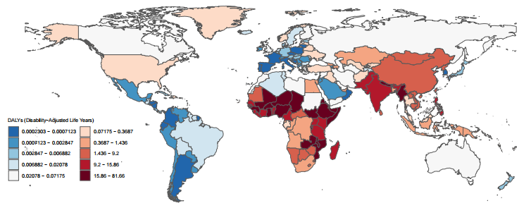
C

Figure S1. The ASR of rabies showed notable differences in 204 countries and territories in 2021 year ( A: ASIR, B: ASMR. C: Age-standardized DALY rate. Abbreviations: ASIR, age-standardized incidence rate; ASMR, age-standardized mortality rate; DALYs, disability-adjusted life years; UI, Uncertainty interval).

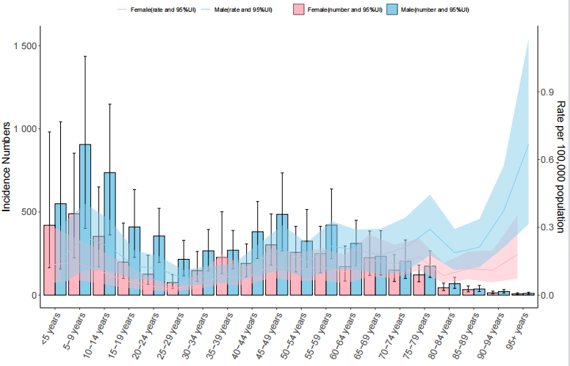\
A
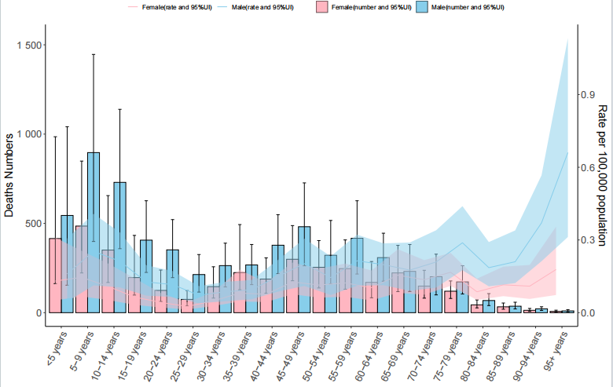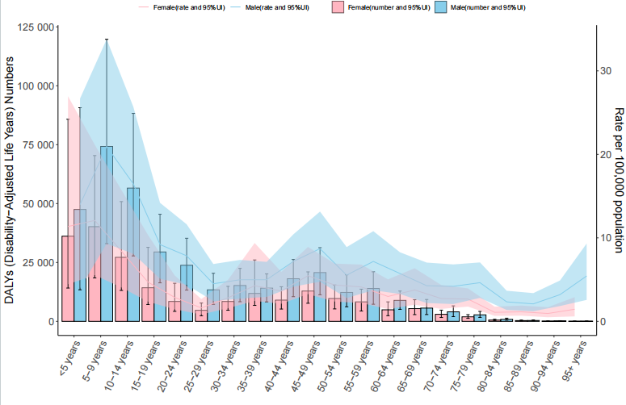
C
B

Fig.S2 The ASR of rabies showed notable differences across age and gender distributions in 2021 year ( A: ASIR, B: ASMR. C: ASDR. Abbreviations: ASIR, age-standardized incidence rate; Abbreviations: ASDR: age-standardized DALY rate; ASMR, age-standardized mortality rate; DALYs, disability-adjusted life years; UI, Uncertainty interval).

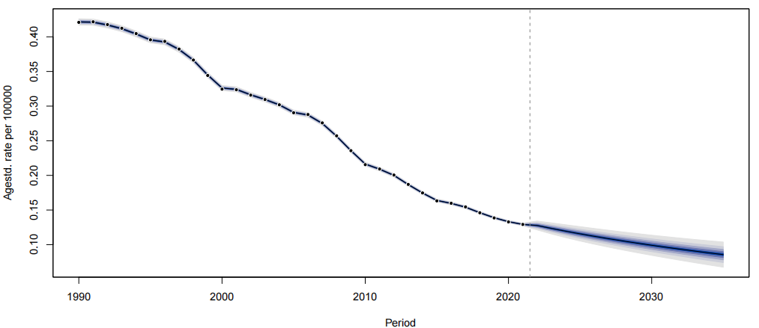
A
B
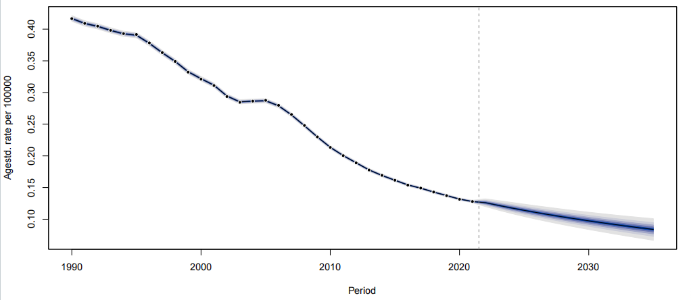
B
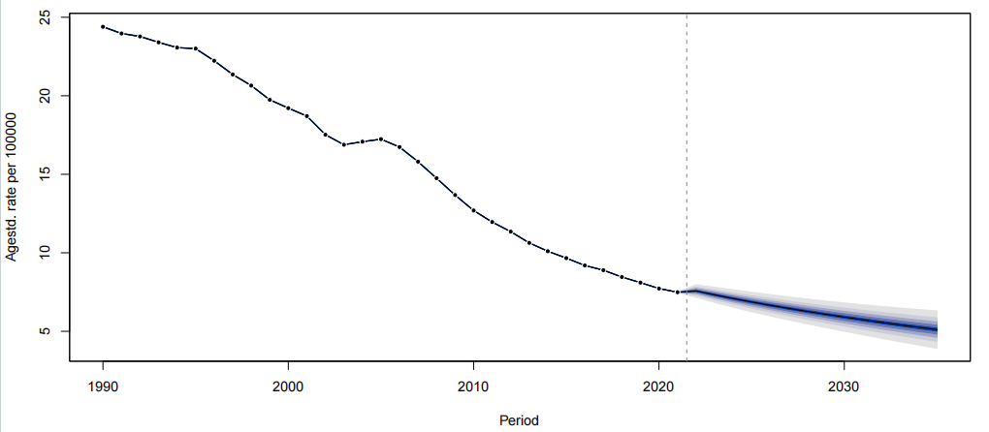
C

Figure S3: Prediction of global disease burden of rabies from 2022–2035 years based on the BAPC model (A: ASIR, B: ASMR. C: Age-standardized DALY rate. Abbreviations: ASIR, age-standardized incidence rate; ASMR, age-standardized mortality rate; ASPR, age-standardized prevalence rate; DALYs, disability-adjusted life years; UI, Uncertainty interval).

Table S5: Frontier analysis exploring ASDR of rabies across 204 countries and territories.

Id | year | val | SDI | frontier | eff_diff | location_name
6 | 2021 | 1.818539993 | 0.72162976 | 0.000296647 | 1.818243346 | China
7 | 2021 | 2.833427708 | 0.569854634 | 0.000414149 | 2.833013559 | Korea
8 | 2021 | 0.002834044 | 0.874747053 | 0.000243422 | 0.002590622 | Taiwan (Province of China)
10 | 2021 | 8.227975524 | 0.473621491 | 0.000558958 | 8.227416566 | Cambodia
11 | 2021 | 1.239592255 | 0.656868336 | 0.000405766 | 1.239186488 | Indonesia
12 | 2021 | 9.200167668 | 0.489136091 | 0.000517688 | 9.19964998 | Lao People's Democratic Republic
13 | 2021 | 0.090023309 | 0.742523828 | 0.000264175 | 0.089759134 | Malaysia
14 | 2021 | 0.047232446 | 0.650886627 | 0.000410385 | 0.046822061 | Maldives
15 | 2021 | 23.44884464 | 0.53390084 | 0.000449687 | 23.44839495 | Myanmar
16 | 2021 | 12.20972112 | 0.651219329 | 0.000412568 | 12.20930855 | Philippines
17 | 2021 | 3.68644499 | 0.701534935 | 0.000336667 | 3.686108323 | Sri Lanka
18 | 2021 | 0.31118341 | 0.682547933 | 0.000401854 | 0.310781556 | Thailand
19 | 2021 | 9.047805726 | 0.444667619 | 0.000734141 | 9.047071585 | Timor-Leste
20 | 2021 | 2.740958067 | 0.627933721 | 0.000400103 | 2.740557964 | Viet Nam
22 | 2021 | 0.191526868 | 0.675051631 | 0.000410021 | 0.191116847 | Fiji
23 | 2021 | 0.859536067 | 0.527186583 | 0.000446414 | 0.859089652 | Kiribati
24 | 2021 | 0.37196756 | 0.574091128 | 0.000408264 | 0.371559296 | Marshall Islands
25 | 2021 | 0.476691542 | 0.587534967 | 0.000408288 | 0.476283254 | Micronesia
26 | 2021 | 0.656358303 | 0.417797443 | 0.000917541 | 0.655440762 | Papua New Guinea
27 | 2021 | 0.48333431 | 0.593392769 | 0.000409337 | 0.482924973 | Samoa
28 | 2021 | 0.6022709 | 0.429360316 | 0.000837358 | 0.601433542 | Solomon Islands
29 | 2021 | 0.326760445 | 0.626349936 | 0.000408259 | 0.326352186 | Tonga
30 | 2021 | 0.484419293 | 0.473100706 | 0.000552449 | 0.483866843 | Vanuatu
33 | 2021 | 0.001733155 | 0.701833194 | 0.000325018 | 0.001408138 | Armenia
34 | 2021 | 0.843328966 | 0.694851274 | 0.000360722 | 0.842968244 | Azerbaijan
35 | 2021 | 0.836869633 | 0.732473604 | 0.000284977 | 0.836584656 | Georgia
36 | 2021 | 0.928338249 | 0.725144495 | 0.00030303 | 0.928035219 | Kazakhstan
37 | 2021 | 0.36358501 | 0.603979328 | 0.000406552 | 0.363178458 | Kyrgyzstan
38 | 2021 | 3.588368909 | 0.617621565 | 0.000405522 | 3.587963387 | Mongolia
39 | 2021 | 0.013980717 | 0.541511187 | 0.000434657 | 0.01354606 | Tajikistan
40 | 2021 | 0.041762829 | 0.682160776 | 0.000402062 | 0.041360767 | Turkmenistan
41 | 2021 | 0.189502686 | 0.662621694 | 0.000407839 | 0.189094848 | Uzbekistan
43 | 2021 | 0.000963641 | 0.706849791 | 0.000320492 | 0.00064315 | Albania
44 | 2021 | 0.000377529 | 0.723077893 | 0.000300315 | 7.72138E-05 | Bosnia and Herzegovina
45 | 2021 | 0.013778852 | 0.768150939 | 0.000250569 | 0.013528283 | Bulgaria
46 | 2021 | 0.000260123 | 0.798341027 | 0.000243467 | 1.66555E-05 | Croatia
47 | 2021 | 0.000230299 | 0.828450433 | 0.000229518 | 7.81402E-07 | Czechia
48 | 2021 | 0.005983345 | 0.790754768 | 0.000253761 | 0.005729584 | Hungary
49 | 2021 | 0.00078858 | 0.750629703 | 0.000257478 | 0.000531102 | North Macedonia
50 | 2021 | 0.014039678 | 0.795800584 | 0.000247522 | 0.013792156 | Montenegro
51 | 2021 | 0.000312993 | 0.812042809 | 0.000256223 | 5.67699E-05 | Poland
52 | 2021 | 0.001081378 | 0.768453864 | 0.000253962 | 0.000827416 | Romania
53 | 2021 | 0.001162228 | 0.792416294 | 0.000253364 | 0.000908864 | Serbia
54 | 2021 | 0.006680599 | 0.81061053 | 0.000247043 | 0.006433556 | Slovakia
55 | 2021 | 0.003879985 | 0.842430731 | 0.000239155 | 0.00364083 | Slovenia
57 | 2021 | 0.220203666 | 0.784484711 | 0.000255881 | 0.219947785 | Belarus
58 | 2021 | 0.005372928 | 0.844917787 | 0.000239565 | 0.005133363 | Estonia
59 | 2021 | 0.103697552 | 0.830663516 | 0.000241255 | 0.103456298 | Latvia
60 | 2021 | 0.000528239 | 0.856484049 | 0.000243617 | 0.000284622 | Lithuania
61 | 2021 | 0.007467585 | 0.732214875 | 0.00028665 | 0.007180935 | Republic of Moldova
62 | 2021 | 0.065533296 | 0.808536005 | 0.000252927 | 0.065280369 | Russian Federation
63 | 2021 | 0.117085639 | 0.760773913 | 0.000254263 | 0.116831376 | Ukraine
66 | 2021 | 0.000378426 | 0.810234367 | 0.000246236 | 0.00013219 | Brunei Darussalam
67 | 2021 | 0.003749975 | 0.871241813 | 0.000244554 | 0.003505421 | Japan
68 | 2021 | 0.000305366 | 0.886675267 | 0.000239079 | 6.62868E-05 | Republic of Korea
69 | 2021 | 0.000584959 | 0.856097766 | 0.000237807 | 0.000347152 | Singapore
71 | 2021 | 0.022062193 | 0.844252814 | 0.000240662 | 0.021821532 | Australia
72 | 2021 | 0.004541061 | 0.849442499 | 0.000240289 | 0.004300772 | New Zealand
74 | 2021 | 0.001385407 | 0.869444113 | 0.000241291 | 0.001144115 | Andorra
75 | 2021 | 0.004708 | 0.853837004 | 0.000242159 | 0.004465841 | Austria
76 | 2021 | 0.00382599 | 0.853654016 | 0.000243438 | 0.003582553 | Belgium
77 | 2021 | 0.006181152 | 0.835630545 | 0.000240204 | 0.005940948 | Cyprus
78 | 2021 | 0.003527909 | 0.896424204 | 0.000240167 | 0.003287742 | Denmark
79 | 2021 | 0.021883359 | 0.859831368 | 0.000239106 | 0.021644253 | Finland
80 | 2021 | 0.000348269 | 0.838364875 | 0.000244515 | 0.000103754 | France
81 | 2021 | 0.004607341 | 0.902957091 | 0.000240643 | 0.004366699 | Germany
82 | 2021 | 0.021075794 | 0.791854408 | 0.00025108 | 0.020824714 | Greece
83 | 2021 | 0.018025911 | 0.87636168 | 0.000240552 | 0.017785359 | Iceland
84 | 2021 | 0.002846772 | 0.87375385 | 0.000241756 | 0.002605016 | Ireland
85 | 2021 | 0.000588439 | 0.809011652 | 0.000251966 | 0.000336473 | Israel
86 | 2021 | 0.000455099 | 0.805773534 | 0.000249547 | 0.000205552 | Italy
87 | 2021 | 0.003481817 | 0.884428955 | 0.000242275 | 0.003239542 | Luxembourg
88 | 2021 | 0.001589619 | 0.801585034 | 0.00025323 | 0.001336389 | Malta
89 | 2021 | 0.007105285 | 0.888464256 | 0.00023836 | 0.006866925 | Netherlands
90 | 2021 | 0.147202949 | 0.91613281 | 0.000243057 | 0.146959891 | Norway
91 | 2021 | 0.000302036 | 0.744151851 | 0.000262442 | 3.95936E-05 | Portugal
92 | 2021 | 0.000268482 | 0.769283698 | 0.000249987 | 1.84951E-05 | Spain
93 | 2021 | 0.017061771 | 0.886880299 | 0.000240352 | 0.016821419 | Sweden
94 | 2021 | 0.000960481 | 0.933059111 | 0.000241264 | 0.000719216 | Switzerland
95 | 2021 | 0.046031918 | 0.859000182 | 0.000241239 | 0.045790678 | United Kingdom
97 | 2021 | 0.000383846 | 0.723122973 | 0.000300706 | 8.31396E-05 | Argentina
98 | 2021 | 0.000904969 | 0.771514716 | 0.000254579 | 0.00065039 | Chile
99 | 2021 | 0.002151063 | 0.719283445 | 0.000296739 | 0.001854324 | Uruguay
101 | 2021 | 0.028678862 | 0.87317068 | 0.000240593 | 0.028438269 | Canada
102 | 2021 | 0.128062572 | 0.862448354 | 0.000242156 | 0.127820416 | United States of America
105 | 2021 | 0.076526951 | 0.749886887 | 0.000259319 | 0.076267632 | Antigua and Barbuda
106 | 2021 | 0.054513848 | 0.805020668 | 0.000249188 | 0.05426466 | Bahamas
107 | 2021 | 0.146642582 | 0.746748764 | 0.000265744 | 0.146376839 | Barbados
108 | 2021 | 0.01239559 | 0.610229002 | 0.000407779 | 0.01198781 | Belize
109 | 2021 | 0.006039381 | 0.668729864 | 0.000404744 | 0.005634637 | Cuba
110 | 2021 | 0.075770732 | 0.746967185 | 0.00026446 | 0.075506272 | Dominica
111 | 2021 | 0.112823766 | 0.619388201 | 0.000406063 | 0.112417703 | Dominican Republic
112 | 2021 | 0.140897194 | 0.668993028 | 0.000408591 | 0.140488603 | Grenada
113 | 2021 | 0.008873869 | 0.650812335 | 0.000410462 | 0.008463407 | Guyana
114 | 2021 | 0.05449984 | 0.448278285 | 0.000679876 | 0.053819964 | Haiti
115 | 2021 | 0.00682765 | 0.683263064 | 0.000401977 | 0.006425673 | Jamaica
116 | 2021 | 0.009479505 | 0.672509735 | 0.000406562 | 0.009072943 | Saint Lucia
117 | 2021 | 0.014218441 | 0.637195963 | 0.000410198 | 0.013808243 | Saint Vincent and the Grenadines
118 | 2021 | 0.010164155 | 0.633665739 | 0.000404891 | 0.009759264 | Suriname
119 | 2021 | 0.012345788 | 0.768763254 | 0.0002553 | 0.012090488 | Trinidad and Tobago
121 | 2021 | 0.01146719 | 0.599010799 | 0.00041259 | 0.011054599 | Bolivia (Plurinational State of)
122 | 2021 | 0.000536421 | 0.661017053 | 0.00040586 | 0.00013056 | Ecuador
123 | 2021 | 0.002538551 | 0.662054037 | 0.000407411 | 0.002131139 | Peru
125 | 2021 | 0.000678685 | 0.655442913 | 0.000411775 | 0.00026691 | Colombia
126 | 2021 | 0.003838374 | 0.700340477 | 0.000351268 | 0.003487106 | Costa Rica
127 | 2021 | 0.002924644 | 0.563775188 | 0.000405674 | 0.002518969 | El Salvador
128 | 2021 | 0.006936596 | 0.539972424 | 0.00043985 | 0.006496746 | Guatemala
129 | 2021 | 0.000431099 | 0.513037248 | 0.000431099 | 0 | Honduras
130 | 2021 | 0.001264098 | 0.664575304 | 0.000412133 | 0.000851965 | Mexico
131 | 2021 | 0.000532583 | 0.523958472 | 0.000448868 | 8.37148E-05 | Nicaragua
132 | 2021 | 0.004534079 | 0.708864828 | 0.00030732 | 0.004226759 | Panama
133 | 2021 | 0.001079093 | 0.596513059 | 0.000406741 | 0.000672352 | Venezuela (Bolivarian Republic of)
135 | 2021 | 0.009601773 | 0.653043887 | 0.00040942 | 0.009192353 | Brazil
136 | 2021 | 0.001478613 | 0.635718099 | 0.000406642 | 0.001071971 | Paraguay
139 | 2021 | 0.020782716 | 0.659500924 | 0.000404715 | 0.020378 | Algeria
140 | 2021 | 0.082636992 | 0.753043204 | 0.000262149 | 0.082374843 | Bahrain
141 | 2021 | 0.421115302 | 0.606787094 | 0.000407948 | 0.420707354 | Egypt
142 | 2021 | 0.056067518 | 0.697207398 | 0.000343827 | 0.055723691 | Iran (Islamic Republic of)
143 | 2021 | 0.323445582 | 0.662626231 | 0.000404959 | 0.323040623 | Iraq
144 | 2021 | 0.001138057 | 0.725307227 | 0.000289559 | 0.000848497 | Jordan
145 | 2021 | 0.022861072 | 0.846651055 | 0.000242104 | 0.022618968 | Kuwait
146 | 2021 | 0.001407501 | 0.744746351 | 0.000258498 | 0.001149003 | Lebanon
147 | 2021 | 0.029311778 | 0.725771399 | 0.000291722 | 0.029020056 | Libya
148 | 2021 | 0.026873049 | 0.562698301 | 0.000408902 | 0.026464147 | Morocco
149 | 2021 | 0.011962419 | 0.631011665 | 0.000411803 | 0.011550616 | Palestine
150 | 2021 | 0.000368352 | 0.773391602 | 0.000255632 | 0.000112721 | Oman
151 | 2021 | 0.001292942 | 0.846860584 | 0.0002418 | 0.001051142 | Qatar
152 | 2021 | 0.001824814 | 0.815143493 | 0.000251803 | 0.001573011 | Saudi Arabia
153 | 2021 | 0.059452109 | 0.623004075 | 0.000403657 | 0.059048451 | Syrian Arab Republic
154 | 2021 | 0.017177216 | 0.682432216 | 0.000402633 | 0.016774583 | Tunisia
155 | 2021 | 0.077974439 | 0.712692673 | 0.000311546 | 0.077662893 | Turkey
156 | 2021 | 0.710692316 | 0.849317734 | 0.000241089 | 0.710451227 | United Arab Emirates
157 | 2021 | 0.062968407 | 0.450376375 | 0.000694045 | 0.062274363 | Yemen
160 | 2021 | 0.086866715 | 0.337199998 | 0.01661625 | 0.070250465 | Afghanistan
161 | 2021 | 0.474227765 | 0.492420885 | 0.000509713 | 0.473718052 | Bangladesh
162 | 2021 | 9.300604383 | 0.473062378 | 0.000555123 | 9.30004926 | Bhutan
163 | 2021 | 14.04721593 | 0.575401649 | 0.00040637 | 14.04680956 | India
164 | 2021 | 81.65786468 | 0.433174635 | 0.000837755 | 81.65702693 | Nepal
165 | 2021 | 15.05837969 | 0.504028689 | 0.000494909 | 15.05788478 | Pakistan
168 | 2021 | 0.792402996 | 0.453721949 | 0.000648355 | 0.791754641 | Angola
169 | 2021 | 1.596178659 | 0.30916769 | 0.078548259 | 1.5176304 | Central African Republic
170 | 2021 | 0.40777731 | 0.583075236 | 0.000409859 | 0.407367451 | Congo
171 | 2021 | 0.982215313 | 0.383179849 | 0.00118664 | 0.981028672 | Democratic Republic of the Congo
172 | 2021 | 0.473955536 | 0.657857456 | 0.000406051 | 0.473549485 | Equatorial Guinea
173 | 2021 | 0.368725472 | 0.634691393 | 0.000408765 | 0.368316707 | Gabon
175 | 2021 | 17.88684917 | 0.289374365 | 0.078595497 | 17.80825368 | Burundi
176 | 2021 | 11.08915596 | 0.475978688 | 0.000551417 | 11.08860455 | Comoros
177 | 2021 | 8.423284164 | 0.487958371 | 0.000516229 | 8.422767935 | Djibouti
178 | 2021 | 16.64597528 | 0.403863943 | 0.001009825 | 16.64496546 | Eritrea
179 | 2021 | 58.03136175 | 0.358823295 | 0.001475514 | 58.02988624 | Ethiopia
180 | 2021 | 10.34471565 | 0.523768077 | 0.000448484 | 10.34426716 | Kenya
181 | 2021 | 10.9274521 | 0.400246943 | 0.001034557 | 10.92641754 | Madagascar
182 | 2021 | 25.45333507 | 0.384553634 | 0.001189845 | 25.45214522 | Malawi
183 | 2021 | 0.000745874 | 0.718260446 | 0.000288366 | 0.000457508 | Mauritius
184 | 2021 | 23.7977744 | 0.326462614 | 0.07853998 | 23.71923442 | Mozambique
185 | 2021 | 12.41752898 | 0.435588706 | 0.000779612 | 12.41674937 | Rwanda
186 | 2021 | 0.033523751 | 0.730150775 | 0.000274248 | 0.033249503 | Seychelles
187 | 2021 | 31.77804659 | 0.077688109 | 30.56962081 | 1.208425781 | Somalia
189 | 2021 | 15.6793842 | 0.446568273 | 0.000696933 | 15.67868727 | United Republic of Tanzania
190 | 2021 | 10.67077108 | 0.423261181 | 0.000866606 | 10.66990448 | Uganda
191 | 2021 | 16.02244108 | 0.505948954 | 0.000478533 | 16.02196254 | Zambia
193 | 2021 | 2.047880749 | 0.642721629 | 0.000406617 | 2.047474132 | Botswana
194 | 2021 | 3.711139047 | 0.510393066 | 0.00045997 | 3.710679077 | Lesotho
195 | 2021 | 2.129226686 | 0.617564872 | 0.000406309 | 2.128820377 | Namibia
196 | 2021 | 1.275130839 | 0.679626598 | 0.000409113 | 1.274721725 | South Africa
197 | 2021 | 2.917932671 | 0.585459713 | 0.000407746 | 2.917524925 | Eswatini
198 | 2021 | 5.787444795 | 0.473819486 | 0.000560282 | 5.786884513 | Zimbabwe
200 | 2021 | 15.70540001 | 0.373486574 | 0.001347818 | 15.70405219 | Benin
201 | 2021 | 18.57571347 | 0.285118402 | 0.078595549 | 18.49711792 | Burkina Faso
202 | 2021 | 11.78632553 | 0.479691223 | 0.000546449 | 11.78577908 | Cameroon
203 | 2021 | 5.196160088 | 0.533534539 | 0.000451095 | 5.195708993 | Cabo Verde
204 | 2021 | 22.81305065 | 0.240436019 | 0.079008754 | 22.73404189 | Chad
205 | 2021 | 12.89666776 | 0.425941883 | 0.0008774 | 12.89579036 | Côte d'Ivoire
206 | 2021 | 13.43121574 | 0.40971416 | 0.000947108 | 13.43026863 | Gambia
207 | 2021 | 21.68558163 | 0.56493039 | 0.000410619 | 21.68517101 | Ghana
208 | 2021 | 18.13626954 | 0.336401293 | 0.039078966 | 18.09719057 | Guinea
209 | 2021 | 16.91082002 | 0.353109621 | 0.003572972 | 16.90724705 | Guinea-Bissau
210 | 2021 | 11.28413161 | 0.352442452 | 0.003210263 | 11.28092135 | Liberia
211 | 2021 | 18.40145684 | 0.268579941 | 0.078554595 | 18.32290225 | Mali
212 | 2021 | 7.253824237 | 0.4989451 | 0.000493512 | 7.253330725 | Mauritania
213 | 2021 | 26.72832277 | 0.168072774 | 26.28833226 | 0.439990513 | Niger
214 | 2021 | 22.39787083 | 0.503390833 | 0.000491795 | 22.39737903 | Nigeria
215 | 2021 | 6.377830731 | 0.505413747 | 0.000478664 | 6.377352066 | Sao Tome and Principe
216 | 2021 | 12.90144887 | 0.408054193 | 0.000957384 | 12.90049149 | Senegal
217 | 2021 | 13.45449737 | 0.358665881 | 0.001685621 | 13.45281175 | Sierra Leone
218 | 2021 | 13.03279133 | 0.408533695 | 0.000958892 | 13.03183244 | Togo
298 | 2021 | 0.456468944 | 0.723727533 | 0.000299516 | 0.456169428 | American Samoa
305 | 2021 | 0.050619625 | 0.821365422 | 0.000251529 | 0.050368096 | Bermuda
320 | 2021 | 0.556326419 | 0.779109955 | 0.000250679 | 0.55607574 | Cook Islands
349 | 2021 | 0.081763249 | 0.826210336 | 0.000246527 | 0.081516722 | Greenland
351 | 2021 | 0.161490942 | 0.803982203 | 0.000254826 | 0.161236117 | Guam
367 | 2021 | 0.064195704 | 0.908262831 | 0.000240531 | 0.063955174 | Monaco
369 | 2021 | 0.506073743 | 0.625177834 | 0.000407632 | 0.505666112 | Nauru
374 | 2021 | 0.202041677 | 0.72622205 | 0.00028788 | 0.201753797 | Niue
376 | 2021 | 0.882606288 | 0.771535213 | 0.000253868 | 0.88235242 | Northern Mariana Islands
380 | 2021 | 0.047332093 | 0.754046931 | 0.000263084 | 0.04706901 | Palau
385 | 2021 | 0.004582856 | 0.825525847 | 0.00024868 | 0.004334176 | Puerto Rico
393 | 2021 | 0.340452116 | 0.754987055 | 0.000258635 | 0.340193481 | Saint Kitts and Nevis
396 | 2021 | 0.001585111 | 0.888005474 | 0.000242733 | 0.001342378 | San Marino
413 | 2021 | 0.242009028 | 0.686425621 | 0.000392484 | 0.241616544 | Tokelau
416 | 2021 | 0.46711267 | 0.576620529 | 0.000406414 | 0.466706257 | Tuvalu
422 | 2021 | 0.029977901 | 0.821830853 | 0.000249731 | 0.029728171 | United States Virgin Islands
435 | 2021 | 17.8585718 | 0.278371125 | 0.078509202 | 17.7800626 | South Sudan
522 | 2021 | 0.042307757 | 0.541949735 | 0.00043655 | 0.041871207 | Sudan

Table S6: Decomposition analysis of incidence cases for rabies globally and across five SDI regions from 1990 to 2021.

Location name | Overall  Difference | Aging | Population | Epidemiological  Change | Aging  Percentage | Population  Percentage | Epidemiological  Change Percentage
Global | -11854.48 | 352.25 | 6965.77 | -19172.5 | -2.97 | -58.76 | 161.73
Middle SDI | -1688.2 | 372.28 | 1052.48 | -3112.96 | -22.05 | -62.34 | 184.4
High-middle SDI | -109.51 | 24.91 | 61.75 | -196.17 | -22.75 | -56.38 | 179.13
Low-middle SDI | -7597.16 | 464.24 | 4529.63 | -12591.03 | -6.11 | -59.62 | 165.73
Low SDI | -2464.65 | -133.64 | 5227.63 | -7558.64 | 5.42 | -212.1 | 306.68
High SDI | 6.43 | 2.81 | 3.04 | 0.58 | 43.66 | 47.27 | 9.07

