Table S1. List of antimicrobial agents used and frequency
Antimicrobials |  | Frequency
Penicillins
 | Penicillin | 1
 | Ampicillin-sulbactam | 5
 | Piperacillin | 1
 | Piperacillin-tazobactam | 3
Cephalosporins
 | Cefazolin | 25
 | Cefotiam | 2
 | Cefmetazole | 4
 | Cefcapene pivoxil | 4
 | Cefdinir | 1
 | Ceftriaxone | 12
 | Cefotaxime | 1
 | Cefoperazone-sulbactam | 4
 | Cefepime | 1
 | Cefozopran | 4
 | Cefpirome | 1
 | Flomoxef | 1
Carbapenems
 | Meropenem | 8
 | Doripenem | 1
 | Imipenem-cilastatin | 1
 | Biapenem | 1
 | Faropenem | 2
Fluoroquinolones
 | Ciprofloxacin | 1
 | Levofloxacin | 7
 | Moxifloxacin | 1
 | Sitafloxacin | 1
Aminoglycosides
 | Isepamicin | 1
Glycopeptides
 | Vancomycin | 11
 | Daptomycin | 1
 | Teicoplanin | 1
Oxazolids
 | Linezolid | 7
 | Tedizolid | 1
Lincosamide
 | Clindamycin | 16
Macrolide
 | Clarithromycin | 3
Tetracycline
 | Minocycline | 5
Other
 | Trimethoprim-sulfamethoxazole | 3
 | Rifampicin | 7
 | Ethambutol | 1
Antifungals
 | Fluconazole | 1
 | Fosfluconazole | 1
 | Voriconazole | 1
 | Amphotericin B | 1
Unknown |  | 2

Table S2. Microorganisms detected in culture tests
Microotganisms |  |  | Frequency
Gram-positive cocci
 | Staphylococci
 |  | Staphylococcus aureus | 21
 |  | Staphylococcus aureus (methicillin-resistant) | 17
 |  | Staphylococcus epidermidis | 4
 |  | Staphylococcus epidermidis (methicillin-resistant) | 3
 |  | Staphylococci (coagulase-negative, methicillin-resistant) | 3
 |  | Staphylococcus hominis | 1
 |  | Staphylococcus intermedius | 1
 |  | Staphylococcus lugdunensis | 1
 | Streptococci
 |  | Streptococcus agalactiae | 3
 |  | Streptococcus anginosus | 1
 |  | Streptococcus bovis | 1
 |  | Streptococcus gordonii | 1
 |  | Streptococcus intermedius | 1
 |  | Streptococcus oralis | 1
 |  | Streptococcus pneumoniae | 1
 |  | Streptococcus pneumoniae (penicillin-resistant) | 1
 |  | Streptococcus salivarius | 1
 |  | Streptococcus sanguinis | 1
 |  | Streptococcus viridans | 1
 |  | Streptococcus spp. | 1
 | Enterococci
 |  | Enterococcus faecalis | 4
 |  | Enterococcus faecium | 1
Gram-negative cocci
 |  | Neisseria sicca | 1
Gram-negative bacilli
 | Enterobacteriaceae
 |  | Escherichia coli | 8
 |  | Escherichia coli (extended-spectrum β-lactamase) | 1
 |  | Klebsiella pneumoniae | 3
 |  | Citrobacter koseri | 1
 |  | Enterobacter cloacae | 1
 | Glucose non-fermenting
 |  | Pseudomonas aeruginosa | 1
 | Anaerobics
 |  | Bacteroides fragilis | 1
 |  | Eikenella corrodens | 1
 |  | Fusobacterium necrophorum | 1
Mycobacterium
 |  | Mycobacterium tuberculosis | 3
 |  | Mycobacterium avium | 1
Fungi
 |  | Candida albicans | 3
 |  | Candida tropicalis | 1
 |  | Unknown species | 1

Table S3. Types of surgery for vertebral osteomyelitis
 | Overall  (n = 54) | No pre-culture  antimicrobial therapy  (n = 36) | Pre-culture  antimicrobial therapy  (n = 18)
Spinal fusion | 32, 59.3% | 20, 55.6% | 12, 66.7%
Laminoplasty / laminectomy | 10, 18.5% | 7, 19.4% | 3, 16.7%
Bone curettage | 6, 11.1% | 3, 8.3% | 3, 16.7%
Implant removal | 3, 5.6% | 3, 8.3% | 0, 0.0%
Others | 3, 5.6% | 3, 8.3% | 0, 0.0%

Table S4. Days of antimicrobial therapy prior to culture tests
Culture | Results | Minimun | 25% | Median | 75% | Maximum
Blood | All | 1 | 2 | 3 | 10 | 474
 | Positive | 1 | 1 | 3 | 16 | 474
 | Negative | 1 | 2 | 3 | 9 | 45
Bone | All | 2 | 4 | 7 | 12 | 43
 | Positive | 2 | 3 | 7 | 12 | 43
 | Negative | 3 | 5 | 7 | 10 | 36
Abscess | All | 1 | 2 | 4 | 8 | 584
 | Positive | 1 | 2 | 3 | 11 | 584
 | Negative | 1 | 4 | 7 | 8 | 22

Table S5. Susceptibilities of cultured microorganisms to antimicrobial agents used
Culture |  | Number of resistance (%)
Blood (n = 12)* |  | 8 (72.7)
Bone (n = 15) |  | 1 (6.7)
 | Open (n =9) | 0 (0.0)
 | Needle (n = 6) | 1 (16.7)
Abscess (n = 23) |  | 4 (17.4)
* Susceptibility unknown in one pathogen.

Table S6. Sensitivity analysis of pre-culture antimicrobial therapy and positive culture results*
 |  | 2 days |  |  | 7 days |  |  | 14 days |  |  | 28 days
 |  | No pre-culture AMT | Pre-culture AMT |  | No pre-culture AMT | Pre-culture AMT |  | No pre-culture AMT | Pre-culture AMT |  | No pre-culture AMT | Pre-culture AMT
Any culture* (n = 133) |  | 62 (71.3%) | 25 (54.4%) |  | 60 (75.0%) | 27 (50.9%) |  | 59 (74.7%) | 28 (51.9%) |  | 57 (74.0%) | 30 (53.6%)
Blood (n = 104) |  | 40 (60.6%) | 12 (31.6%) |  | 39 (63.9%) | 13 (30.2%) |  | 39 (63.9%) | 13 (30.2%) |  | 37 (62.7%) | 15 (33.3%)
Bone (n = 60) |  | 13 (50.0%) | 15 (44.1%) |  | 12 (52.2%) | 16 (43.2%) |  | 12 (54.6%) | 16 (42.1%) |  | 12 (54.6%) | 16 (42.1%)
 | Open (n = 22) | 5 (71.4%) | 9 (60.0%) |  | 5 (71.4%) | 9 (60.0%) |  | 5 (71.4%) | 9 (60.0%) |  | 5 (71.4%) | 9 (60.0%)
 | Needle (n = 37) | 8 (42.1%) | 6 (33.3%) |  | 7 (43.8%) | 7 (33.3%) |  | 7 (46.7%) | 7 (31.8%) |  | 7 (46.7%) | 7 (31.8%)
Abscess (n = 54) |  | 12 (85.7%) | 23 (57.5%) |  | 11 (84.6%) | 24 (58.5%) |  | 11 (84.6%) | 24 (58.5%) |  | 11 (84.6%) | 24 (58.5%)
All results are shown in the number of positive results (%).
Abbreviation: AMT, antimicrobial therapy.
* Includes blood, bone, and abscess.

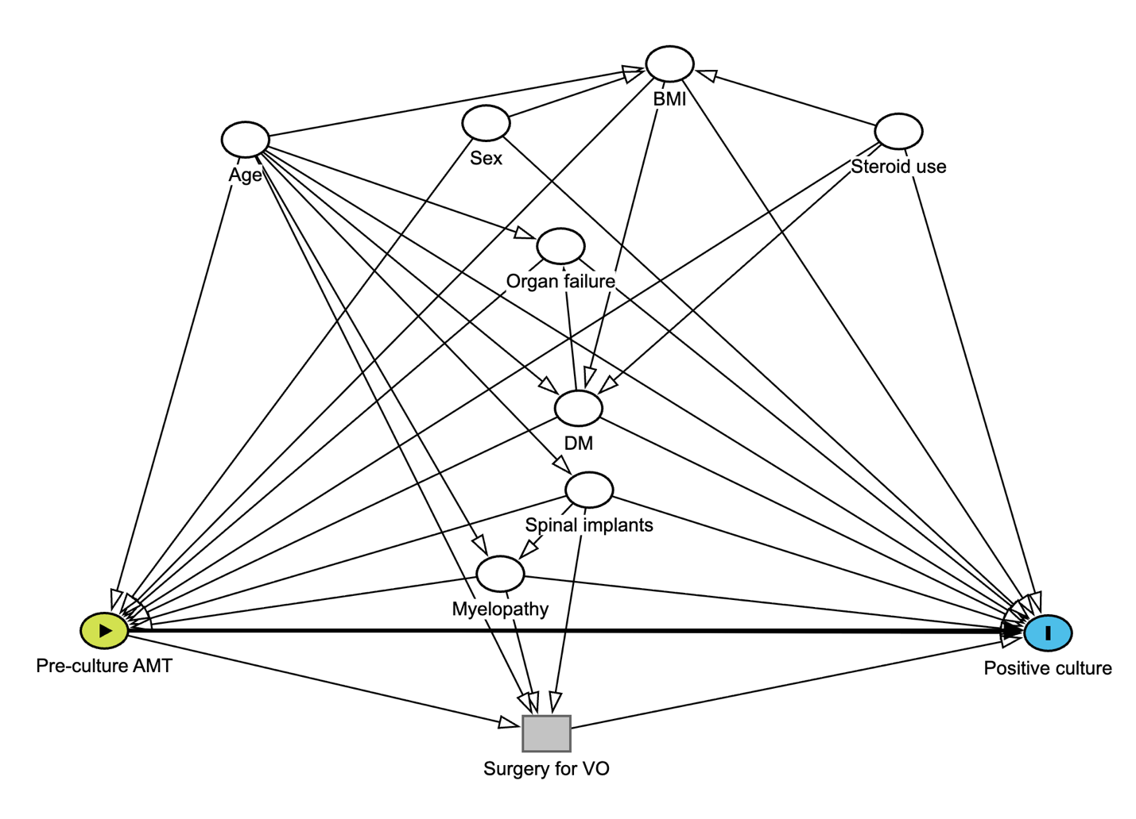
Figure S1. The directed acyclic graph of the hypothetical relationship among the exposure, outcome, and covariates

Abbreviations: AMT, antimicrobial therapy; BMI, body mass index; DM, diabetes mellitus; VO, vertebral osteomyelitis.
The ovals with a triangle and a vertical rectangle inside represent exposure (pre-culture antimicrobial therapy) and outcome (positive culture), respectively. The blank ovals represent adjusted confounding factors. The gray rectangle represents an intermediate factor that was not adjusted. The direction of the arrow indicates the direction of the association between each factor. The arrow from exposure to outcome indicates a causal path of interest.

A directed acyclic graph illustrates the hypothesized relationships among pre-culture antimicrobial therapy, culture positivity, and confounding factors.

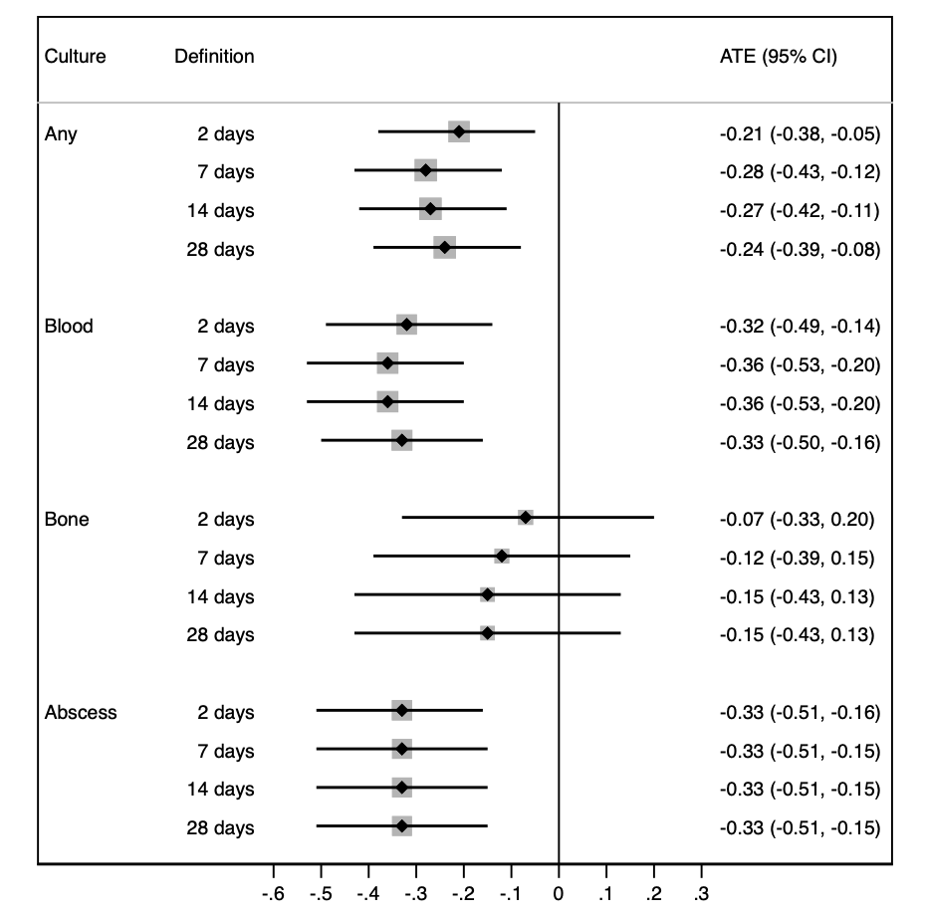
Figure S2. Sensitivity analysis of the average treatment effects of pre-culture antimicrobial therapy among culture tests

Abbreviations: ATE, average treatment effect; CI, confidence interval.
Any culture includes blood, bone, and abscess.
Adjusted for age, sex, body mass index, diabetes mellitus, concomitant steroid use, comorbid organ failure, presence of myelopathy, and spinal implants using inverse probability of treatment weighting with multiple imputation. (Spinal implants were excluded as a confounding factor in the bone culture analysis because there were no patients with implants in the pre-culture antimicrobial therapy group.)

Graph and data display the average treatment effects and 95% confidence intervals for different culture types and alternative definitions of the pre-culture antimicrobial therapy period using inverse probability of treatment weighting with multiple imputation.

