Supplementary Material
Predictive Value of the Neutrophil-to-Lymphocyte Ratio for 28-Day Mortality in Elderly Patients with Sepsis: A Cohort Study Based on the MIMIC-IV Database.

Supplementary Figures and Tables
Table S1 Sensitivity analysis Sensitivity Analysis of the Association Between Neutrophil-to-Lymphocyte Ratio (NLR) and 28-Day Mortality——Hazard Ratios (HRs) for Different NLR Transformations
Variable | Crude Model |  | Adjusted Model
Variable | HR (95% CI) | P value | HR (95% CI) | P value
Continuous variable
NLR.z | 1.14 (1.11~1.18) | <0.001 | 1.06 (1.03~1.1) | 0.001
Log (NLR+1) | 1.44 (1.36~1.52) | <0.001 | 1.17 (1.1~1.25) | <0.001
NLR | 1.01 (1.01~1.01) | <0.001 | 1.004 (1.002~1.006) | 0.001
Notes: Crude Model: Adjusted for age and gender. Adjusted Model: Adjusted for age, gender, race, BMI, SBP, DBP, RR, HR, temperature, SpO₂, hemoglobin, platelets, ALT, INR, creatinine, BUN, lactate, pH, glucose, sodium, potassium, calcium, CHF, CVD, COPD, MI, liver disease, renal disease, diabetes, SAPS II, SOFA, MV, RRT, and vasopressor use.
Abbreviations: NLR.z: Z-standardized value of the Neutrophil-to-Lymphocyte Ratio (NLR); log(NLR+1): Log-transformed value of the Neutrophil-to-Lymphocyte Ratio (NLR) after adding 1; NLR, Neutrophil-to-Lymphocyte Ratio; BMI, Body Mass Index; SBP, systolic blood pressure; DBP, diastolic blood pressure; RR, respiratory rate; HR, heart rate; SpO₂, Peripheral Capillary Oxygen Saturation; ALT, alanine transaminase; INR, international normalized ratio; BUN, blood urea nitrogen; pH, Potential of Hydrogen; CHF, congestive heart failure; CVD, cerebrovascular disease; COPD, chronic obstructive pulmonary disease; MI, myocardial infarction; SAPS II, simplified acute physiology score II; SOFA, sequential organ failure assessment; MV, mechanical ventilation; RRT, renal replacement therapy.

Table S2. Summary of missing data for all variables included in the analysis
Variable | Number | Percentage%
Age (years) | 0 | 0
ALT (U/L) | 2597 | 34.5254
BMI (kg/m²) | 2702 | 35.9213
BUN (mg/dL) | 0 | 0
Calcium (mg/dL) | 565 | 7.5113
CVD | 0 | 0
COPD | 0 | 0
CHF | 0 | 0
Creatinine (mg/dL) | 1 | 0.0133
DBP (mmHg) | 29 | 0.3855
Diabetes | 0 | 0
Sex (Male, n, %) | 0 | 0
Glucose (mg/dL) | 20 | 0.2659
HR (beats/min) | 4 | 0.0532
Hemoglobin(g/dL) | 2 | 0.0266
INR | 209 | 2.7785
Lactate (mmol/L) | 2504 | 33.289
LOS hospital, day | 0 | 0
LOS ICU, day | 0 | 0
Lymphocytes (×10⁹/L) | 0 | 0
MV | 0 | 0
MI | 0 | 0
Neutrophils (×10⁹/L) | 0 | 0
NLR | 0 | 0
pH | 1941 | 25.8043
Platelets(×10⁹/L) | 1 | 0.0133
Potassium (mmol/L) | 4 | 0.0532
Race | 0 | 0
Renal disease | 0 | 0
RR (breaths/min) | 6 | 0.0798
RRT | 0 | 0
SAPS II | 0 | 0
SBP (mmHg) | 28 | 0.3722
Liver disease | 0 | 0
Sodium (mmol/L) | 1 | 0.0133
SOFA | 0 | 0
Spo₂(%) | 4 | 0.0532
Temperature (◦C) | 337 | 4.4802
Vasopressor use | 0 | 0
WBC(×10⁹/L) | 0 | 0
28-Day Survival Status | 0 | 0
Survival Time | 0 | 0
Abbreviations: NLR, Neutrophil-to-Lymphocyte Ratio; BMI, Body Mass Index; SBP, systolic blood pressure; DBP, diastolic blood pressure; RR, respiratory rate; HR, heart rate; SpO₂, Peripheral Capillary Oxygen Saturation; WBC, white blood cells; PLT, platelet; ALT, alanine transaminase; INR, international normalized ratio; BUN, blood urea nitrogen; pH, Potential of Hydrogen; CHF, congestive heart failure; CVD, cerebrovascular disease; COPD, chronic obstructive pulmonary disease; MI, myocardial infarction; SAPS II, simplified acute physiology score II; SOFA, sequential organ failure assessment; MV, mechanical ventilation; RRT, renal replacement therapy; LOS, length of stay.

Table S3. Comparison of Cox regression results for NLR.z between complete-case analysis and multiple imputation datasets
Variable | Crude Model |  |  | Adjusted Model
Variable | HR (95% CI) | P value | HR (95% CI) |  | P value
NLR.z（Without multiple imputation） | 1.14 (1.11~1.18) | <0.001 |  | 1.03 (0.97~1.09) | 0.333
NLR.z（After multiple imputation） | 1.14 (1.11~1.18) | <0.001 |  | 1.06 (1.03~1.1) | 0.001
Notes: Crude Model: Adjusted for age and gender. Adjusted Model: Adjusted for age, gender, race, BMI, SBP, DBP, RR, HR, temperature, SpO₂, hemoglobin, platelets, ALT, INR, creatinine, BUN, lactate, pH, glucose, sodium, potassium, calcium, CHF, CVD, COPD, MI, liver disease, renal disease, diabetes, SAPS II, SOFA, MV, RRT, and vasopressor use.
Abbreviations: NLR.z: Z-standardized value of the Neutrophil-to-Lymphocyte Ratio (NLR).

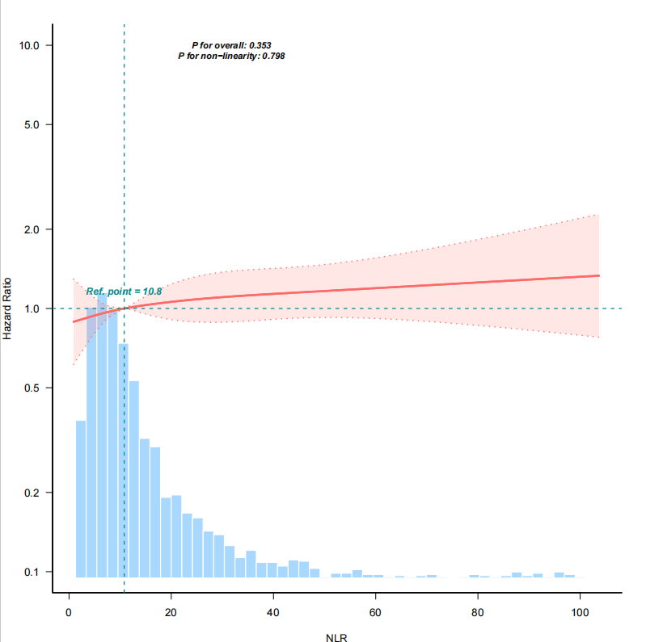
Figure S1: Restricted Cubic Spline (RCS) Curve of the Association Between Neutrophil-to-Lymphocyte Ratio (NLR) and 28-Day Mortality in Elderly Patients with Sepsis

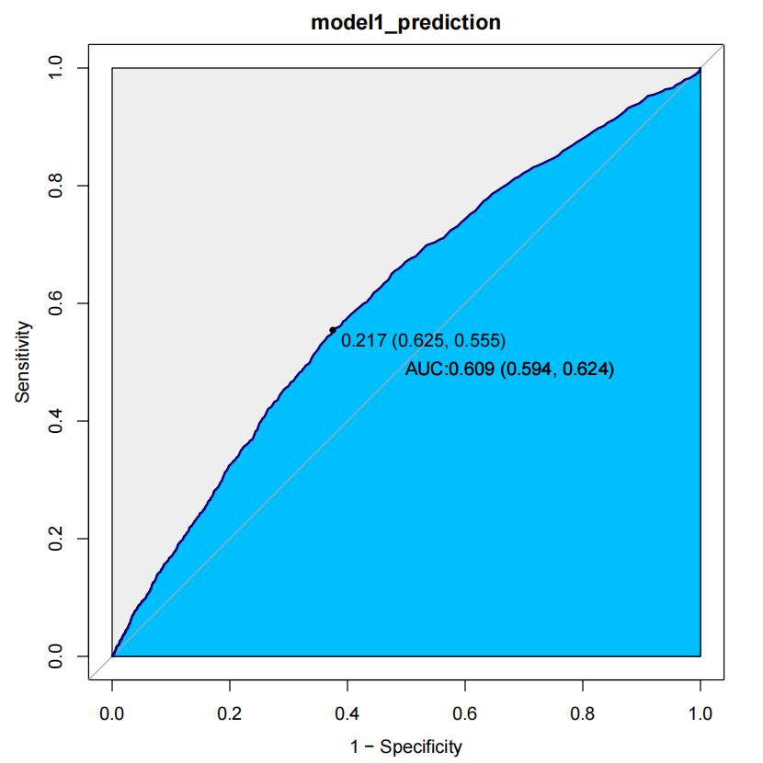
Figure S2: Receiver Operating Characteristic Curve of NLR in Elderly Sepsis Patients

Table S4. The collinearity assessment outcomes
variables | GVIF | df | GVIF^(1/(2*df))
Age (years) | 1.467 | 1 | 1.211
Gender | 1.164 | 1 | 1.079
Race | 1.178 | 2 | 1.042
BMI (kg/m²) | 1.227 | 1 | 1.108
SBP (mmHg) | 1.416 | 1 | 1.19
DBP (mmHg) | 1.501 | 1 | 1.225
RR (breaths/min) | 1.374 | 1 | 1.172
HR (beats/min) | 1.53 | 1 | 1.237
Temperature (◦C) | 1.294 | 1 | 1.137
SpO₂ (%) | 1.28 | 1 | 1.131
WBC (×10⁹/L) | 1.407 | 1 | 1.186
Hemoglobin (g/dL) | 1.292 | 1 | 1.137
Platelets (×10⁹/L) | 1.257 | 1 | 1.121
ALT (U/L) | 1.179 | 1 | 1.086
INR | 1.209 | 1 | 1.099
Creatinine (mg/dL) | 2.991 | 1 | 1.73
BUN (mg/dL) | 2.637 | 1 | 1.624
Lactate (mmol/L) | 1.336 | 1 | 1.156
pH | 1.856 | 1 | 1.362
Glucose (mg/dL) | 1.358 | 1 | 1.165
Sodium (mmol/L) | 1.212 | 1 | 1.101
Potassium (mmol/L) | 1.269 | 1 | 1.127
Calcium (mg/dL) | 1.274 | 1 | 1.129
Lymphocytes (×10⁹/L) | 2.139 | 1 | 1.463
Neutrophils (×10⁹/L) | 2.368 | 1 | 1.539
CHF | 1.283 | 1 | 1.133
Cerebrovascular disease (CVD) | 1.145 | 1 | 1.07
COPD | 1.057 | 1 | 1.028
MI | 1.126 | 1 | 1.061
Liver disease | 1.224 | 1 | 1.106
Renal disease | 1.473 | 1 | 1.214
Diabetes | 1.423 | 1 | 1.193
SAPS II | 1.706 | 1 | 1.306
SOFA score | 1.395 | 1 | 1.181
MV | 1.29 | 1 | 1.136
RRT | 1.75 | 1 | 1.323
Vasopressor use | 1.266 | 1 | 1.125

