Additional Files

Additional file 1
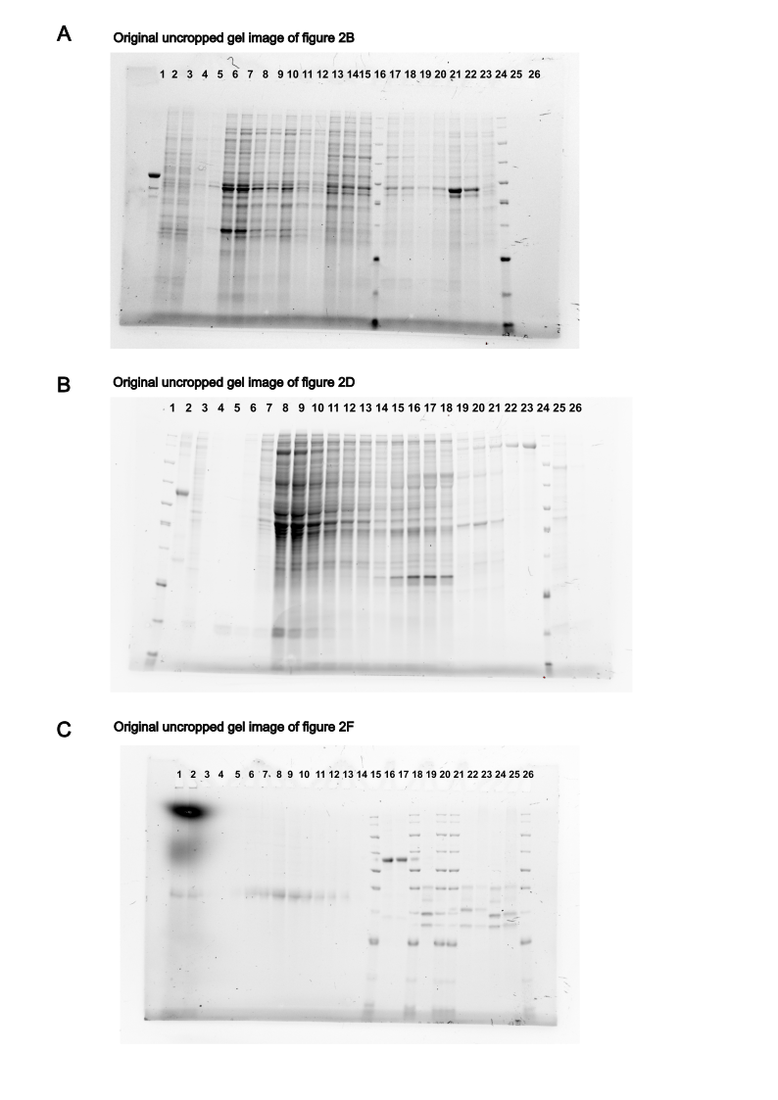

Supplementary Figure 1 Characterization of the purified vaccine antigens. A) Original uncropped SDS-PAGE gel image of figure 2B. Wells 21 and 24 have been cropped to form figure 2B. Wells 1-15, 17-20 and 22-23 contain unrelated protein samples. Well 16 contains a molecular weight marker and wells 25-26 are empty. B) Original uncropped SDS-PAGE gel image of figure 2D. Wells 22-24 have been cropped to form figure 2D. Wells 2-21 and 25 contain unrelated protein samples. Well 1 contains a molecular weight marker and well 26 is empty. C) Original uncropped SDS-PAGE gel image of figure 2F. Wells 16-18 have been cropped to form figure 2F. Wells 1-14 and 19-26 contain unrelated protein samples. Well 15 contains a molecular weight marker.

Additional file 2

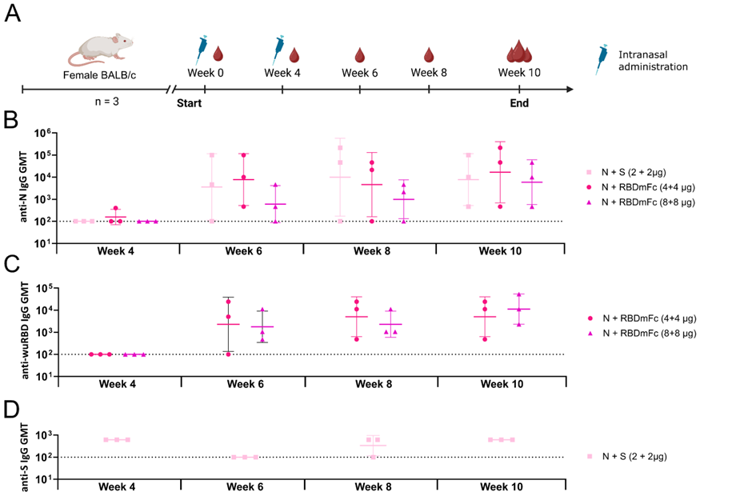
Supplementary Figure 2 Comparison of humoral immune responses following intranasal vaccination in mice. A) Vaccination regimen for mice indicating the timepoints for immunizations and blood sampling. B) Kinetics of N-specific, C) wuRBD-specific (RBD of original Wuhan strain) and D) S-specific total IgG endpoint titres depicted in serum measured with an ELISA assay. The results are expressed as geometric means with geometric standard deviations for the groups on Log10 scale. Significant differences between groups are compared with Mann-Whitney U test or Kruskal-Wallis’ test and Dunn’s multiple comparison. Undetectable antibody titres are denoted with a titre of 100 and represented as a dotted line.

Additional file 3

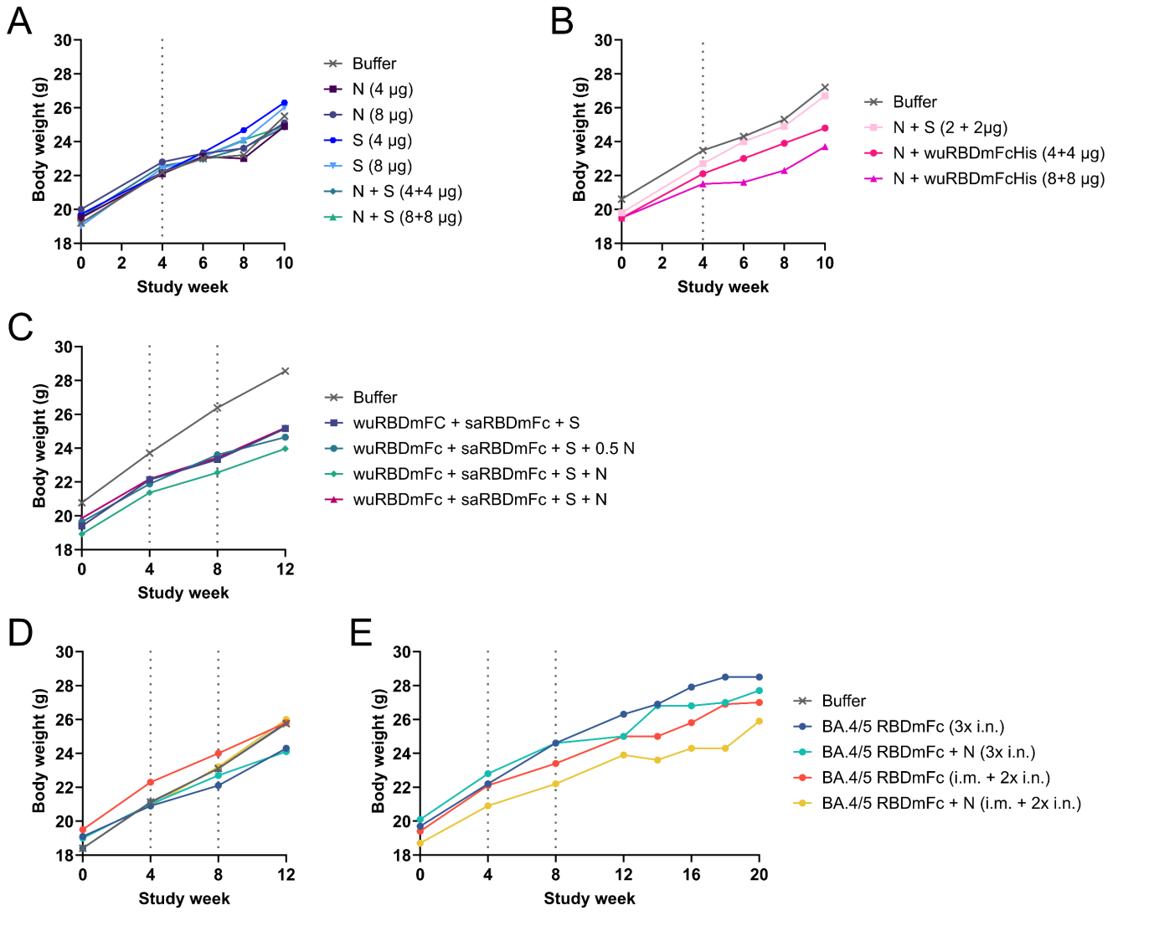
Supplementary Figure 3 Weight charts of the preclinical studies. Firstly, the arithmetic mean weight of subcutaneously (A) and intranasally (B) vaccinated mice in different vaccination groups during the first preclinical study is represented as a function of time. Secondly, the arithmetic mean weight of vaccinated mice in different vaccination groups during the second preclinical study is represented as a function of time (C). Lastly, the arithmetic mean weight of vaccinated mice in different vaccination groups during the third preclinical study is represented as a function of time (D) mice terminated at week 12, E) mice terminated at week 20). Time points for vaccine administrations are shown as vertical lines. wuRBD stands for RBD from the original strain, saRBD for RBD from the beta strain and BA.4/5 RBD stands for RBD containing the mutations from both the BA.4 and BA.5 subvariant of omicron strain.

