Supplementary Table 1. Univariable Cox regression analyses of covariates for 28- and 90-day transplant-free mortality in HBV-ACLF.
 | 28-day |  |  | 90-day
Variables | HR | 95%CI | P | HR | 95%CI | P
Age (years) | 1.02 | (1.01 ~ 1.03) | 0.004 | 1.02 | (1.01 ~ 1.03) | <.001
Male, n (%) | 0.69 | (0.45 ~ 1.07) | 0.098 | 0.69 | (0.48 ~ 0.99) | 0.047
Liver cirrhosis, n (%) | 1.29 | (0.87 ~ 1.93) | 0.209 | 1.31 | (0.94 ~ 1.82) | 0.109
HBV DNA, (log10 IU/ml) | 1.02 | (0.92 ~ 1.14) | 0.682 | 1.03 | (0.94 ~ 1.12) | 0.567
HBeAg positive, n (%) | 1.09 | (0.72 ~ 1.66) | 0.688 | 1.15 | (0.81 ~ 1.62) | 0.431
Causes of disease, n (%)
HBV with other etiologies | 1.00 | (Reference) |  | 1.00 | (Reference)
HBV infection only | 0.99 | (0.61 ~ 1.61) | 0.971 | 1.12 | (0.74 ~ 1.70) | 0.581
Complications, n (%)
Ascites | 0.73 | (0.51 ~ 1.07) | 0.105 | 0.96 | (0.70 ~ 1.31) | 0.778
Gastrointestinal bleeding | 2.91 | (1.35 ~ 6.25) | 0.006 | 2.04 | (0.96 ~ 4.35) | 0.065
Bacterial infection | 1.47 | (1.01 ~ 2.16) | 0.049 | 1.51 | (1.10 ~ 2.07) | 0.011
Hepatic encephalopathy | 2.75 | (1.80 ~ 4.20) | <.001 | 2.81 | (1.96 ~ 4.01) | <.001
Hepatorenal syndrome | 1.96 | (1.03 ~ 3.76) | 0.042 | 1.94 | (1.12 ~ 3.35) | 0.018
Common chronic diseases, n (%)
Hypertension | 1.26 | (0.67 ~ 2.34) | 0.473 | 1.19 | (0.70 ~ 2.02) | 0.526
Diabetes | 1.46 | (0.86 ~ 2.48) | 0.161 | 1.51 | (0.98 ~ 2.34) | 0.061
Coronary heart disease | 0.99 | (0.37 ~ 2.69) | 0.986 | 1.36 | (0.67 ~ 2.77) | 0.393
ALSS therapy, n (%) | 2.21 | (1.24 ~ 3.94) | 0.007 | 2.04 | (1.29 ~ 3.23) | 0.002
MELD score | 1.13 | (1.10 ~ 1.15) | <.001 | 1.12 | (1.10 ~ 1.14) | <.001

Supplementary Table 2. Results of the Variance Inflation Factor.
Variables | VIF
NHHR | 1.144
Age | 1.341
Gender | 1.158
Liver cirrhosis | 1.251
HBV DNA | 1.291
HBeAg positive | 1.291
Causes of disease | 1.019
Ascites | 1.047
Gastrointestinal bleeding | 1.092
Bacterial infection | 1.064
Hepatic encephalopathy | 1.076
Hepatorenal syndrome | 1.125
Hypertension | 1.046
Diabetes | 1.029
Coronary heart disease | 1.073
ALSS therapy | 1.126
MELD score | 1.312

Supplementary Table 3. Proportional hazards (PH) assumption test for NHHR and 28- and 90-day transplant-free mortality in HBV-ACLF.
 | 28-day |  |  | 90-day
Variables | χ² | df | P value | χ² | df | P value
NHHR | 1.353 | 1 | 0.245 | 2.346 | 1 | 0.126
Gender | 0.114 | 1 | 0.736 | 0.000 | 1 | 0.983
Age | 1.888 | 1 | 0.169 | 2.163 | 1 | 0.141
Causes of liver disease | 1.861 | 1 | 0.173 | 1.327 | 1 | 0.249
Liver cirrhosis | 0.292 | 1 | 0.589 | 0.186 | 1 | 0.666
HBV DNA | 2.110 | 1 | 0.146 | 1.158 | 1 | 0.282
HBeAg positive | 0.010 | 1 | 0.919 | 0.011 | 1 | 0.916
Ascites | 0.417 | 1 | 0.518 | 3.122 | 1 | 0.077
Gastrointestinal bleeding | 0.114 | 1 | 0.736 | 0.718 | 1 | 0.397
Bacterial infection | 0.006 | 1 | 0.939 | 0.429 | 1 | 0.513
Hepatic encephalopathy | 0.013 | 1 | 0.909 | 0.487 | 1 | 0.485
Hepatorenal syndrome | 0.004 | 1 | 0.950 | 0.260 | 1 | 0.610
Hypertension | 1.199 | 1 | 0.274 | 0.114 | 1 | 0.736
Diabetes | 3.290 | 1 | 0.070 | 0.937 | 1 | 0.333
Coronary heart disease | 0.823 | 1 | 0.364 | 0.240 | 1 | 0.624
ALSS therapy | 0.862 | 1 | 0.353 | 0.049 | 1 | 0.825
MELD score | 0.015 | 1 | 0.903 | 0.207 | 1 | 0.649
Global | 14.837 | 17 | 0.607 | 14.153 | 17 | 0.656

Supplementary Figure 1.
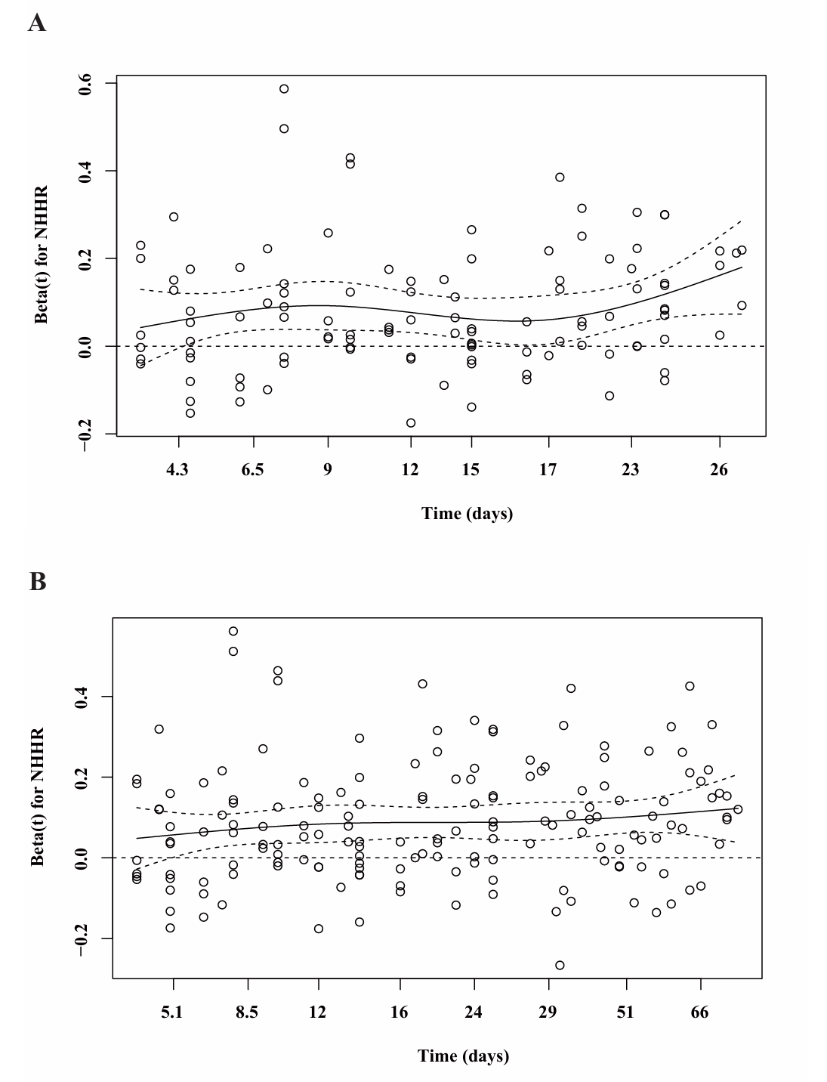
Schoenfeld residual plots for assessing the proportional hazards (PH) assumption of NHHR (A: 28-day; B: 90-day).

