S1. Potential multicollinearity among predictor variables by computing the variance inflation factors
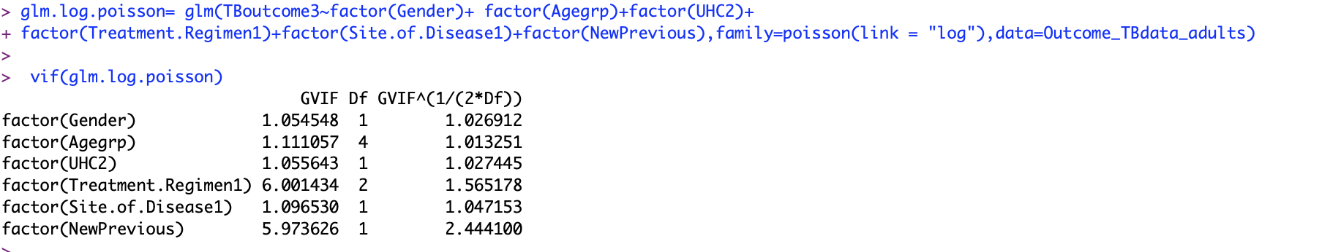
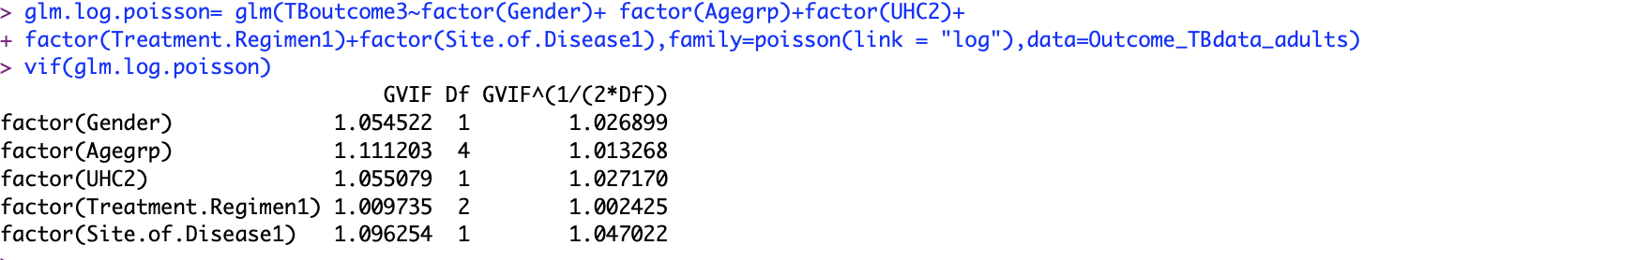
Full model results:
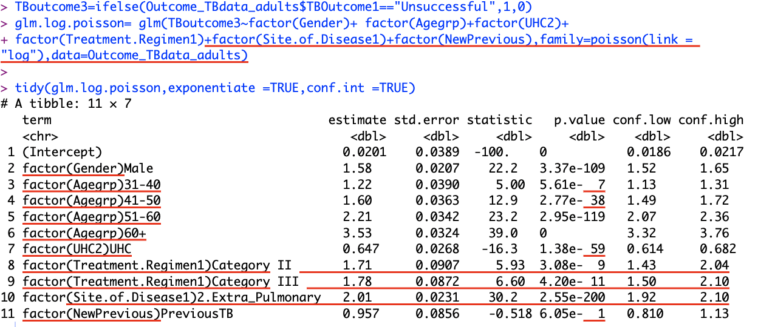

S2 Table: Child TB Patient Characteristics by Treatment Outcome
Variable | Categories | Treatment outcomes—successful (n=14109, 97.2%) | Treatment outcomes—unsuccessful (n=409, 2.8%) | Row Total (%)
Gender | Female | 7497 (97.3%) | 208 (2.7%) | 7705 (53.1%)
Gender | Male | 6612 (97.0%) | 201 (3.0%) | 6813 (46.9%)
Age group | 0-04 Years | 755 (92.3%) | 63 (6.7%) | 818 (5.6%)
Age group | 05-09 Years | 1711 (96.4%) | 65 (3.6%) | 1776 (12.2%)
Age group | 10-14 Years | 7988 (97.9%) | 169 (2.1%) | 8157 (56.2%)
Age group | 15-17 Years | 3655 (97.0%) | 112 (3.0%) | 3767 (25.9%)
Location of Health facility where TB notifications were registered | Upazila Health facilities (Semi-urban or rural) | 2048 (94.7%) | 113 (5.3%) | 2161 (14.9%)
 | City Health facilities (Urban) | 12061 (97.6%) | 296 (2.4%) | 12357 (85.1%)
Year | 2019 | 3500 (97.0%) | 107 (3.0%) | 3607 (24.8%)
Year | 2020 | 5926 (97.5%) | 146 (2.5%) | 6072 (41.8%)
Year | 2021 | 4683 (96.8%) | 156 (3.2%) | 4839 (33.3%)
Treatment stage | Initial regimen with first-line drugs | 13800 (97.3%) | 385 (2.7%) | 14185 (97.8%)
Treatment stage | Retreatment regimen with first-line drugs | 106 (93.0%) | 8 (7.0%) | 114 (0.8%)
Treatment stage | Second-line treatment regimen (MDR TB or Tuberculous Meningitis or Bone TB or CNS TB) | 189 (92.6%) | 15 (7.4%) | 204 (1.4%)
Types by clinical manifestation of TB | Pulmonary | 9257 (97.9%) | 199 (2.1%) | 9456 (65.1%)
Types by clinical manifestation of TB | Extra-pulmonary | 4850 (95.8%) | 209 (4.2%) | 5059 (34.9%)
Types by history of Tuberculosis | New TB | 13872 (97.3%) | 395 (2.7%) | 14267 (98.3%)
Types by history of Tuberculosis | Previous TB | 233 (95.2%) | 12 (4.8%) | 245 (1.7%)

