Supplementary Materials
Renal function during tenofovir‑based antiretroviral therapy among people living with HIV in Lilongwe, Malawi: findings from the prospective LighTen Cohort Study

Melani R. MAHANANI^{1,2}, Florian NEUHANN^{1,3}, Ethel RAMBIKI⁴, Angelina NHLEMA⁴, Hannock TWEYA⁵, Myo CHIT¹, Jane CHIWOKO⁴, Thom CHAWEZA⁴, Claudia WALLRAUCH^{4,6}, Tom HELLER^{4,7}, Volker WINKLER¹, Gerd FÄTKENHEUER⁸, Hans-Michael STEFFEN^{9,10,11}

¹Heidelberg Institute of Global Health, Heidelberg University Hospital, Heidelberg, Germany.
²Centre for Preventive Medicine and Digital Health, Division of Prevention of Cardiovascular and Metabolic Conditions, Medical Faculty Mannheim, Heidelberg University, Mannheim, Germany.
³School of Medicine and Clinical Sciences, Levy Mwanawasa Medical University, Lusaka, Zambia.
⁴Lighthouse Clinic, Kamuzu Central Hospital, Lilongwe, Malawi.
⁵International Training and Education Center for Health (I-TECH), Lilongwe, Malawi.
⁶Institute of Infectious Diseases and Tropical Medicine, LMU University Hospital, LMU Munich, Germany.
⁷International Training and Education Centre for Health, University of Washington, Seattle, WA, USA.
⁸Division of Infectious Diseases, Department I of Internal Medicine, University of Cologne, Faculty of Medicine and University Hospital Cologne, Cologne, Germany
⁹Clinic for Gastroenterology and Hepatology, University of Cologne, Faculty of Medicine and University Hospital Cologne, Cologne, Germany.
¹⁰Hypertension Center, University of Cologne, Faculty of Medicine and University Hospital Cologne, Cologne, Germany.
¹¹Department of Postgraduate Studies and Research, Chreso University, Lusaka, Zambia.

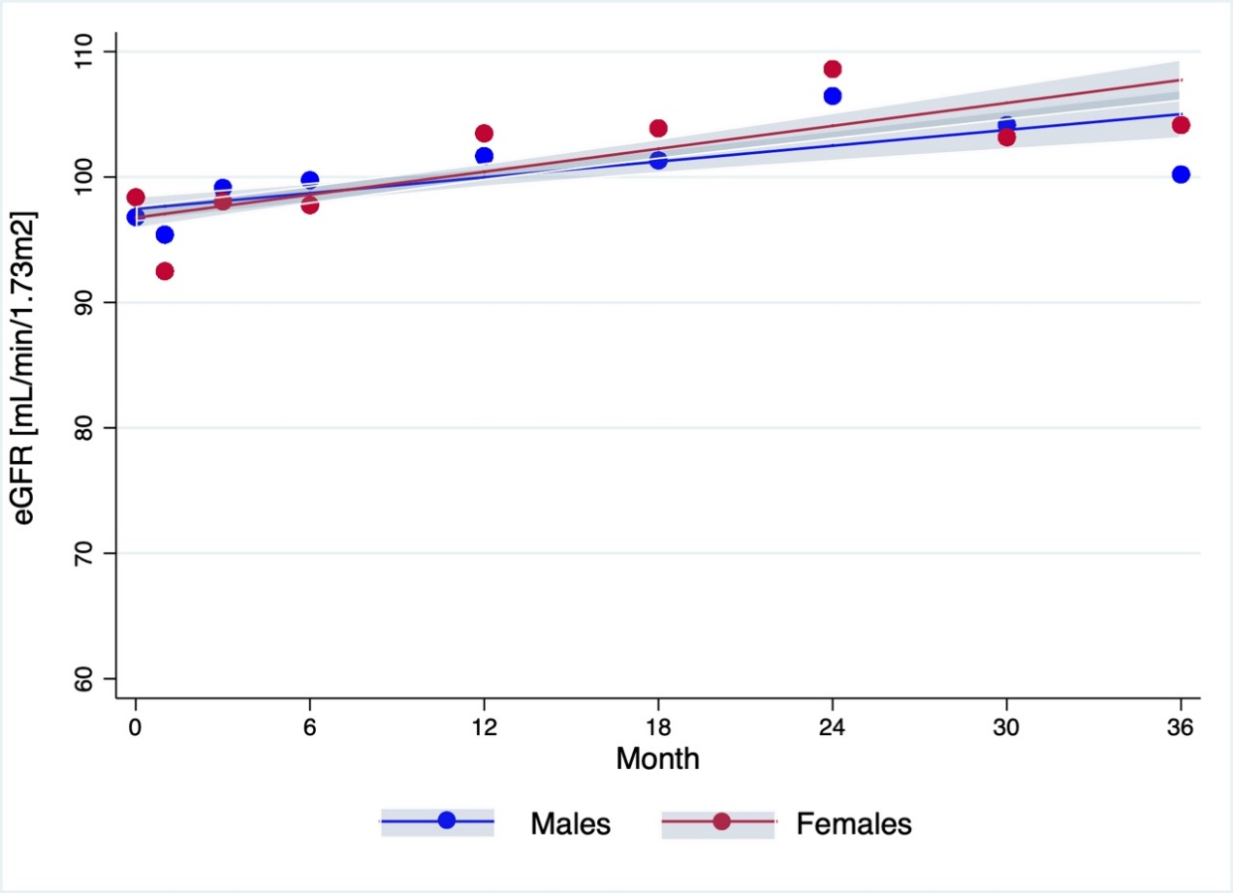
Figure A1. Mean eGFR over time from month 0 to month 36 along with modelled line and 95% confidence interval, separated by sex.

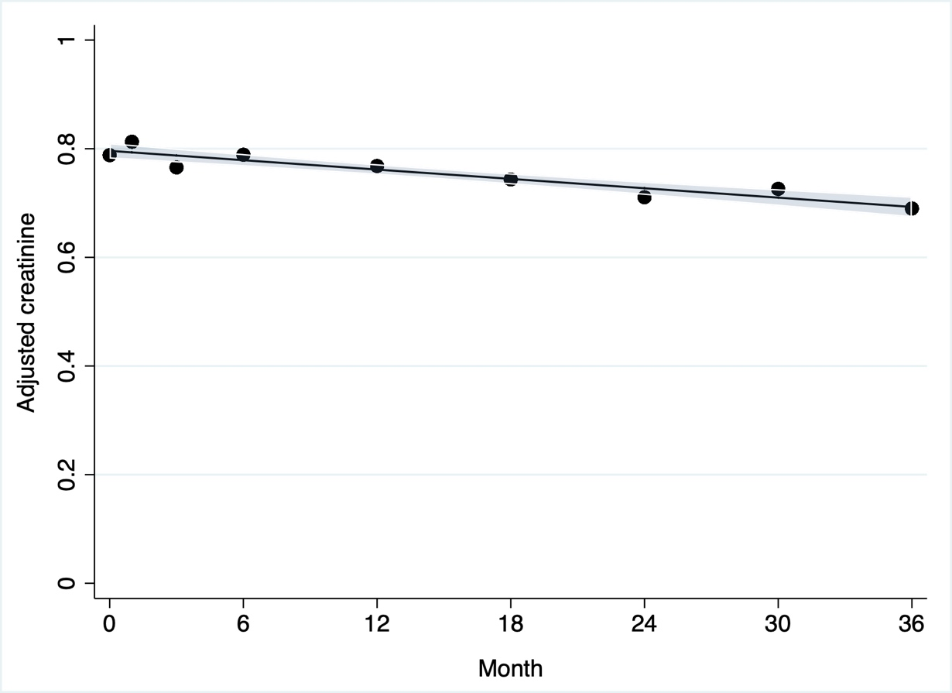
Figure A2. Changes of mean adjusted creatinine over time from month 0 to month 36 along with modelled line and 95% confidence interval.

Table A1. A cohort comparison of PLHIV who enrolled vs those who did not enrol in the period 2014-2016.
Baseline Characteristics |  | Total  n=2503 |  | Enrolled  n= 1433 (57%) |  | Not enrolled  n=1070 (43%) |  | p-value^{b}
Sex |  |  |  |  |  |  |  | 0.453
Male |  | 1097 | (44%) | 618 | (43%) | 479 | (45%)
Female |  | 1406 | (56%) | 815 | (57%) | 591 | (55%)
Age at ART start (years) |  |  |  |  |  |  |  | 0.001
18-35 |  | 1340 | (54%) | 727 | (51%) | 613 | (57%)
36-55 |  | 1057 | (42%) | 649 | (45%) | 408 | (38%)
56+ |  | 106 | (4%) | 57 | (4%) | 49 | (5%)
Mean±SD |  | 35.9±9.6 |  | 36.5±9.3 |  | 35.1±9.9
BMIª(kg/m²) |  |  |  |  |  |  |  | 0.001
<18.5 |  | 178 | (7%) | 82 | (6%) | 96 | (9%)
18.5-24.9 |  | 15191 | (61%) | 868 | (61%) | 651 | (61%)
25-29.9 |  | 545 | (22%) | 317 | (33%) | 228 | (22%)
>30 |  | 254 | (10%) | 166 | (12%) | 88 | (8%)
Mean±SD |  | 23.9±4.7 |  | 24.2±4.9 |  | 23.5±4.5
WHO stage at ART start |  |  |  |  |  |  |  | 0.010
WHO stage 1 |  | 1184 | (47%) | 658 | (46%) | 526 | (49%)
WHO stage 2 |  | 402 | (16%) | 223 | (16%) | 179 | (17%)
WHO stage 3 |  | 718 | (29%) | 448 | (31%) | 270 | (25%)
WHO stage 4 |  | 199 | (8%) | 104 | (7%) | 95 | (9%)
ART outcomeª |  |  |  |  |  |  |  | 0.001
Alive |  | 1286 | (51%) | 803 | (56%) | 483 | (45%)
Dead |  | 91 | (4%) | 54 | (4%) | 37 | (3%)
Defaulted |  | 745 | (30%) | 398 | (28%) | 357 | (33%)
Stop ART |  | 14 | (1%) | 9 | (1%) | 5 | (1%)
Transfer Out |  | 356 | (14%) | 168 | (12%) | 188 | (18%)
 | Follow-up on ART (months) |  |  |  |  |  |  | 0.001
 | <6 | 571 | (23%) | 271 | (19%) | 300 | (28%)
 | 6-12 | 204 | (8%) | 116 | (8%) | 88 | (8%)
 | 13-24 | 194 | (8%) | 113 | (8%) | 81 | (8%)
 | 25+ | 1528 | (61%) | 930 | (65%) | 598 | (56%)
 | Mean±SD | 31.0±21.6 |  | 32.1±20.4 |  | 29.6±23.4
ªMissing records: BMI=7; Reason for ART=59; ART outcome=1; Period on ART=36
^{b}Chi2 test, α=0.05

Table A2. Multivariable linear regression for changes in adjusted creatinine over time from month 0 to month 36.
Variables |  | Model 1 |  | Model 2 |  | Model 3 |  | Model 4 |  | Model 5
Variables |  | n=443 |  | n=443 |  | n=368 |  | n=368 |  | n=352
 |  | ß | p-value | ß | p-value | ß | p-value | ß | p-value | ß | p-value
Adjusted creatinine at baseline |  | -0.915 | <0.001 | -0.917 | <0.001 | -0.928 | <0.001 | -0.929 | <0.001 | -0.928 | <0.001
MAP at baseline |  | <0.001 | 0.128 | <0.001 | 0.103 | <0.001 | 0.238 | <0.001 | 0.240 | <0.001 | 0.134
WHO HIV stage | 1 or 2 | - | - | Ref. | 0.143 | Ref. | 0.181 | Ref. | 0.174 | Ref. | 0.229
WHO HIV stage | 3 or 4 | - | - | 0.025 |  | 0.027 |  | 0.027 |  | 0.024
Dipstick proteinuria | 0 | - | - | - | - | Ref. | 0.694 | Ref. | 0.682 | Ref. | 0.553
Dipstick proteinuria | 1+ª | - | - | - |  | 0.015 |  | 0.016 |  | 0.023
CD4 count at baseline | ≥200 | - | - | - | - | - | - | Ref. | 0.696 | Ref. | 0.378
CD4 count at baseline | <200 | - | - | - | - | - | - | -0.020 |  | -0.046
log (viral load) at baseline | <4 | - | - | - | - | - | - | - | - | Ref, | 0.453
log (viral load) at baseline | 4 to <5 | - | - | - | - | - | - | - | - | 0.027
log (viral load) at baseline | 5 to <6 | - | - | - | - | - | - | - | - | -0.057
log (viral load) at baseline | ≥6 | - | - | - | - | - | - | - | - | -0.071
Constant |  | 0.623 | <0.001 | 0.542 | <0.001 | 0.563 | <0.001 | 0.564 | <0.001 | 0.614 | <0.001
ªDipstick proteinuria (1+ or more).

