Dynamic Changes of Hand, Foot, and Mouth Disease Epidemic crossing Three Periods in Jiangxi Province, China: a Long-term Epidemiology Retrospective Study from 2009 to 2022

Supplementary Material

Contents
Supplementary Figure 1. Flowchart of the HFMD cases included in this study from 2009 to 2022 in Jiangxi, China
Supplementary Figure 2. Flowchart of HFMD pathogen surveillance from 2009 to 2022 in Jiangxi, China
Supplementary Figure 3. The trends in HFMD incidence.
Supplementary Figure 4. The spatiotemporal distributions of HFMD cases during 2009-2022.
Supplementary Table 1. The scanning results of spatiotemporal clusters for HFMD incidence in Jiangxi, 2009-2022.
Supplementary Table 2 Performance metrics of HFMD pathogen prediction models during cross-validation, 2009-2022

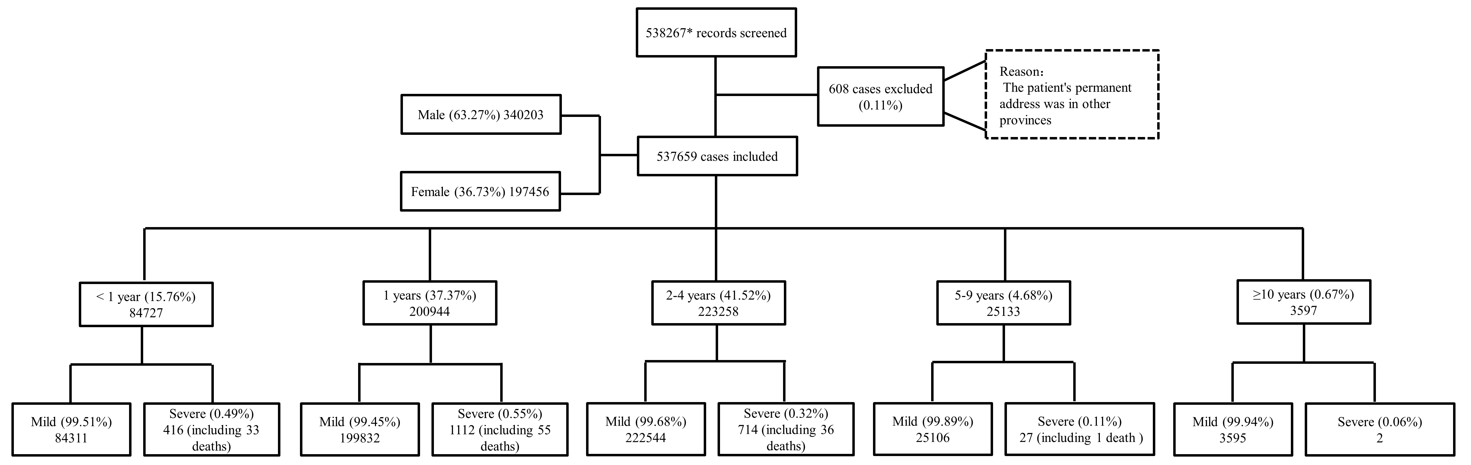

Supplement Figure 1: Flowchart of the HFMD cases included in this study from 2009 to 2022 in Jiangxi, China
* Data of HFMD cases (2009-2022) were collected from the National Notifiable Infectious Diseases Reporting Information System. The individual information of all cases, including demographic information, dates of illness onset and diagnosis, et al.

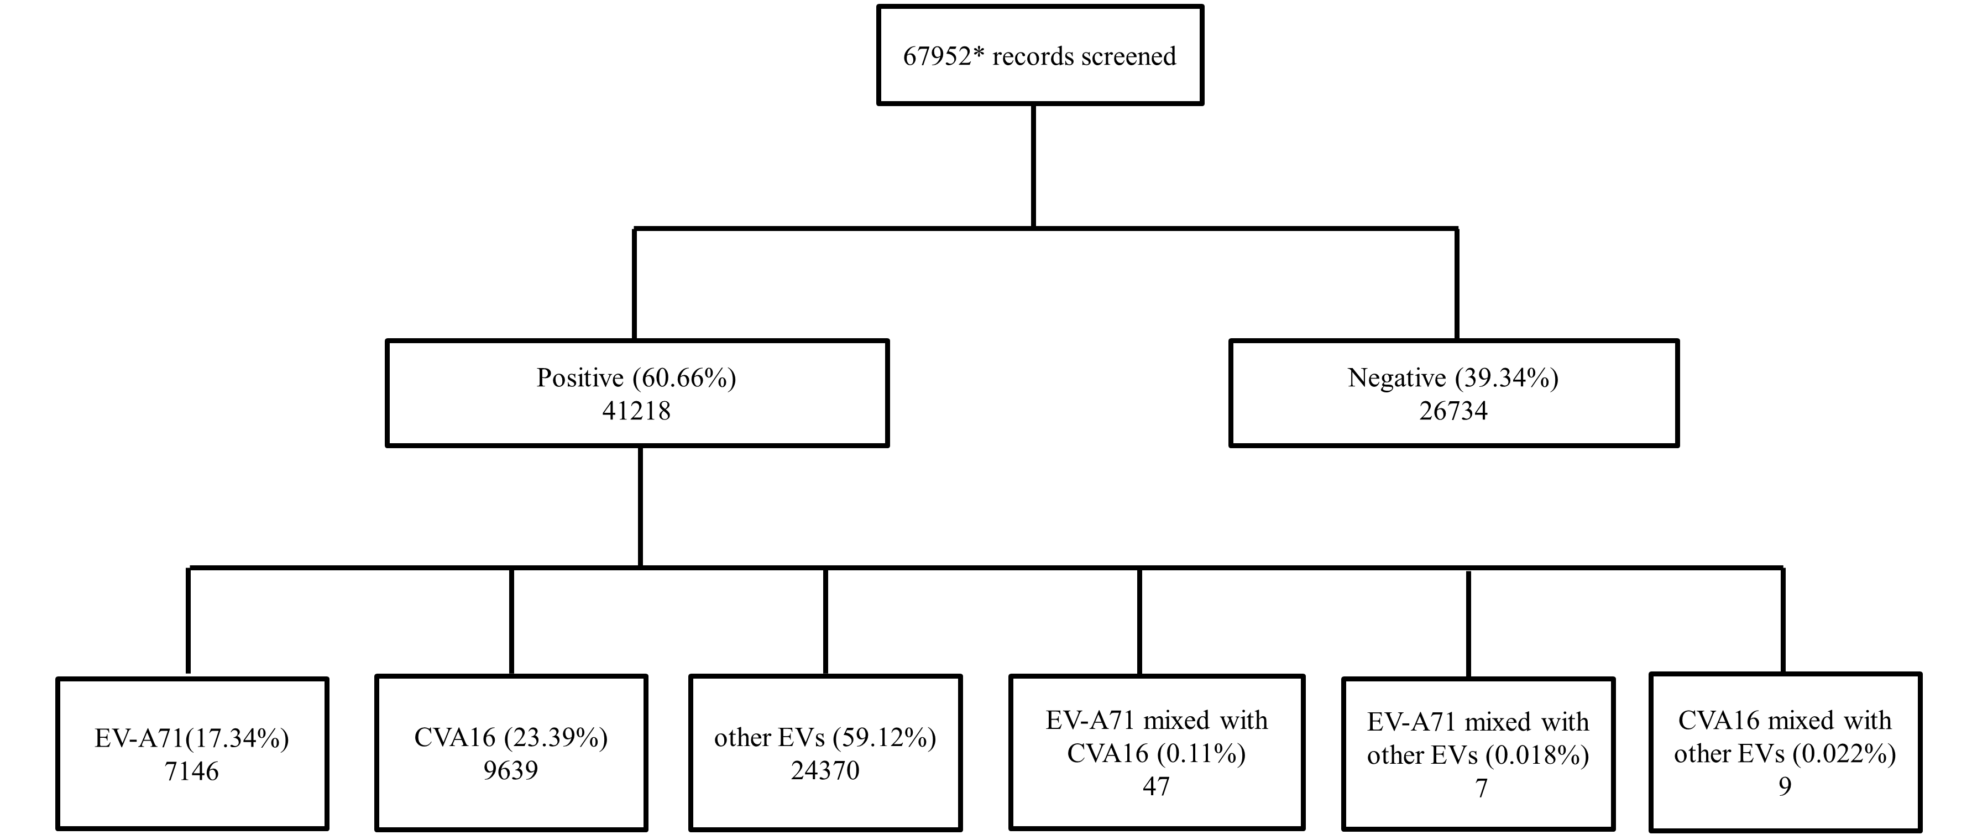

Supplement Figure 2: Flowchart of HFMD pathogen surveillance from 2009 to 2022 in Jiangxi, China

Supplement Figure 3: The trends in HFMD incidence. (A) Overall incidence. (B-F) Incidence by age groups. (A) Overall incidence. (B-F) Incidence by age groups.

Supplementary Figure 4: The spatiotemporal distributions of HFMD cases during 2009-2022. The map was generated by ArcGIS software.

Supplementary Table 1. The scanning results of spatiotemporal clusters for HFMD incidence in Jiangxi, 2009-2022.

Cluster  type | Time  frame | Cluster  center | Radius(km²⁾ | Specific  districts | Cluster areas | Observed cases | Expected cases | RR | LLR | P-value
Grade Ⅰ | 2018/4/15 to 2018/6/23 | 29.880000 N, 116.550000 E | 211.57 | Pengze, Hukou, Xunyang, Duchang, Lushan, Xingzi, Poyang, Jiujiang, Fuliang, Ruichang, Changjiang, Zhushan, Gongqingcheng, De'an, Leping, Yongxiu, Yugan, Wannian, Dexing, Wuyuan, Qingshanhu, Donghu, Xinjian, Xihu, Anyi, Qingyunpu, Wanli, Nanchang, Wuning, Jingan, Jinxian, Fengxin, Dongxiang, Yiyang, Yujiang, Guixi, Yuehu, Hengfeng, Gao'an, Fengcheng, Yanshan, Shangrao, Xinzhou, Yushan | 44 | 15857 | 3465.71 | 4.68 | 11855 | <0.001
Grade Ⅱ | 2012/3/4 to 2018/12/22 | 27.635000 N, 113.809722 E | 43.78 | Anyuan, Xiangdong, Luxi, Shangli, Lianhua | 5 | 51039 | 12661.69 | 4.32 | 34088 | <0.001
Cluster point | 2016/3/13 to 2022/7/16 | 25.847778 N, 114.901944 E | 0 | Zhanggong District | 1 | 20157 | 4620.35 | 4.48 | 14366 | <0.001

Supplementary Table 2 Performance metrics of HFMD pathogen prediction models during cross-validation, 2009-2022

Pathogen | RMSE(mean±SD) | MAE(mean±SD) | CV period
CA-16 | 8.2±7.35 | 5.58±3.8 | 2009-2022
EV-A71 | 4.22±3.66 | 3.28±2.8 | 2009-2022
Other EVs | 14.28±6.54 | 11.16±4.89 | 2009-2022

