Fig. S1 Results of COVID-19 testing and 13-pathogen panel detection
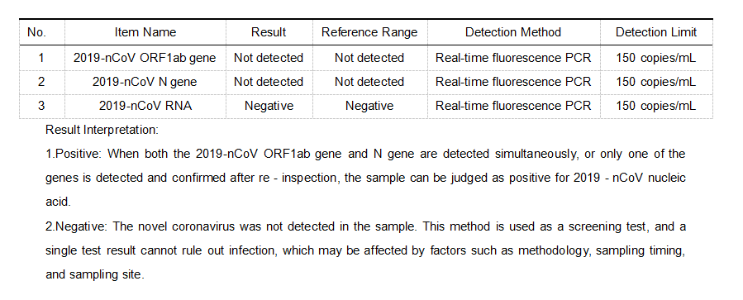
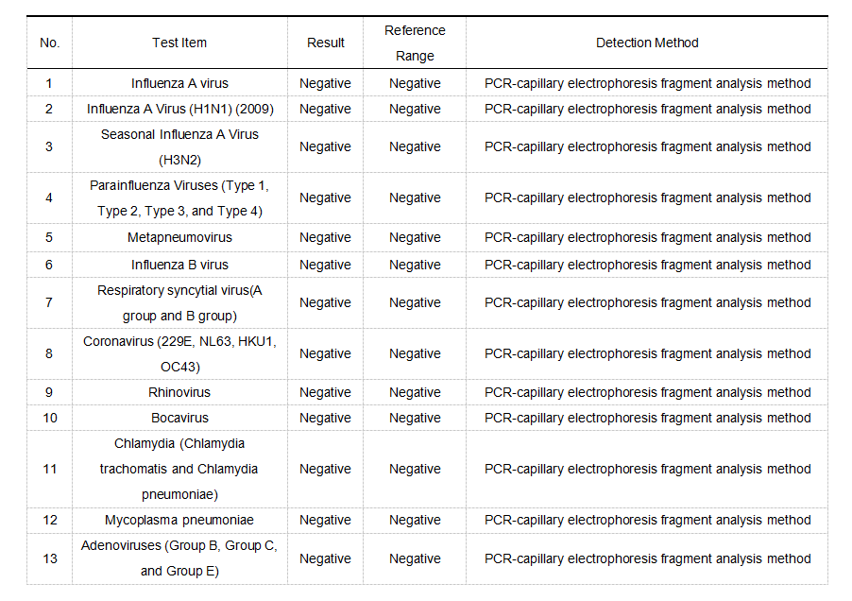
Fig. S2 Dynamic Changes of Peripheral Blood WBC and Its Subpopulations
