[Supplementary Materials]

Supplementary Material 1:
Comparison of laboratory confirmed CCHF casesª from 2015-2020 to year 2025 in Iraq by month
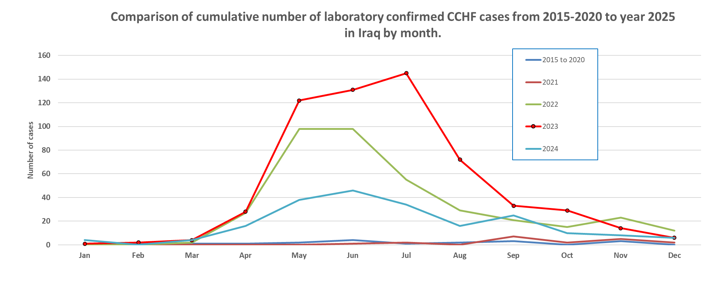
a: Data source: Ministry of Health Iraq/Communicable Disease Control Center. CCHF cases with known outcome, reported from 2015 to 2024.

Supplementary Material 2:
Data collection form (original Arabic)
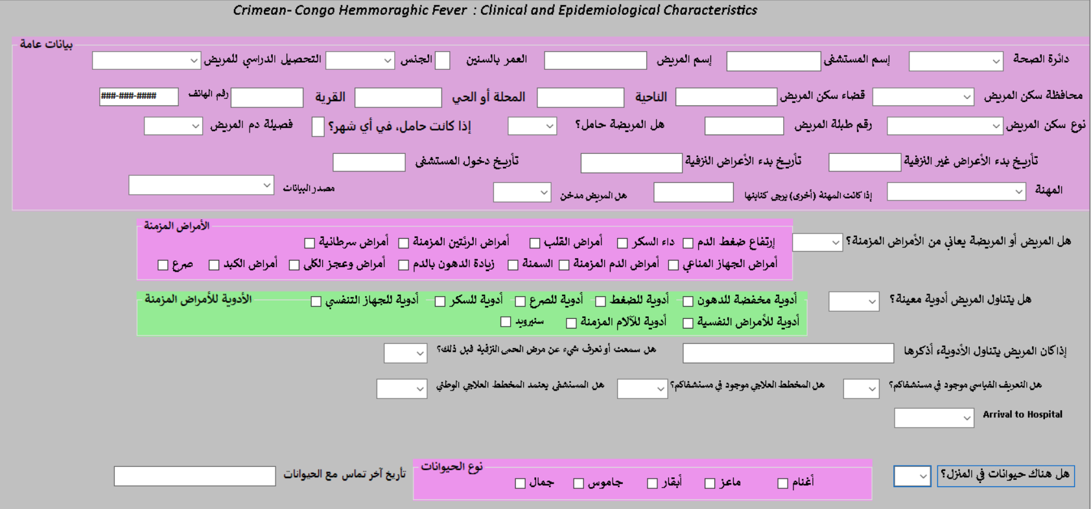

The list of indicators collected (English)

Indicators
ID
Confirmed_case
ReportedDOH
HospitalName
PatientName
Age
Sex
Education
ResidencyProvince
District
Nahia
Mahalaa
Village
Kindofresidency
Case number
Pregnancy
IfPregnantinWhichMonth
BGroupRH
Occupation
Other (occupation)
D. Non bleeding onset
D. bleeding onset
onset_admission
DateofAdmission
Month
Year
Smoking
DataSource
Comorbidities
Hypertension
IschemicHeartDiseases
Epilepsy
Diabetes
Obesity
Malignant
ChronicobstructivePulmonaryDiseases
Other
Other Specify
Drughistory
Antihypertensive
CholesterolloweringDrug
AntiDiabetes
Anticonvulsions
Renal diseases
Steroid
Otherdrug history
Other drug history specify
Knowing CCHF
Presence of Case definition
Presence of treatment protocol
Using National ttt protocol
Patient arrival at hospital
Presence of Animal
Sheep
Goat
Cows
Buffalo
Camel
Other animal
Date of Contact with Animal
Presence of ticks on animals or at home
History of Tick Bite
Date of Tick Bite
Slaughtering history
Slaughtering date
Raw meat History
Raw meat Date
Family case contact history
CCHF case contact history
CCHF case contact date
Travel History within Last 14 days
Travel History Where if any
Fever
Headaches
Malaise
Joint Pain
Diarrhea
Vomiting
Abdominal Pain
Retro Orbital Pain
Eye Redness
Jaundice
Somnolence
Confusion
Others Specify
Ecchymosis
Petechiae
Bleeding from site of injection
Hepatomegally
Failure of organ
BleedingGums
Epistaxis
GIT Bleeding
Hematuria
Vaginal bleeding
Bleeding
Temp
PR
BP
Spo2
Date of investigation
Inv_adm
Hemoglobin
WBC
Lymphocytes
Neutrophils
Platelets
LDH
TSB
Fibrinogenlevel
CRP
esr
DDimer
SAlbumin
PT
INR
PTT
aPTT
ALT
AST
Ferritin
RBS
HBA1C
Burea
Fibrinogen Score
Platletes Score
aPTT score
Bleeding Score
Somnolence Score
SSI
Final Scoring SSI
Full_SSI
ASTs
ALTs
LDHs
WBCs
Hepatomegaly s
organ failuare s
Bleeding-S
Age-S
Platelets-S
PT-S
aPTT-S
INR-S
SGS
Final Score SGS
Full_SGS
Date of Sample taken
PCR
CT
CT_group
Lab2f
Follow up test date
HemoglobinF
PlateletsF
WBCF
PTF
PTTF
FibrinogenlevelF
CRPF
RBSF
BureaF
TSBF
ALTF
ASTF
Lab3
Lab3 date
Hgb3
Platelets3
WBC3
RBC3
ALT3
AST3
TSB3
PT3
PTT3
Sodium
Potassium
Creatinine
Chloride
INR3
Burea3
RBS.1
Glucose
ESR
Others investigations Done1
Other investigation type1
Others investigations results1
Others investigations date1
Other investigation type2
Others investigations results2
Others investigations date2
Other investigation type3
Others investigations results3
Others investigations date3
Supportive Therapy
IV Fluids
IV fluids dose in CC
IV fluids start date
IV fluids cessation date
Antipyeritic
Antipyeritic dose in mg
Antipyeritic start date
Antipyeritic cessation date
PPIs
PPIs dose in mg
PPIs start date
PPIs cessation date
Anti-emetic
Anti-emetic dose in mg
Anti-emetic start date
Anti-emetic cessation date
Cyklokapron
Cyklokapron dose in mg
Cyklokapron start date
Cyklokapron cessation date
Others Type
Other supportive dose
Other Supportive date
Other Cessation date
Blood and Bloodproduct
Platelets transfusion
Platelets amount in pints
Platelets date
Platelets cessation
Plasma transfusion
Plasma amount in pints
Plasma date
Plasma cessation
RBCs transfusion
RBCs amount in pints
RBCs date
RBCs cessation
Cryoprecipitate
Cryoprecipitateamount
Cryoprecipitatedate
Cryoprecipitatecessationdate
Antibiotics usage
Antibiotic1type
Antibiotic1dose in mg
Antibiotic1formula
Antibiotics1date
Antibiotic1cessation
Antibiotic2type
Antibiotic2dose
Antibiotic2formula
Antibiotics2date
Antibiotic2cessation
Name of Antibiotic3
DosesofAntibiotic3
Antibiotic3formula
Date of Antibiotics3 used
Date of Cessation antibiotic3
rib_onset
ribavarin_usage
Ribavarin1dose in mg
Ribavirin1type
Ribavarin1date
Ribavirin1cessation
Ribavarin2dose in mg
Ribavarin2type
Ribavarin2date
Ribavarin2cessation
ribavarin_duration
rib_admission
Total dose
av_daily_rib_dose
main_rib_type
Steriods case ttt
Steroid1type
Steroid1dose in mg
Steroid1formula
Steroid1date
Steroid1cessation
Steroid2type
Steroid2dose in mg
Steroid2date
Steroid2 cessation
Complications
Peripheral Neuropathy
Bradycardia
Behavior change
Depression
Hyperglycemia
Hallucination
Carditis
Renal Failure
Liver Failure
BleedingofBodyorfices
IntraAlveolarHemorrage
Secondary Infection
Pleural Effusion
Agitation
Seizures
ARDS
Liver failure
FinalDiagnosis
IF Diagnosis is not CCHF Mention it
Final_outcome
Date of outcome
If outcome is death Mention cause of death
IncubationPeriodinDays
IPA
IPS
IPM
IPT
IPC
DaysIgM
DaysIgG
PCR_adm
DaysPCR
Difference in Days between no bleeding symptoms and date of bleeding
Days between Date of onset OF no bleeding symptoms and date of investigation
Difference Between Date of investigation and Date of Bleeding signs
Days between Investigation and followup Tests
Stay in Hospital
Name of Data entry
PhyscianName

Supplementary Material 3:
Age Group and Baseline Profile among 273 Laboratory-Confirmed CCHF Cases in Iraqª

Age Group  (Years) | Survived  N=240 | Survived Median Age (IQR^{b}) | Death  N=33 | Death Median Age (IQR^{b}) | p-value^{c,d}
<20 | 27 | 17.0 (14-20) | 3 | 18 (17-18) | 0.207256
20-39 | 118 | 30.0 (25-35) | 15 | 30 (25-34.5) | 0.726513
40-59 | 66 | 47.5 (42.5-52.5) | 12 | 47 (45-49) | 0.823882
≥60 | 28 | 64.5 (59.5-69.5) | 3 | 64 (62-66) | 0.80921
N/A* | 1 | N/A* | 0 | N/A* | N/A*

Baseline Profile | All  N=273 | Survived  N=240 | Death  N=33 | p-value^{c,d} overall
Gender | N*=273 (100%) | 240 | 33 | 0.146
Female | 105 (38.5%) | 88 (36.7%) | 17 (51.5%)
Male | 168 (61.5%) | 152 (63.3%) | 16 (48.5%)
Type of Residency | N*=273 (100%) | 240 | 33 | 0.246
Rural | 86 (31.5%) | 77 (32.1%) | 9 (27.3%)
Semi-urban | 113 (41.4%) | 95 (39.6%) | 18 (54.5%)
Urban | 73 (26.7%) | 67 (27.9%) | 6 (18.2%)
N/A* | 1 (0.4%) | 1 (0.4%) | 0 (0.0%)
Animal Owner | N*=273 (100%) | 240 | 33 | 1.000
No | 246 (90.1%) | 216 (90.0%) | 30 (90.9%)
Yes | 27 (9.9%) | 24 (10.0%) | 3 (9.1%)
Butcher | N*=273 (100%) | 240 | 33 | 0.783
No | 237 (86.8%) | 209 (87.1%) | 28 (84.8%)
Yes | 36 (13.2%) | 31 (12.9%) | 5 (15.2%)
Homemaker | N*=273 (100%) | 240 | 33 | 0.178
No | 189 (69.2%) | 170 (70.8%) | 19 (57.6%)
Yes | 84 (30.8%) | 70 (29.2%) | 14 (42.4%)
Presence of Animal | N*=273 (100%) | 240 | 33 | 0.760
No | 118 (43.4%) | 105 (43.9%) | 13 (39.4%)
Yes | 154 (56.6%) | 134 (56.1%) | 20 (60.6%)
N/A* | 1 (0.4%) | 1 (0.4%) | 0 (0.0%)
History of Tick Bite | N*=255 (93%) | 240 | 33 | 0.230
No | 241 (94.5%) | 210 (93.8%) | 31 (93.9%)
Yes | 14 (5.5%) | 14 (5.8%) | 0 (0.0%)
N/A* | 18 (6.6%) | 16 (6.7%) | 2 (6.06%)
Presence of ticks on animals or at home | N*=273 (100%) | 240 | 33 | 0.700
No | 212 (77.7%) | 186 (77.5%) | 26 (78.8%)
Yes | 45 (16.5%) | 41 (17.1%) | 4 (12.1%)
N/A* | 16 (5.9%) | 13 (5.4%) | 3 (9.1%)
Slaughtering history | N*=273 (100%) | 240 | 33 | 0.316
No | 181 (66.3%) | 162 (68.1%) | 19 (57.6%)
Yes | 90 (33.0%) | 76 (31.9%) | 14 (42.4%)
N/A* | 2 (0.7%) | 2 (0.8%) | 0 (0.0%)
Exposure to raw meat | N*=273 (100%) | 240 | 33 | 0.580
No | 164 (60.1%) | 142 (59.2%) | 22 (66.7%)
Yes | 106 (38.8%) | 95 (39.5%) | 11 (33.3%)
N/A* | 3 (1.1%) | 3 (1.3%) | 0 (0.0%)
Comorbidities | N*=273 (100%) | 240 | 33 | 0.094
No | 239 (87.5%) | 207 (86.3%) | 32 (97.0%)
Yes | 34 (12.5%) | 33 (13.8%) | 1 (3.0%)

a: Data source: Ministry of Health Iraq/Communicable Disease Control Center. N=273 CCHF cases with known outcome, reported from 2021 to 2024.
b: IQR=Interquartile Range
c: Comparisons were conducted using chi-square tests or Fisher’s exact tests for categorical variables and Student's t-tests for continuous variables.
d: A two-sided p-value of <0.05 was considered statistically significant.
N*=Actual number of collected data out of total 273 confirmed CCHF cases
N/A*=Data not available

Supplementary Material 4:
4-1: Median Time from Symptom Onset to Hospital Admission by Governorate
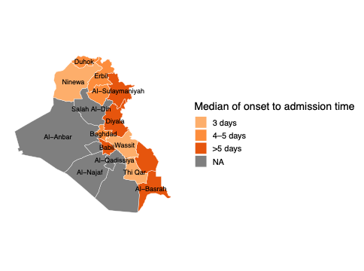

4-2: Geospatial Differences in Onset to Admission Time by Governoratesª

Reported DOH^{b} | Confirmed CCHF Cases with Available Data* | Onset to Admission (days),  Median (IQR^{c})
Babylon | 30 | 6 (5-7)
Baghdad | 16 | 5 (4-6)
Basrah | 11 | 5 (4-6)
Dahuk | 5 | 5 (3-6)
Diyala | 1 | 14 (14-14)
Erbil | 7 | 4 (2-5)
Kirkuk | 17 | 4 (2-5)
Missan | 5 | 5 (4-6)
Ninewa | 25 | 3 (2-4)
Sulamaniyah | 5 | 6 (3-6)
Thiqar | 118 | 3 (2-5)
Wassit | 38 | 3 (1-4)

a: Data source: Ministry of Health Iraq/Communicable Disease Control Center. N=273 CCHF cases with known outcome, reported from 2021 to 2024.
b: DOH: Directorate of Health which represents the main local health authority responsible for overseeing and managing health services at the provincial (governorate) level in Iraq.
c: IQR=Interquartile Range
* Only data with available information was included in this analysis, and this is not representing the total number of confirmed CCHF cases from each governorate over the same time period.

4-3: Time to Hospital Admission vs Mortality among 273 Laboratory-Confirmed CCHF Cases in Iraqª

Time From Symptom Onset to Hospital Admission | All  N=273 (Male/Female) | Survived  N=240  (Male/Female) | Death  N=33  (Male/Female) | CFR^{e} (%)  (Male CFR/  Female CFR) | p-value^{c,d}
0–2 days | 68 (43/25) | 61 (40/21) | 7 (3/4) | 10.3 (7/16) | 0.751
3–5 days | 119 (72/47) | 104 (65/39) | 15 (7/8) | 12.6 (9.7/17) | 0.967
6–9 days | 52 (37/15) | 46 (33/13) | 6 (4/2) | 11.5 (10.8/13.3) | 1.000
≥10 days | 9 (6/3) | 7(5/2) | 2 (1/1) | 22.2 (16.7/33.3) | 0.668
N/A* | 25 (10/15) | 22 (9/13) | 3 (1/2) | 12.0 (10/13.3) | N/A*

a: Data source: Ministry of Health Iraq/Communicable Disease Control Center. N=273 CCHF cases with known outcome, reported from 2021 to 2024.
b: CFR=Case Fatality Rate
c: Comparisons were conducted using chi-square tests or Fisher’s exact tests for categorical variables and Student's t-tests for continuous variables.
d: A two-sided p-value of <0.05 was considered statistically significant.

