Appendix 1. Operation Methods Of TST, C-TST, And IGRAs

1.1 TST
With the previously reported methods of operation and observation,¹ one selected subject was injected by a trained professional using the Mantoux technique.² It is considered MTB infection in the areas where BCG vaccination was carried out and/or where MTB infection was not endemic when the mean diameter exceeds 10mm.³

1.2 C-TST
The same subjects were injected with 0.1 ml of EC intradermally into the medial forearm of their right arm in an identical way, with the previously reported observation interval.^{1,4} The presence of hardness and/or redness ≥5 mm at the injection site was considered positive, indicating MTB infection.

1.3 IGRAs
Considering the economic cost and the difficulty of clinical practice, IGRAs were not performed on blood samples from all subjects. Here, the subjects who underwent two skin trials between October and December 2023 were selected for IGRA (QFT-GIT) through enzyme-linked immunosorbent assay (ELISA). The IGRA (QFT-GIT) were carried out according to the manufacturer’s instructions.
Appendix 2. Decision Tree-Markov Model

Figure S2.1. Decision Tree Model For Simulating Crowd Queues (PCF Was Taken As An Example)

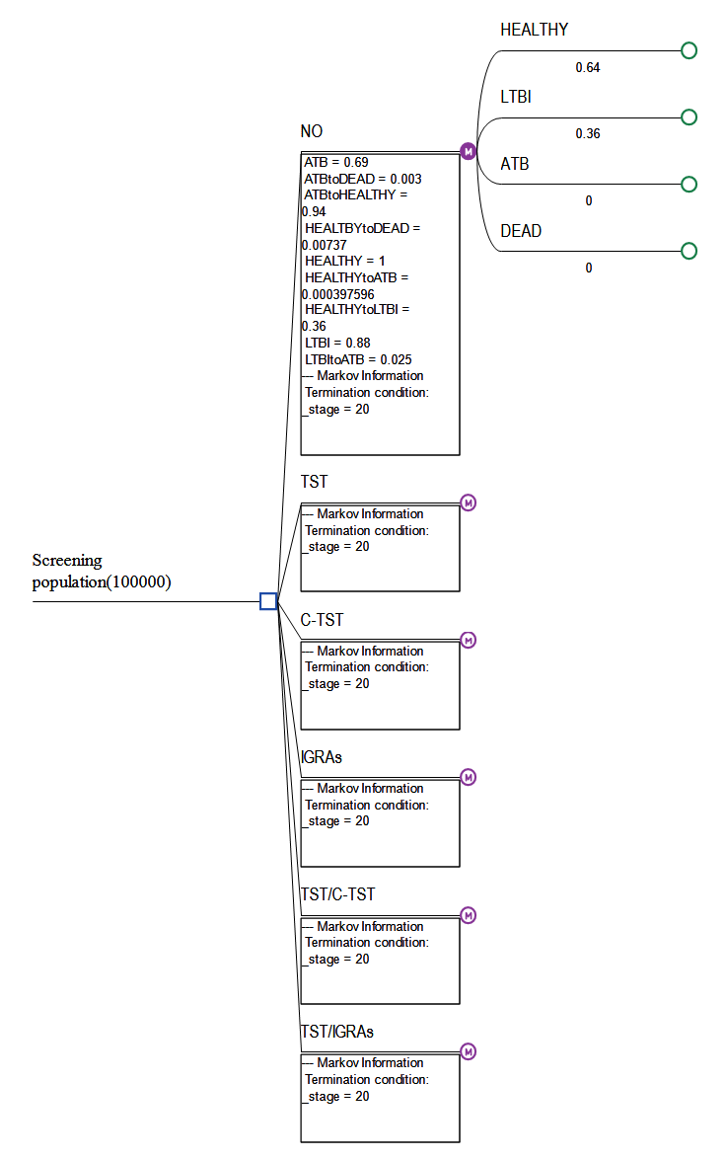

The decision tree model can effectively represent complex decision-making events. The starting point is defined from the left as a cohort of 100,000 simulated people, where the whole cohort starts at time zero. Six screening strategies were applied to these contacts: PCF, TST, C-TST, IGRAs, TST/C-TST, and TST/IGRAs. After the events of each screening strategy, the probability values and endings of the occurrence were obtained, with the state probabilities noted on each branch.
Figure S2.2. Markov Model For Simulating Crowd Queues

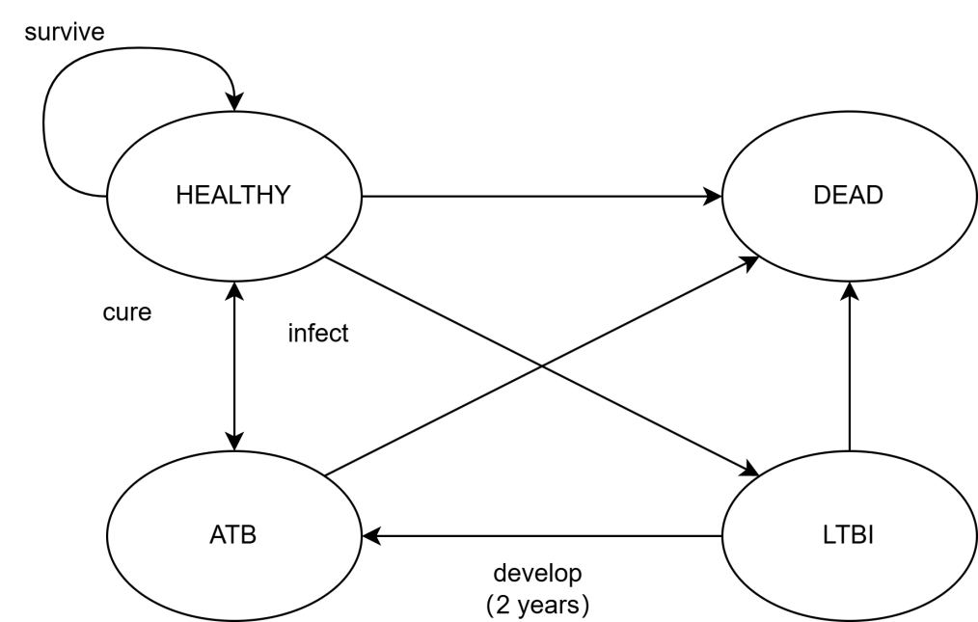

Our study included four health states, namely healthy (subjects were in a healthy state), LTBI (a state in which the body has a sustained immune response to MTB antigens and reacted as positive result on the TST test, whereas there is no clinical evidence of ATB), ATB (with TB-related clinical signs and symptoms, and confirmed by MTB aetiological, pathological, and imaging examinations), and death (including deaths occurring in a healthy state, successful treatment, LTBI, and ATB).

Figure S2.3. Decision Tree-Markov Model For PCF

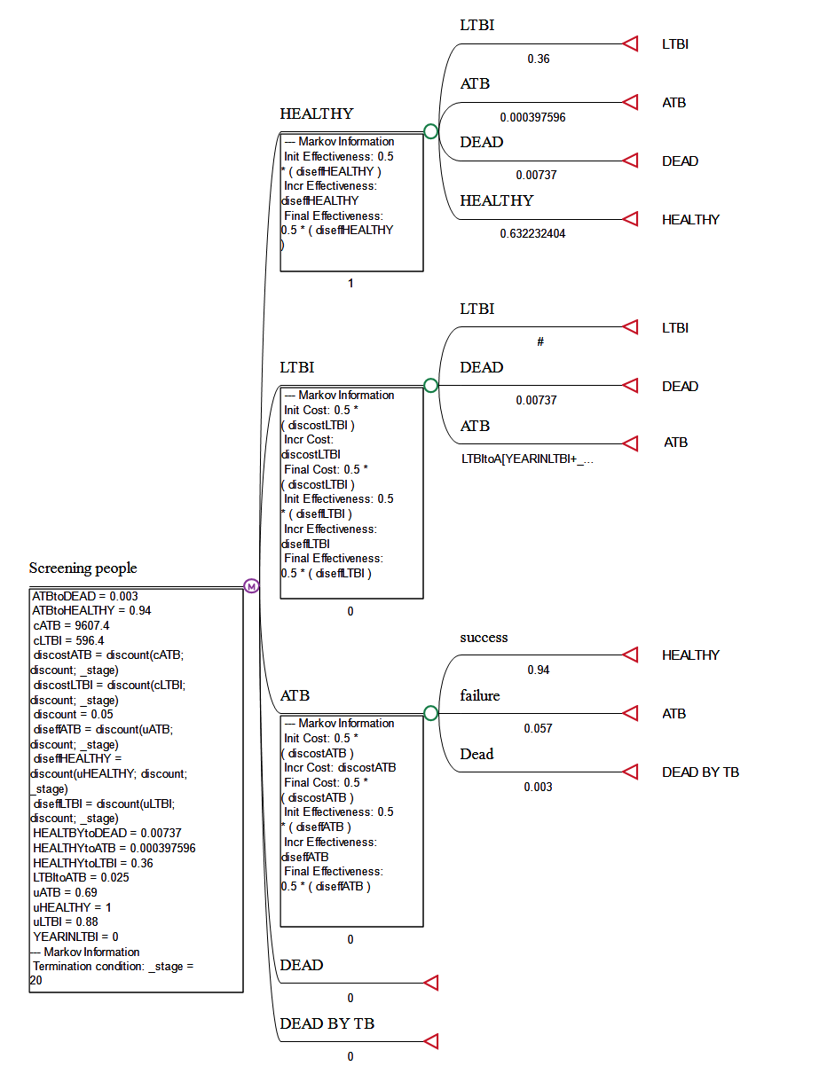

In the Markov model, all study individuals in the cohort used healthy status as the starting point to move to other states, with LTBI, ATB, and successful TB treatment as the transitional states. Healthy individuals who are exposed to MTB can develop LTBI, ATB, or die naturally from a variety of causes. Untreated LTBI can transition from LTBI to ATB, and the risk is highest within the first two years after the initial LTBI. Besides that, a significant portion of LTBI may experience natural death. For ATB, the subjects have the chance to be cured, benefit from the anti-TB medications, or may die of TB disease. Natural mortality applies to all health statuses (LTBI, ATB, and cured/healthy), while only ATB status is associated with TB-related mortality.
Figure S2.4. Decision Tree-Markov Model For C-TST
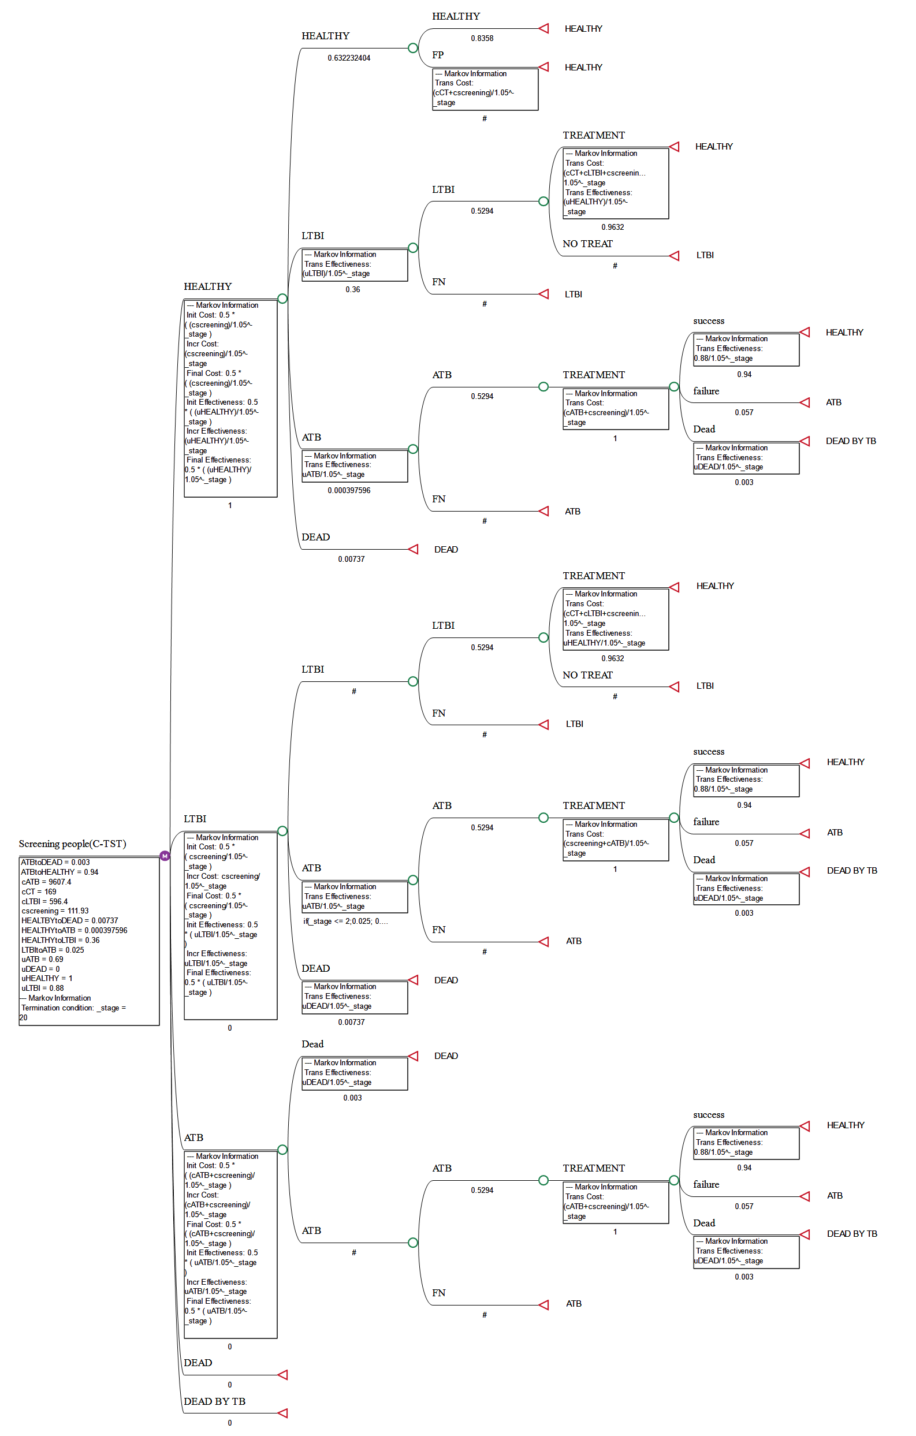

Figure S2.5. Decision Tree-Markov Model For IGRAs

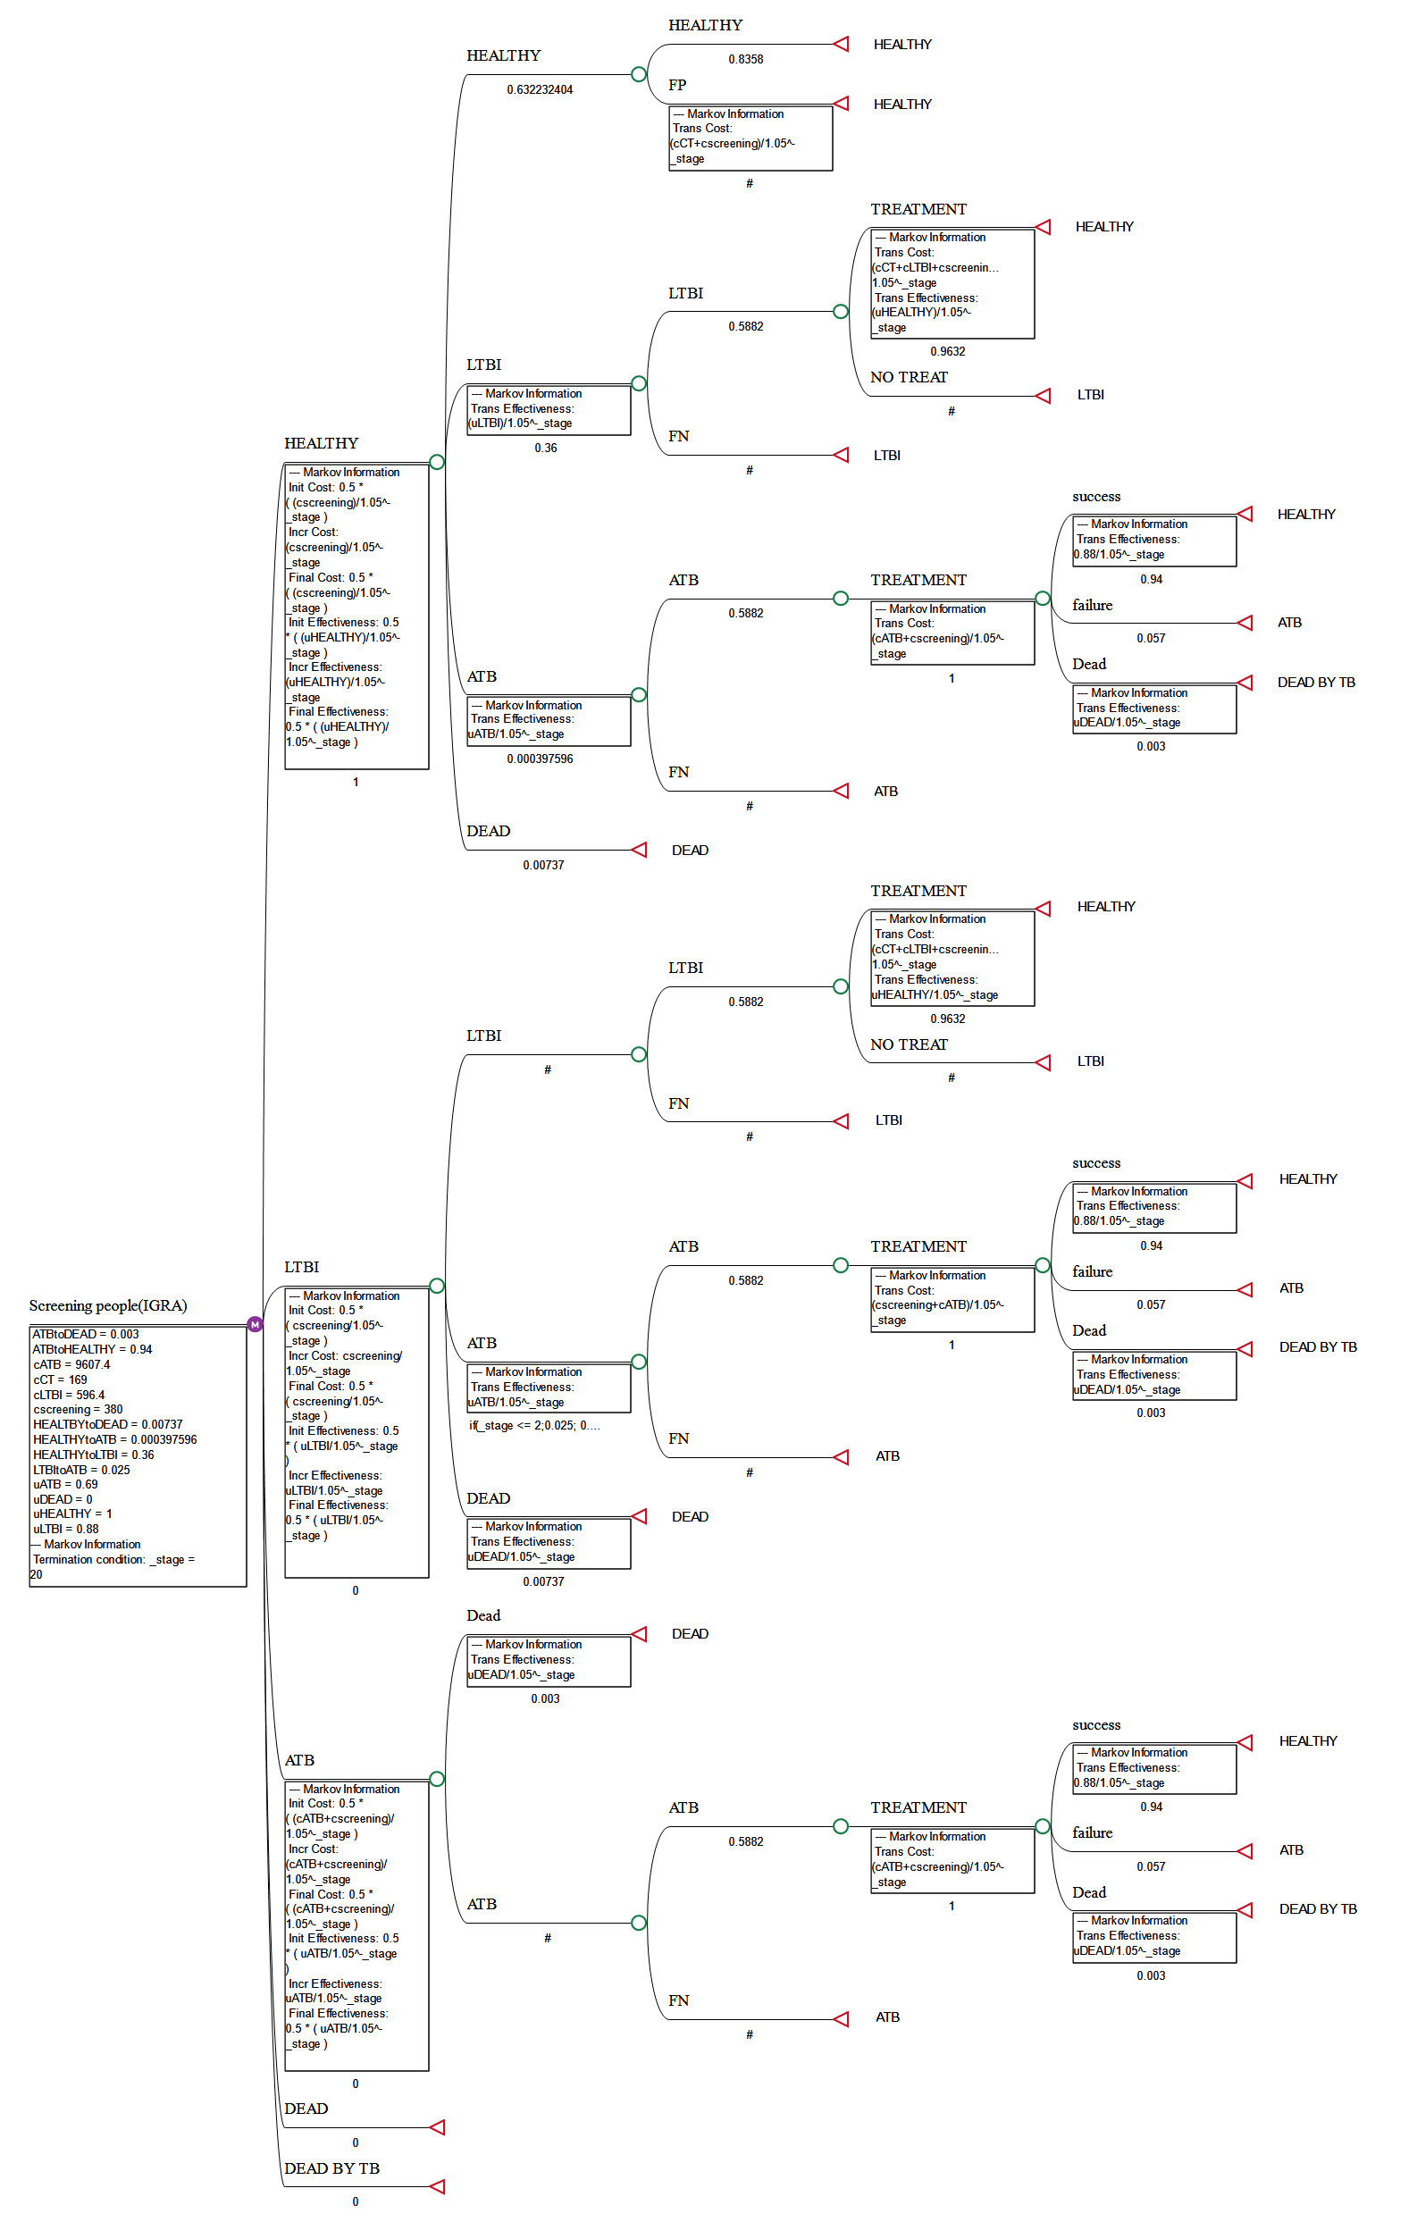
Figure S2.6. Decision Tree-Markov Model For TST

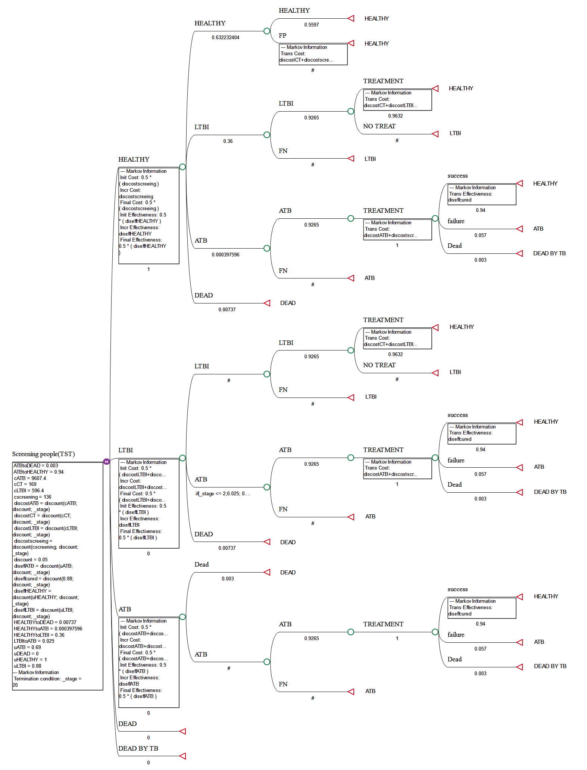

Figure S2.7. Decision Tree-Markov Model For Combined TST/C-TST Screening

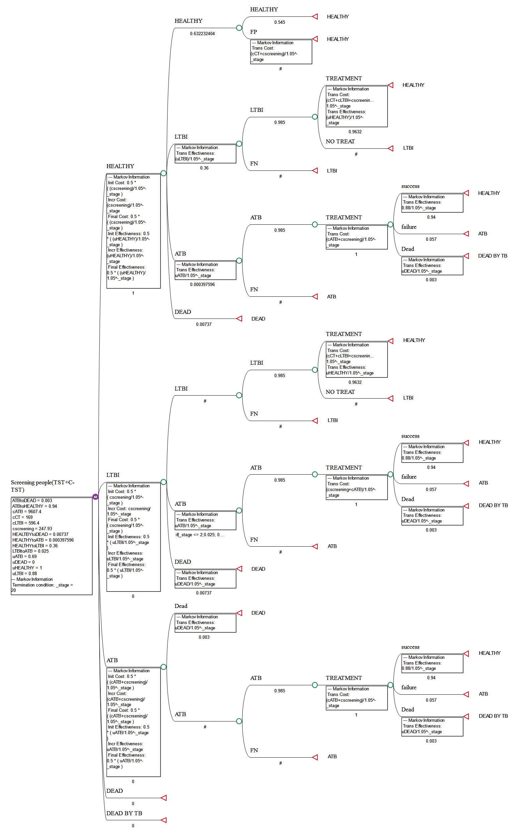
Figure S2.8. Decision Tree-Markov Model For Combined TST/IGRAs Screening
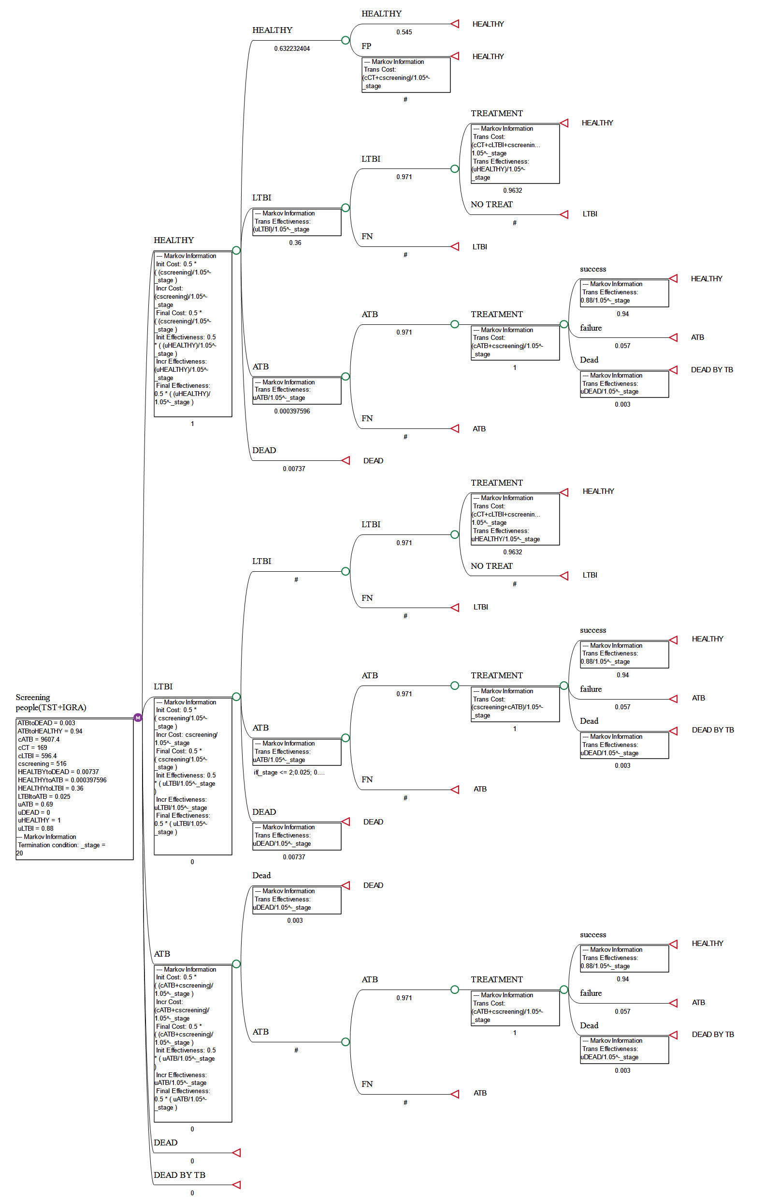
Appendix 3. The Model Parameters Of The Decision Tree-Markov Model For The Screening Strategies

3.1 Transitional Probability
As one of the important parameters in the Markov model, transitional probability reflects how subjects of each health state move to another state in the simulated cohort. The annual risk rate for LTBI to develop into ATB was obtained from a study conducted by Shedrawy.⁵ Notably, the risk of developing ATB is at its highest in the first two years after the initial LTBI, then decreases over time.⁶ Estimated transitional probabilities from TB status to cured status and from TB status to death status were obtained from the Chinese Health and Wellness Yearbook and the Chinese Statistical Yearbook.⁷

3.2 Cost
In this study, the cost parameters were considered mainly from the perspective of the social group. The costs associated with screening, diagnosis, and treatment in the general population were categorized into two main groups: direct costs and indirect costs. Due to differences among individuals and leading to double counting, indirect costs were not included in the model. The direct healthcare costs considered in the model include costs of screening (TST, C-TST, IGRAs), outpatient visits (OPD), drugs, laboratory tests, hospitalization (IPD), directly observed treatment (DOT), TB preventive treatment, and adverse reaction (ADR) management. The cost parameters in this study were obtained by referring to the pricing of healthcare organizations and reviewing relevant yearbooks.⁷ All cost data were discounted and converted to the study baseline year at a discount rate of 5.0%, which aligns with the recommended standards of the Chinese guidelines for pharmacoeconomic evaluation.⁸

3.3 Utility
QALYs have been widely used in health economics as a health utility metric, which can integrate both the quality of life and the duration of survival to provide an objective reflection of a patient’s health status. In this study, the utility values referred to in the research by Yoopetch and Kittikraisak,^{2,9} where the utility score for patients undergoing TB treatment is 0.69, and for those who have completed TB treatment, it is 0.88. For individuals with LTBI, their utility value is equivalent to that of patients who have completed treatment or been cured of TB, namely 0.88.
Appendix 4. Cost-Utility Evaluation Indicators

4.1 Cost-Utility Ratio (CUR)
The ratio between the total cost and the total utility of an intervention represents how much it costs to achieve the same intervention utility or level of health during the intervention. This ratio can be used to compare expenditures on screening programs and willingness to pay. In general, the lower the cost-utility ratio, the more effective the screening strategy in terms of health economics.
CUR=C/U
C: Full cost of intervention inputs
U: Full effectiveness of the intervention program

4.2 Incremental Cost-Utility Ratio (ICUR)
ICUR is the cost per health utility gained, which can be used to compare the cost-utility between passive case finding (ACF) and PCF in the subject population. The larger the ICUR, the higher the cost of obtaining additional QALYs.
ICUR=C1-C0/U1-U0
C1: ACF programme model end-of-cycle cumulative cost
C0: PCF programme model end-of-cycle cumulative cost
U1: ACF programme model end-of-cycle cumulative QALYs value
U0: PCF programme model end-of-cycle cumulative QALYs value

Appendix 5. Survey Of Influencing Factors Related To Skin Test Status In The Subject Population

Table S5.1. Survey Of Influencing Factors Related To Skin Test Status In The Subject Population

Characteristics | case, No. (%) | Std. Error | z value | Pr(>|z|) | ORª
Total | 1412
Age
18-20 | 406 (28.8)
21-25 | 926 (65.6) | 0.304 | -0.084 | 0.933 | 0.975
26-30 | 64 (4.5) | 0.545 | 1.010 | 0.313 | 1.734
31-35 | 11 (0.8) | 1.107 | 1.037 | 0.300 | 3.153
36-40 | 5 (0.4) | 1.200 | 3.291 | <0.001^{b} | 51.994
Location
country | 831 (58.9)
town | 322 (22.8) | 0.294 | 1.505 | 0.132 | 1.556
city | 259 (18.3) | 0.425 | -0.993 | 0.321 | 0.656
Monthly income
<5000 | 303 (21.5)
5000-10000 | 893 (63.2) | 0.386 | 1.144 | 0.253 | 1.556
>10000 | 216 (15.3) | 0.495 | 0.971 | 0.332 | 1.617
Drug allergies
non-allergenic | 1383 (98.0)
allergenic | 29 (2.1) | 689.775 | -0.021 | 0.983 | <0.001
Number of exercises
non-exercise | 30 (2.1)
1~3/month | 479 (33.9) | 0.502 | -5.641 | <0.001^{b} | 0.059
1~4/week | 589 (41.7) | 0.461 | -5.120 | <0.001^{b} | 0.094
5~7/week | 314 (22.2) | 0.491 | -4.348 | <0.001^{b} | 0.118
Smoking status
non-smoking | 817 (57.9)
Quit smoking | 261 (18.5) | 0.425 | -1.210 | 0.226 | 0.598
Smoking | 334 (23.7) | 0.348 | -0.614 | 0.539 | 0.807
Alcohol consumption
never | 616 (43.6)
1~3/month | 788 (55.8) | 0.273 | -1.310 | 0.190 | 0.700
1~4/week | 6 (0.4) | 1536.824 | -0.009 | 0.993 | <0.001
every day | 2 (0.1) | 2266.161 | -0.007 | 0.994 | <0.001
TB Contact
non-contact | 1403 (99.4)
contact | 9 (0.6) | 1242.978 | -0.011 | 0.992 | <0.001
Awareness of TB-related knowledge
unknown | 389 (27.6)
a little | 781 (55.3) | 0.350 | 2.212 | 0.027 | 2.168
very well | 242 (17.1) | 0.669 | -1.350 | 0.177 | 0.405
Any vaccination in the last year
unvaccinated | 1348 (95.5)
vaccinated | 64 (4.5) | 1.037 | -0.920 | 0.358 | 0.385
Scar shape
no BCG scar | 294 (20.8)
BCG scar | 1118 (79.2) | 0.361 | 0.546 | 0.585 | 1.218
ª OR (Odds Risk): the times the proportion of the case group exposed to a risk factor is more significant than that of the control group exposed.
^{b} denotes significance (P < 0.05)
Abbreviations: TB, tuberculosis; BCG, Bacillus Calmette-Guerin.
Appendix 6. Comparison Of Sensitivity And Specificity Of The Three Screening Methods

Table S6.1. Comparison Of Sensitivity And Specificity Of The Three Screening Methods
Screening methods |  | Gold standard |  | Sensitivity, No.  (%) | Lower limit | Upper limit | Specificity, No.  (%) | Lower limit | Upper limit | Total
 |  | Positive | Negative
TST | Positive | 63 | 59 | 63/68 (92.6) | 0.829794 | 0.972614 | 75/134 (56.0) | 0.471451 | 0.644479 | 122
TST | Negative | 5 | 75 |  |  |  |  |  |  | 80
C-TST | Positive | 36 | 22 | 36/68 (52.9) | 0.405367 | 0.650122 | 112/134 (83.6) | 0.759753 | 0.892086 | 58
C-TST | Negative | 32 | 112 |  |  |  |  |  |  | 144
IGRAs | Positive | 40 | 22 | 40/68 (58.8) | 0.462379 | 0.704079 | 112/134 (83.6) | 0.759753 | 0.892086 | 62
IGRAs | Negative | 28 | 112 |  |  |  |  |  |  | 140
Total |  | 68 | 134 |  |  |  |  |  |  | 202

Abbreviations: TST, tuberculin skin test; C-TST, recombinant Mycobacterium tuberculosis (MTB) fusion protein skin test; IGRAs, interferon-gamma release assays.
Appendix 7. ROC Curves of TST, C-TST, And IGRAs

Figure S7.1. ROC Curves of TST, C-TST, And IGRAs

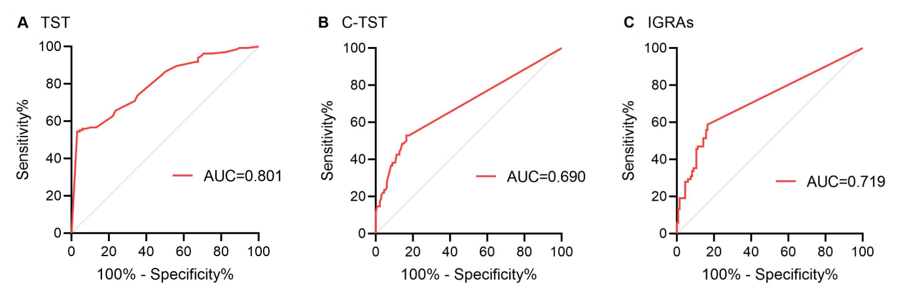
ROC curves are shown for the accuracy of (A) TST, (B) C-TST, and (C) IGRA for LTBI. The red line represents the ROC curve, and the area under the curve is shown in the lower right corner.

Table S7.1. AUC values and related parameters of various screening strategies
Screening tests | AUC | Q1 | Q2 | SE | Upper limit | Lower limit
TST | 0.801 | 0.668056714 | 0.71249417 | 0.035309872 | 0.870207348 | 0.731792652
C-TST | 0.69 | 0.526717557 | 0.563431953 | 0.04087018 | 0.770105553 | 0.609894447
IGRAs | 0.719 | 0.56128025 | 0.601467132 | 0.039768238 | 0.796945747 | 0.641054253
TST/C-TST | 0.821 | 0.696352841 | 0.740297639 | 0.033871473 | 0.887388088 | 0.754611912
TST/IGRAs | 0.813 | 0.684919966 | 0.72914396 | 0.034465719 | 0.88055281 | 0.74544719
Abbreviations: TST, tuberculin skin test; C-TST, recombinant Mycobacterium tuberculosis (MTB) fusion protein skin test; IGRAs, interferon-gamma release assays; BCG, Bacillus Calmette-Guerin; AUC, area under the curve; Q1, first quartile; Q2, second quartile; SE, standard error.
Appendix 8. Coordinates Of The ROC Curve For TST, C-TST, and IGRAs

Table S8.1. Coordinates Of The ROC Curve For TST

Positive when greater than or equal to this value | sensitivity | 1 - specificity | specificity | Yoden index
-1 | 1 | 1 | 0 | 0
1.75 | 0.971 | 0.47 | 0.53 | 0.501
4.25 | 0.971 | 0.455 | 0.545 | 0.516
6 | 0.956 | 0.455 | 0.545 | 0.501
7.5 | 0.956 | 0.448 | 0.552 | 0.508
8.5 | 0.941 | 0.448 | 0.552 | 0.493
9.25 | 0.941 | 0.44 | 0.56 | 0.501
9.75 | 0.926 | 0.44 | 0.56 | 0.486
10.25 | 0.897 | 0.433 | 0.567 | 0.464
10.75 | 0.868 | 0.433 | 0.567 | 0.435
11.25 | 0.779 | 0.373 | 0.627 | 0.406
11.75 | 0.765 | 0.343 | 0.657 | 0.422
12.25 | 0.662 | 0.291 | 0.709 | 0.371
12.75 | 0.647 | 0.261 | 0.739 | 0.386
13.25 | 0.515 | 0.149 | 0.851 | 0.366
13.75 | 0.5 | 0.134 | 0.866 | 0.366
14.5 | 0.441 | 0.104 | 0.896 | 0.337
15.25 | 0.338 | 0.082 | 0.918 | 0.256
15.75 | 0.324 | 0.082 | 0.918 | 0.242
16.25 | 0.324 | 0.06 | 0.94 | 0.264
16.75 | 0.309 | 0.052 | 0.948 | 0.257
17.25 | 0.294 | 0.037 | 0.963 | 0.257
17.75 | 0.25 | 0.037 | 0.963 | 0.213
18.25 | 0.176 | 0.03 | 0.97 | 0.146
18.75 | 0.118 | 0.015 | 0.985 | 0.103
19.25 | 0.103 | 0.007 | 0.993 | 0.096
19.75 | 0.059 | 0.007 | 0.993 | 0.052
21 | 0 | 0 | 1 | 0

Table S8.2. Coordinates Of The ROC Curve For C-TST
Positive when greater than or equal to this value | sensitivity | 1 - specificity | specificity | Yoden index
-1 | 1 | 1 | 0 | 0
1.75 | 0.529 | 0.179 | 0.821 | 0.35
3.75 | 0.529 | 0.172 | 0.828 | 0.357
5 | 0.529 | 0.164 | 0.836 | 0.365
7 | 0.5 | 0.164 | 0.836 | 0.336
8.75 | 0.485 | 0.149 | 0.851 | 0.336
10.75 | 0.485 | 0.142 | 0.858 | 0.343
12.25 | 0.456 | 0.134 | 0.866 | 0.322
12.75 | 0.441 | 0.127 | 0.873 | 0.314
13.5 | 0.426 | 0.127 | 0.873 | 0.299
14.5 | 0.426 | 0.112 | 0.888 | 0.314
15.25 | 0.382 | 0.104 | 0.896 | 0.278
16 | 0.382 | 0.097 | 0.903 | 0.285
17 | 0.382 | 0.09 | 0.91 | 0.292
17.75 | 0.368 | 0.09 | 0.91 | 0.278
19 | 0.368 | 0.082 | 0.918 | 0.286
20.25 | 0.279 | 0.06 | 0.94 | 0.219
20.75 | 0.265 | 0.06 | 0.94 | 0.205
21.5 | 0.25 | 0.06 | 0.94 | 0.19
22.25 | 0.235 | 0.052 | 0.948 | 0.183
22.75 | 0.235 | 0.045 | 0.955 | 0.19
23.25 | 0.221 | 0.045 | 0.955 | 0.176
24.25 | 0.221 | 0.037 | 0.963 | 0.184
25.75 | 0.206 | 0.03 | 0.97 | 0.176
26.75 | 0.191 | 0.03 | 0.97 | 0.161
27.25 | 0.176 | 0.022 | 0.978 | 0.154
28 | 0.162 | 0.022 | 0.978 | 0.14
28.75 | 0.147 | 0.022 | 0.978 | 0.125
29.25 | 0.147 | 0.015 | 0.985 | 0.132
29.75 | 0.147 | 0.007 | 0.993 | 0.14
31.25 | 0.118 | 0 | 1 | 0.118
33.75 | 0.103 | 0 | 1 | 0.103
42.5 | 0.074 | 0 | 1 | 0.074
50.5 | 0.059 | 0 | 1 | 0.059
55.5 | 0.044 | 0 | 1 | 0.044
68.25 | 0.029 | 0 | 1 | 0.029
83.25 | 0.015 | 0 | 1 | 0.015
91 | 0 | 0 | 1 | 0

Table S8.3. Coordinates Of The ROC Curve For IGRAs
Positive when greater than or equal to this value | sensitivity | 1 - specificity | specificity | Yoden index
-1 | 1 | 1 | 0 | 0
8 | 0.588 | 0.164 | 0.836 | 0.424
18.5 | 0.574 | 0.164 | 0.836 | 0.41
31.5 | 0.559 | 0.164 | 0.836 | 0.395
43.9 | 0.559 | 0.157 | 0.843 | 0.402
46.85 | 0.544 | 0.157 | 0.843 | 0.387
51.7 | 0.529 | 0.157 | 0.843 | 0.372
55.75 | 0.515 | 0.157 | 0.843 | 0.358
61.4 | 0.515 | 0.149 | 0.851 | 0.366
66.9 | 0.515 | 0.142 | 0.858 | 0.373
69.5 | 0.5 | 0.142 | 0.858 | 0.358
73.5 | 0.485 | 0.142 | 0.858 | 0.343
75.1 | 0.471 | 0.142 | 0.858 | 0.329
78.5 | 0.471 | 0.134 | 0.866 | 0.337
86.05 | 0.471 | 0.127 | 0.873 | 0.344
97.65 | 0.471 | 0.119 | 0.881 | 0.352
111.45 | 0.471 | 0.112 | 0.888 | 0.359
123.45 | 0.456 | 0.112 | 0.888 | 0.344
133.1 | 0.456 | 0.104 | 0.896 | 0.352
137.6 | 0.441 | 0.104 | 0.896 | 0.337
140 | 0.426 | 0.104 | 0.896 | 0.322
155.9 | 0.412 | 0.104 | 0.896 | 0.308
169.95 | 0.397 | 0.104 | 0.896 | 0.293
174.4 | 0.382 | 0.104 | 0.896 | 0.278
182.35 | 0.368 | 0.104 | 0.896 | 0.264
191.05 | 0.353 | 0.104 | 0.896 | 0.249
198.55 | 0.353 | 0.097 | 0.903 | 0.256
201.5 | 0.353 | 0.09 | 0.91 | 0.263
213.8 | 0.338 | 0.09 | 0.91 | 0.248
234.8 | 0.338 | 0.082 | 0.918 | 0.256
267 | 0.324 | 0.082 | 0.918 | 0.242
291 | 0.309 | 0.082 | 0.918 | 0.227
313.7 | 0.309 | 0.075 | 0.925 | 0.234
340 | 0.294 | 0.075 | 0.925 | 0.219
352.3 | 0.294 | 0.067 | 0.933 | 0.227
367.5 | 0.294 | 0.06 | 0.94 | 0.234
386.65 | 0.279 | 0.06 | 0.94 | 0.219
399.65 | 0.279 | 0.052 | 0.948 | 0.227
418.15 | 0.279 | 0.045 | 0.955 | 0.234
436.15 | 0.265 | 0.045 | 0.955 | 0.22
439 | 0.25 | 0.045 | 0.955 | 0.205
442.05 | 0.235 | 0.045 | 0.955 | 0.19
449.6 | 0.221 | 0.045 | 0.955 | 0.176
462.55 | 0.206 | 0.045 | 0.955 | 0.161
472.5 | 0.191 | 0.045 | 0.955 | 0.146
480.5 | 0.191 | 0.037 | 0.963 | 0.154
492.5 | 0.191 | 0.03 | 0.97 | 0.161
514.5 | 0.191 | 0.022 | 0.978 | 0.169
531 | 0.191 | 0.015 | 0.985 | 0.176
539.5 | 0.176 | 0.015 | 0.985 | 0.161
547 | 0.162 | 0.015 | 0.985 | 0.147
548.5 | 0.147 | 0.015 | 0.985 | 0.132
552.5 | 0.132 | 0.015 | 0.985 | 0.117
557.5 | 0.132 | 0.007 | 0.993 | 0.125
559.5 | 0.118 | 0.007 | 0.993 | 0.111
562 | 0.103 | 0.007 | 0.993 | 0.096
565 | 0.074 | 0.007 | 0.993 | 0.067
567 | 0.059 | 0.007 | 0.993 | 0.052
569 | 0.059 | 0 | 1 | 0.059
572.5 | 0.044 | 0 | 1 | 0.044
586 | 0.029 | 0 | 1 | 0.029
601 | 0.015 | 0 | 1 | 0.015
606 | 0 | 0 | 1 | 0

Appendix 9. Consistency Analysis

Table S9.1. Consistency Analysis Of Different Screening Programmes
Screening tests | McNemar test | Kappa Coefficient
C-TST vs TST | <0.001ª | 0.327
C-TST vs TST (BCG scar) | <0.001ª | 0.239
C-TST vs TST (no BCG scar) | 0.125 | 0.773
IGRAs vs TST | <0.001ª | 0.377
IGRAs vs TST (BCG scar) | <0.001ª | 0.287
IGRAs vs TST (no BCG scar) | 0.250 | 0.831
C-TST vs IGRAs | 0.388 | 0.858
C-TST vs IGRAs (BCG scar) | 0.508 | 0.865
C-TST vs IGRAs (no BCG scar) | 1.000 | 0.819
TST/C-TST vs TST/IGRAs | 0.227 | 0.869
ª denotes significance (P<0.001)
Abbreviations: TST, tuberculin skin test; C-TST, recombinant Mycobacterium tuberculosis (MTB) fusion protein skin test; IGRAs, interferon-gamma release assays; BCG, Bacillus Calmette-Guerin.
Table S9.2. Consistency Analysis Of TST And C-TST

 |  | C-TST |  | Total | PPA, No. (%)
 |  | - | + | Total | PPA, No. (%)
TST | - | 965 | 2 | 967
TST | + | 273 | 19 | 292 | 19/292 (6.5)
TST | ++ | 117 | 49 | 166 | 49/166 (29.5)
TST | +++ | 28 | 37 | 65 | 37/65 (57)
Total |  | 1383 | 107 | 1490
Abbreviations: TST, tuberculin skin test; C-TST, recombinant Mycobacterium tuberculosis (MTB) fusion protein skin test; PPA, positive concordance rate.
Appendix 10. Probability Distribution Of Population Markov Cohort Simulations

Figure S10.1. Probability Distribution Of Population Markov Cohort Simulations With PCF

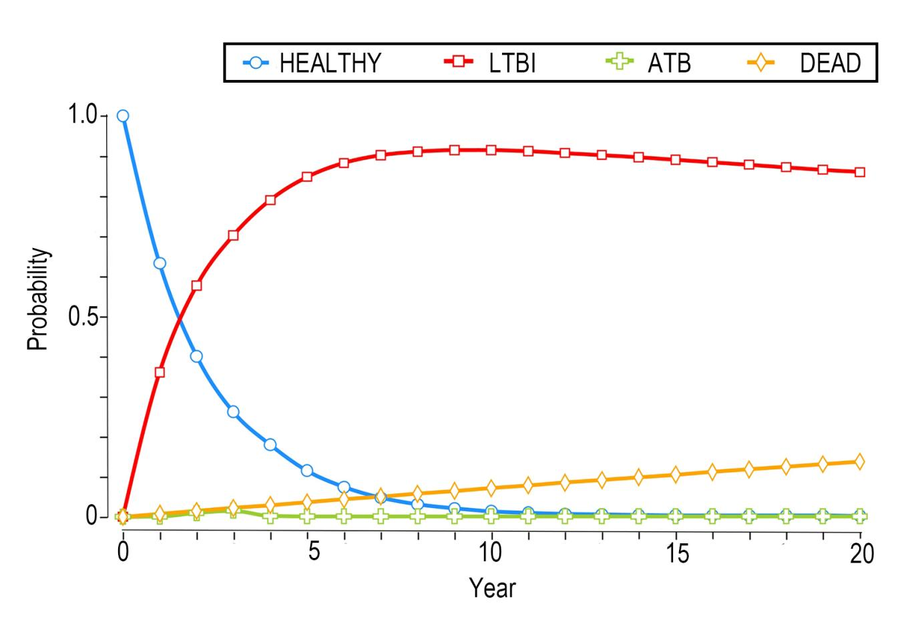

Markov Cohort was used to simulate the probability distribution of PCF for healthy people, LTBIs, ATBs, and the dead.
Figure S10.2. Probability Distribution Of Population Markov Cohort Simulations With TST, C-TST, And IGRAs

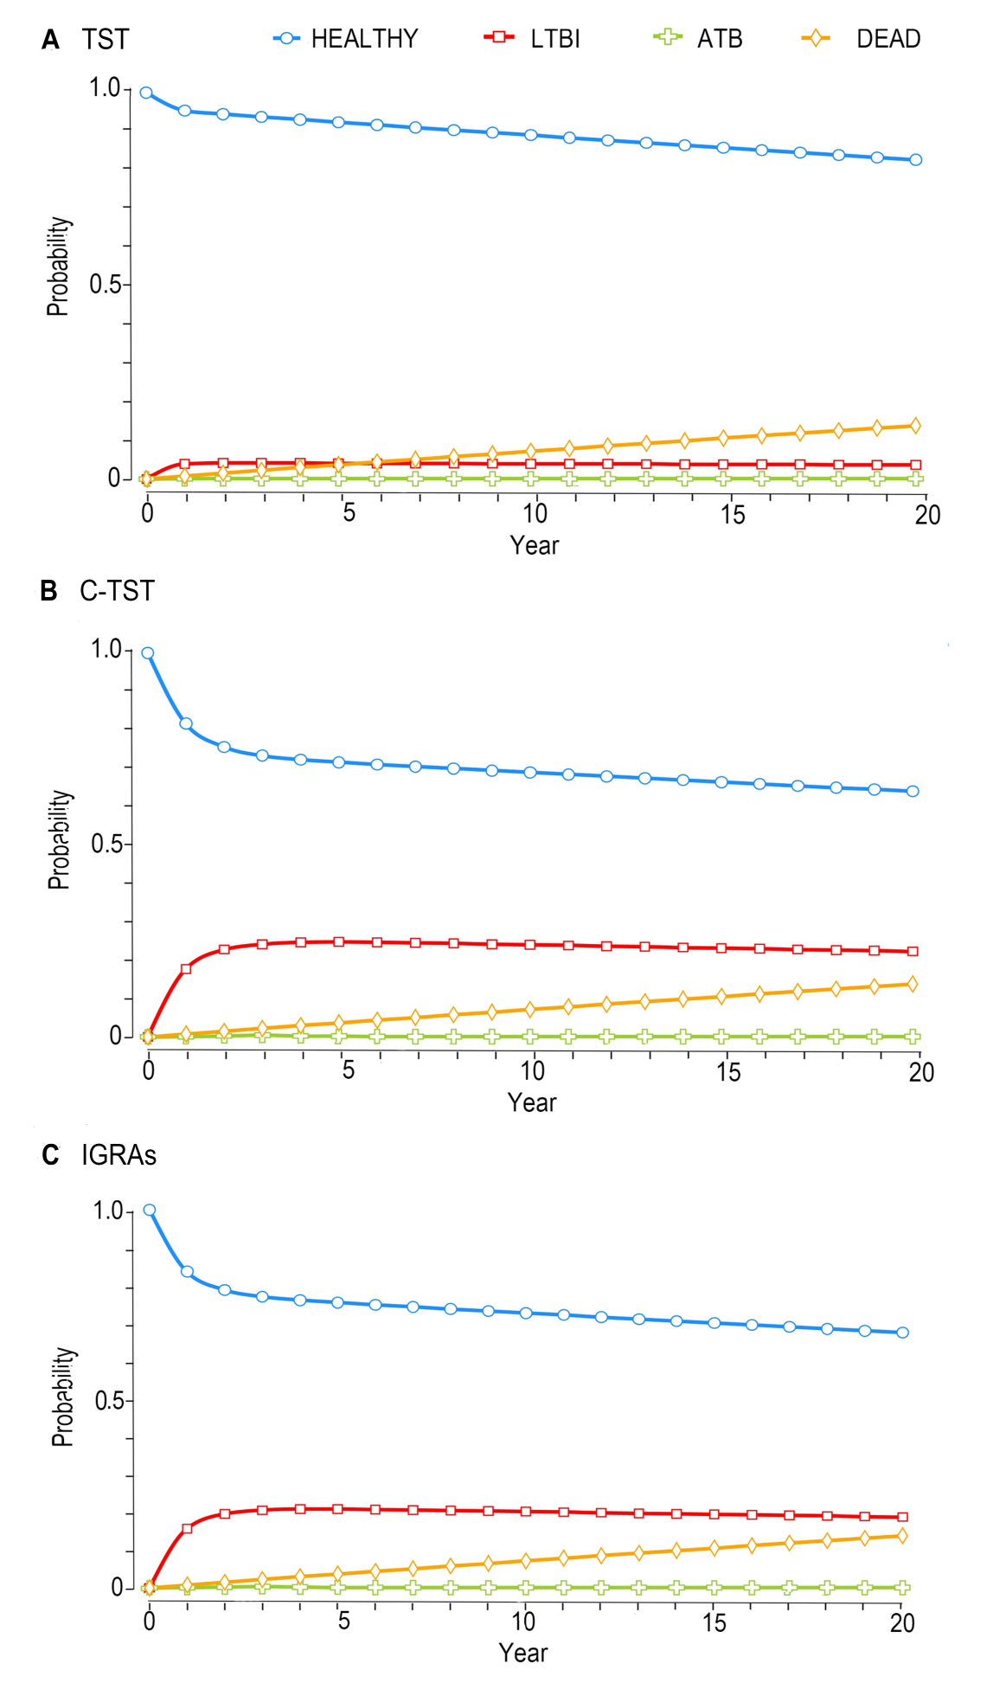
Markov Cohort was used to simulate the probability distribution of (A) TST, (B) C-TST, and (C) IGRAs for healthy people, LTBIs, ATBs, and the dead.

eReferences.
1. Yang Y, Fang Z, Huang W, Zhang H, Luo S, Lin S, et al. Safety of a Novel ESAT6-CFP10 skin test compared with tuberculin skin test in a double-blind, randomized, controlled study. BMC Infect Dis. 2022; 22(1): 780
2. Kittikraisak W, Kingkaew P, Teerawattananon Y, Yothasamut J, Natesuwan S, Manosuthi W, et al. Health related quality of life among patients with tuberculosis and HIV in Thailand. PLoS One. 2012; 7(1): e29775.
3. National Health and Family Planning Commission of the People's Republic of China. Diagnosis for pulmonary tuberculosis: WS 288-2017. Beijing: Standards Press of China. 2017.
4. Xu M, Lu W, Li T, Li J, Du W, Wu Q, et al. Sensitivity, specificity, and safety of a novel ESAT6-CFP10 skin test for tuberculosis infection in China: 2 randomized, self-controlled, parallel-group phase 2b trials. Clin Infect Dis. 2022; 74(4): 668-77.
5. Shedrawy J, Deogan C, Öhd JN, Hergens MP, Bruchfeld J, Jonsson J, et al. Cost-effectiveness of the latent tuberculosis screening program for migrants in Stockholm Region. Eur J Health Econ. 2021, 22(3): 445-54.
6. Du Y, He Y, Zhang H, Shen F, Guan L, Xin H, et al. Declining incidence rate of tuberculosis among close contacts in five years post-exposure: a systematic review and meta-analysis. BMC Infect Dis. 2023; 23(1): 373.
7. National Bureau of Statistics. Chinese Statistical Yearbook-2023. Beijing: China Statistics Press. 2023.
8. A Guide to Pharmacoeconomic Evaluation in China. Beijing: China Market Press. 2020.
9. Yoopetch P, Wu O, Jittikoon J, Thavorncharoensap M, Youngkong S, Praditsitthikorn N, et al. Economic evaluation of diagnosis and treatment for latent tuberculosis infection among contacts of pulmonary tuberculosis patients in Thailand. Sci Rep. 2024; 14(1): 17693.

