Supplementary Materials

Table S1. Characteristics of subjects with active tuberculosis (ATB), latent tuberculosis infection (LTBI), and healthy controls (HC)
Dataset | Group | Number of subjects | Females/Males | Mean age (range)
ScRNA-seq | ATB | 3 | 0/3 | 57.7 (45-68)
 | LTBI | 3 | 0/3 | 46.3 (31-56)
 | HC | 2 | 0/2 | 28 (26-30)
GSE19491 (discovery dataset) | ATB | 31 | 11/20 | 34.7 (18-78)
 | LTBI | 35 | 22/13 | 31.4 (18-68)
 | HC | 18 | 9/9 | 29.6 (21-43)
GSE19491 (validation dataset) | ATB | 30 | 11/19 | 38.8 (20-72)
 | LTBI | 34 | 18/16 | 26.5 (18-52)
 | HC | 18 | 13/5 | 31.5 (20-49)
GSE28623 (test dataset) | ATB | 46 | 21/25 | 30 (16-53)
 | LTBI | 25 | 15/10 | 29 (16-54)
 | HC | 37 | 21/16 | 30 (16-54)

Table S2. Annotated Markers in scRNA-Seq Data
Cell Type | Marker Genes
Monocyte | "CST3", "LYZ","CD14","CCL3","FCGR3A","VCAN",  "HLA-DPB1", "MS4A7","S100A12"
CD4+T cell | "CD3D","CD3E","CD40LG","IL7R"
CD8+T cell | "CD3D","CD3E","CD8A", "CD8B"
MAIT | "CD3D","CD3E","SLC4A10","ZBTB16","KLRB1"
NK cell | "NKG7","GNLY","TYROBP","PRF1"
B cell | "CD79A","CD79B","MS4A1","MZB1","XBP1"
DC | "CST3","LYZ","CLEC9A","CD1C","LILRA4","FCER1A",  "ITGAX","CLEC4C"
Proliferative cell | "MKI67","PCNA"
Platelet | "PPBP", "PF4"

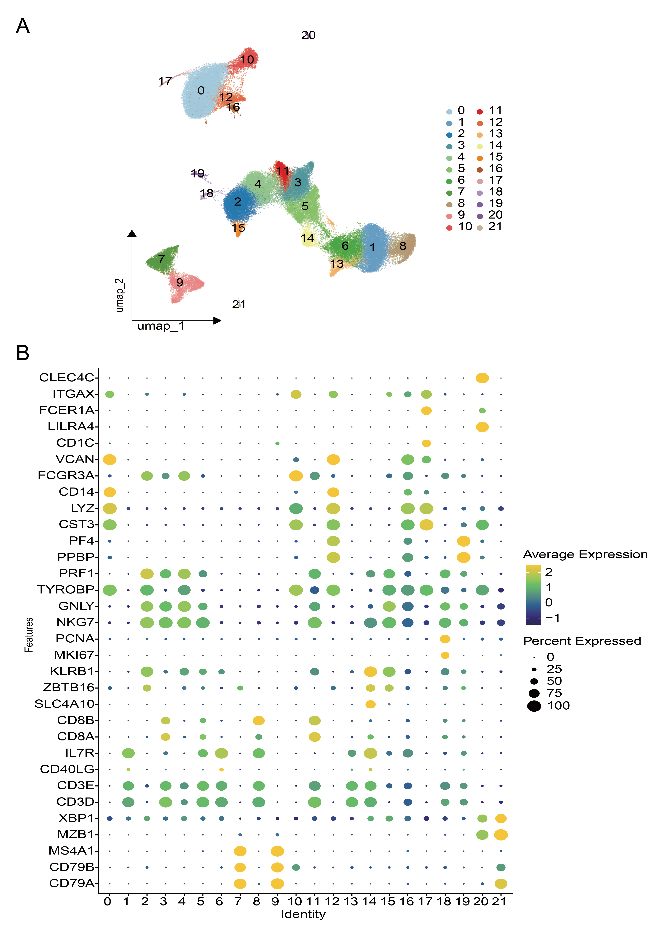
Figure S1. Single-cell transcriptomic profiling of PBMCs from patients with active tuberculosis (ATB), individuals with latent tuberculosis infection (LTBI), and healthy controls (HC).
A) Uniform Manifold Approximation and Projection (UMAP) visualization of dimensionality reduction clustering results, showing all cells partitioned into 21 distinct clusters. B) Bubble plot displaying the expression levels of canonical marker genes across the 21 cell clusters, with bubble size indicating the proportion of cells expressing the gene and color representing the average expression level.

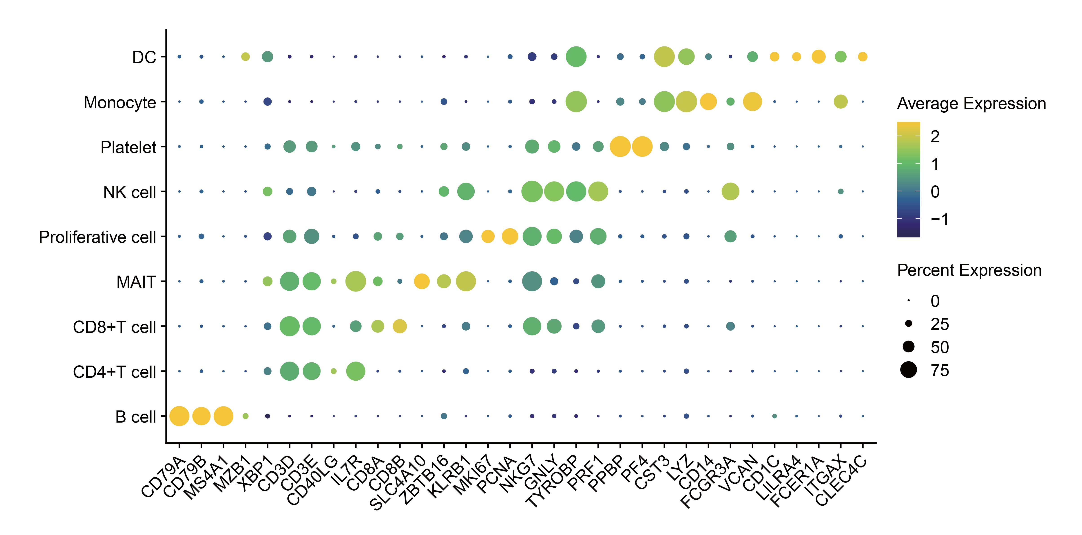
Figure S2. Bubble plot displaying the expression levels of canonical marker genes across the 9 celltype clusters

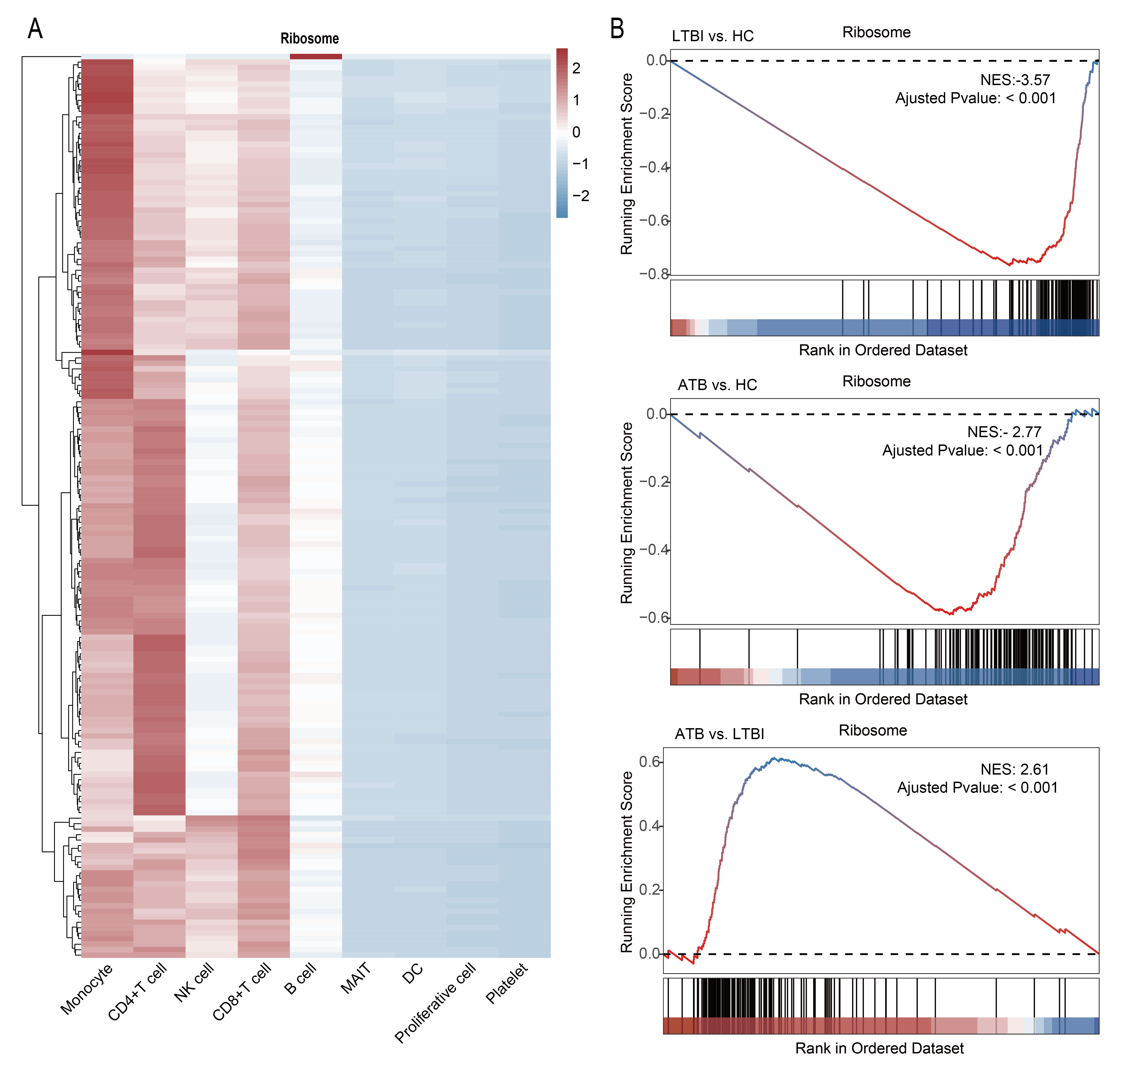
Figure S3. Single-cell transcriptomic profiling of PBMCs from patients with active tuberculosis (ATB), individuals with latent tuberculosis infection (LTBI), and healthy controls (HC).
A) Heatmap presenting the expression levels of genes enriched in the Ribosome signaling pathway across different cell clusters. Red indicates high expression, and blue indicates low expression. B) Gene Set Enrichment Analysis (GSEA) showing the functional enrichment patterns of the Ribosome signaling pathway in the comparisons of LTBI vs. HC, ATB vs. HC, and ATB vs. LTBI.

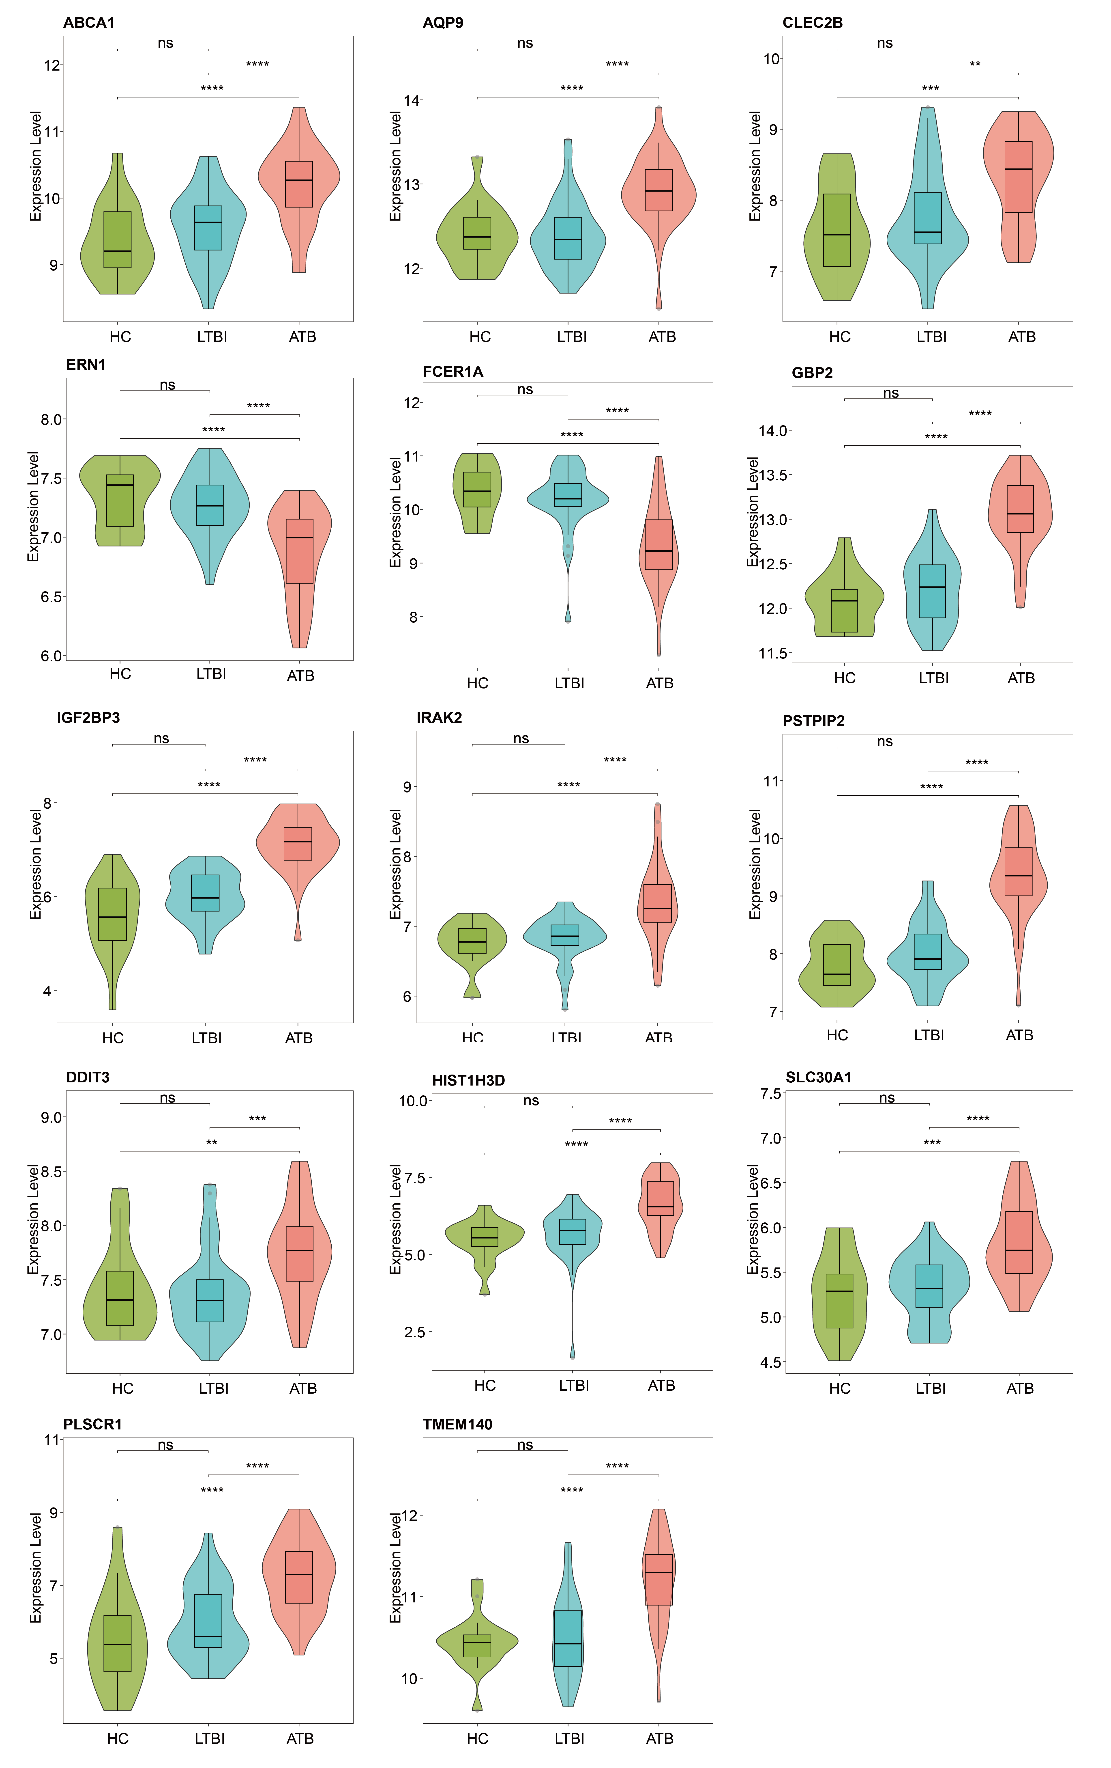
Figure S4. Expression levels of ABCA1, AQP9, CLEC4E, DDIT3, ERN1, FCER1A, GBP2, HIST1H3D, IGF2BP3, IRAK2, PLSCR1, PSTPIP2, SLC30A1, and TMEM140 genes in the discovery dataset, comparing patients with active tuberculosis (ATB), individuals with latent tuberculosis infection (LTBI), and healthy controls (HC).

