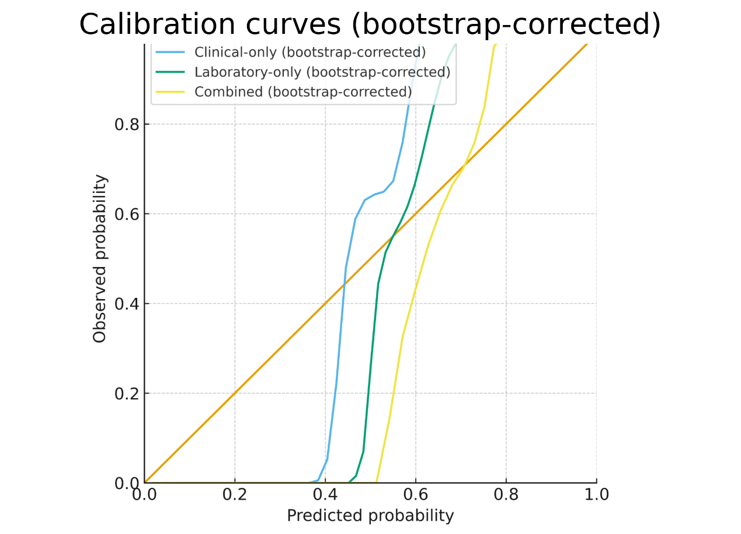

Additional file 6: Fig. S1. Calibration curves using LOWESS (locally weighted scatterplot smoothing) with bootstrap optimism correction for three multivariable logistic models (clinical-only, laboratory-only, and combined). For laboratory variables, LDH, CRP, and ALT were log-transformed, and albumin was sign-inverted (−albumin) as prespecified. Curves depict the bootstrap-corrected relationship between predicted probabilities and observed event rates; the 45° dashed line indicates perfect calibration. Model definitions align with clinical predictors in Tables 1–2 and laboratory variables in Table 3; single-predictor ROC characteristics are provided in Additional file 3: Table S3. (B = 1,000 bootstrap resamples; no missing data.)

