SUPPLEMENTARY MATERIAL

Appendix 1. Figure - Overall efficacy data in the ITT and PP analysis.
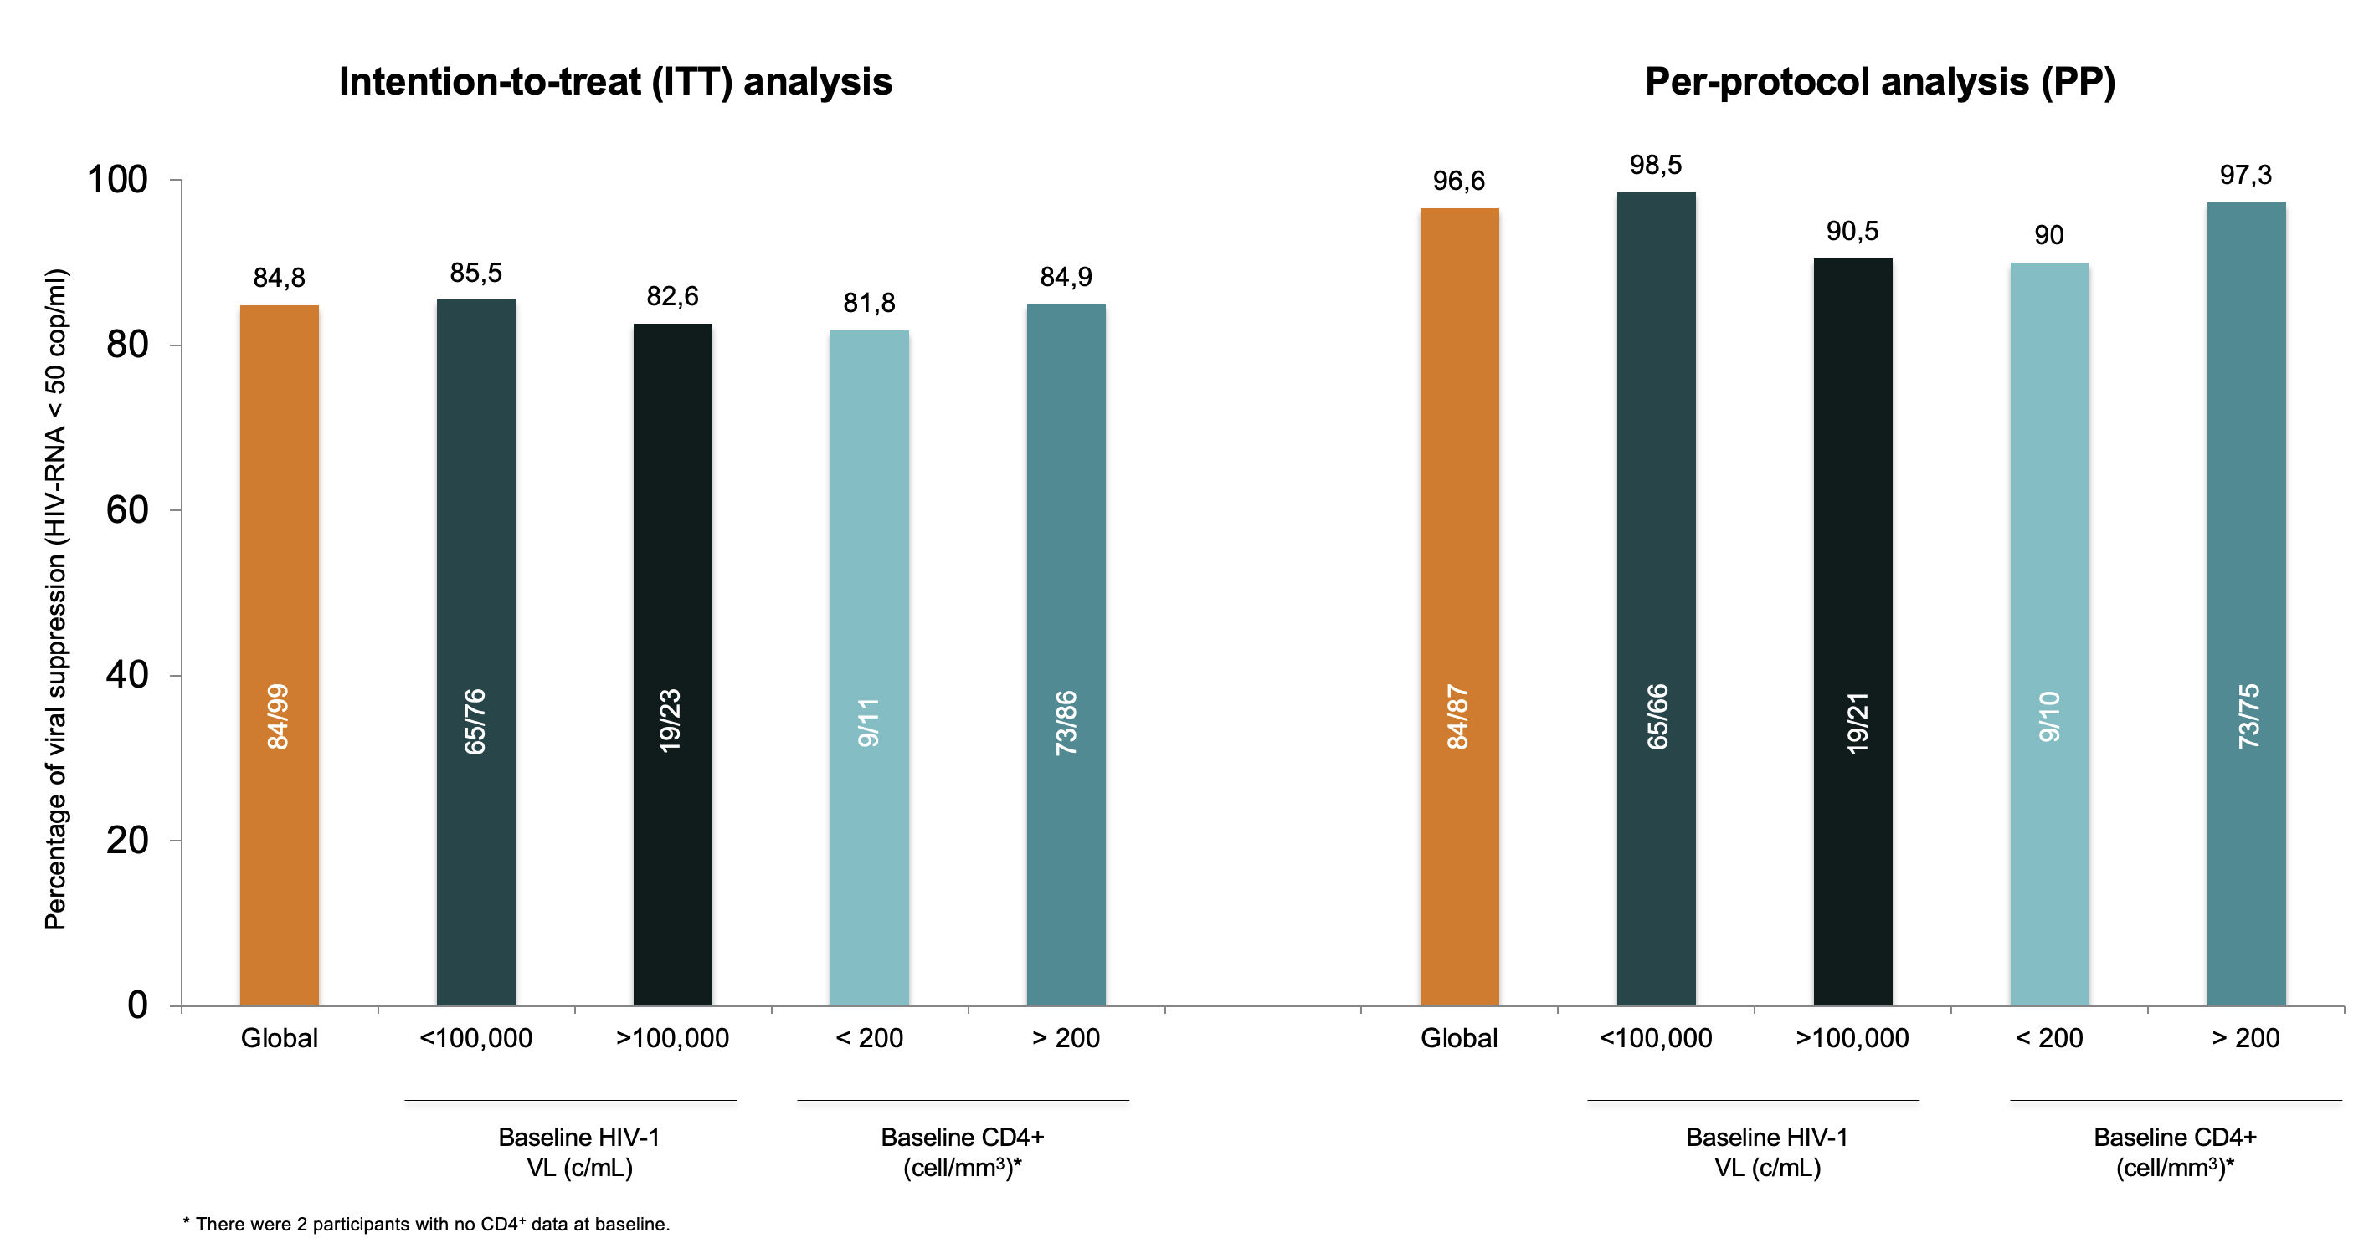
* There were 2 participants with no CD4⁺ data at baseline.

Appendix 2. Participants who did not achieve therapeutic success at 48 weeks.
PARTICIPANT (SUBJECT Nº) | BASAL  VL | WEEK 4  VL | WEEK 12  VL | WEEK 24  VL | WEEK 48  VL | REASON | GROUP
1 (030) | 38700 | No data | No data | No data | No data | LTFU | GROUP 1
2 (090) | 15900 | < 50 | 72 | -- | -- | Withdrawal of consent ¹ | GROUP 1
3 (021) | 15300 | < 50 | -- | -- | -- | Change of healthcare provider | GROUP 1
4 (072) | 36100 | 86 | < 50 | < 50 | No data | LTFU ² | GROUP 1
5 (012) | 14900 | < 50 | < 50 | < 50 | No data | Lack of data on W48 ³ | GROUP 1
6 (004) | 3190000 | 1350 | 100 | 90 | 85 ⁴ | VL > 50 copies/mL | GROUP 2
7 (015) | 1720000 | 1590 | 139 | 68 | 59 ⁵ | Confirmed Virological failure | GROUP 2
8 (066) | 56400 | 64 | < 50 | < 50 | 192 ⁶ | CVP > 50 copies/mL | GROUP 2
9 (049) | 65400 | < 50 | < 50 | No data | No data | LTFU | GROUP 2
10 (061) | 11200 | < 50 | < 50 | 904 | No data | LTFU | GROUP 2
11 (039) | 74100 | < 50 | No data | No data | No data | LTFU | GROUP 2
12 (059) | 171000 | 311 | No data | No data | No data | LTFU | GROUP 2
13 (050) | 20300 | < 50 | -- | -- | -- | Change of healthcare provider | GROUP 2
14 (050) | 4280 | < 50 | < 50 | -- | -- | Adverse event ⁷ | GROUP 2
15 (058) | 485000 | -- | -- | -- | -- | Per protocol ⁸ | GROUP 2

* LTFU = Lost to Follow-Up
¹ Voluntarily withdrew consent.

² There is no data available beyond week 24, and it's noted that the patient did not collect ART from the hospital pharmacy.

³ No data available at week 48, however, the participant has undetectable VL in subsequent follow-up.

⁴ Single determination with VL > 50 copies/mL and there is lack of further analysis beyond week 48. At the end of the study, the participant changed healthcare provider.

⁵ Post-week 48 analyses show VL with 92 copies/mL, and in subsequent follow-ups, maintains an undetectable VL < 50 copies/mL (specifically 37 and 42 copies/mL, respectively).

⁶ Single instance of VL > 50 copies/mL, but no further tests were performed after week 48. In the patient's clinical history, its recorded poor adherence to ART.

⁷ Changed ART due to peripheral vertigo-type dizziness (changed to DAR/c/TDF/TAF).

⁸ Per-protocol withdrawal. ART was modified to DTG+TDF/TFC following suspicion of pulmonary tuberculosis infection. Ultimately, the diagnosis was pulmonary histoplasmosis.

Appendix 3. Safety: adverse events during the study.

EVENT CATEGORY | Nº (%)
Sexually transmitted infections (STIs):  - Early syphilis  - Proctitis (NG and/or CT)  - Urethritis (NG and/or CT)  - HSV 1-2 genital ulcers  - Anal condylomasta  - Mpox | 17 (42.5)  7 (17.5)  3 (7.5)  3 (7.5)  2 (5)  1 (2.5)  1 (2.5)
Surgical events:  - Anal pathology (fistulas, fissures... etc.)  - Inguinal hernia  - Hiatal hernia  - Motor vehicle accident  - Pilonidal sinus  - Tooth extraction  - Forearm abscess | 9 (22.5)  3 (7.5)  1 (2.5)  1 (2.5)  1 (2.5)  1 (2.5)  1 (2.5)  1 (2.5)
Others:  - COVID-19  - Viral tonsillitis  - Viral conjunctivitis  - Left knee pain  - Facial cellulitis  - Vitamin D deficiency  - Erectile dysfunction  - Exercise-induced rhabdomyolysis  - Dizziness  - Latent TB infection  - Helminthiasis  - Pulmonary histoplasmosis  - Allergic skin rash  - Forunculosis  - Not specified | 19 (47.5)  3 (7.5)  2 (5)  1 (2.5)  1 (2.5)  1 (2.5)  1 (2.5)  1 (2.5)  1 (2.5)  1 (2.5)  1 (2.5)  1 (2.5)  1 (2.5)  1 (2.5)  1 (2.5)  2 (5)
Total | 40 (100)

The majority (89%) of the reported events were Grade 1 (mild). The rhabdomyolysis case, secondary to intense physical exercise, was considered also a serious adverse event (SAE). It required the participant's hospital admission for intravenous hydration and was not considered drug-related. One participant switched ART regimen and withdrew from the study per protocol due to initially suspected pulmonary tuberculosis, which was ultimately diagnosed as pulmonary histoplasmosis. All events, except the one described as dizziness, were considered unrelated to the treatment at the discretion of the investigators.

NG: Neisseria gonorrhoeae.
CT: Chlamydia trachomatis.
HSV: Herpes simplex virus type 1-2.
Mpox: Monkeypox virus.
COVID-19: Coronavirus Disease 2019 (SARS-CoV-2 virus infection).
TB: tuberculosis.

