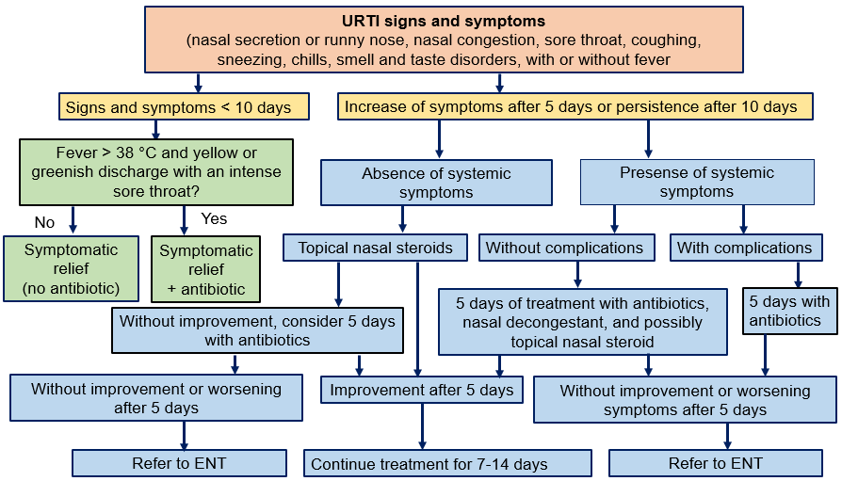
Supplementary file 1. Clinical Decision Support Algorithm for Management of URTIs

