Appendix A.
Search strategy
CNKI (n=18) |  | 2024/10/17
#1 | (主题: 尿路结石) OR (主题: 肾结石) OR (主题: 输尿管结石) OR (主题: 尿道结石) OR (主题: 肾脏结石) OR (主题: 尿系结石病) OR (主题: 腔镜碎石取石术) | 4,430,000
#2 | (主题: 尿路结石) OR (主题: 肾结石) OR (主题: 输尿管结石) OR (主题: 尿道结石) OR (主题: 肾脏结石) OR (主题: 尿系结石病) OR (主题: 腔镜碎石取石术) AND (主题: 尿毒血症) OR (主题: 感染性并发症)OR (主题: 尿源性脓毒血症) | 227
#3 | (主题: 尿路结石) OR (主题: 肾结石) OR (主题: 输尿管结石) OR (主题: 尿道结石) OR (主题: 肾脏结石) OR (主题: 尿系结石病) OR (主题: 腔镜碎石取石术) AND (主题: 尿毒血症) OR (主题: 感染性并发症)OR (主题: 尿源性脓毒血症) AND (主题: 风险预测模型) OR (主题: 预测因子) OR (主题: 模型) OR (主题: 风险评分) OR (主题: 预警评估) | 18
Wanfang (n=58) |  | 2024/10/17
 | 主题:(尿路结石 OR 肾结石 OR 输尿管结石 OR 泌尿道结石 OR 肾脏结石 OR 泌尿系结石病 OR 腔镜碎石取石术) and 主题:(尿脓毒血症 OR 感染性并发症 OR 尿源性脓毒血症) and 主题:(风险预测模型 OR 预测因子 OR 模型 OR 风险评分 OR 预警评估) | 58
PubMed (n=27) |  | 2024/10/17
#1 | (((Urinary Calculi[MeSH Terms]) OR (Kidney Calculi[MeSH Terms])) OR (Ureteral Calculi[MeSH Terms])) OR (Urolithiasis[MeSH Terms]) | 43,860
#2 | ((((((((Urinary Calculus[Title/Abstract]) OR (Urinary Stone[Title/Abstract])) OR (Urinary Tract Stone[Title/Abstract])) OR (Kidney Calculus[Title/Abstract])) OR (Kidney Stones[Title/Abstract])) OR (Renal Calculi[Title/Abstract])) OR (Renal Calculus[Title/Abstract])) OR (Nephrolith[Title/Abstract])) OR (Ureteral Calculus[Title/Abstract]) | 12,217
#3 | ((urosepsis[Title/Abstract]) OR (Infectious complication[Title/Abstract])) OR (urinary sepsis[Title/Abstract]) | 3,661
#4 | (((Risk prediction model[Title/Abstract]) OR (Predictor[Title/Abstract])) OR (Model[Title/Abstract])) OR (Risk Score[Title/Abstract]) | 3,211,948
#5 | (#1 OR #2 ) AND #3 AND #4 | 27
EMBASE (n=64) |  | 2024/10/16
#1 | urinary calculi' OR 'kidney calculi' OR 'ureteral calculi' OR 'urolithiasis' | 39,042
#2 | urinary calculus' OR 'urinary stone' OR 'urinary tract stone' OR 'kidney calculus' OR 'kidney stones' OR 'renal calculi' OR 'renal calculus' OR 'nephrolith' OR 'ureteral calculus' | 19,558
#3 | #1 OR #2 | 51,055
#4 | urosepsis' OR 'infectious complication' OR 'urinary sepsis' | 23,967
#5 | urosepsis' OR 'infectious complication' OR 'urinary sepsis' | 6,097,451
#6 | #3 AND #4 AND #5 | 64
Web of Science (n=385) |  | 2024/10/17
#1 | TS=(Urinary Calculi OR Kidney Calculi OR Ureteral Calculi OR Urolithiasis OR Urinary Calculus OR Urinary Stone OR Urinary Tract Stone OR Kidney Calculus OR Kidney Stones OR Renal Calculi OR Renal Calculus OR Nephrolith OR Ureteral Calculus) | 76,454
#2 | TS=(urosepsis OR Infectious complication OR urinary sepsis) | 210,273
#3 | TS=(Risk prediction model OR Predictor OR Model OR Risk Score) | 15149489
#4 | #1 AND #2 AND #3 | 385
Cochrane Library (n=16) |  | 2024/10/16
#1 | MeSH descriptor: [Urinary Calculi] explode all trees | 1,924
#2 | MeSH descriptor: [Kidney Calculi] explode all trees | 1,196
#3 | MeSH descriptor: [Ureteral Calculi] explode all trees | 604
#4 | MeSH descriptor: [Urolithiasis] explode all trees | 2,067
#5 | (Urinary Calculus OR Urinary Stone OR Urinary Tract Stone OR Kidney Calculus OR Kidney Stones OR Renal Calculi OR Renal Calculus OR Nephrolith OR Ureteral Calculus):ti,ab,kw | 4,438
#6 | (urosepsis OR Infectious complication OR urinary sepsis):ti,ab,kw | 7,044
#7 | (Risk prediction model OR Predictor OR Model OR Risk Score):ti,ab,kw | 260,563
#8 | (#1 or #2 or #3 or #4 or #5) AND #6 AND #7 | 16
EBSCO (n=5) |  | 2024/10/16
 | SU ( Urinary Calculi OR Kidney Calculi OR Ureteral Calculi OR Urolithiasis OR Urinary Calculus OR Urinary Stone OR Urinary Tract Stone OR Kidney Calculus OR Kidney Stones OR Renal Calculi OR Renal Calculus OR Nephrolith OR Ureteral Calculus) AND SU (urosepsis OR Infectious complication OR urinary sepsis ) AND SU ( Risk prediction model OR Predictor OR Model OR Risk Score ) | 5

Table S1 PROBAST results of the included studies.
Study (year) | ROB |  |  |  |  | Applicability |  |  |  | Overall
Study (year) | Participants | Predictors | Outcome | Analysis |  | Participants | Predictors | Outcome |  | ROB | Applicability
Wang et al. (2020) | H | H | L | H |  | L | L | L |  | H | L
Wang et al. (2024) | L | H | L | H |  | L | L | L |  | H | L
Hu et al. (2017） | H | H | H | H |  | L | L | L |  | H | L
Liu et al. (2018) | H | H | L | H |  | L | L | L |  | H | L
Cai et al. (2020) | H | H | L | H |  | L | L | L |  | H | L
Liu (2020) | H | H | L | H |  | L | L | L |  | H | L
Liu et al. (2021) | H | H | H | H |  | L | L | L |  | H | L
Pietropaolo (2021) | H | H | L | H |  | H | L | L |  | H | L
Tang et al. (2021) | H | H | L | H |  | L | L | L |  | H | L
Gu et al. (2022) | H | H | L | H |  | L | L | L |  | H | L
Luo et al. (2022) | H | H | L | H |  | L | L | L |  | H | L
Margolin et al. (2022) | H | H | L | H |  | L | L | L |  | H | L
Wang et al. (2022) | H | H | L | H |  | L | L | L |  | H | L
Yan et al. (2022) | H | H | L | H |  | L | L | L |  | H | L
Gou et al. (2023） | H | H | L | H |  | H | L | L |  | H | H
Hong et al. (2023) | H | H | L | H |  | L | L | L |  | H | L
Tan et al. (2023) | H | H | L | H |  | L | L | L |  | H | L
Wu (2023) | H | H | H | H |  | L | L | L |  | H | L
Zhong et al. (2023) | L | H | L | H |  | L | L | L |  | H | L
Qiu et al. (2024) | L | H | L | H |  | L | L | L |  | H | L
Shen et al. (2024) | H | H | L | H |  | L | L | L |  | H | L
Wang et al. (2024) | H | H | L | H |  | L | L | L |  | H | L
Xu et al. (2024) | L | H | L | H |  | L | L | L |  | H | L
Yuan et al. (2024) | H | H | L | H |  | L | L | L |  | H | L
Zhang et al. (2024) | H | H | L | H |  | L | L | L |  | H | L
ROB= risk of bias, H= high risk of bias; L= low risk of bias.
Subgroup analysis:
Fig S1. Forest plot of AUC of prediction models after subgroup analysis (Participants).
Fig S2. Forest plot of AUC of prediction models after subgroup analysis (Study design).

- AUC
Fig. S3. Sensitivity analysis

Fig. S4 Funnel plot

Note: If P> 0.1 and I² < 50%, heterogeneity was considered acceptable, and a fixed-effects model was applied. Conversely, if I² ≥ 50% or P ≤ 0.1, heterogeneity among the studies was considered significant, prompting the performance of sensitivity analyses.

- Urine culture
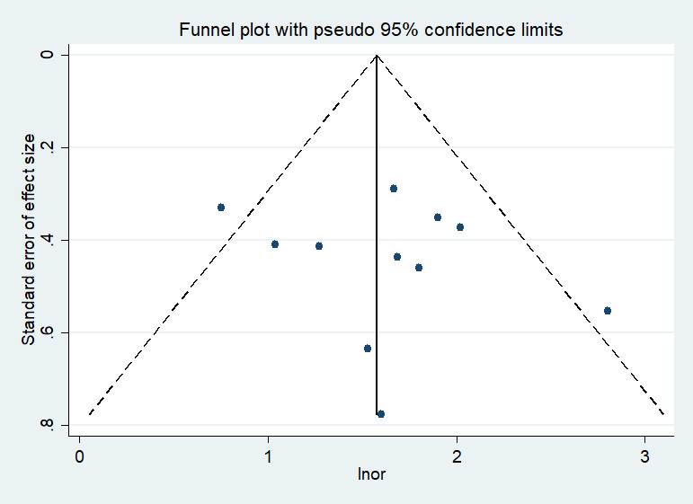

- Gender

- Urine nitrite

- Operation time

- Urine WBC
- Stone diameter

- Diabetes mellitus

- Age

- Staghorn stone

- White blood cell

- Degree of stone clearance

- Degree of hydronephrosis

- Neutrophil to lymphocyte ratio

- Temperature

- Mean CT value of hydronephrosis

- Number of stones

- Larger stone burden

- Increased irrigation rate

- Infectious calculi

- C-reactive protein

