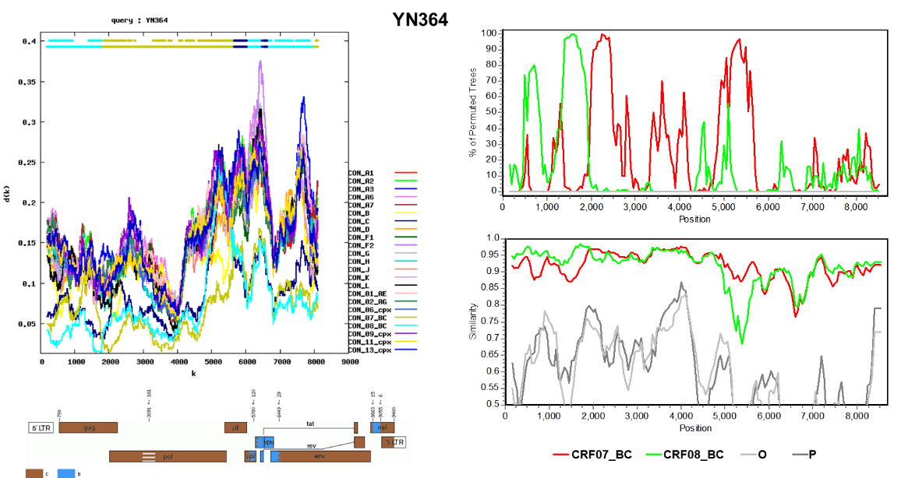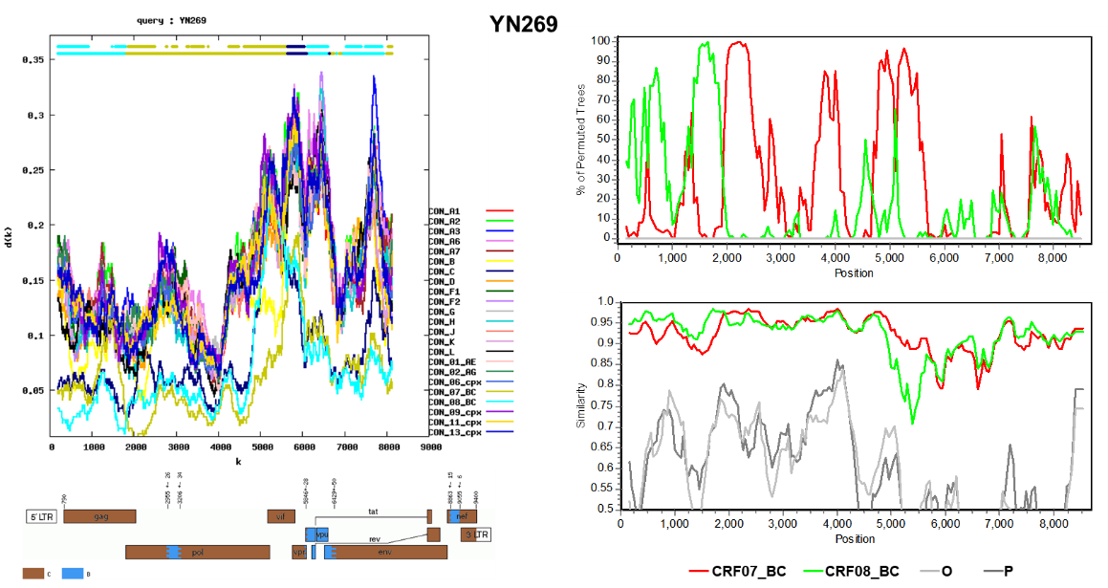
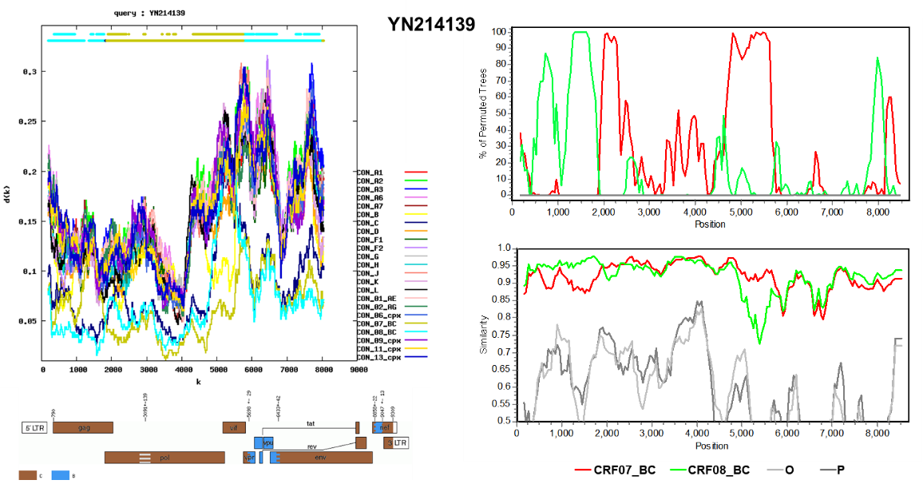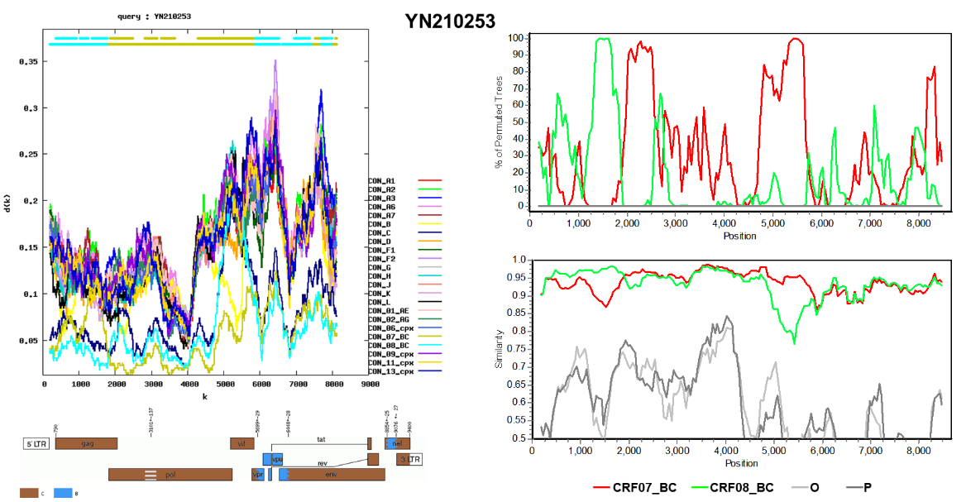
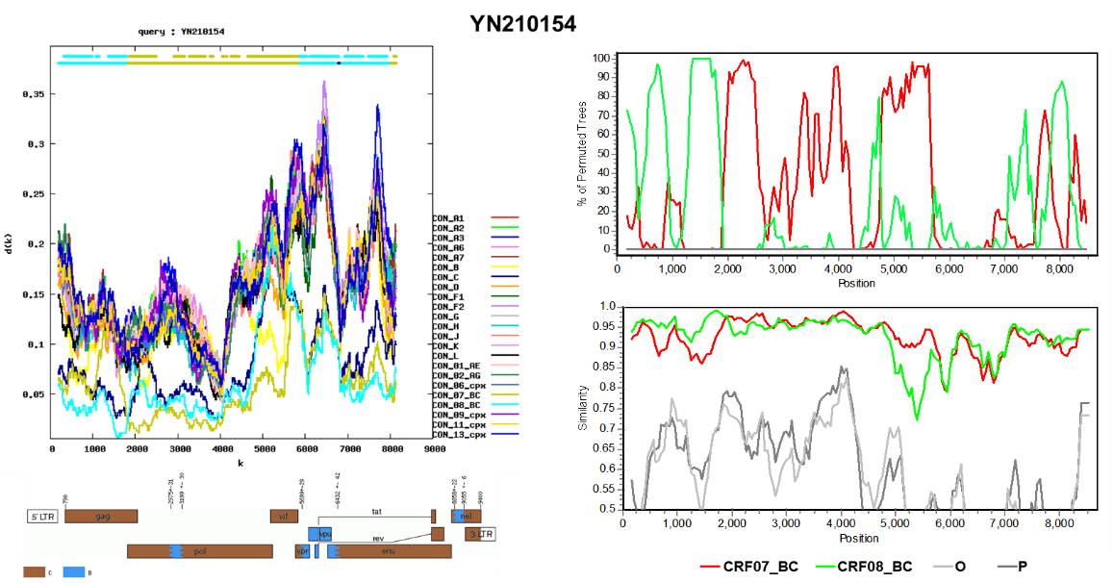
Fig. S1 Recombination analysis of five HIV-1 samples (YN364, YN269, YN24139, YN210253, YN210154). For each sample, four methods were used to detect and characterize recombination: RIP (Recombinant Identification Program), jpHMM (jumping profile Hidden Markov Model), Bootscanning, and SimPlot. The RIP results are shown in the first panel for each sample, plotting recombination scores across the genome. The second panel displays the most likely recombination breakpoints inferred by jpHMM. The third panel presents Bootscanning analysis under the Kimura 2-parameter model, with bootstrap support values on the y-axis. The fourth panel shows the SimPlot-derived mosaic genome structure. Reference sequences used for Bootscanning and SimPlot included representatives subtype CRF07_BC, the reference group consisted of JX392380, EF368372, EF368370, EF420986, JX392378, KF835494, KF835510, KF835532, KF250375, KF250377, OQ513528, OQ513533, OQ513538, OQ513481, OQ513489, OQ513595, and OQ513597; for CRF08_BC, the reference group included KF835493, KF835507, KF835497, KF835508, KF835534, KF835500, KF835501, KF835512, and AY008717. HIV-1 group O (KU168286) and group P (GU111555) were used as outgroups.

