Fig. S1: Replicate identification of plasma extracellular vesicle markers. Western blot analysis was performed on another set of samples, including total cell lysate, plasma, and the corresponding purified extracellular vesicles (EVs) derived from the plasma sample. The blot was probed for EV-positive markers (HSP70, Tsg101, and CD9) and the EV-negative marker, calnexin.
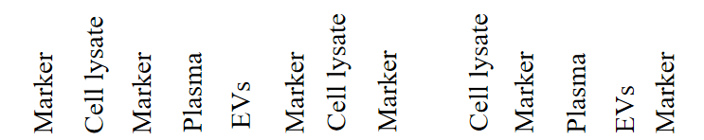
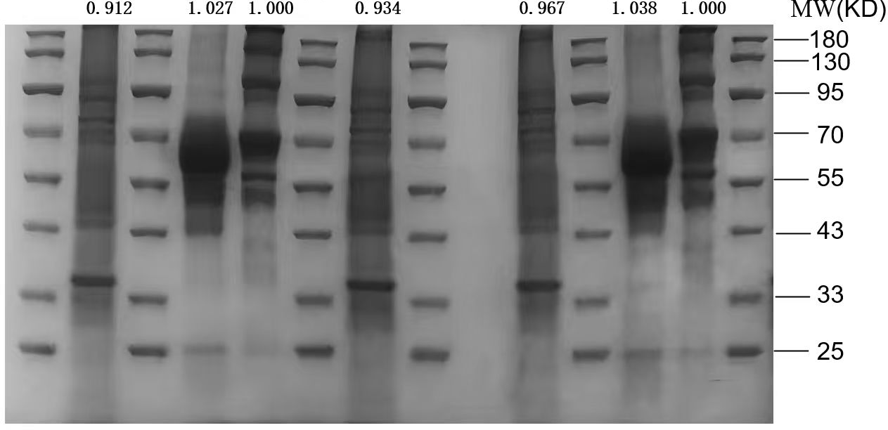
Figure 1B Figure S1
Fig. S2: Coomassie brilliant blue-stained images corresponding to the loading amount of each group in Figure 1B and Figure S1.

Fig. S3: The protein expression levels of WARS in plasma extracellular vesicles between other healthy controls and IM patients. Other samples were used to extract plasma extracellular vesicles and then evaluated the WARS proteins level by Western blotting. (C: healthy control; I: IM patient).

Fig. S4: The correlation analysis between EBV viral load and WARS levels in plasma EVs of IM patients. The scatter plot illustrates a positive correlation between the concentration of WARS in plasma EVs (measured by ELISA) and the EBV viral load in the plasma of IM patients. Due to the non-normal distribution of the data, statistical analysis was performed using Spearman's rank correlation analysis (r=0.4980, p=0.0044). The blue line represents the linear regression fit.

