Supplementary Table S1 Case definitions for herpes zoster and postherpetic neuralgia
Category | Definition | Diagnostic sources | Diagnostic references (ICD-10 codes and diagnostic terms)
Herpes Zoster | Identified using ICD-10 codes or diagnostic text | ICD-10 diagnosis fields; Western medicine and Traditional Chinese Medicine (TCM) diagnostic fields | ICD-10 codes: B02.0-B02.9;  Western diagnostic terms: names containing "带状疱疹" (herpes zoster) or "Ramsay-Hunt 综合征";  TCM diagnostic terms:"蛇串疮 (snake-clustered sores)", "蛇丹 (snake-related rash)" and "缠腰火丹 (fire-belt sore)"^{[1]}
Postherpetic Neuralgia | Identified within HZ patients whose diagnostic text explicitly indicates postherpetic neuralgia | Western medicine diagnosis fields | Diagnostic terms: names containing "带状疱疹后神经痛 (postherpetic neuralgia)" only; terms such as "带状疱疹性神经痛 (zoster-related neuralgia)" were not considered indicative of PHN; ICD-10 codes were not used because they cannot reliably distinguish acute from chronic neuralgia; therefore, text-based identification was applied

Supplementary Table S2 Estimated coverage correction factors (K-values) for the Jinan Regional Health Information Platform, 2018-2023
Year | Total patient visits  (person-times)^{[2, 3]} | Tertiary hospital visits^{[2, 3]} | Secondary hospital visits^{[2, 3]} | Community health center (CHC) visits^{[3]} | RHIP coverage (%)Tertiary / Secondary / CHC^{[4-10]} | Estimated K-value | Notes
2018 | 67312773 | 23260731 | 9828176 | — | 74.07 / 83.87 / — | 0.3784 | Very few CHCs were incorporated into RHIP
2019 | 71934198 | 25441064 | 11325519 | — | 81.48 / 90.32 / — | 0.4304 | Very few CHCs were incorporated into RHIP
2020 | 64527102 | 21811606 | 10148620 | — | 88.89 / 93.55 / — | 0.4476 | Very few CHCs were incorporated into RHIP
2021 | 71986758 | 27076164 | 10616179 | — | 81.48 / 93.55 / — | 0.4444 | Very few CHCs were incorporated into RHIP
2022 | 71367749 | 25485631 | 8346459 | 12929335 | 88.89 / 83.87 / 52.38 | 0.5104 | More than 50% of CHCs incorporated into RHIP
2023 | 90028826 | 29563572 | 9170723 | 19096758 | 88.89 / 87.10 / 57.45 | 0.5024 | More than 50% of CHCs incorporated into RHIP
Abbreviations: CHC, community health centers including community health service stations.

Supplementary Figure S1 Flowchart of patients selection for the cost analysis of HZ-related visits in Jinan Regional Health Information Platform (2018-2023)

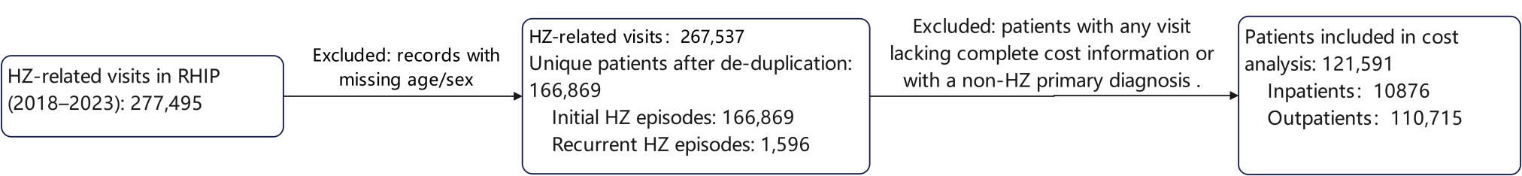

Supplementary Figure S2. Flowchart of PHN classification
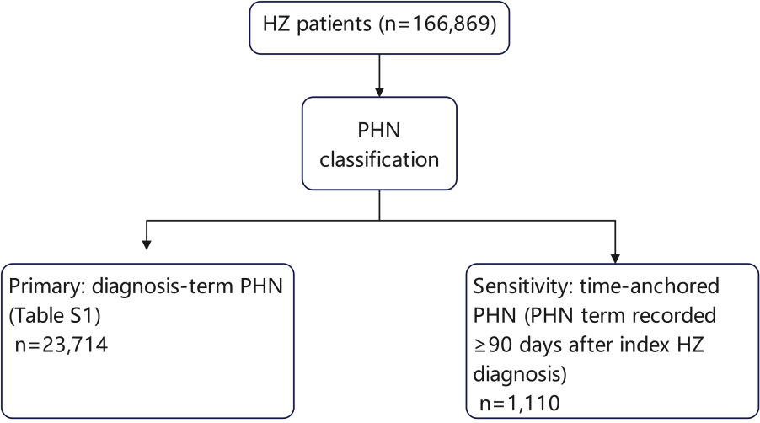

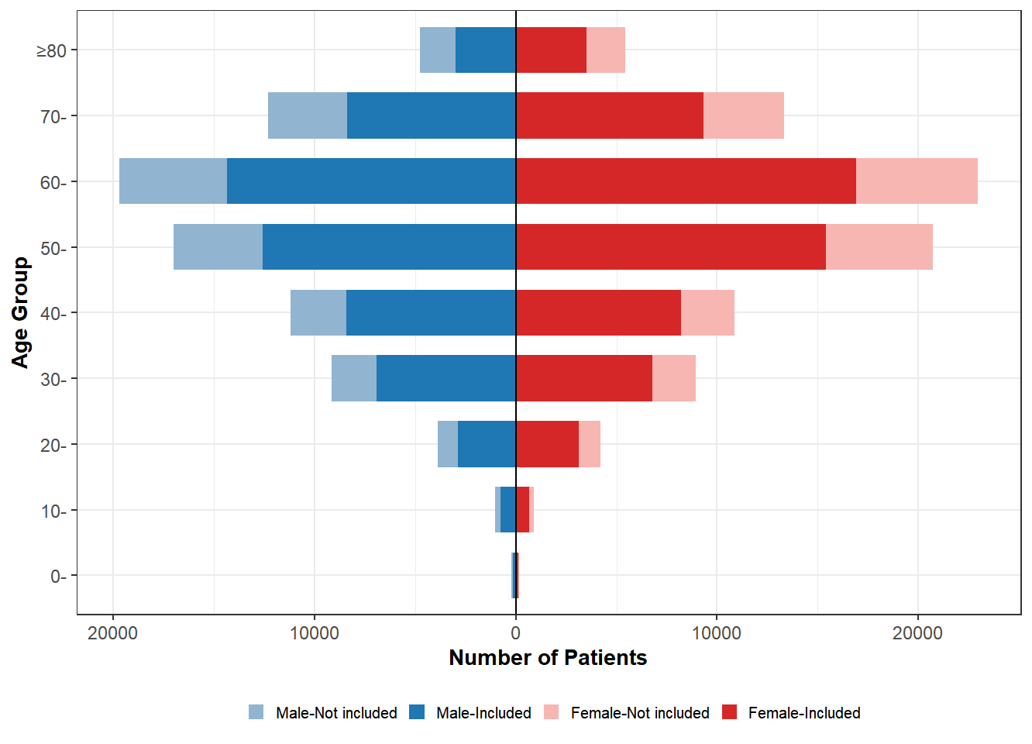
Supplementary Figure S3 Age and sex distribution of patients included and not included in cost analysis

Supplementary Table S3. Comparison between the full HZ cohort and the cost-analysis cohort
Characteristic | Cost-analysis cohort | Full cohort
Age, median (IQR), (years) | 58.0 (45.0-67.0) | 58.0 (46.0-68.0)
Sex, n (%)
Female | 64128 (52.7%) | 87580 (52.5%)
Male | 57463 (47.3%) | 79289 (47.5%)
Care setting, n (%)
Outpatient | 110715 (91.1%) | 144027 (86.3%)
Inpatient | 10876 (8.9%) | 22842 (13.7%)
PHN status, n (%)
No | 102353 (84.2%) | 143155 (85.8%)
Yes | 19238 (15.8%) | 23714 (14.2%)
Hospital level, n (%)
Primary hospital | 51348 (42.2%) | 57493 (34.5%)
Secondary or above | 70243 (57.8%) | 109376 (65.5%)
Total | 121591 | 166869

Supplementary Figure S4 Trends in age-specific incidences of herpes zoster and postherpetic neuralgia, 2018-2023 A) Age-specific coverage-adjusted incidence of HZ; B) Age-specific coverage-adjusted incidence of PHN
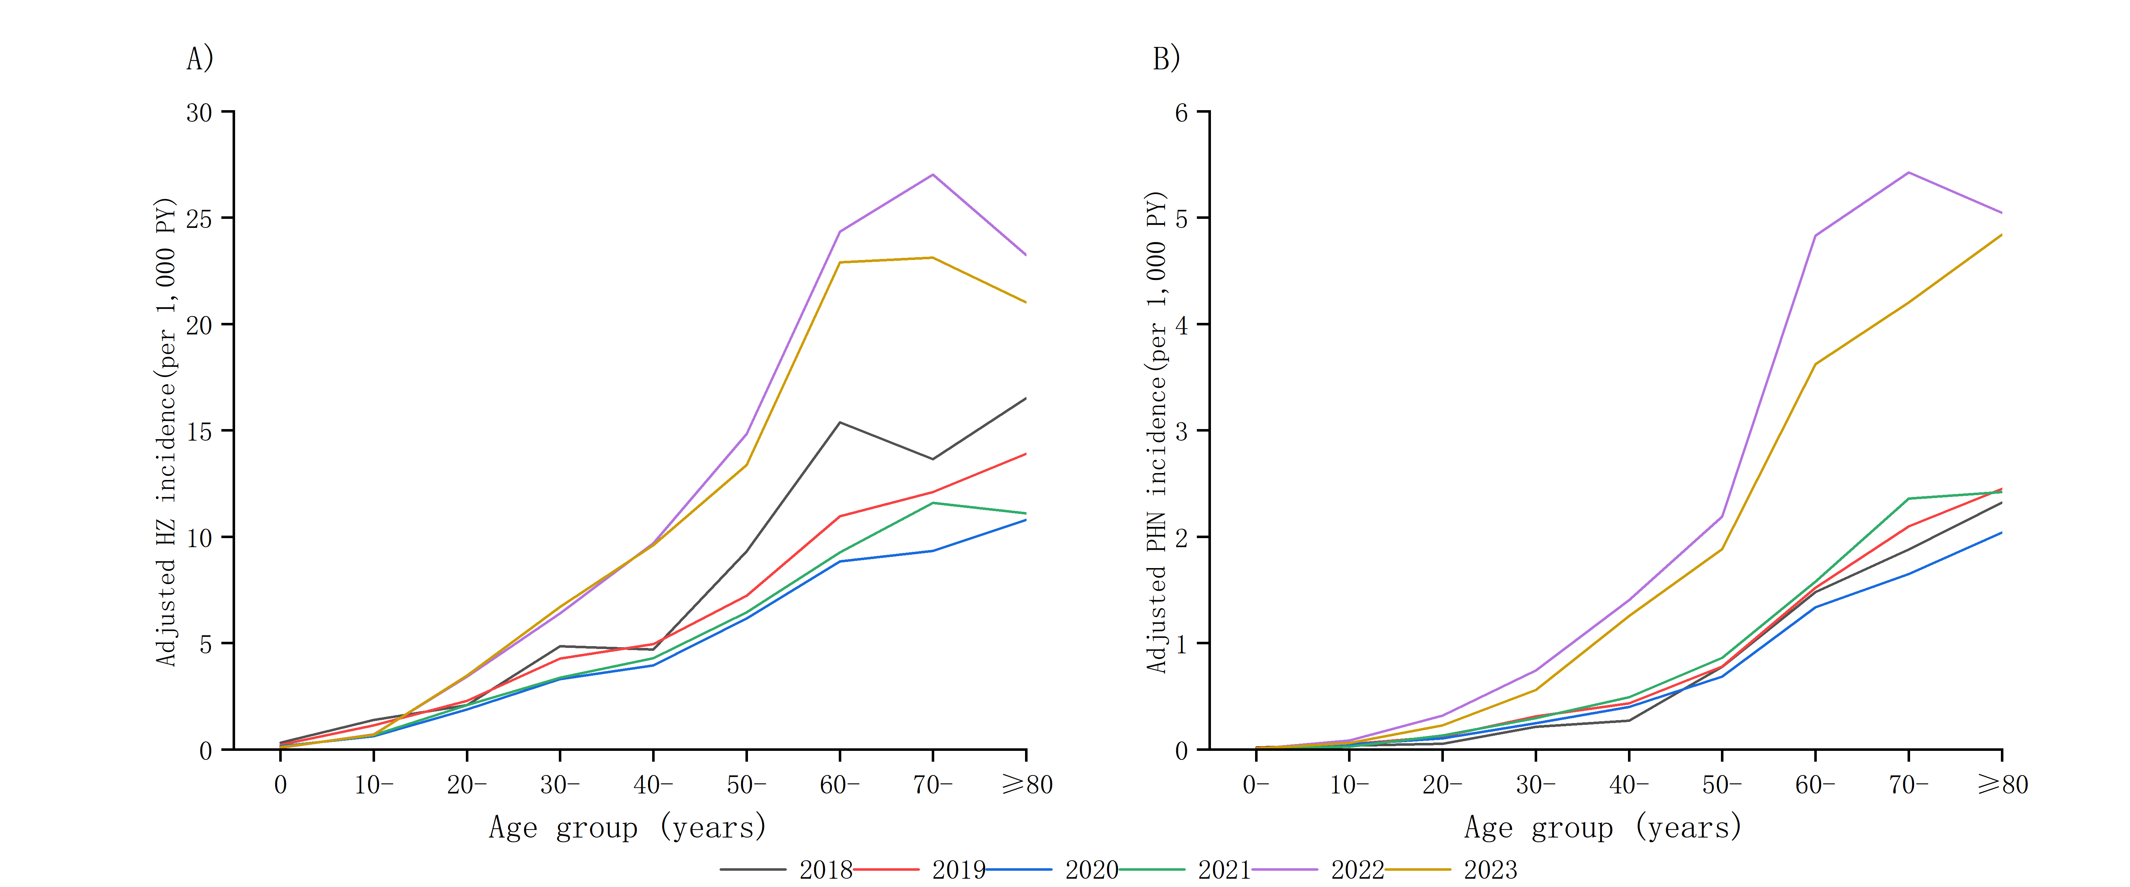

Supplementary Table S4. Incidence of PHN using a time-anchored definition (≥90 days after index herpes zoster diagnosis)
Group | PHN cases (n) | Unadjusted PHN incidence  (per1,000PY) | Coverage-adjusted PHN incidence  (per1,000PY) | RR (95% CI )
Agegroup
0- | 0 | 0.000 (0.000-0.000) | 0.000 (0.000-0.001) | Notestimable
10- | 2 | 0.000 (0.000-0.001) | 0.001 (0.000-0.002) | Reference
20- | 19 | 0.003 (0.002-0.004) | 0.006 (0.005-0.008) | 7.69 (2.83-20.89)
30- | 61 | 0.008 (0.006-0.010) | 0.018 (0.015-0.021) | 21.47 (8.15-56.56)
40- | 97 | 0.013 (0.010-0.015) | 0.028 (0.024-0.032) | 33.74 (12.86-88.52)
50- | 187 | 0.022 (0.019-0.026) | 0.050 (0.046-0.056) | 61.47 (23.54-160.54)
60- | 313 | 0.052 (0.047-0.058) | 0.118 (92.02-104.85) | 143.16 (54.92-373.18)
70- | 262 | 0.078 (0.069-0.088) | 0.174 (99.21-113.09) | 212.02 (81.29-553.01)
≥80 | 169 | 0.119 (0.102-0.139) | 0.270 (95.85-109.43) | 328.82 (125.84-859.21)
Sex
Male | 571 | 0.021 (0.020-0.023) | 0.047 (0.045-0.050) | Reference
Female | 539 | 0.021 (0.019-0.022) | 0.047 (0.044-0.050) | 0.99 (0.91-1.07)
Total | 1110 | 0.021 (0.020-0.022) | 0.047 (0.045-0.049)
Abbreviations: PHN in this table was defined as herpes zoster-related neuralgia recorded≥90 day safter the index herpes zoster diagnosis.

Supplementary Table S5. Per-episode direct medical costs of herpes zoster by PHN status (180-day washout)
 |  | Without PHN |  |  |  | With PHN
Group | N episodes | Mean±SD, CNY | Median (IQR), CNY |  | N episodes | Mean±SD, CNY | Median (IQR), CNY
Sex
Female | 54522 | 937.2±3761.9 | 140.5 (47.6-482.4) |  | 10035 | 1263.3±3514.2 | 225.4 (56.5-786.4)
Male | 48630 | 955.6±3439.2 | 148.9 (50.3-486.2) |  | 9203 | 1393.5±5126.5 | 237.5 (63.1-818.4)
Age group (years)
<40 | 19465 | 612.8±3541.7 | 152.2 (56.8-409.0) |  | 2064 | 713.4±1755.6 | 203.6 (63.2-545.0)
40- | 14518 | 709.6±1875.7 | 152.7 (53.0-453.0) |  | 2281 | 912.6±3876.4 | 213.9 (53.2-691.2)
50- | 23950 | 916.1±2800.8 | 142.9 (48.8-491.0) |  | 4268 | 1261.7±3886.7 | 235.3 (62.3-780.4)
60- | 25810 | 1076.9±4632.1 | 134.3 (44.7-499.8) |  | 5617 | 1503.1±5439.5 | 227.6 (54.1-860.9)
≥70 | 19409 | 1319.0±3956.3 | 144.8 (45.9-623.3) |  | 5008 | 1621.2±4305.1 | 258.6 (65.5-1022.8)
Hospitalization during episode
No | 94022 | 312.2±563.9 | 119.5 (43.1-336.6) |  | 17446 | 516.0±1056.5 | 184.1 (51.7-546.2)
Yes | 9130 | 7471.4±9875.7 | 6040.5 (3906.1-8794.8) |  | 1792 | 9207.2±11173.8 | 7459.5 (4951.7-10583.0)
Total | 103152 | 945.8±3613.4 | 144.5 (48.7-483.9) |  | 19238 | 1325.6±4360.9 | 230.6 (59.5-804.2)
Abbreviations: Episodes were defined using a 180-day washout interval, consistent with the recurrence definition. Per-episode costs were calculated as the sum of HZ-related direct medical costs across all encounters within each episode.

References:
- National Administration of Traditional Chinese Medicine. Classification and Codes of Diseases and Patterns of Traditional Chinese Medicine. https://std.samr.gov.cn/gb/search/gbDetailed?id=CE1E6A1DD54558F6E05397BE0A0A68DF. Accessed 3 November 2025.
- Jinan Municipal Health Commission. Statistical bulletin on the development of Jinan’s health sector (2020). http://jnmhc.jinan.gov.cn/art/2021/8/27/art_14372_4774036.html. Accessed 3 November 2025.
- Jinan Municipal Health Commission. Statistical bulletin on the development of Jinan’s health sector (2023). http://jnmhc.jinan.gov.cn/art/2024/8/8/art_14372_4816760.html. Accessed 3 November 2025.
- Shandong Provincial Health Commission. List of secondary and higher-level medical institutions in Shandong Province. http://wsjkw.shandong.gov.cn/wmfw/cxfw/202201/t20220129_3852032.html. Accessed 3 November 2025.
- Jinan Municipal Health Commission. Statistics on the number, beds, distribution, personnel, and equipment (over 10,000 RMB) of medical and health institutions in Jinan (2018). http://jnmhc.jinan.gov.cn/art/2019/5/20/art_14372_4764370.html. Accessed 3 November 2025.
- Jinan Municipal Health Commission. Statistics on the number, beds, distribution, personnel, and equipment (over 10,000 RMB) of medical and health institutions in Jinan (2019). http://jnmhc.jinan.gov.cn/art/2020/12/28/art_14372_4764368.html. Accessed 3 November 2025.
- Jinan Municipal Health Commission. Statistics on the number, beds, distribution, personnel, and equipment (over 10,000 RMB) of medical and health institutions in Jinan (2020). http://jnmhc.jinan.gov.cn/art/2021/11/7/art_14372_4776294.html. Accessed 3 November 2025.
- Jinan Municipal Health Commission. Statistics on the number, beds, personnel, and equipment (over 10,000 RMB) of medical and health institutions in Jinan (2021). http://jnmhc.jinan.gov.cn/art/2022/2/22/art_14372_4782777.html. Accessed 3 November 2025.
- Jinan Municipal Health Commission. Statistics on the number, beds, personnel, and equipment (over 10,000 RMB) of medical and health institutions in Jinan (2022). http://jnmhc.jinan.gov.cn/art/2023/11/1/art_14372_4814646.html. Accessed 3 November 2025.
- Jinan Municipal Health Commission. Statistics on the number, beds, personnel, and equipment (over 10,000 RMB) of medical and health institutions in Jinan (2023). http://jnmhc.jinan.gov.cn/art/2024/5/15/art_14372_4814667.html. Accessed 3 November 2025.

