Supplementary materials
Supplementary Figure S1. Flowchart of Patient Selection for Inclusion and Exclusion in the Study of Confirmed MRSA Bacteremia
Abbreviation: BSI, Bloodstream infection; MRSA, Methicillin-resistant Staphylococcus aureus.
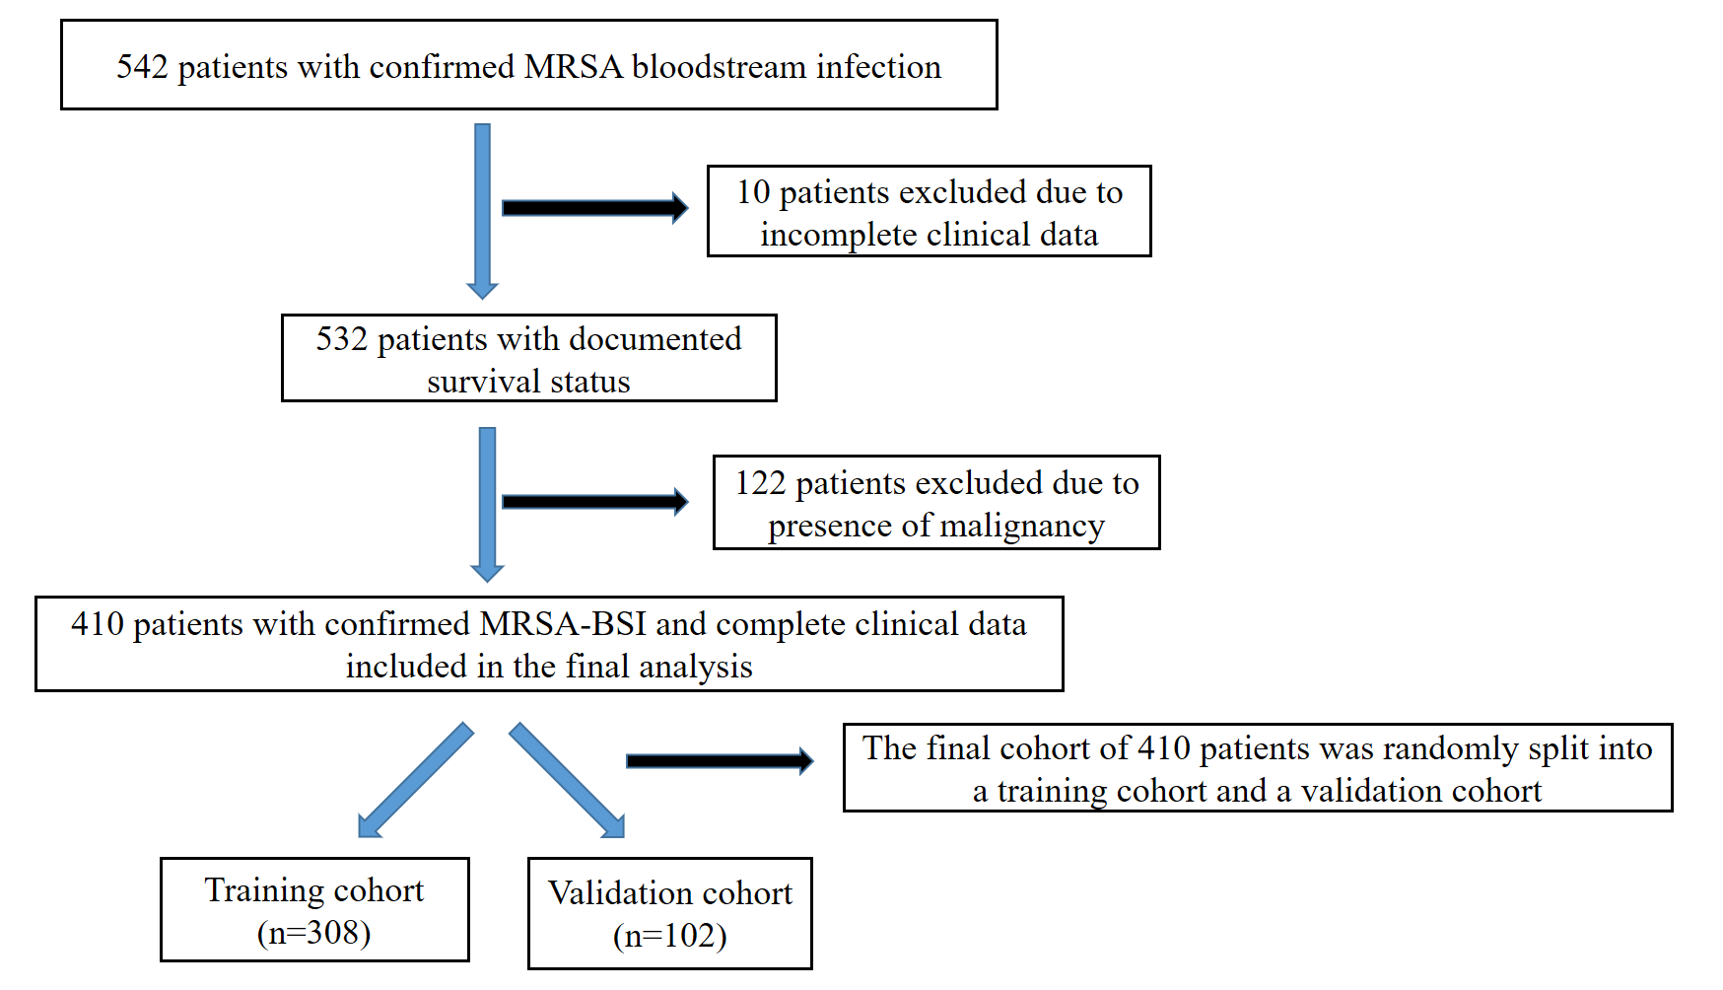
Supplementary Table S1. Comparison of Baseline Patient Characteristics Between Mortality and Non-Mortality Groups Among Patients With MRSA Bacteremia
 | Mortality  (n=91) | Non-Mortality (n=319) | p-value
Age, years | 78.01 ± 11.78 | 68.96 ± 17.11 | <0.001
Sex, male | 55 (60.4%) | 203 (63.6%) | 0.579
Body mass index, kg m⁻² | 21.10 ± 4.06 | 22.68 ± 5.25 | 0.009
Coexisting diseases
Hypertension | 58 (63.7%) | 199 (62.4%) | 0.814
Diabetes mellitus | 37 (40.7%) | 128 (40.1%) | 0.927
Cardiovascular disease | 57 (62.6%) | 205 (64.3%) | 0.776
Vital signs
Respiratory rate, breaths·min⁻¹ | 21.67 ± 10.50 | 19.40 ± 5.25 | 0.005
Systolic blood pressure, mm Hg | 119.24 ± 27.39 | 124.46 ± 25.13 | 0.088
Heart rate, bpm | 90.49 ± 29.26 | 88.79 ± 20.27 | 0.525
Body temperature, °C | 36.60 (36.10–37.00) | 36.70 (36.40–37.00) | 0.189
Pulmonary infection | 47 (51.6%) | 83 (26.0%) | <0.001
Urinary tract infection | 47 (51.6%) | 155 (48.6%) | 0.029
Laboratory blood testing
BAR | 24.74 (14.29–36.00) | 5.37 (3.75–12.86) | <0.001
Blood urea nitrogen, mg/dL | 51.50 (30.00–91.75) | 19.00 (13.00–40.00) | <0.001
Albumin, g/dL | 2.30 ± 0.66 | 3.12 ± 0.66 | <0.001
Red blood cell count, ×10⁶/µL | 3.36 ± 1.07 | 3.63 ± 0.89 | 0.012
White blood cell count, ×10³/µL | 14.27 ± 9.22 | 13.34 ± 6.31 | 0.267
Hemoglobin, g/dL | 9.83 ± 2.34 | 10.53 ± 2.49 | 0.017
International normalized ratio | 1.69 ± 0.93 | 1.32 ± 0.55 | <0.001
aPTT, seconds | 61.60 ± 55.24 | 46.57 ± 29.77 | 0.005*
C-reactive protein, mg/L | 15.10 ± 11.64 | 13.37 ± 11.42 | 0.239
Creatinine, mg/dL | 2.87 ± 2.35 | 2.33 ± 2.75 | 0.098
Troponin-I, ng/mL | 70.60 (22.30–174.83) | 27.40 (10.00–89.60) | 0.010
Creatine kinase-MB, ng/mL | 2.90 (1.30–7.70) | 2.54 (1.30–5.10) | 0.094
Lactate, mmol/L | 3.70 (1.90–9.30) | 1.74 (1.20–3.30) | <0.001
Total bilirubin, mg/dL | 0.80 (0.50–2.00) | 0.70 (0.40–1.10) | 0.001
Length of Hospital Stay, days | 11.00 (3.00–23.00) | 19.00 (10.00–32.00) | 0.001
Antibiotic therapy duration, days | 11.00 (3.00–23.00) | 18.00 (10.00–31.00) | 0.002
Abbreviations: aPTT, activated partial thromboplastin time; BAR, blood urea nitrogen-to-albumin ratio. Data are presented as mean ± standard deviation or median (interquartile range), as appropriate. Skewed continuous variables were compared using the Mann–Whitney U test, and categorical variables were compared using the chi-square test or Fisher’s exact test, as appropriate.

