Supplementary Material 1

Kwame Nkrumah University of Science and Technology, Kumasi
School Of Medical Sciences
Department Of Clinical Microbiology

Questionnaire

This questionnaire was designed by Allou Frederick, a postgraduate student (MPhil student) at the Department of Clinical Microbiology, Kwame Nkrumah University of Science and Technology (KNUST), Kumasi. He is undertaking a research study titled: “Sero-epidemiology of Hepatitis B and C Virus Infection among Pregnant Women in Sekondi-Takoradi Metropolis, Western Region of Ghana”. The questionnaire aims to gather information on participants’ knowledge levels in the Sekondi-Takoradi Metropolis regarding hepatitis B and C virus infections. Information provided will be treated with complete confidentiality. Participation by pregnant women is purely voluntary; refusal to participate in the study will not prevent them from enjoying hospital services.

Instructions: Kindly tick your answer or write in the space provided, where necessary. Do NOT write your name on this questionnaire.

Study ID: ………………….…………… Date of Interview: …………………...…………….

PART 1 – Demographic Information
1. Maternal Age: ≤18 19-24 25-30 31 – 40 >40 years
2. Gender: Male Female
3. Marital status: Single Married Divorced Widowed
4. Educational Status: None Basic JHS Secondary Tertiary

5. Employment Status: Formally employed Self-employed
Unemployed Other specify: ………………………
6. Religion: Christianity Muslim
Traditionalist Other specify: ……………………
7. Residence: Rural Peri-urban Urban

8. Gestational age: First trimester Second trimester Third trimester

9. Number of children? 0 1 2 3 4 5 Other specify: …………

PART 2 – KNOWLEDGE ON HEPATITIS B
10. Have you ever heard of Hepatitis B before? Yes No

11. If yes, where did you hear about it? (Tick as many as apply)
Media Health worker School
Friend Other(s): ……………………………………………

12. Hepatitis B is caused by: Microorganisms Evil spirits
Chemicals/drugs Foods Other specify: ……………

13. Which organ in the body does Hepatitis B attack? Brain Heart
Kidney Liver Blood Other specify: ……………………….

14. Can Hepatitis B kill someone? Yes No

15. Have you ever been tested for Hepatitis B before? Yes No

16. Can the hepatitis B virus be spread through sexual contact?
Yes No I don’t know

17. Can hepatitis B spread through skin exposure to the blood of an infected household member?
Yes No I don’t know

18. Can a person get the hepatitis B virus from a mosquito or other insect bites?
Yes No I don’t know
19. Can a person spread hepatitis B without symptoms?
Yes No I don’t know

20. Can hepatitis B be spread through eating in the same bowl with an infected person?
Yes No I don’t know

21. Can hepatitis B spread during childbirth?
Yes No I don’t know

22. Can hepatitis B be spread through blood transfusion?
Yes No I don’t know

23. Can hepatitis B be spread by kissing?
Yes No I don’t know

24. Can hepatitis B be spread by someone who looks healthy?
Yes No I don’t know

25. Is there a vaccine that can prevent hepatitis B?
Yes No I don’t know

26. If yes, have you ever received Hepatitis B vaccination? Yes No

27. If yes, how many doses or shots of the vaccine did you receive?
1 dose 2 doses
3 doses More than 3 doses

28. Can Hepatitis B affect any age group? Yes No
29. Please mention some of the signs or symptoms of Hepatitis B you know of. ………………………………………………………………………………………

PART 3 – KNOWLEDGE ON HEPATITIS C
30. Have you ever heard of Hepatitis C before? Yes No
31. If yes, where did you hear about it? (Tick as many as apply)
Media Health worker School
Friend Other(s) specify: …………………………………
32. Hepatitis C is caused by: Microorganisms Evil spirits
Chemicals/drugs Foods Other specify: …………

33. Which organ in the body does Hepatitis C attack? Brain Heart
Kidney Liver Blood Other specify: ……….

34. Can Hepatitis C kill someone? Yes No

35. Have you ever been tested for Hepatitis C before? Yes No

36. Can the hepatitis C virus be spread through sexual contact?
Yes No I don’t know

37. Can you get hepatitis C by getting a tattoo or piercing?
Yes No I don’t know

38. Can hepatitis C be spread through skin exposure to the blood of an infected household member?
Yes No I don’t know

39. Can a person get the hepatitis C virus from a mosquito or other insect bites?
Yes No I don’t know

40. Can a person spread hepatitis C without symptoms?
Yes No I don’t know

41. Can hepatitis C be spread through eating in the same bowl with an infected person?
Yes No I don’t know

42. Can hepatitis C spread during childbirth?
Yes No I don’t know

43. Can hepatitis C be spread through blood transfusion?
Yes No I don’t know

44. Can hepatitis C be spread by kissing?
Yes No I don’t know

45. Can hepatitis C be spread by someone who looks healthy?
Yes No I don’t know

46. Is there a vaccine that can prevent hepatitis C?
Yes No I don’t know

47. If yes, have you ever received Hepatitis C vaccination? Yes No

48. If yes, how many doses or shots of the vaccine did you receive?
1 dose 2 doses
3 doses More than 3 doses

49. Can Hepatitis C affect any age group? Yes No

50. Please mention some of the signs or symptoms of Hepatitis C you know of. …………………………………………………………………………………

PART 4 – RISK AND CONFOUNDING FACTORS ASSESSMENT
51. How many sex partners have you had?
1 partner 2 partners 3-5 partners
  - partners More than 10 partners

52. Did/Do you use condoms during intercourse with them?
Yes No Sometime Never
53. Which of the following do you associate with?
Alcohol Smoking Narcotics

54. If yes, how often?
Very Often Somehow often
Occasionally Rarely

55. Do you share blades/ sharps with friends or family at home when you trim your nails?
Yes No Sometimes

56. Have you been diagnosed with any liver problems before?
Yes No I don’t know

57. Have you received a blood product while on admission at the hospital before? Yes No

58. Do you have a tribal mark/piercing/ tattoo on your body? Yes No

59. Do you have any history of STIs? Yes No

60. Do you have a history of any of the following? Tick the most appropriate
Caesarean section Ear/Nose piercing Tattooing on body Dental procedure Abortion Surgical procedure History of Contact with jaundiced Patient/Liver disease

THANK YOU FOR YOUR TIME AND COOPERATION

Supplementary Material 2

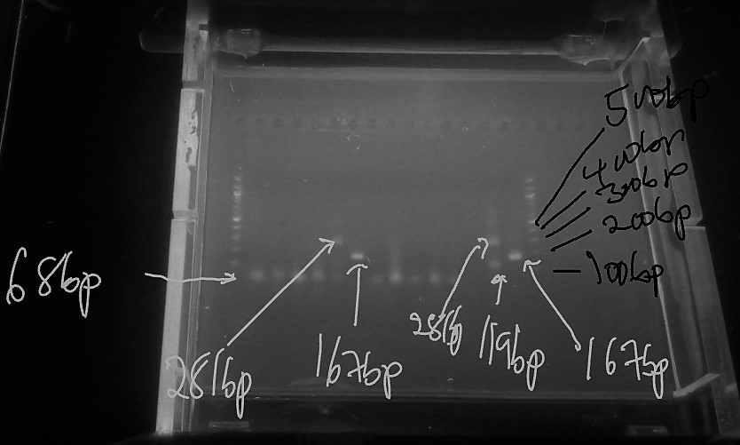

Supplementary figure: 2% agarose gel analysis of final PCR products for the detection of HBV genotypes,100bp molecular base marker. Type A- 68bp, Type B-281bp, Type C- 122bp, Type D-119bp, Type E-167bp, Type F-97bp

