Supplemental appendix: Length of stay for RSV disease according to season of study, among infants <6months

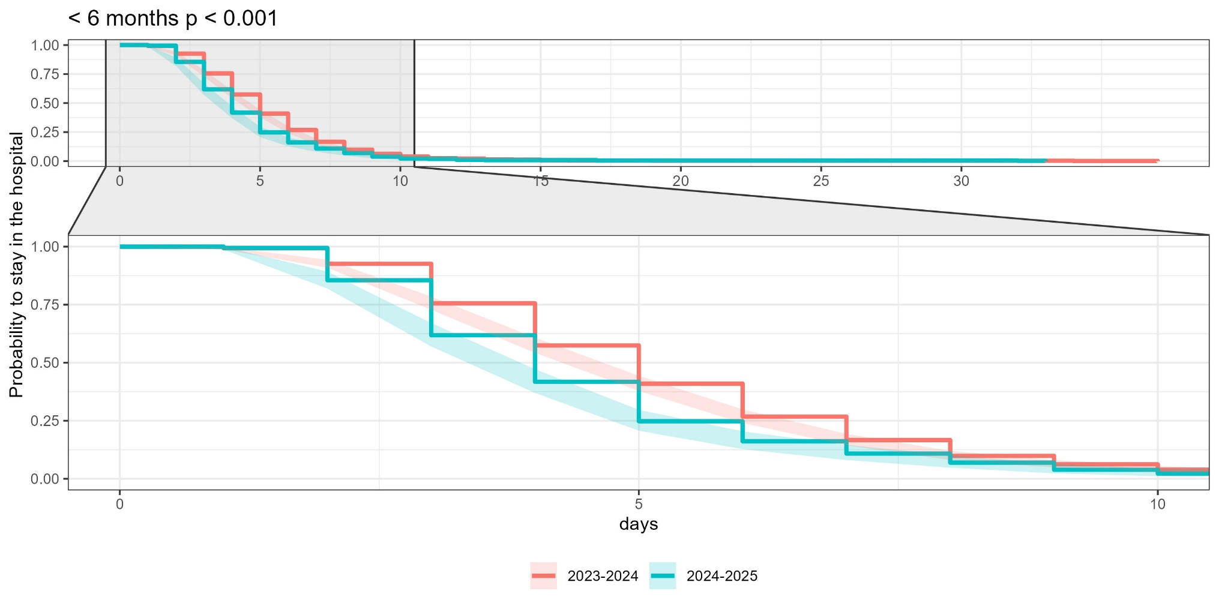

Legend: Kaplan-Meier plot, suggesting shorter length of stay in 2024-2025 than in 2023-2024 (a curve lying below another one indicates that events, here discharges, are occurring sooner). The log-rank test performed to assess differences between LOS distributions of the 2 seasons was significant, highlighting a potential seasonal effect on hospitalization duration.

