Supplementary Figures
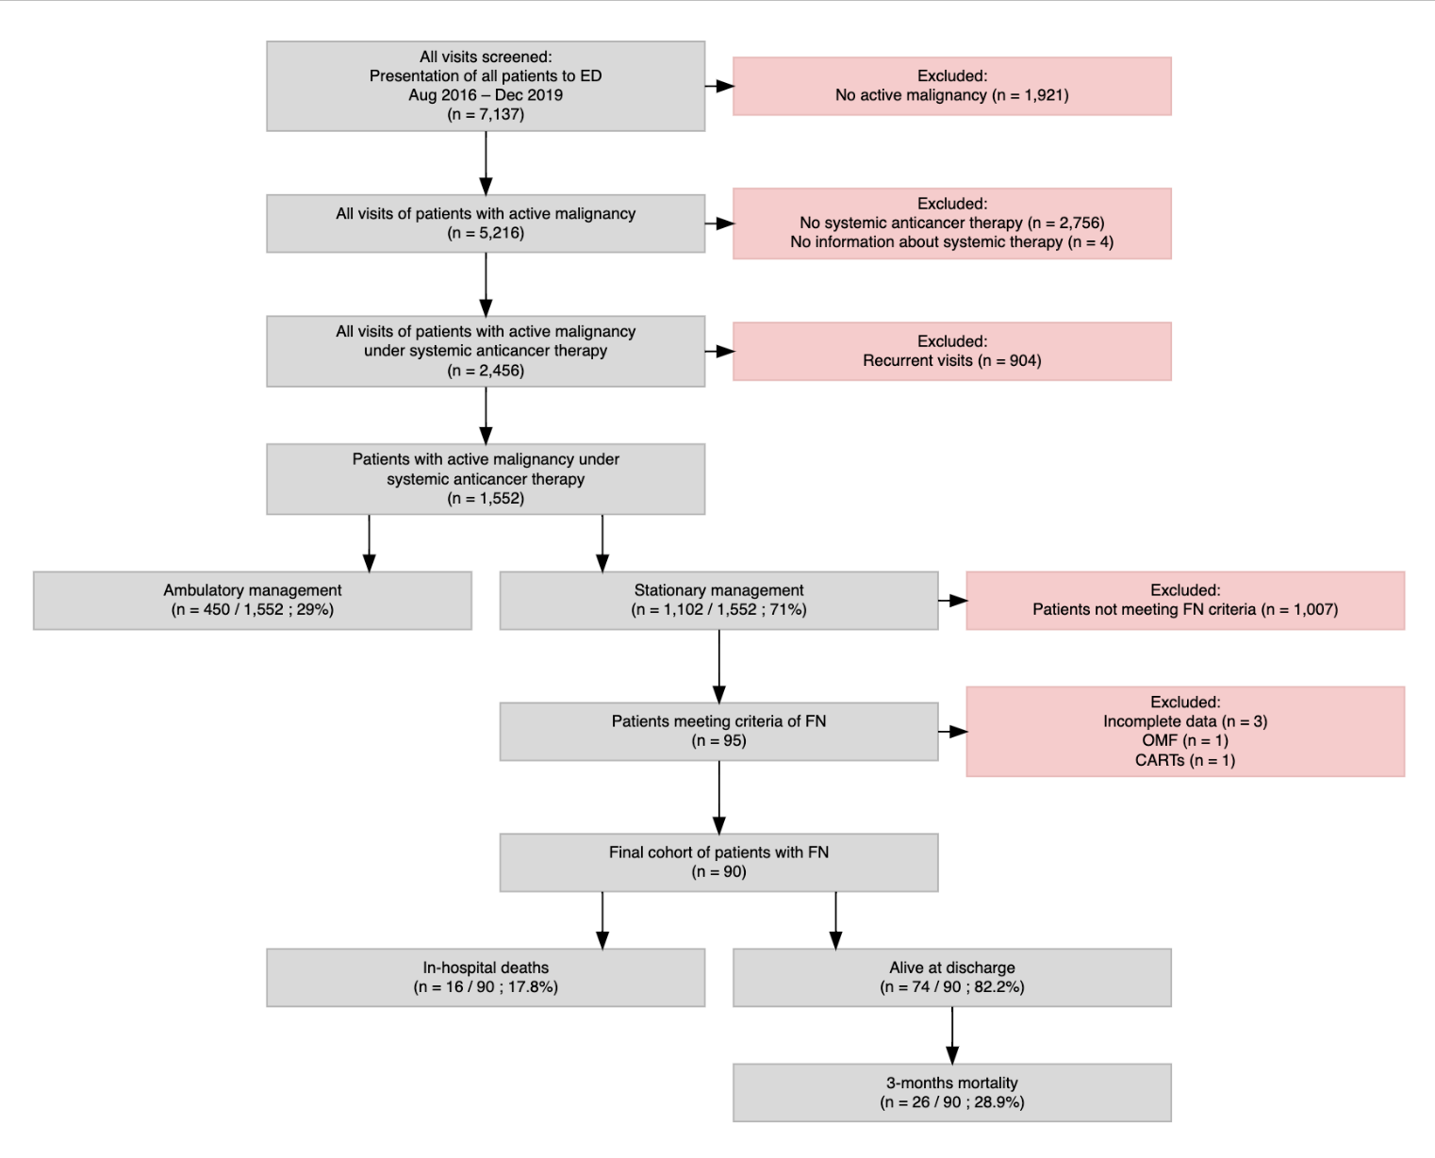
Supplementary Figure 1. Flowchart of patient selection for the febrile neutropenia (FN) cohort. Between August 2016 and December 2019, all oncology patients presenting to the emergency department (ED) were screened for febrile neutropenia. Of these, 95 patients fulfilled the diagnostic criteria for FN. After exclusion of cases with incomplete data (n=3), one case of osteomyelofibrosis (OMF), and one case treated with chimeric antigen receptor T-cells (CARTs), 90 patients were included in the final analysis. Among them, 16 (17.8%) patients died during hospitalization, and 26 (28.9%) had died within three months after admission.
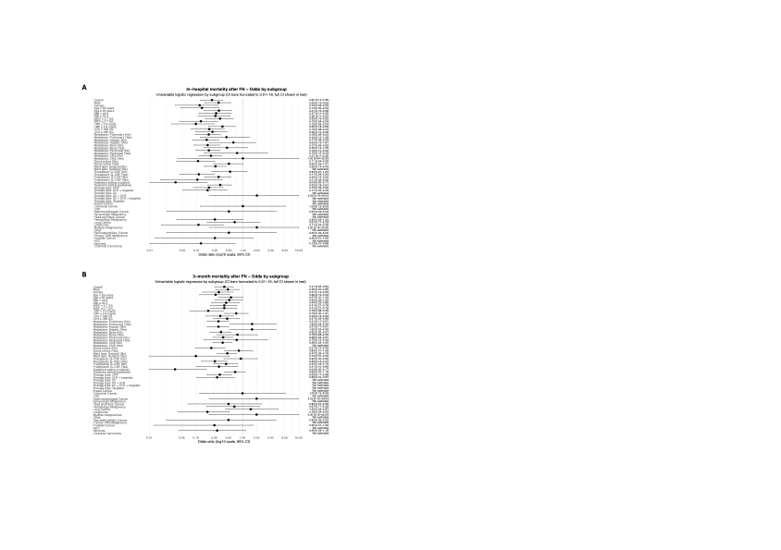
Supplementary Figure 2. Univariable subgroup analyses of mortality after febrile neutropenia. (A) In-hospital mortality; (B) 3-month mortality. Each point represents the estimated odds of death within the respective subgroup based on single-variable logistic regression models. Odds ratios (ORs) with 95 % confidence intervals (CIs) are displayed on a log10 scale. CIs were truncated at 0.01 and 16.0 for visual clarity. Subgroups with few or no events were not estimable due to limited sample size or complete separation of outcomes.
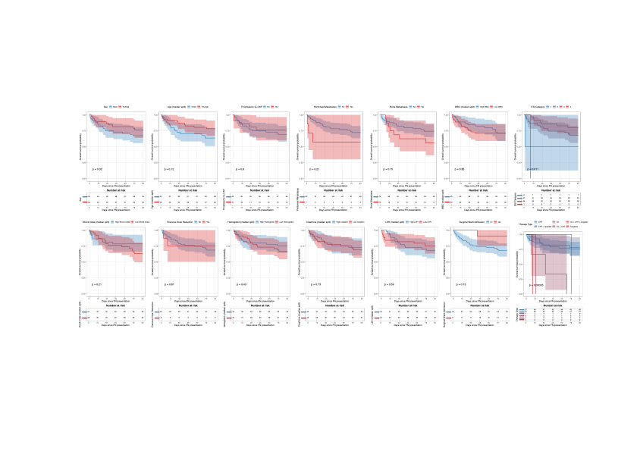
Supplementary Figure 3. Additional Kaplan-Meier curves for predictors of 3-month overall survival following febrile neutropenia.

Supplementary Tables
Variable | n = 33¹
Age at admission [years] | 69.00 (56.00, 76.00)
Sex
Male | 23 (70%)
Female | 10 (30%)
Underlying malignancy
Hematologic Malignancy | 5 (15%)
Lung Cancer | 4 (12%)
Breast Cancer | 3 (9.1%)
Lymphoma | 3 (9.1%)
Sarcoma | 3 (9.1%)
Colorectal Cancer | 2 (6.1%)
Head and Neck Cancer | 2 (6.1%)
Multiple malignancies | 2 (6.1%)
Gastroesophageal Cancer | 2 (6.1%)
CUP | 1 (3.0%)
Gynecologic Malignancy | 1 (3.0%)
Pancreaticobiliary Cancer | 1 (3.0%)
Primary CNS Malignancy | 1 (3.0%)
Prostate Cancer | 1 (3.0%)
RCC | -
Urothelial Carcinoma | -
Other | 2 (6.1%)
Malignancy type
Solid tumour | 25 (76%)
Hematological | 8 (24%)
Treatment type
CHT | 22 (67%)
CHT + targeted | 11 (33%)
Treatment setting
palliative | 25 (76%)
curative | 8 (24%)
Pulmonary metastases | 2 (6.1%)
CNS metastases | -
Hepatic metastases | 7 (21%)
Bone metastases | 3 (9.1%)
Peritoneal metastases | 4 (12%)
¹Median (IQR); n (%)

Supplementary Table 1. Characteristics of patients with positive blood cultures

Section | Variable | Value
Blood culture sampling | Total FN patients | 90 (100%)
 | Blood cultures obtained | 84 (93.3%)
 | No blood cultures obtained | 6 (6.7%)
 | Positive blood cultures | 33/84 (39.3%)
 | Negative blood cultures | 51/84 (60.7%)
Site of culture positivity | Peripheral only | 29/33 (87.9%)
 | Peripheral and central | 3/33 (9.1%)
 | Central line only | 1/33 (3.0%)
Culture bottle type | Aerobic only positive | 20/33 (60.6%)
 | Aerobic and anaerobic positive | 10/33 (30.3%)
 | Anaerobic only positive | 3/33 (9.1%)
Pathogen burden | 1 microorganism | 24/33 (72.7%)
 | 2 microorganisms | 6/33 (18.2%)
 | 3 microorganisms | 1/33 (3.0%)
Time to positivity & sets | Time to positivity [h] | Median 11.9  (range 3.7–60.9)  (IQR 8.5–18.5)
 | Peripheral blood culture sets per patient | Median 2  (range 0–6)  (IQR 2–3)
 | Central blood culture sets per patient | Median 0  (range 0–3)  (IQR 0–0)
 | Total blood culture sets per patient | Median 2  (range 0–6)  (IQR 2–3)
 | Total blood culture sets analysed | 222
Isolated microorganisms | Pseudomonas aeruginosa | 10 (30.3%)
 | Escherichia coli | 9 (27.3%)
 | Staphylococcus epidermidis | 5 (15.2%)
 | Staphylococcus aureus (incl. 1 MRSA) | 2 (6.1%)
 | Staphylococcus haemolyticus | 2 (6.1%)
 | Streptococcus pneumoniae | 1 (3.0%)
 | Enterobacter cloacae | 1 (3.0%)
 | Streptococcus mitis/oralis | 1 (3.0%)
 | Rothia mucilaginosa | 1 (3.0%)
 | Beta-haemolysing streptococci | 1 (3.0%)
 | Leptotrichia wadei | 1 (3.0%)
 | Staphylococcus saprophyticus | 1 (3.0%)
 | Staphylococcus hominis | 1 (3.0%)
 | Klebsiella variicola | 1 (3.0%)
 | Candida albicans | 1 (3.0%)
 | Proteus mirabilis | 1 (3.0%)
Supplementary Table 2. Blood culture sampling & microbiology.

Microorganism | n (%) | Piperacillin/  Tazobactam | Cefepim | Ceftazidim | Meropenem | Ertapenem | Trimetho-prim | Cipro-floxacin
Pseudomonas aeruginosa | 10 (30.3%) | +  (100%) | +  (100%) | +  (100%) | +  (80%)ª | na | +  (20%)^{b} | +  (100%)
Escherichia coli^{c} | 9 (27.3%) | +  (50%)^{d} | +  (100%) | +  (87.5%) | +  (100%) | +  (100%) | +  (87.5%) | +  (62.5%)
Staphylococcus epidermidis | 5 (15.2%) | na | na | na | na | na | +  (60%) | +  (60%)
Staphylococcus aureus | 2 (6.1%) | na | na | na | na | na | +  (100%) | +  (100%)
Staphylococcus haemolyticus | 2 (6.1%) | na | na | na | na | na | -  (100%) | -  (100%)
Streptococcus pneumoniae | 1 (3.0%) | + | na | na | + | na | Na | na
Enterobacter cloacae | 1 (3.0%) | + | + | - | + | + | + | +
Streptococcus mitis/oralis | 1 (3.0%) | na | na | na | na | na | na | na
Rothia mucilaginosa | 1 (3.0%) | na | na | na | na | na | na | na
Beta-haemolysing streptococci | 1 (3.0%) | na | na | na | na | na | na | na
Leptotrichia wadei | 1 (3.0%) | na | na | na | + | na | na | na
Staphylococcus saprophyticus | 1 (3.0%) | na | na | na | na | na | S | +
Staphylococcus hominis | 1 (3.0%) | na | na | na | na | na | + | -
Klebsiella variicola | 1 (3.0%) | + | + | + | + | + | + | +
Candida albicans | 1 (3.0%) | na | na | na | na | na | na | na
Proteus mirabilis | 1 (3.0%) | + | + | + | + | + | - | -
Supplemenaty Table 3. Identified microbiota and sensitivity to antibiotic regimen. Among Pseudomonas aeruginosa isolates, 8/10 were susceptible to meropenem, while the remaining 2/10 showed intermediate susceptibilityª. Trimethoprim susceptibility was observed in 2/10 isolates; however, only these two isolates were tested for this agent^{b}. For Escherichia coli, one isolate did not undergo susceptibility testing; therefore, analyses were based on 8/9 isolates^{c}. Additionally, two isolates were not tested for piperacillin/tazobactam^{d}. Among Staphylococcus epidermidis isolates (n = 5), susceptibility rates were as follows: clindamycin 2/5, erythromycin 0/5, doxycycline 4/5, fosfomycin 3/5, linezolid 4/5, and rifampicin 5/5. Of the two Staphylococcus aureus isolates, one was identified as MRSA and demonstrated resistance to oxacillin and gentamicin, with teicoplanin and vancomycin MICs of 2 mg/L and 1.5 mg/L, respectively; the second isolate was susceptible to all tested agents. Both Staphylococcus haemolyticus isolates were resistant to ciprofloxacin, erythromycin, and trimethoprim, while one of the two (50%) was additionally susceptible to clindamycin, doxycycline, rifampicin, and fosfomycin. Streptococcus mitis/oralis was susceptible to vancomycin and linezolid but resistant to clindamycin. Rothia mucilaginosa was susceptible to penicillin G and vancomycin. Beta-haemolytic streptococci were susceptible to penicillin G, moxifloxacin, erythromycin, clindamycin, and doxycycline. Leptotrichia wadei (anaerobic) demonstrated susceptibility to meropenem, ampicillin/sulbactam, clindamycin, and metronidazole. Staphylococcus saprophyticus was resistant to fosfomycin but otherwise susceptible to all tested agents, including gentamicin, erythromycin, clindamycin, doxycycline, linezolid, and rifampicin. Staphylococcus hominis was resistant to ciprofloxacin but otherwise susceptible to the tested antibiotics, including gentamicin, erythromycin, clindamycin, doxycycline, fosfomycin, linezolid, and rifampicin. Klebsiella variicola was resistant to ampicillin. Candida albicans was susceptible to all tested antifungal agents, with MICs of <0.25 mg/L for amphotericin B, <1 mg/L for fluconazole, 0.023 mg/L for voriconazole, 0.032 mg/L for posaconazole, and 0.002 mg/L for anidulafungin. Proteus mirabilis was resistant to ampicillin, ciprofloxacin, gentamicin, and trimethoprim, but remained susceptible to ampicillin/sulbactam, amoxicillin/clavulanic acid, and the other tested antimicrobial agents.

Outcome | Variable | Unadjusted OR | 95% CI | p-value
In-hospital mortality | Blood cultures positive (yes) | 4.60 | 1.48-16.1 | 0.011
In-hospital mortality | G-CSF therapeutical (yes) | 0.21 | 0.06-0.70 | 0.012
In-hospital mortality | CRP (per mg/L) | 1.05 | 1.01-1.10 | 0.020
In-hospital mortality | Treatment setting (curative) | 0.11 | 0.01-0.59 | 0.037
In-hospital mortality | Hepatic metastases (yes) | 3.75 | 0.99-13.5 | 0.044
3-month mortality | Treatment setting (curative) | 0.05 | 0.003-0.27 | 0.005
3-month mortality | LDH (per U/L) | 1.01 | 1.00-1.01 | 0.006
3-month mortality | Pulmonary metastases (yes) | 5.24 | 1.56-19.3 | 0.009
3-month mortality | Hepatic metastases (yes) | 5.24 | 1.56-19.3 | 0.009
3-month mortality | Blood cultures positive (yes) | 3.89 | 1.47-10.9 | 0.007
3-month mortality | G-CSF therapeutical (yes) | 0.28 | 0.10-0.78 | 0.015
Supplementary Table 4. Univariable logistic regression for in-hospital and 3-month mortality among patients with febrile neutropenia. CI = confidence interval; CRP = C-reactive protein; FN = febrile neutropenia; G-CSF = granulocyte colony-stimulating factor; LDH = lactate dehydrogenase; OR = odds ratio.
Outcome | Variable | Adjusted OR | 95% CI | p-value
In-hospital mortality | G-CSF therapeutical (yes) | 0.34 | 0.09-1.31 | 0.112
In-hospital mortality | Blood cultures positive (yes) | 2.81 | 0.77-10.9 | 0.120
In-hospital mortality | CRP (per mg/L) | 1.03 | 0.99-1.09 | 0.180
3-month mortality | LDH (per U/L) | 1.01 | 1.00-1.02 | 0.008
3-month mortality | Blood cultures positive (yes) | 6.71 | 1.72-32.4 | 0.010
3-month mortality | Treatment setting (curative) | 0.085 | 0.004-0.591 | 0.036
3-month mortality | G-CSF therapeutical (yes) | 0.49 | 0.12-1.91 | 0.299
Supplementary Table 5. Multivariable logistic regression for in-hospital and 3-month mortality among patients with febrile neutropenia. CI = confidence interval; FN = febrile neutropenia; G-CSF = granulocyte colony-stimulating factor; LDH = lactate dehydrogenase; OR = odds ratio.

