Supplementary Material 1: Study centres (5 medical colleges), their ancillary hospitals, and feeder hospitals from Chennai and Chengalpet, Tamil Nadu (India)

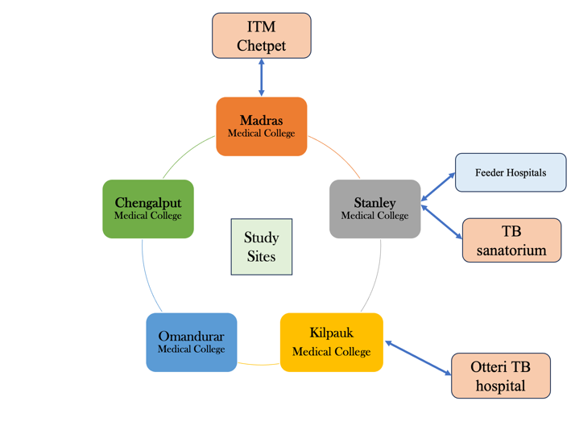

*ITM-Institute of Thoracic Medicine.

