SUPPLEMENTARY MATERIALS

- Supplementary Appendix 1. Detailed Search Strategy
A comprehensive literature search was performed in PubMed, Google Scholar, and Index Medicus Africa to identify studies reporting mortality and associated risk factors in Ebola virus disease. Searches were completed on 10 November 2025. No language restrictions were applied. The following search terms and combinations were used.
PubMed
("Ebola" OR "Ebola virus disease" OR "Ebolavirus" OR "EVD")
AND
("mortality" OR "case fatality" OR "death" OR "survival" OR "outcome" OR "prognosis")
AND
("risk factor" OR "risk factors" OR "predictor" OR "predictors" OR "determinant" OR "determinants" OR "clinical factor" OR "clinical predictors")
Google Scholar
Ebola virus disease mortality predictors
EVD mortality risk factors
Ebola mortality outcome predictors
Index Medicus Africa
Ebola AND mortality AND risk factors
- SUPPLEMENTARY TABLES

Supplementary Table S1. Risk of Bias Assessment Using the JBI Checklist
Study | Study design | Selection bias | Information bias | Confounding control | Overall risk
Mulangu | RCT | Low | Low | Yes | Low
Cherif | Retrospective | Moderate | Moderate | Limited | Moderate
Barry | Prospective | Moderate | Moderate | Limited | Moderate
Aluisio | Retrospective | Moderate | Moderate | Yes | Moderate
Qin | Retrospective | Moderate | Moderate | Limited | Moderate
Yeabah | Cohort | Moderate | Moderate | Yes | Moderate
Sow | Retrospective | Moderate | Moderate | Limited | Moderate
Xu | Retrospective | Moderate | Moderate | Limited | Moderate
Shah | Retrospective | Moderate | Moderate | Yes | Moderate
Mobula | Prospective | Moderate | Moderate | Limited | Moderate
Isekusu | Retrospective | Moderate | Moderate | Limited | Moderate

Supplementary Table S2. Summary of Findings (GRADE) for Main Outcomes

Outcome | No. studies | Participants | Effect estimate | Certainty | Reasons
Overall EVD mortality | 11 | 16,413 | 54% (95% CI: 45–63) | Low | High heterogeneity, observational studies
Hemorrhagic manifestations | 3 | 2,538 | OR 3.52 (95% CI: 1.65–7.48) | Moderate | Observational design
Diarrhea | 2 | 2,399 | OR 6.64 (95% CI: 0.85–51.66) | Very low | Imprecision, few studies
Age | 3 | 2,510 | No significant association | Very low | Heterogeneity, imprecision
Abbreviations: GRADE, Grading of Recommendations Assessment, Development and Evaluation; EVD, Ebola virus disease; CI, confidence interval; OR, odds ratio

- Supplementary Figures

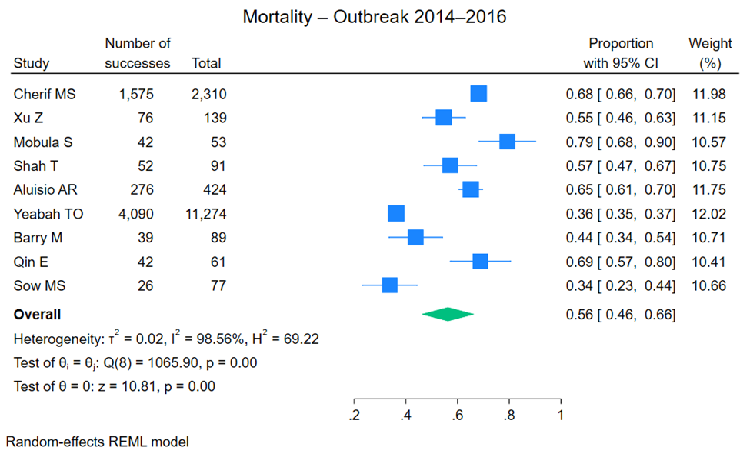
Supplementary Figure S1. Case-fatality proportions reported during the West Africa epidemic (2014–2016).

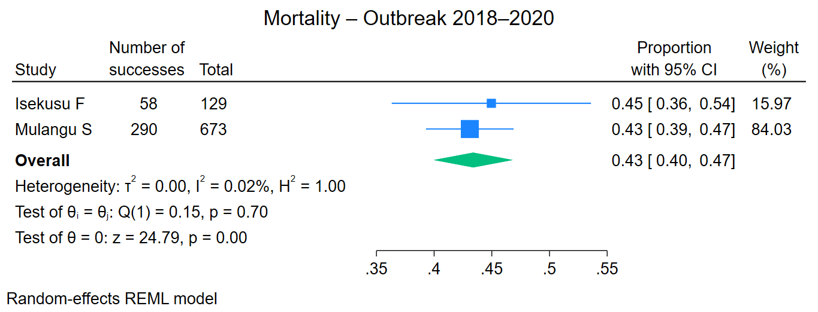
Supplementary Figure S2. Case-fatality proportions reported during the Central Africa epidemic (2018–2020).
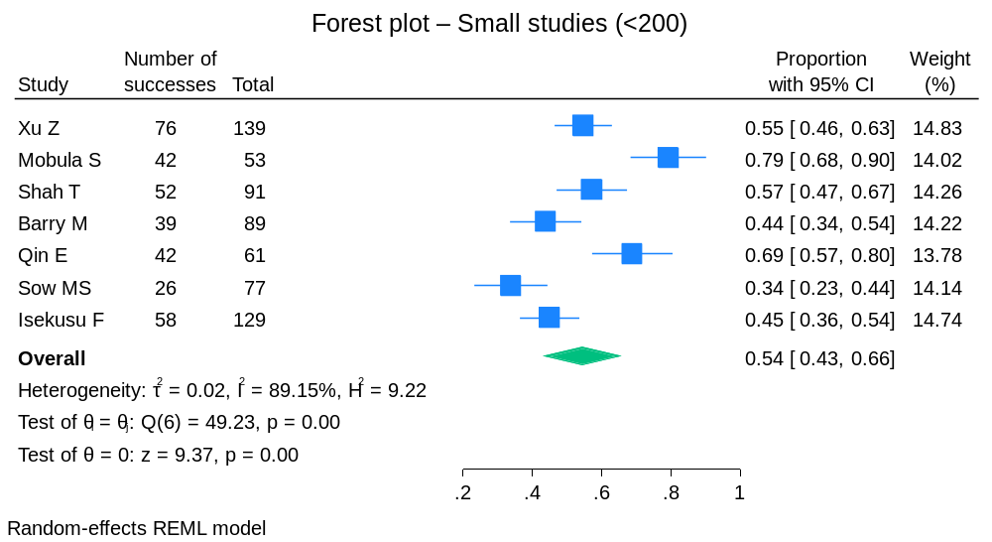

Supplementary Figure S3. Case-fatality proportions reported in small studies (samples <200).

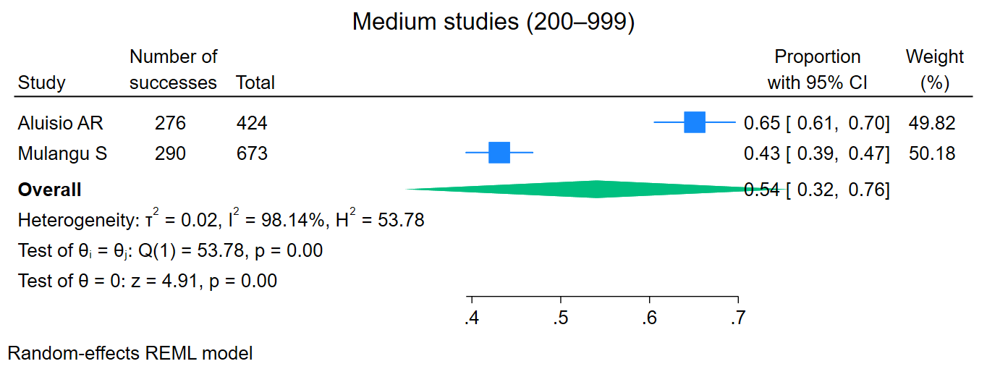
Supplementary Figure S4. Case-fatality proportions reported in intermediate studies (samples 200-999).

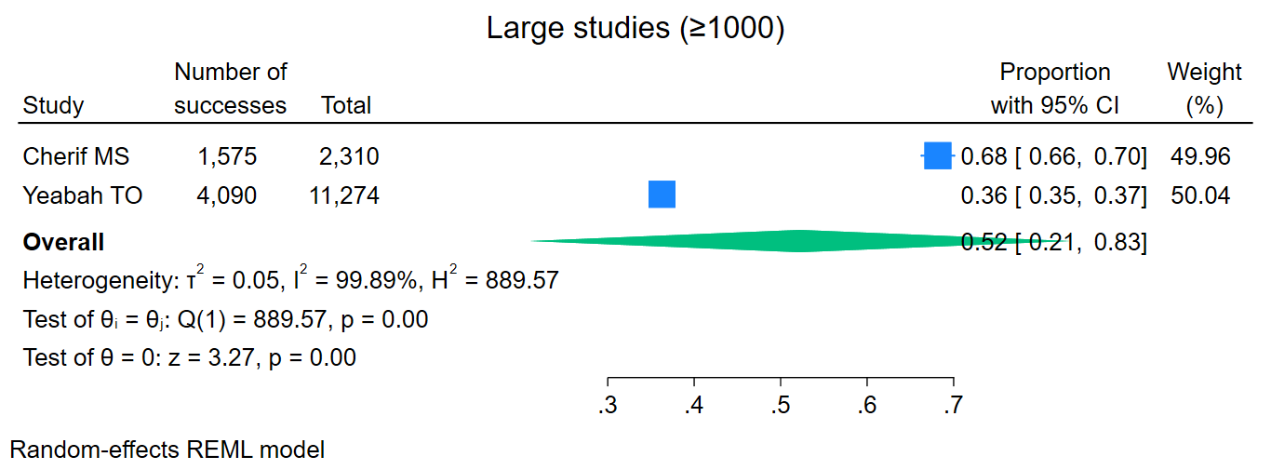
Supplementary Figure S5. Case-fatality proportions reported in large studies (samples ≥1000).

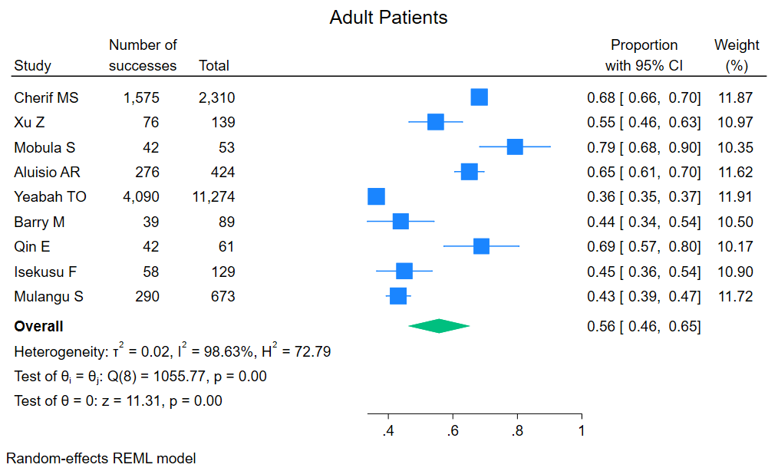
Supplementary Figure S6. Case-fatality proportions reported in studies including adult patients.

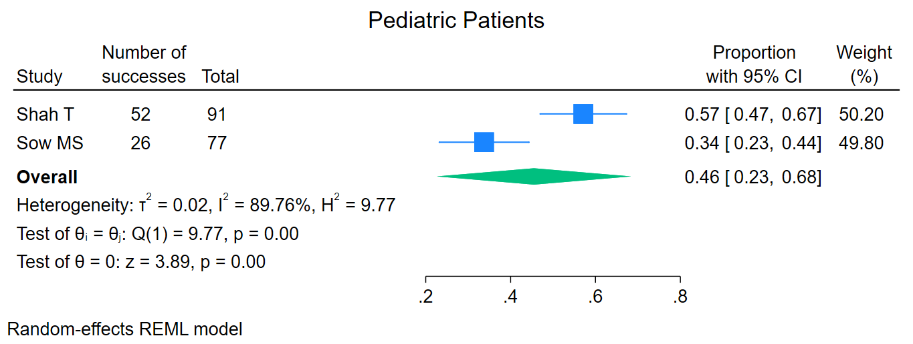
Supplementary Figure S7. Case-fatality proportions reported in studies including pediatric patients.

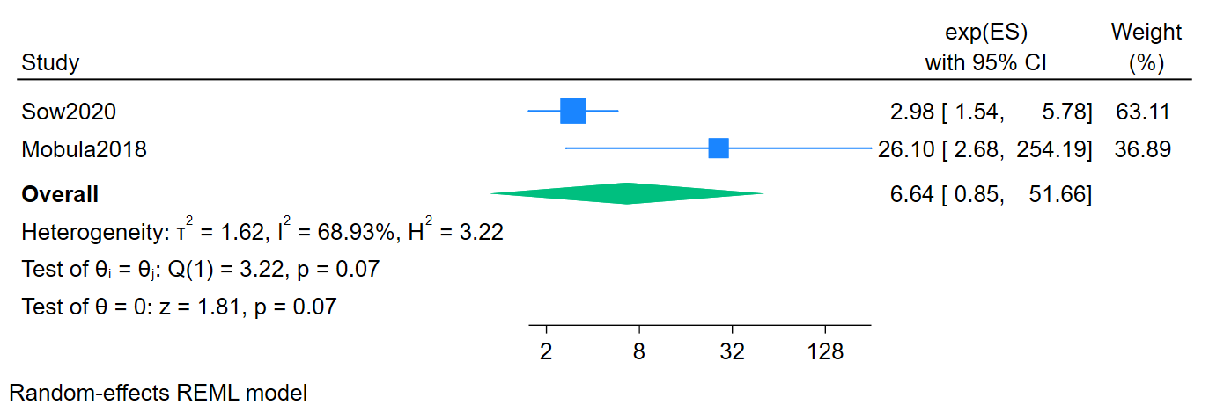

Supplementary Figure S8. Association between diarrhea and Ebola virus disease (EVD) mortality.
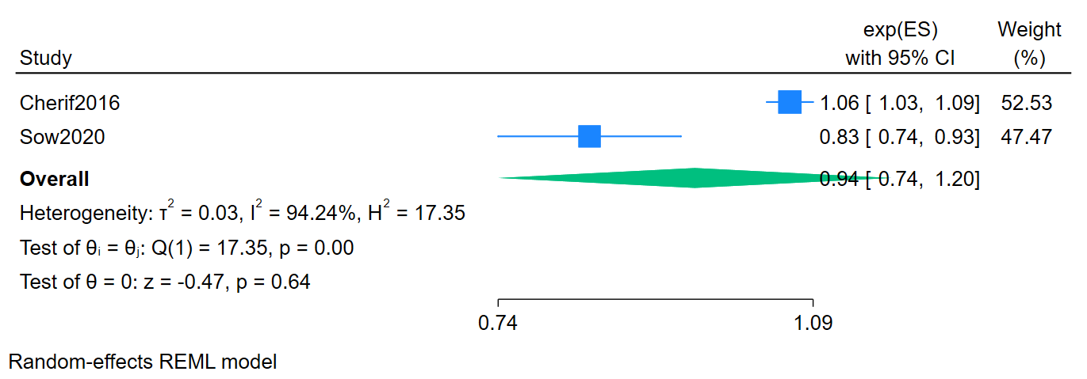

Supplementary Figure S9. Association between age and Ebola virus disease (EVD) mortality.

