Supplement Material

S1. Covariates
- Demographics
  - Female
- COVID-19 vaccination count
- Race/ethnicity
  - Native Hawaiian and Pacific Islander
  - White
  - Hispanic or Latino
  - American Indian and Alaska Native
  - Black
  - Asian
- Age – divided into 7 quantiles:
  - 18-33
  - 34-45
  - 45-52
  - 53-59
  - 60-66
  - 67-74
  - 75+
- BMI categories
  - Normal or underweight (BMI < 25)
  - Overweight (25 to < 30)
  - Obese (30 to < 40)
  - Obese Class 3 (40+)
- CCI index: divided into 5 quantiles:
  - 0
  - 1
  - 2
  - 3-4
  - 5-18
- Conditions that increase risk for severe COVID-19
  - Cancer
  - Cerebrovascular disease
  - Chronic kidney disease
  - Liver disease
  - Lung disease
  - Cystic fibrosis
  - Dementia
  - Diabetes mellitus
  - Disability
  - Heart disease
  - Hemoglobin blood disorder
  - HIV
  - Mental health disorder
  - Obesity overweight
  - Immunocompromised
  - Immunosuppressive therapy
  - Corticosteroid use
  - Tuberculosis
  - Substance abuse
  - Smoking
- Additional conditions
  - Rheumatologic disease
  - Inflammation
  - Hypertension
  - Pneumonia
  - Pregnancy
- Conditions that have interactions with NMV-R
  - Hyperlipidemia
  - Hemophilia
- Procedures
  - Non-invasive ventilation
  - Mechanical ventilation or ECMO
- Relatively contraindicated drugs for NMV-R with severe reactions
  - Anti arrhythmia medications
  - Anticoagulants
  - Cardiovascular agents
  - Narcotics
  - SGC stimulator
  - Alpha1 adrenoceptor antagonist
  - Endothelin receptor antagonists
  - Hepatitis c direct acting antivirals
  - Jak inhibitors
  - Immunosuppressants
  - Pde5 inhibitors
  - Sedatives
  - Migraine medications
  - Muscarinic receptor antagonists
- Relatively contraindicated drugs for NMV-R with moderate reactions
  - Antipsychotics
  - Anti-cancer drugs
  - Anti-mycobacterial agents
  - Antifungals
  - Corticosteroids
  - Anti-infectives
  - Anticonvulsant
  - Neuropsychiatric agents
  - Antidepressants
  - Calcium channel blockers
  - DPP4 inhibitors
- Other Medication Exposures
  - Antipsychotics
  - Anti-arrhythmic
  - Anticoagulants
  - Anti-cancer
  - Sedatives
  - Narcotics
  - Anti-infectives
  - Influenza vaccine
- Lab Measures
  - Alanine Aminotransferase
    - High (>56)
    - Low (< 7)
    - Normal (7-56)
  - EGFR
    - Low (< 90)
    - Normal (90+)
  - Creatinine
    - Low (< 0.5)
    - High (> 7.5)
    - Normal (0.5-7.5)
- Emergency Department Visits prior to COVID-19 diagnosis
  - 0
  - 1
  - 2-3
  - 4+
- Hospitalizations prior to 10-days before COVID-19 diagnosis
  - 0
  - 1
  - 2+
- Healthcare center visits before COVID-19 diagnosis
  - 1-32
  - 33-50
  - 51-70
  - 71-96
  - 97-133
  - 134-203
  - 203+
- SDOH index
  - Quantile 1 (0-49)
  - Quantile 2 (50-52)
  - Quantile 3 (53-55)
  - Quantile 4 (55-57)
  - Quantile 5 (58-59)
  - Quantile 6 (60-62)
  - Quantile 7 (63+)

S2. Outcome Definitions
The table below describes the coding of each of the five outcomes in the present study
Outcome | Components | Relevant OMOP Concept Set Names or description
1. Severe Illness: One or more of an emergency department visit, hospitalization, receipt of supplemental oxygen or death | Emergency Department Visit | Visit with one of the following concept types:  - Emergency Room and Inpatient Visit  - Emergency Room – Hospital  - Emergency Room Visit  - Emergency Room Critical Care Facility
 | Supplemental Oxygen | Visit with a concept recorded within one or more of the following OMOP concept sets:  - ECMO  - [Critical Care] Ventilation/ECMO  - Kostka – ECMO  - Mechanical Ventilation  - [N3C] [ISC] Mechanical Ventilation  - Invasive Mechanical Ventilation Gabriel V2  - Invasive Mechanical Ventilation  - Invasive ventilation  - [ICU/MODS]IMV  - Non-invasive ventilation  - NIV (test) Atlas# 884  - Non-Invasive Ventilation  - High Flow Oxygen  - Acute Respiratory Failure - High Flow  - Supplemental Oxygen (low or high flow oxygen)  - [DATOS] Supplemental Oxygen  - Supplemental Oxygen  - [RHDT] Supplemental Oxygen
 | Hospitalization | Visit defined as a “macrovisit” based on the N3C definition described below:  - Must have a non-null start and end date  - Must have an end date that occurs on or after the start date  Must be one of these visit concept types:  - 262 Emergency Room and Inpatient Visit  - 8717 Inpatient Hospital  - 9201 Inpatient Visit  - 32037 Intensive Care  - 581379 Inpatient Critical Care Facility  OR  - 581385 Observation Room (with LOS>= 2 days)  OR  - 8756 Outpatient Hospital (with LOS>=2 days)  OR  - 9203 ER visit (with LOS>= 2 days)  AND  - Marked as a “likely hospitalization” based on pre-defined developed by N3C [1]
 | Death | Visits identified as deaths using OMOP Death table, and linked records (privacy-preserving record linkage) from obituaries and government records (e.g., Social Security Administration death records).
2. Hospitalization or Death | Hospitalization | Hospitalization as described above
 | Death | Death as described above
3. Hospitalization | Hospitalization | Hospitalization as described above
4. Death | Death | Death as described above
5. Long COVID | Long COVID diagnosis | - ICD-10 diagnosis code for long COVID (U09.9) or Sequelae of other specified infectious and parasitic diseases (B94.8)  - Long COVID diagnosis OMOP concept sets:  - Long-COVID (PASC)
 | Visit to long COVID clinic | - Concept sets capturing concepts indicating a visit to a long COVID clinic:  - Long COVID Clinic Visit  - Long COVID Clinic Observation and U09.9 Conditions
 | Predicted long COVID | - Predicted long COVID label based on a machine learning model developed in N3C. Patient is classified as likely long COVID if probability >= 0.9 [2, 3]

S3. Longitudinal Matching Approach
After fitting the propensity score model, which was a discrete time survival model that estimated the probability of NMV-R exposure for each of the first five days since COVID-19 diagnosis, we obtained predicted hazard probabilities for each patient-day, which we converted to the log-odds scale (i.e., logits). We then implemented longitudinal matching within the full cohort using sequential 1:1 greedy matching with replacement using the Matchit package in R (version 4.5.4), to match a NMV-R treatment initiator to a non-initiator with the same propensity to receive NMV-R on the day it was initiated. We applied constraints such that initiators were matched only to non-initiators who were eligible within the same day (i.e., the day of treatment initiation), with the same vaccination status (i.e., never vaccinated versus vaccinated), the same number of days between the SARS-CoV-2 testing and hospitalization, and the same oxygenation type on the day of treatment.
As described above, the dataset was structured so each patient had multiple rows, 1 per day of hospitalization through day 5, meaning each patient had a propensity score (i.e., hazard probability) for each day of COVID-19 diagnosis unless they experienced one or more outcomes (severe illness, hospitalization, or death) or were treated. Rows from when the patient experiences the outcome, or after the patient received treatment were not included in the dataset. We then used sequential 1:1 greedy matching using the Matchit package in R (version 4.5.4) to match initiators with non-initiators having the most similar log-odds of being treated on the day in which the initiator took NMV-R. As we were applying a sequential target trial emulation approach, a patient who went on to initiate treatment on a later day (e.g., day 5) was a potential non-initiator and could be matched to initiators on days 1-4 if he or she met eligibility criteria on each of those days.
We applied a caliper of 0.1 SDs to the matching, meaning that if the propensity score difference was less than 0.1 times the standard deviation of the logit hazard on the day of treatment, then the pair was considered matched [4]. A single non-initiator patient could be matched to multiple patients who initiated treatment on different days if the propensity score difference was smaller than the caliper on each of those days. This meant a single non-initiator patient could enter multiple trials. In the statistical analyses it was therefore necessary to modify the standard error and the resulting confidence intervals to account for such matching with replacement using the technique described by Austin [5]. A visual example of the longitudinal matching process is provided in the Figure below.
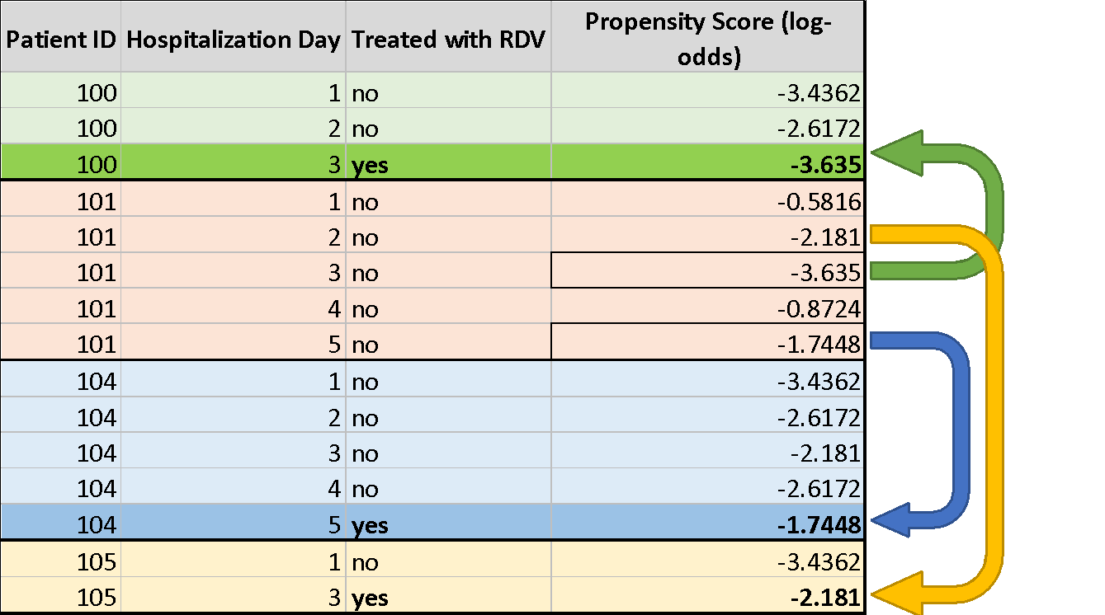
Visualization of longitudinal matching. Patients 100, 104, and 105 initiated NMV-R at some point within days 1-5 of COVID-19 diagnosis, whereas patient 101 never initiated NMV-R during this period, but initiated treatment after day 8 (this is not shown in the diagram). The visual shows the data structure. Patients have a maximum of 5 rows, 1 per day of hospitalization. Rows after when the patient received treatment are not included. Patient 100 initiates treatment on day 3. He or she is matched to day 3 of patient 101 who was yet to initiate treatment by day 3, and has the closest log odds of initiating treatment on day 3 as patient 100. Patient 104 initiates treatment on day 5. He or she is matched to day 5 of patient 101 since patient 101 has yet to initiate treatment on day 5 and has the most similar log-odds of initiating treatment on day 5. Finally, Patient 105 initiates treatment on day 2 and is matched to day 2 of patient 101 who hasn’t initiated treatment by day 2, and has the most similar log-odds of initiating treatment on day 2 as patient 105. Each unique patient-day combination could only be matched once (and enter only a single matched initiator-noninitiator pair. However, a single unique patient who was a non-initiator on multiple days could be matched with multiple initiators, who initiated treatment on different days.

We tested whether the matching procedure balanced treated and untreated patients on each of the pre-treatment covariates by examining the standardized mean differences (SMDs) on each covariate before and after matching [6, 7]. The SMD was calculated as the difference in the mean of a covariate between initiators and non-initiators divided by the pooled standard deviation
$$Pooled SD =\sqrt{\frac{{(SD}_{Initiator}^{2} +{ SD}_{Non-initiator}^{2}) }{2}}$$
SMDs prior to matching were calculated across the full sample of eligible person-trials, whereas SMDs after matching were calculated among the matched pairs. SMDs were calculated across patients in all severity subgroups, and in each subgroup separately.

Supplementary Table 1. Specification of Design Components of the Hypothetical Target Randomized Controlled Trial to Test the Impact of Initiating treatment with Nirmatrelvir/Ritonavir (NMV-R) on day of COVID-19 Diagnosis on the Risk of Hospitalization and Death in COVID-19 positive adults who are at Risk of Progressing to Severe COVID-19, and Emulation of These Elements in the Present Retrospective Cohort Study
Section | Design Component | Target Trial Specification | Emulation
Causal Estimand | Eligibility | Adults aged 18 and over with a new outpatient diagnosis of COVID-19 between December 22, 2021 through February 28, 2023 | Used EHR to identify patients aged over 18 with a diagnosis of COVID-19 or positive SARS-CoV-2 PCR or AG test between December 22, 2021 through February 28, 2023. The earlier of the two dates (if patients had both) was used as the date of COVID-19 diagnosis for the patient.
 |  | Mild to moderate COVID-19 and not requiring hospitalization due to severe or critical COVID-19 at treatment initiation | The COVID-19 treatment guidelines define mild illness as having one or more of the various signs and symptoms consistent with COVID-19 (e.g., headache, fever, sore throat, muscle pain) in the absence of shortness of breath, dyspnea, or abnormal chest imaging. Symptom ascertainment within the EHR is incomplete and likely missing for the majority of patients. We defined mild COVID-19 as no hospitalization, ED visit, supplemental oxygen receipt, or death occurring within 24 hours of COVID-19 diagnosis.
 |  | Has one or more risk factors for progression to severe COVID-19 | Patients were identified as at risk for severe COVID-19 if they had healthcare visits which identified the presence of one or more of the risk factors for severe COVID-19 as defined by the Centers for Disease Control (CDC) on each of the three days in which NMV-R eligibility was assessed. Concept sets were selected for each of the risk factors, and using these concept sets, visits associated with the presence or occurrence of these risk factors could be identified for each patient. We were able to identify visits relating to the following risk factors: asthma, cancer, cerebrovascular disease, chronic kidney disease, chronic lung diseases, cystic fibrosis, diabetes, disabilities, heart conditions, human immunodeficiency virus (HIV), mental health conditions, dementia, overweight/obese, recent pregnancy, primary immunodeficiencies, smoking (former or current), had an organ or blood stem cell transplant, tuberculosis, use of corticosteroids or other immunosuppressants, and sickle cell disease. Some risk factors required additional rules. For cancer, we excluded basal cell carcinomas. For disabilities, we included autism, Down’s syndrome, Attention-Deficit/Hyperactivity Disorder, developmental disorder (birth defects, intellectual and developmental disabilities, and learning disabilities), spinal cord injuries (hemiplegia, paraplegia, and quadriplegia), and cerebral palsy. For chronic kidney disease, we included stages 1-3 not requiring dialysis. For recent pregnancy, we identified all pregnancy-related visits within six weeks prior to day of COVID-19 diagnosis
 |  | No known or suspected severe renal impairment (eGFR < 30 mL/min) | We excluded patients who had a record of severe renal impairment which was defined as eGFR values < 30 mL/min/1.73m2 in the 30 days prior to and including each of the 5 days in which patients were eligible for NMV-R treatment. We also excluded patients with a record of Stage 4 chronic kidney disease (CKD) in the 180 days prior day of COVID-19 diagnosis. Records for severe renal impairment or Stage 4 were identified using concepts sets defined for each condition.
 |  | No known or suspected severe hepatic impairment (Child-Pugh Class C) | We used concept sets to identify patients’ visits with recorded Child-Pugh Class C or severe liver disease in the 180 days prior to and including day of COVID-19 diagnosis, and these patients were excluded.
 |  | Patient is not taking any of the medications contraindicated for NMV-R | We created concept sets for each of the 37 contraindicated medications for NMV-R as defined by the FDA and identified for each patient, healthcare visits with one or more of these contraindicated medications recorded in the 180 days prior to and including day of COVID-19 diagnosis. Patients with a healthcare visit where a prescription to one or more of these medications was recorded in the 180 days prior to and including the day of COVID-19 diagnosis were excluded.
 |  | Patient is taking one or more of the medications that should be avoided with NMV-R, if the dose has been adjusted, medication use is being held, or increased monitoring is being planned. | It was not possible to identify from the EHR whether or not patients using one or more of the medications to be avoided with NMV-R as specified by the FDA received dose adjustment, were holding their use of the drug, or were receiving increased monitoring of the drug. We instead included these drug classes having severe or moderately severe interactions with NMV-R as covariates in the analysis. Two of the medications in this list however (i.e., rivaroxaban and salmeterol) should be completely avoided as recommended by the Infectious Disease Society of America. Hence, patients with recorded use of either one of these drugs in the 180 days prior to and including day of COVID-19 diagnosis were excluded.
 |  | No history of clinically significant hypersensitivity reactions [e.g., toxic epidermal necrolysis (TEN) or Stevens-Johnson syndrome] to the active ingredients (nirmatrelvir or ritonavir) or other components of the NMV-R product | The EHR data does not enable identification of whether a patient’s recorded hypersensitivity reaction was a result of the active ingredients or other components of NMV-R.
 | Treatment Strategy | Exposure to nirmatrelvir plus ritonavir (NMV-R) using the recommended schedule of 2 tablets (300 mg) of nirmatrelvir and 1 tablet (100 mg) of ritonavir every 12 hours for 5 day, compared to no treatment. | Using concept sets for NMV-R we were able to identify eligible patients (using criteria above) with a record of NMV-R prescription, and the date of the prescription. A patient was considered a treatment Initiator if the recorded date of the NMV-R prescription fell on day of COVID-19 diagnosis. Patients who either did not receive NMV-R or received it after the diagnosis day were Non-initiators.  It was not possible to determine if patients adhered to the recommended treatment strategy.
 | Assignment Procedure (unmasked) | Eligible patients randomly assigned to treatment with NMV-R or no treatment. Assignment will be open-label (no blinding). | To emulate random assignment, which naturally removes systematic differences between treated and untreated groups on confounding variables, we used propensity score matching to balance treatment initiators and non-initiators on pretreatment covariates that may confound associations between NMV-R exposure and our outcomes of interest. The list of confounding variables is described in the Covariates section of this Supplement.  Because patients know whether or not they received NMV-R, this emulates the open-label assignment of the target trial.
 | Outcomes | Hospitalization and death in the 14-day period following patients’ first day of enrollment into the trial. | Same as trial.
 | Start/End of follow-up | Start at baseline. Each patient was followed until the occurrence of a target outcome or administrative end of study (day 14), whichever came first. | Same as trial.
 | Causal Contrast of Interest | Intent-to-treat effect, comparing the difference in risk of hospitalization and death between patients who initiated NMV-R treatment compared to those who did not, at the start of the trial, irrespective of whether or not they adhered to their assigned treatment strategy | Same as trial, with the intent-to-treat effect comparing the risk of severe illness, hospitalization or death, hospitalization, death, and long COVID, between NMV-R initiators and non-initiators.
Identifying Assumptions | Randomized Assignment | Simple Randomized Assignment | Assumed conditional exchangeability (i.e., potential outcomes are independent of treatment assignment), by aiming to include all known, major confounders between NMV-R exposure and the outcomes of interest (death, hospitalization, long-COVID) and competing events that were available via the EHR. The competing events (death, hospitalization) were assumed to have similar, if not identical, confounders.  Confounders were informed by prior research [8-10] and clinical expertise. These included patient demographics, history of healthcare usage, and indicators of health status including medications, in particular drugs known to have moderate and severe interactions with NMV-R, comorbidities including known disease interactions with NMV-R, and prior healthcare utilization all of which were recorded in the EHR. Furthermore, relevant lab measures captured in the EHR which were indicative of impaired kidney and hepatic function and adverse outcomes associated with NMV-R exposure were included (see Supplementary section S1. Covariates). Said confounders were included in the propensity score model to match NMV-R treated and untreated patients. Longitudinal matching ensured patients treated on a certain day since COVID-19 diagnosis were matched to untreated patients still alive on day of treatment, and had the most similar distribution of covariates up to that day.  Further, exact matching was performed patients’ COVID-19 vaccination count, healthcare site, and the dominant SARS-CoV-2 variant (based on the date of patients’ positive SARS-CoV-2 test), which is conceptually analogous to stratified randomization within each emulated trial to balance treated and untreated patients on additional known (and unobserved, but correlated) confounders.
Estimator | Data Analysis | Intent-to-treat analysis, comparing 14-day difference in risk of severe illness, hospitalization or death, hospitalization, and death, and 180-day difference in risk of long COVID between patients assigned to receive NMV-R-treatment or no treatment expressed as a hazard ratio. | Same as trial to estimate the observational analog of the intent-to-treat effect. Multiple additional sensitivity analyses were conducted to assess robustness of the estimated intent-to-treat effect including (1) dropping BMI as a covariate, and including patients with missing BMI in the analysis; (2) complete case analysis (i.e., dropping patients with missing BMI, SDOH index, and lab measures); (3) dropping the SDOH index, and including patients without SDOH and/or postal code data; (4) changing the age cut-off for being at risk of severe COVID-19 from 65 to 50; and (5) keeping all healthcare sites in the analysis (with at least 1 patient treated with NMV-R).
 | Subgroup analyses | Subgroup intent-to-treat analyses performed on vaccinated and unvaccinated patients, and patients who received early treatment (i.e., day of COVID-19 diagnosis) and delayed treatment with NMV-R (i.e., treated on day 2 to 5 of COVID-19 diagnosis). | Same as trial.
 | Modeling assumptions | Intent-to-treat analysis assumes all individuals randomized to receive NMV-R or no treatment remain in their assigned groups when analyzed. Randomization ensures individuals in each treatment group are balanced on known and unknown confounders of treatment and primary as well as competing outcomes to properly estimate the intent-to-treat effect is validly estimated. | Longitudinal matching to emulate randomization to estimate the observational analog of the intent-to-treat effect. Use of Fine-Gray subdistribution hazard model to approximate the intent-to-treat effect for outcomes with competing risks (i.e., hospitalization).
Note. We emulated four additional trials, with the starting day/baseline of each trial being the second to fifth days of confirmed COVID-19 diagnosis, respectively. We applied the above design approach in relation to the corresponding start days of each of these two additional trials.

S4. Coding of SARS-CoV-2 Variant
  - During the matching process, patients were exact-matched based on the predominant COVID-19 variant around the time of the patients’ COVID-19 diagnosis.
  - The variants were coded using the following date ranges (such that patients were exact matched if their COVID-19 diagnosis date fell within the same date range, in addition to having a similar propensity to receive NMV-R treatment within the caliper of 0.1 SDs)
    - PREALPHA: COVID_index_date < 2021-03-01
    - ALPHA: COVID-19 diagnosis < 2021-07-01
    - DELTA: COVID-19 diagnosis < 2021-12-16
    - OMICRON-BA2: COVID-19 diagnosis < 2022-10-01
    - OMICRON-X: COVID-19 diagnosis < 2023-07-01
    - OMICRON-E-HV: COVID-19 diagnosis < 2024-01-01
    - OMICRON-LATE: COVID-19 diagnosis >= 2024-01-01
Supplementary Table 2. Concept Sets and OMOP Concept Names and IDs for nirmatrelvir/ritonavir (NMV-R) Exposure
Concept set | concept | OMOP concept id
Paxlovid | PAXLOVID - nirmatrelvir and ritonavir kit | 36902202
Paxlovid | nirmatrelvir 150 MG Oral Tablet | 36501266
Paxlovid | nirmatrelvir and ritonavir KIT | 36900648
Paxlovid | nirmatrelvir and ritonavir KIT | 42631714
Paxlovid | nirmatrelvir and ritonavir KIT [paxlovid] | 1632579
Paxlovid | nirmatrelvir and ritonavir KIT [paxlovid] | 749191
Paxlovid | nirmatrelvir and ritonavir KIT [paxlovid] | 36901848
Paxlovid | ritonavir 100 MG Oral Tablet | 36501120
Paxlovid | 20 (nirmatrelvir 150 MG Oral Tablet) / 10 (ritonavir 100 MG Oral Tablet) Pack [Paxlovid 5-Day] | 42631191
Paxlovid | 20 (nirmatrelvir 150 MG Oral Tablet) / 10 (ritonavir 100 MG Oral Tablet) Pack [Paxlovid 5-Day] | 1626323
Paxlovid | 20 (nirmatrelvir 150 MG Oral Tablet) / 10 (ritonavir 100 MG Oral Tablet) Pack [Paxlovid 5-Day] | 36900156
Paxlovid | 20 (nirmatrelvir 150 MG Oral Tablet) / 10 (ritonavir 100 MG Oral Tablet) Pack [Paxlovid 5-Day] | 1994869
Paxlovid - Ruvos | nirmatrelvir | 702530
Paxlovid - Ruvos | nirmatrelvir 150 MG | 702531
Paxlovid - Ruvos | nirmatrelvir 150 MG Oral Tablet | 702535
Paxlovid - Ruvos | nirmatrelvir Oral Product | 702532
Paxlovid - Ruvos | nirmatrelvir Oral Tablet | 702534
Paxlovid - Ruvos | nirmatrelvir Pill | 702533
Paxlovid - Ruvos | 10 (nirmatrelvir 150 MG Oral Tablet) / 10 (ritonavir 100 MG Oral Tablet) Pack | 780185
Paxlovid - Ruvos | 10 (nirmatrelvir 150 MG Oral Tablet) / 10 (ritonavir 100 MG Oral Tablet) Pack [Paxlovid 150 MG /100 MG Dose Pack] | 780186
Paxlovid - Ruvos | 20 (nirmatrelvir 150 MG Oral Tablet) / 10 (ritonavir 100 MG Oral Tablet) Pack | 702577
Paxlovid - Ruvos | 20 (nirmatrelvir 150 MG Oral Tablet) / 10 (ritonavir 100 MG Oral Tablet) Pack [Paxlovid 5-Day] | 702578

Supplementary Table 3. Adjusted hazard ratios and 95% confidence intervals for each outcome from the main and all sensitivity analyses corresponding event counts and proportions
 |  | Hazard Ratio | Relative Risk | Risk Reduction | At Risk | Event Count | % | At Risk |  | Event Count | %
Analysis | Outcome | (95% CI) | (95% CI) | (95% CI) | Initiators |  |  |  | Non-initiators
Main Analysis | Severe illness | 0.76 (0.71 to 0.81) | 0.74 (0.69 to 0.79) | 0.64 (0.48 to 0.79) | 68,386 | 1,221 | 1.79% | 68,386 |  | 1,660 | 2.43%
 | Hospitalization or death | 0.5 (0.44 to 0.57) | 0.5 (0.44 to 0.56) | 0.49 (0.41 to 0.59) | 68,386 | 339 | 0.50% | 68,386 |  | 675 | 0.99%
 | Hospitalization | 0.52 (0.46 to 0.6) | 0.52 (0.46 to 0.59) | 0.43 (0.35 to 0.51) | 68,386 | 320 | 0.47% | 68,386 |  | 612 | 0.89%
 | Death | 0.33 (0.21 to 0.51) | 0.33 (0.19 to 0.5) | 0.07 (0.04 to 0.1) | 68,386 | 24 | 0.04% | 68,386 |  | 75 | 0.11%
 | Long COVID | 0.85 (0.77 to 0.95) | 0.86 (0.78 to 0.95) | 0.25 (0.08 to 0.41) | 45,388 | 1,911 | 4.21% | 45,388 |  | 1,957 | 4.31%
Vaccinated | Severe illness | 0.75 (0.68 to 0.82) | 0.75 (0.68 to 0.82) | 0.57 (0.4 to 0.75) | 44,854 | 763 | 1.70% | 44,854 |  | 1,019 | 2.27%
 | Hospitalization or death | 0.55 (0.47 to 0.66) | 0.55 (0.46 to 0.65) | 0.36 (0.26 to 0.47) | 44,854 | 201 | 0.45% | 44,854 |  | 363 | 0.81%
 | Hospitalization | 0.56 (0.47 to 0.66) | 0.56 (0.47 to 0.68) | 0.33 (0.23 to 0.43) | 44,854 | 188 | 0.42% | 44,854 |  | 337 | 0.75%
 | Death | 0.5 (0.27 to 0.93) | 0.5 (0.24 to 0.83) | 0.03 (0.01 to 0.06) | 44,854 | 15 | 0.03% | 44,854 |  | 30 | 0.07%
 | Long COVID | 0.94 (0.82 to 1.07) | 0.94 (0.83 to 1.05) | 0.11 (-0.08 to 0.31) | 29,765 | 1,219 | 4.10% | 29,765 |  | 1,271 | 4.27%
Unvaccinated | Severe illness | 0.69 (0.61 to 0.77) | 0.69 (0.61 to 0.77) | 0.86 (0.6 to 1.13) | 23,552 | 448 | 1.90% | 23,552 |  | 650 | 2.76%
 | Hospitalization or death | 0.43 (0.35 to 0.52) | 0.43 (0.34 to 0.53) | 0.76 (0.59 to 0.95) | 23,552 | 136 | 0.58% | 23,552 |  | 316 | 1.34%
 | Hospitalization | 0.46 (0.38 to 0.57) | 0.46 (0.38 to 0.56) | 0.64 (0.49 to 0.81) | 23,552 | 130 | 0.55% | 23,552 |  | 280 | 1.19%
 | Death | 0.17 (0.08 to 0.35) | 0.17 (0.06 to 0.32) | 0.17 (0.11 to 0.23) | 23,552 | 8 | 0.03% | 23,552 |  | 48 | 0.20%
 | Long COVID | 0.82 (0.68 to 1) | 0.82 (0.68 to 0.99) | 0.27 (0.02 to 0.54) | 15,726 | 680 | 4.32% | 15,726 |  | 649 | 4.13%
Drop BMI as a covariate | Severe illness | 0.74 (0.69 to 0.8) | 0.75 (0.7 to 0.8) | 0.61 (0.46 to 0.75) | 69,106 | 1,227 | 1.78% | 69,106 |  | 1,646 | 2.38%
 | Hospitalization or death | 0.51 (0.45 to 0.58) | 0.51 (0.44 to 0.58) | 0.47 (0.38 to 0.57) | 69,106 | 337 | 0.49% | 69,106 |  | 664 | 0.96%
 | Hospitalization | 0.52 (0.46 to 0.59) | 0.52 (0.45 to 0.6) | 0.42 (0.34 to 0.51) | 69,106 | 319 | 0.46% | 69,106 |  | 611 | 0.88%
 | Death | 0.34 (0.22 to 0.55) | 0.34 (0.2 to 0.54) | 0.06 (0.04 to 0.09) | 69,106 | 23 | 0.03% | 69,106 |  | 67 | 0.10%
 | Long COVID | 0.89 (0.8 to 0.99) | 0.89 (0.79 to 0.98) | 0.19 (0.03 to 0.35) | 46,033 | 1,938 | 4.21% | 46,033 |  | 1,938 | 4.21%
Complete Case Analysis | Severe illness | 0.73 (0.67 to 0.79) | 0.73 (0.68 to 0.79) | 0.62 (0.46 to 0.78) | 56,864 | 977 | 1.72% | 56,864 |  | 1,330 | 2.34%
 | Hospitalization or death | 0.45 (0.39 to 0.53) | 0.46 (0.39 to 0.53) | 0.52 (0.43 to 0.62) | 56,864 | 247 | 0.43% | 56,864 |  | 542 | 0.95%
 | Hospitalization | 0.47 (0.41 to 0.55) | 0.47 (0.4 to 0.56) | 0.45 (0.35 to 0.55) | 56,864 | 232 | 0.41% | 56,864 |  | 489 | 0.86%
 | Death | 0.25 (0.14 to 0.42) | 0.25 (0.12 to 0.41) | 0.09 (0.06 to 0.12) | 56,864 | 16 | 0.03% | 56,864 |  | 65 | 0.11%
 | Long COVID | 0.83 (0.74 to 0.94) | 0.84 (0.74 to 0.95) | 0.3 (0.09 to 0.49) | 37,220 | 1,591 | 4.27% | 37,220 |  | 1,644 | 4.42%
Drop SDOH index | Severe illness | 0.72 (0.67 to 0.77) | 0.72 (0.67 to 0.78) | 0.67 (0.52 to 0.83) | 70,972 | 1,235 | 1.74% | 70,972 |  | 1,712 | 2.41%
 | Hospitalization or death | 0.48 (0.43 to 0.55) | 0.49 (0.43 to 0.56) | 0.5 (0.41 to 0.6) | 70,972 | 337 | 0.47% | 70,972 |  | 694 | 0.98%
 | Hospitalization | 0.52 (0.45 to 0.59) | 0.52 (0.45 to 0.59) | 0.42 (0.34 to 0.5) | 70,972 | 319 | 0.45% | 70,972 |  | 617 | 0.87%
 | Death | 0.26 (0.16 to 0.41) | 0.26 (0.16 to 0.38) | 0.09 (0.07 to 0.12) | 70,972 | 23 | 0.03% | 70,972 |  | 89 | 0.13%
 | Long COVID | 0.85 (0.77 to 0.95) | 0.85 (0.78 to 0.95) | 0.25 (0.09 to 0.4) | 47,457 | 1,943 | 4.09% | 47,457 |  | 2,010 | 4.24%
Age >= 50 to be at risk of severe COVID-19 | Severe illness | 0.74 (0.69 to 0.79) | 0.74 (0.69 to 0.79) | 0.62 (0.5 to 0.76) | 69,151 | 1,227 | 1.77% | 69,151 |  | 1,658 | 2.40%
 | Hospitalization or death | 0.5 (0.44 to 0.57) | 0.5 (0.44 to 0.56) | 0.49 (0.41 to 0.58) | 69,151 | 340 | 0.49% | 69,151 |  | 682 | 0.99%
 | Hospitalization | 0.52 (0.45 to 0.59) | 0.52 (0.46 to 0.59) | 0.44 (0.35 to 0.52) | 69,151 | 322 | 0.47% | 69,151 |  | 623 | 0.90%
 | Death | 0.33 (0.21 to 0.52) | 0.33 (0.2 to 0.51) | 0.07 (0.04 to 0.09) | 69,151 | 23 | 0.03% | 69,151 |  | 70 | 0.10%
 | Long COVID | 0.89 (0.79 to 0.99) | 0.89 (0.79 to 0.99) | 0.19 (0.02 to 0.36) | 46,070 | 1,916 | 4.16% | 46,070 |  | 1,959 | 4.25%
Keep All Data Partners | Severe illness | 0.69 (0.65 to 0.74) | 0.69 (0.65 to 0.74) | 0.77 (0.64 to 0.92) | 84,104 | 1,480 | 1.76% | 84,104 |  | 2,131 | 2.53%
 | Hospitalization or death | 0.45 (0.4 to 0.51) | 0.45 (0.4 to 0.51) | 0.6 (0.52 to 0.69) | 84,104 | 424 | 0.50% | 84,104 |  | 932 | 1.11%
 | Hospitalization | 0.46 (0.41 to 0.52) | 0.46 (0.41 to 0.52) | 0.55 (0.47 to 0.64) | 84,104 | 400 | 0.48% | 84,104 |  | 864 | 1.03%
 | Death | 0.35 (0.23 to 0.53) | 0.35 (0.21 to 0.51) | 0.06 (0.04 to 0.09) | 84,104 | 29 | 0.03% | 84,104 |  | 83 | 0.10%
 | Long COVID | 0.81 (0.74 to 0.9) | 0.82 (0.74 to 0.9) | 0.33 (0.17 to 0.47) | 56,483 | 2,275 | 4.03% | 56,483 |  | 2,420 | 4.28%
Early Treatment | Severe illness | 0.73 (0.67 to 0.79) | 0.73 (0.67 to 0.79) | 0.62 (0.47 to 0.78) | 56,308 | 945 | 1.68% | 56,308 |  | 1,293 | 2.30%
 | Hospitalization or death | 0.49 (0.42 to 0.57) | 0.49 (0.43 to 0.56) | 0.49 (0.4 to 0.58) | 56,308 | 267 | 0.47% | 56,308 |  | 545 | 0.97%
 | Hospitalization | 0.51 (0.43 to 0.59) | 0.51 (0.43 to 0.59) | 0.43 (0.34 to 0.53) | 56,308 | 251 | 0.45% | 56,308 |  | 495 | 0.88%
 | Death | 0.32 (0.19 to 0.53) | 0.32 (0.17 to 0.52) | 0.07 (0.04 to 0.1) | 56,308 | 19 | 0.03% | 56,308 |  | 60 | 0.11%
 | Long COVID | 0.89 (0.79 to 1) | 0.89 (0.8 to 1.01) | 0.18 (-0.01 to 0.36) | 37,179 | 1,603 | 4.31% | 37,179 |  | 1,791 | 4.82%
Late Treatment | Severe illness | 1.02 (0.86 to 1.22) | 1.02 (0.86 to 1.21) | -0.06 (-0.48 to 0.39) | 9,627 | 250 | 2.60% | 9,627 |  | 244 | 2.53%
 | Hospitalization or death | 0.62 (0.45 to 0.86) | 0.62 (0.45 to 0.84) | 0.36 (0.12 to 0.6) | 9,627 | 58 | 0.60% | 9,627 |  | 93 | 0.97%
 | Hospitalization | 0.63 (0.45 to 0.88) | 0.63 (0.44 to 0.88) | 0.33 (0.1 to 0.56) | 9,627 | 55 | 0.57% | 9,627 |  | 87 | 0.90%
 | Death | 0.5 (0.15 to 1.7) | 0.5 (0 to 2.3) | 0.03 (-0.03 to 0.09) | 9,627 | 3 | 0.03% | 9,627 |  | 6 | 0.06%
 | Long COVID | 0.86 (0.51 to 1.45) | 0.86 (0.52 to 1.53) | 0.28 (-0.75 to 1.26) | 1,545 | 76 | 4.92% | 1,545 |  | 84 | 5.44%

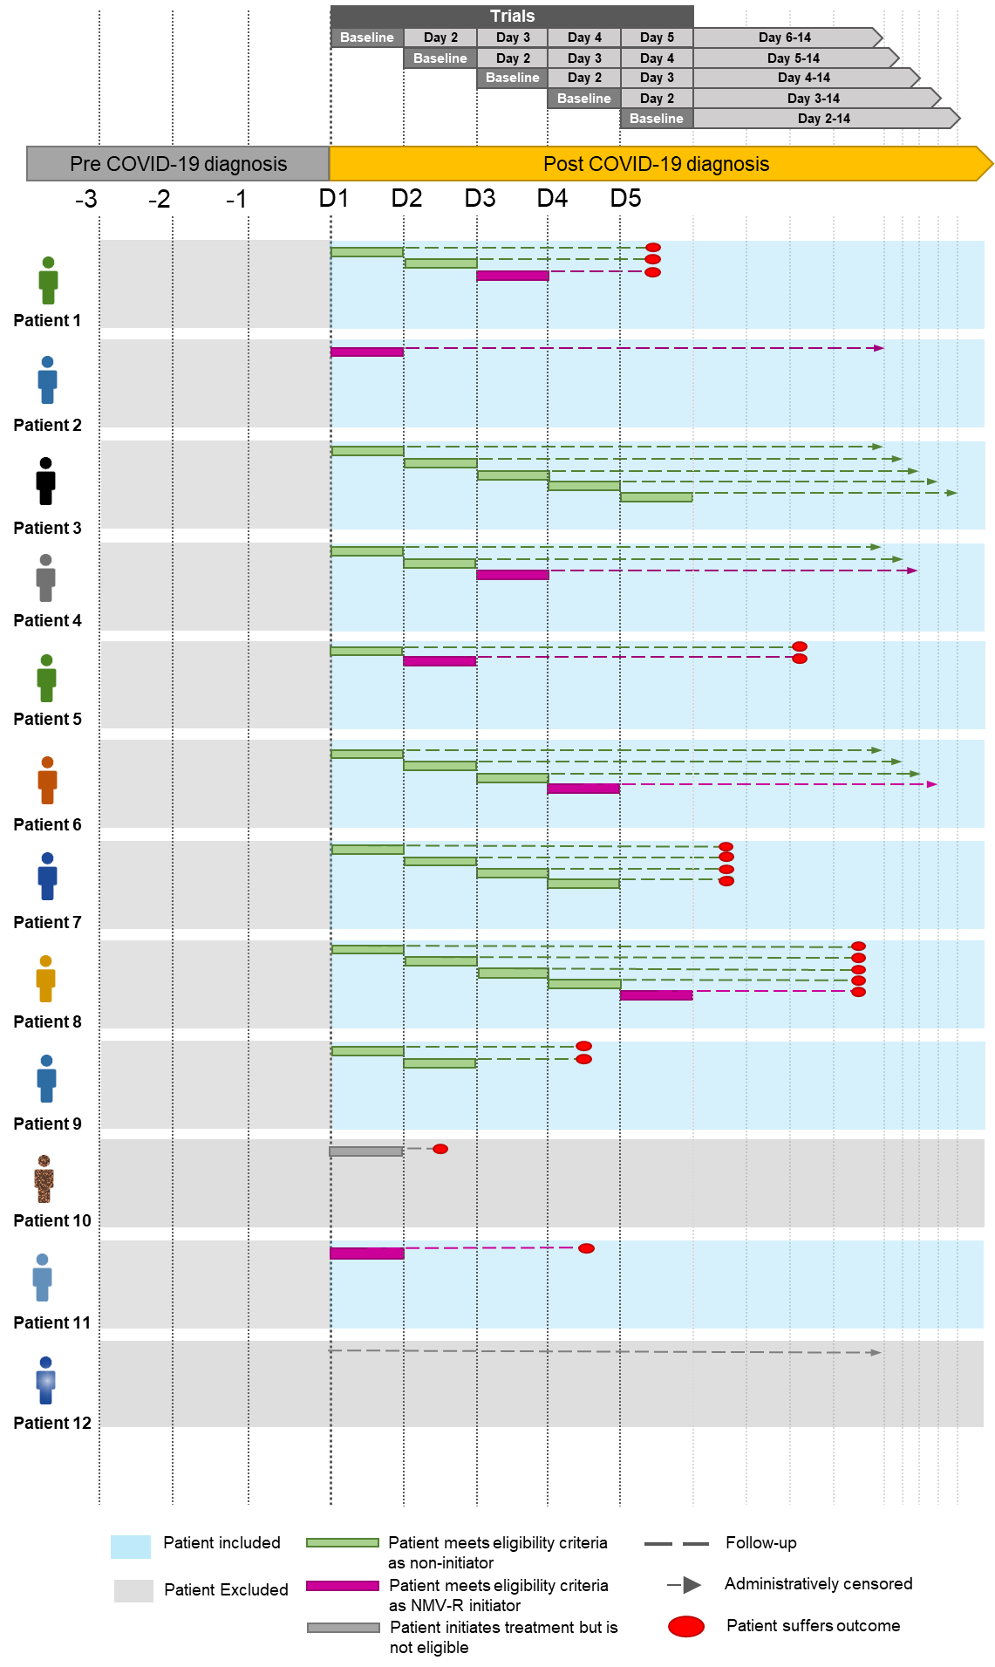
Supplementary Figure 1. Schematic displaying the sequential trial design applied in the present study. At the top of the figure, separate pseudo-trials begin on each of the first 5 days of COVID-19 diagnosis, with baseline for the trial re-initialized to begin on each successive day. In each trial, patients are identified who meet eligibility criteria. Patients are eligible to enter multiple trials if they meet eligibility criteria on each trial. This is shown as stacked and staggered follow-up lines in the figure. As can be seen, eligible non-initiators are able to enter each successive trial including when they initiate treatment. Treatment initiators are matched to 1 other non-initiator within the same trial if they have a similar propensity of initiating treatment on the start day (baseline) of the trial. After treatment is initiated, however, they are no longer eligible to enter subsequent trials. Other reasons for non-eligibility shown in the figure include experiencing the outcome within 24 hours of trial entry (oval). Eligible patients are followed up (dashed line) until the occurrence of the outcome or administrative censoring on day 14 (for long COVID, administrative censoring occurred on day 180), whichever came first. Patient 1 is eligible to enter trials 1-2 as a non-initiator, and trial 3 as an NMV-R initiator, after which he/she is no longer eligible to enter subsequent trials. Patient 1 is followed up until death on day 5. Patient 2 initiates treatment on day 1 (trial 1) and is followed up until administrative censoring. This patient does not enter subsequent trials as he/she has already initiated treatment previously. Patient 3 is eligible to enter all 5 trials as he/she never initiates treatment in the first 5 days since being diagnosed with COVID-19, and is followed up until administrative censoring in each trial. Patient 4 enters trials 1 and 2 as a non-initiator, and trial 3 as an initiator and is followed up until administrative censoring. Patient 5 enters trial 1 as a non-initiator, and enters trial 2 as an initiator of NMV-R treatment and is followed up the occurrence of the outcome which occurs before end of follow-up. Patient 5 does not enter subsequent trials because treatment was already initiated. Patient 6 enters trials 1-3 as a non-initiator, enters trial 4 as an initiator, and does not enter subsequent trials as treatment has already been initiated. He/she is followed up in each trial until administrative censoring in each trial. Patient 7 enters trial 1-4 as a non-initiator, but is no longer eligible to enter trial 5 since he/she experiences the outcome within 24 hours of this trial’s baseline. Patient 8 enters trials 1-4 as a non-initiator, trial 5 as a late NMV-R initiator, and does not enter subsequent trials because treatment was already initiated previously. He or she is followed up until the outcome occurs between before day 14. Patient 9 enters trials 1 and 2 as a non-initiator, but is not eligible to enter trial 3 (day 3) because he/she experiences the outcome within 24 hours of day 3’s baseline. Patient 10 initiates treatment on day 1 of COVID-19 diagnosis, but is not eligible to enter the study as he/she experiences the outcome within 24 hours of the trial on day 1. Patient 11 enters trial 1 as an early NMV-R initiator, and does not enter subsequent trials due to treatment already being initiated. The patient is followed until outcome occurrence on day 4. Patient 12 is not eligible to enter the study since he/she is discharged within 24 hours of being hospitalized (i.e., day 1). Patient 12 is not eligible to enter to enter any trial.

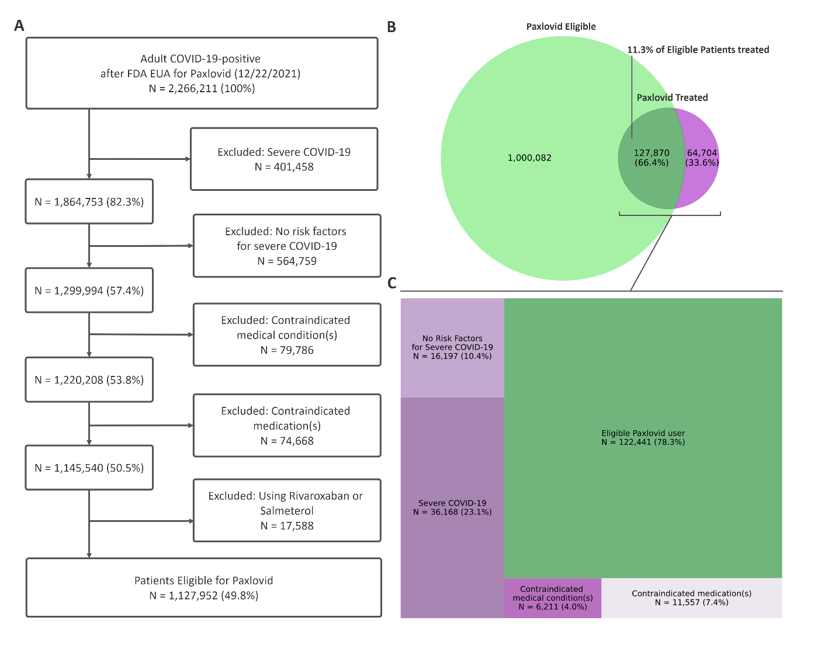
Supplementary Figure 2. (A) Flow diagram illustrating nirmatrelvir/ritonavir (NMV-R) eligibility exclusions adapted from FDA screening checklist applied to patients on day of COVID-19 diagnosis. (B) Venn diagram displaying overlap between patients eligible for NMV-R on day of COVID-19 diagnosis and those who received NMV-R (at any point following COVID-19 diagnosis). First, focusing on the large circle, of the 1,127,952 patients identified as eligible for NMV-R on day of COVID-19 diagnosis, only 11.3% of patients (in the dark green region) have record of NMV-R prescription. Second focusing on the smaller circle, of the 192,574 patients identified as having received a prescription for NMV-R on or at any point after COVID-19 diagnosis, 36.4% of patients (in the purple non-overlapping region) had a record of NMV-R treatment in the EHR but did not satisfy the FDA eligibility criteria. (C) Tree diagram showing the numeric breakdown for those patients with a record of NMV-R treatment being regarded as (retrospectively) ineligible for treatment. Ineligibility was primarily due to severe COVID-19 (i.e., hospitalization, ED visit, or death on day of diagnosis), followed by absence of severe COVD-19 risk factors, use of contraindicated medications, and presence of contraindicated medical conditions. Abbreviations: EUA = Emergency Use Authorization, FDA = US Food and Drug Administration, NMV-R = nirmatrelvir/ritonavir

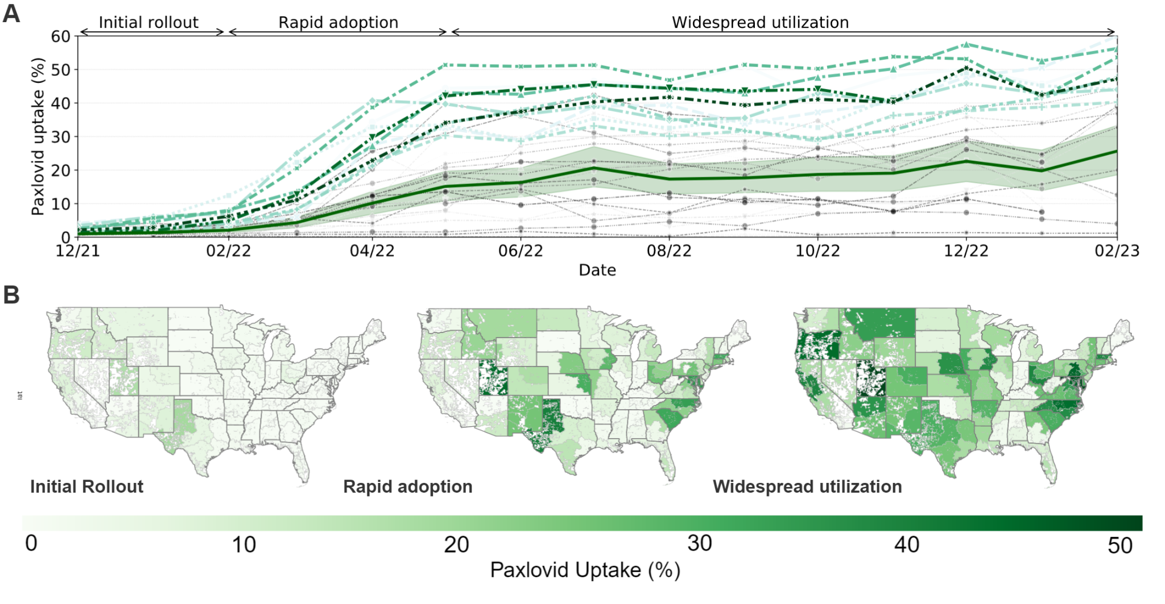
Supplementary Figure 3. Nirmatrelvir/ritonavir (NMV-R) uptake across follow-Up period of December 2021 to February 2023. (A) Line chart showing NMV-R uptake over time varying considerably between top adopters (colored lines) and remaining healthcare organizations (gray lines). Uptake segments into three phases: an initial rollout (12/21 to 2/22) followed by rapid adoption (2/22 to 5/22) and widespread utilization (5/22 and beyond), with average uptake stabilizing at approximately 15% (red line, shaded region is 95% CI). (B) Geospatial visualizations at 1/22, 5/22, and 1/23 show regional uptake variability.

References
1. Leese P, Anand A, Girvin A, Manna A, Patel S, Yoo YJ, Wong R, Haendel M, Chute CG, Bennett T et al: Clinical encounter heterogeneity and methods for resolving in networked EHR data: a study from N3C and RECOVER programs. Journal of the American Medical Informatics Association : JAMIA 2023, 30(6):1125-1136.
2. Crosskey M, McIntee T, Preiss S, Brannock D, Yoo YJ, Hadley E, Blancero F, Chew R, Loomba J, Bhatia A et al: Reengineering a machine learning phenotype to adapt to the changing COVID-19 landscape: A study from the N3C and RECOVER consortia. medRxiv : the preprint server for health sciences 2023:2023.2012.2008.23299718.
3. Pfaff ER, Girvin AT, Bennett TD, Bhatia A, Brooks IM, Deer RR, Dekermanjian JP, Jolley SE, Kahn MG, Kostka K et al: Identifying who has long COVID in the USA: a machine learning approach using N3C data. The Lancet Digital Health 2022, 4(7):e532-e541.
4. Austin PC: Optimal caliper widths for propensity-score matching when estimating differences in means and differences in proportions in observational studies. Pharmaceutical statistics 2011, 10(2):150-161.
5. Austin PC, Cafri G: Variance estimation when using propensity-score matching with replacement with survival or time-to-event outcomes. Statistics in medicine 2020, 39(11):1623-1640.
6. Harder VS, Stuart EA, Anthony JC: Propensity score techniques and the assessment of measured covariate balance to test causal associations in psychological research. Psychological methods 2010, 15(3):234-249.
7. Stuart EA: Matching methods for causal inference: A review and a look forward. Statistical science : a review journal of the Institute of Mathematical Statistics 2010, 25(1):1-21.
8. Xie Y, Choi T, Al-Aly Z: Association of Treatment With Nirmatrelvir and the Risk of Post–COVID-19 Condition. JAMA Internal Medicine 2023, 183(6):554–564.
9. Najjar-Debbiny R, Gronich N, Weber G, Khoury J, Amar M, Stein N, Goldstein LH, Saliba W: Effectiveness of Paxlovid in Reducing Severe Coronavirus Disease 2019 and Mortality in High-Risk Patients. Clinical Infectious Diseases 2023, 76(3):e342-e349.
10. Bajema KL, Berry K, Streja E, Rajeevan N, Li Y, Mutalik P, Yan L, Cunningham F, Hynes DM, Rowneki M et al: Effectiveness of COVID-19 Treatment With Nirmatrelvir–Ritonavir or Molnupiravir Among U.S. Veterans: Target Trial Emulation Studies With One-Month and Six-Month Outcomes. Annals of internal medicine 2023, 176(6):807-816.

