Supplementary Fig. 1 Flowchart of data collection and sorting procedures.
757,064 participants recruited
753,921 participants analyzed
•Demographic
•Pattern of age-specific positivity rates
•Population-level pathogen correlations
3,143 participants were not enrolled
•2740 participants without respiratory pathogen testing
•24 participants over 100 years of age
•301 participants with testing dates prior to October 1, 2023
•66 participants exhibited symptoms other than 'fever,' 'cough,' or 'asymptomatic' on or prior to January 1, 2024*
•54samples labeled as "pregnant or lactating" with age < 15 years or > 50 years; no participants labeled as "pregnant or lactating" were recorded as male
Underwent screening
232,719 participants tested positive for a single pathogen among the 7 pathogens
•Symptom composition
•Pathogen clustering
521,202 participants were not enrolled
•106,011 tested on or before January 1, 2024*
•61 with missing symptoms
• 415,130 observed co-detection of pathogens
Epidemic dynamics and age-specific distribution of respiratory pathogens
Underwent screening
*Symptom data collected between August 2023 and January 1, 2024, included only “fever” and “cough”. Additional symptoms were added to the questionnaire after January 1, 2024. Therefore, symptom-related analyses were restricted to participants tested after January 1, 2024, for whom complete symptom data were available.
Supplementary Table 1. Comparison of age, sex, region, season distribution, and symptom reporting rates between participants with self-reported symptoms but no pathogen detection and those with pathogen detection
Variable | Participants with pathogen detection*[n(%)] | Symptom reported without pathogen detection** [n(%)] | χ² | P | Cramér’s V
Gender† |  |  | 318.39 | < 0.001 | 0.0222
Male | 135,500(44.43) | 144,315(42.23)
Female | 169,443(55.57) | 197,405(57.77)
Age group(years)† |  |  | 6009.30 | < 0.001 | 0.0964
0-1 | 10,808(3.54) | 12,053(3.53)
2-5 | 40,064(13.14) | 39,980(11.70)
6-17 | 84,827(27.82) | 70,262(20.56)
18-59 | 151,003(49.52) | 198,548(58.1)
60-74 | 15,337(5.03) | 17,635(5.16)
75-100 | 2,904(0.95) | 3,242(0.95)
Region† |  |  | 959.85 | < 0.001 | 0.0385
North China | 139,259(45.67) | 146,971(43.01)
East China | 111,502(36.56) | 132,951(38.91)
South China | 50,532(16.57) | 55,444(16.22)
Southwest China | 3,650(1.20) | 6,354(1.86)
Season† |  |  | 872.07 | < 0.001 | 0.0367
spring | 65,272(21.40) | 72,817(21.31)
summer | 29,162(9.56) | 37,149(10.87)
autumn | 21,811(7.15) | 29,327(8.58)
winter | 188,698(61.88) | 202,427(59.24)
Symptoms‡
fever | 183,777(60.27) | 180,804(52.91) | 3550.47 | < 0.001 | 0.074
cough | 171,984(56.40) | 177,500(51.94) | 1290.83 | < 0.001 | 0.045
throat pain | 75,179(29.62) | 119,337(34.92) | 1863.92 | < 0.001 | 0.056
sneeze/rhinorrhea | 84,080(33.12) | 102,406(29.97) | 674.16 | < 0.001 | 0.034
expectoration | 49,343(19.44) | 66,396(19.43) | 0.01 | 0.935 | 0
nasal obstruction | 75,723(29.83) | 96,052(28.11) | 210.53 | < 0.001 | 0.019
hoarseness | 32,774(12.91) | 49,213(14.40) | 272.34 | < 0.001 | 0.021
muscle soreness | 49,088(19.34) | 68,636(20.09) | 51.23 | < 0.001 | 0.009
headache | 58,811(23.17) | 81,150(23.75) | 27.12 | < 0.001 | 0.007
emesis | 10,712(4.22) | 17,047(4.99) | 193.44 | < 0.001 | 0.018
diarrhea | 5,788(2.28) | 13,838(4.05) | 1430.21 | < 0.001 | 0.049
*Samples with pathogen detection. **Samples with reported symptoms but negative for all seven pathogens. †Proportion. ‡Symptom reporting rate.

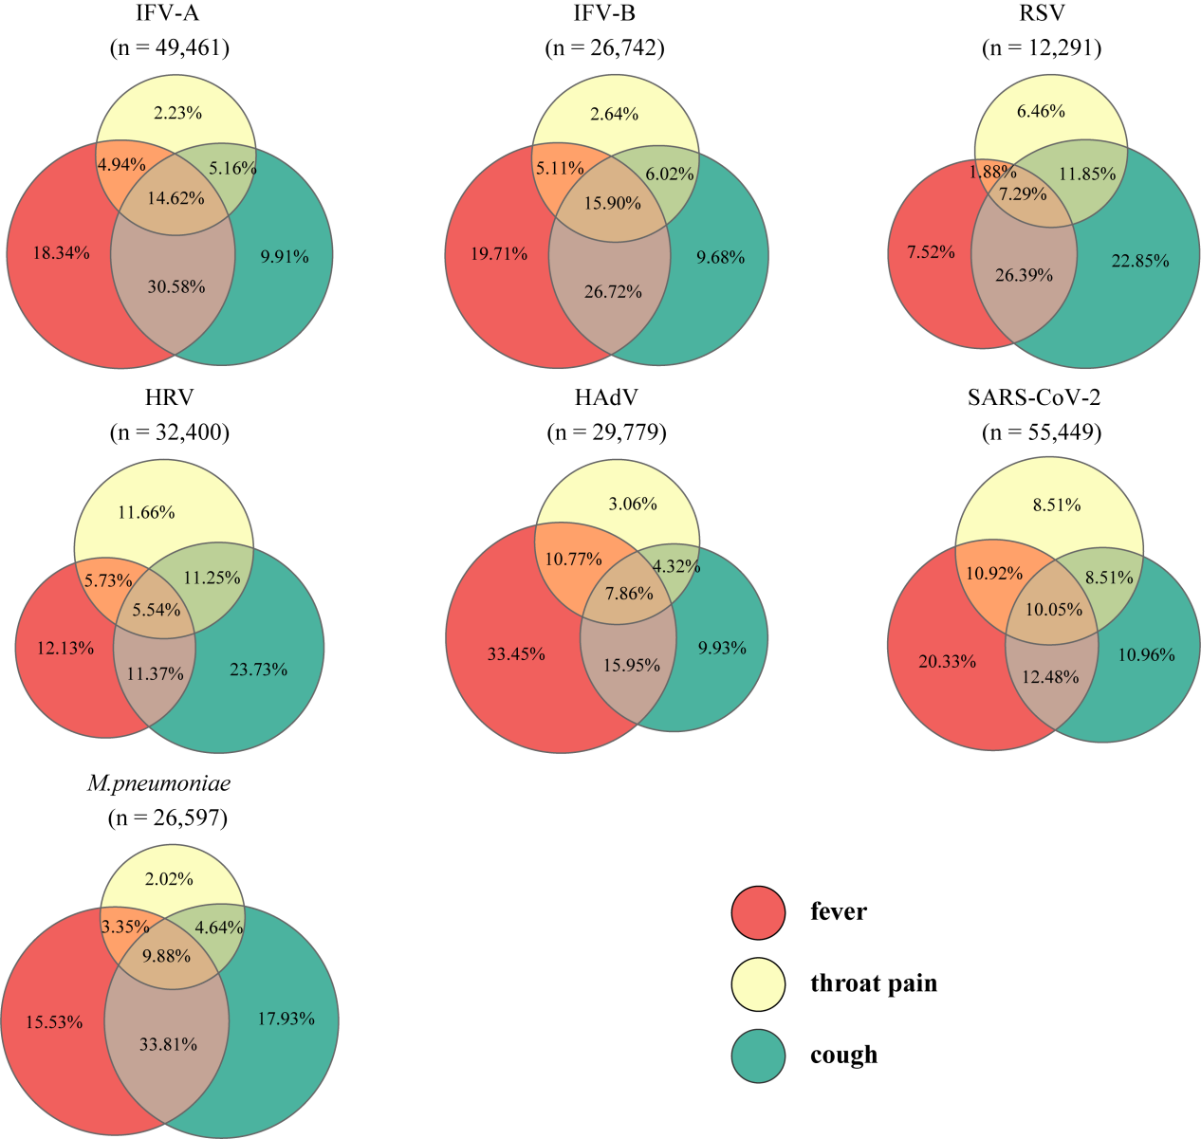

Supplementary Fig. 2 Proportional Venn diagram of symptom overlap among 7 pathogens without co-detection.

