Supplementary Material
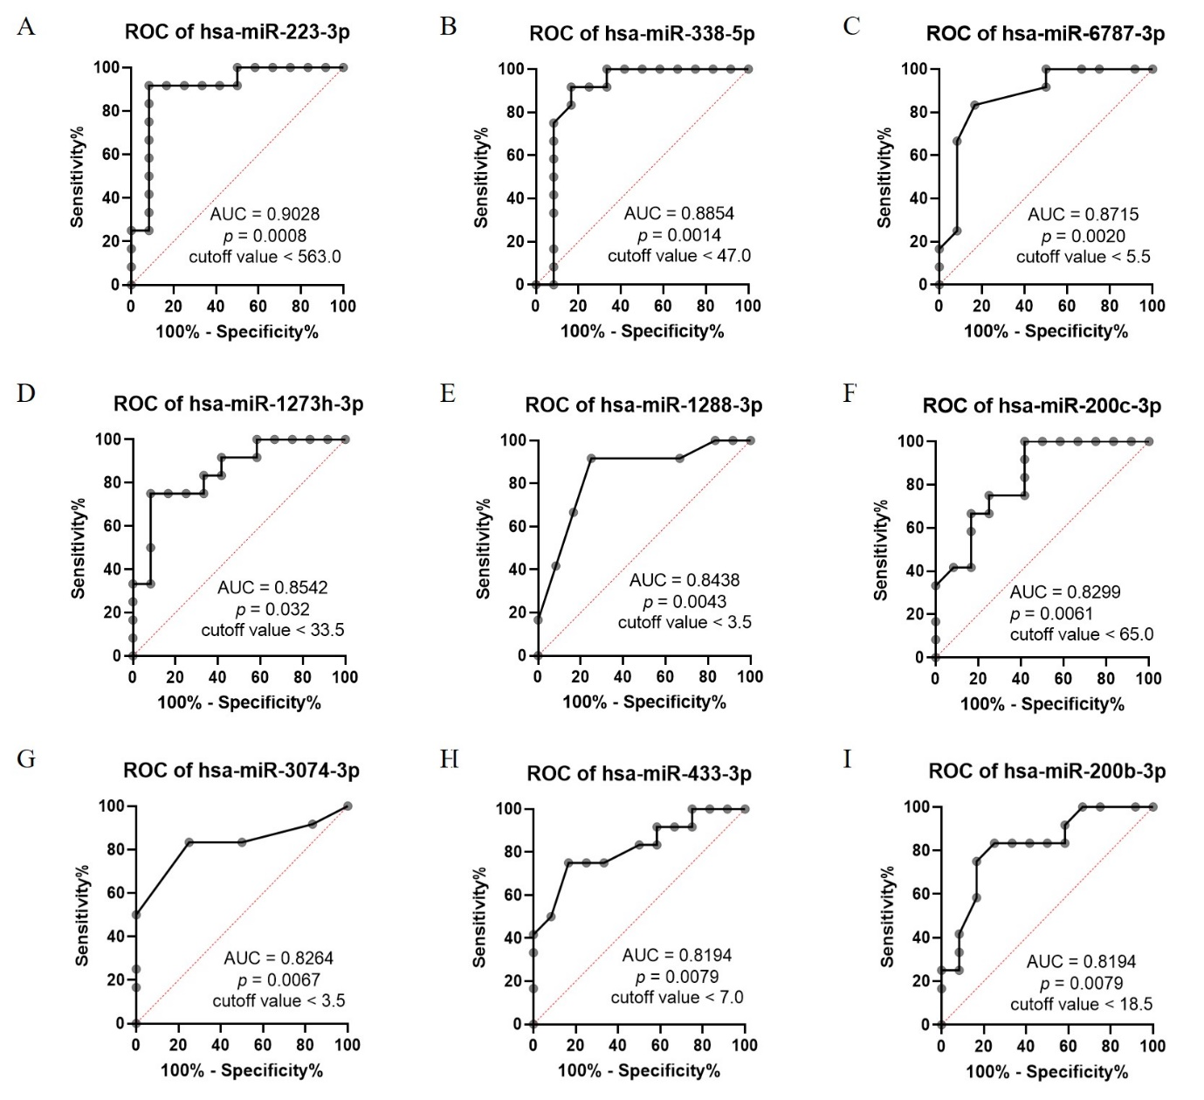
Supplementary Figure 1. ROC curve analysis of the top nine miRNAs. The optimal cutoff value for (A) miR-223-3p, (B) miR-338-5p, (C) miR-6787, (D) miR-1273h-3p, (E) miR-1288-3p, (F) miR-200c-3p, (G) miR-3074-3p, (H) miR-433-3p, and (I) miR-200b-3p was calculated using ROC curve analysis.
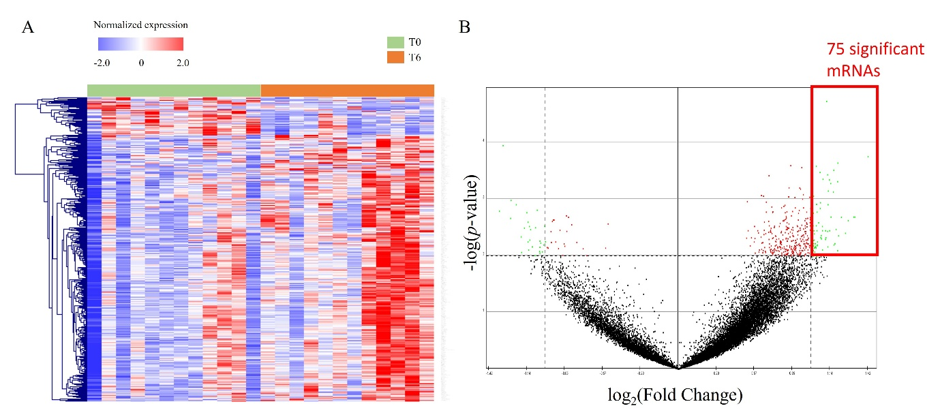
Supplementary Figure 2. Heat map and volcano plot of differentially expressed mRNAs in the whole blood of patients with active tuberculosis (T0) and those who have completed anti-tuberculosis treatment (T6). (A) Heatmap showing differentially expressed mRNAs between patients at T0 and T6, identified by Pearson correlation analysis (p < 0.01) and visualized using hierarchical clustering. Upregulated mRNAs are indicated in red, whereas downregulated mRNAs are shown in blue. (B) Volcano plot of mRNAs between patients with T0 and those with T6. The x-axis represents the difference between the mean mRNA expression values of the T6 and T0 groups (T6 − T0). Cutoff points for the p value (< 0.01; -log 10 (0.01) = 2.00) or log₂ (fold change) are indicated using dotted lines.
Supplementary Table 1. Characteristics of nine miRNAs in previous studies
miRNAs | Potential target genes in our study | Association with disease | Functions | Reference
miR-223-3p | AFF3 and NT5C1B | Viral hepatitis, HIV, COVID-19, TB, and sepsis | It influences neutrophil infiltration, macrophage function, dendritic cell (DC) maturation, and inflammasome activation. | Yuan et al. [1] and Houshmandfar et al. [2]
miR-338-5p | AFF3, HIC2, HPCAL4, PDE7B, SPATA25, SPHK2, UBE3D, and ZFYVE9 | Tumor progression | It plays a role in tumor progression by regulating WNT, MAPK, and PI3K/AKT signaling pathways. | [3]
miR-6787-3p | DTX1, HPCAL4, METTL2A, NTMT1, PDE7B, PEG10, TMEM139, and ZFYVE9 | Colorectal cancer | It is involved in a potential epigenetic mechanism induced by RAPA therapy in the regulation of the pre-metastatic niche of post-transplant colorectal cancer. | [4]
miR-1273h-3p | HTR7, LRRC8E, METTL2A, PDE7B, PLD4, and RGS5 | - | - | -
miR-1288-3p | AFF3, ANKRD23, DEPTOR, EME2, FAAP100, GPR135, HPCAL4, PDE7B, RGS5, SEMA4G, SMCO3, and TIGD5 | Colorectal cancer | RERG, the regulator of the Ras/ERK pathway, is the target gene of miR-1288. | [5]
miR-200c-3p | EME2, PEG10, and TIGD5 | TB and lung adenocarcinoma | It serves as a regulator in cells that undergo epithelial-mesenchymal transformation. | [6]
miR-3074-3p | HIC2, IMMP2L, METTL2A, NTMT1, RGS5, and TIGD5 | Zaire ebolavirus | It affects innate and adaptive immune responses, cellular metabolism, cell cycle progression, apoptosis,  and autophagy. | [7]
miR-433-3p | DDTL, DEPTOR, HPCAL4, and SMCO3 | Glioma | It restrains the proliferation, migration, and invasion of glioma cells. | You et al. [8] and Zhang et al. [9]
miR-200b-3p | AFF3, LYSMD4, PDE7B, PEG10, and TMEM134 | Tumor progression | It inhibits proliferation, invasion, and migration | [10]

References
1. Yuan S, Wu Q, Wang Z, Che Y, Zheng S, Chen Y, et al. miR-223: An immune regulator in infectious disorders. Front Immunol. 2021;12:781815. doi: 10.3389/fimmu.2021.781815.
2. Houshmandfar S, Khodadadi A, Mahmoudian-Sani MR, Nashibi R, Rashno M. Comparing the expression of MiR-223-NLRP3-IL-1β axis and serum IL-1β levels in patients with severe COVID-19 and healthy individuals. Immunobiology. 2023;228:152710. doi: 10.1016/j.imbio.2023.152710.
3. Moghbeli M. Molecular interactions of miR-338 during tumor progression and metastasis. Cell Mol Biol Lett. 2021;26:13. doi: 10.1186/s11658-021-00257-w.
4. Tubita V, Segui-Barber J, Lozano JJ, Banon-Maneus E, Rovira J, Cucchiari D, et al. Effect of immunosuppression in miRNAs from extracellular vesicles of colorectal cancer and their influence on the pre-metastatic niche. Sci Rep. 2019;9:11177. doi: 10.1038/s41598-019-47581-y.
5. Hou R, Liu Y, Su Y, Shu Z. Overexpression of long non-coding RNA FGF14-AS2 inhibits colorectal cancer proliferation via the RERG/Ras/ERK signaling by sponging microRNA-1288-3p. Pathol Oncol Res. 2020;26:2659–67. doi: 10.1007/s12253-020-00862-8.
6. Mirzaei R, Babakhani S, Ajorloo P, Ahmadi RH, Hosseini-Fard SR, Keyvani H, et al. The emerging role of exosomal miRNAs as a diagnostic and therapeutic biomarker in Mycobacterium tuberculosis infection. Mol Med. 2021;27:34. doi: 10.1186/s10020-021-00296-1.
7. Oliver GF, Orang AV, Appukuttan B, Marri S, Michael MZ, Marsh GA, et al. Expression of microRNA in human retinal pigment epithelial cells following infection with Zaire Ebolavirus. BMC Res Notes. 2019;12:639. doi: 10.1186/s13104-019-4671-8.
8. You A, Rao G, Wang J, Li J, Zhang Y, Gu J, et al. MiR-433-3p restrains the proliferation, migration and invasion of glioma cells via targeting SMC4. Brain Res. 2021;1767:147563. doi: 10.1016/j.brainres.2021.147563.
9. Zhang J, Guo Y, Ma Y, Wang L, Li W, Zhang M, et al. miR-433-3p targets AJUBA to inhibit malignant progression of glioma. Neuroimmunomodulation. 2022;29:44–54. doi: 10.1159/000518084.
10. Chen S, Tu Y, Yuan H, Shi Z, Guo Y, Gong W, et al. Regulatory functions of miR-200b-3p in tumor development ((Review). Oncol Rep. 2022;47:96. doi: 10.3892/or.2022.8307.

