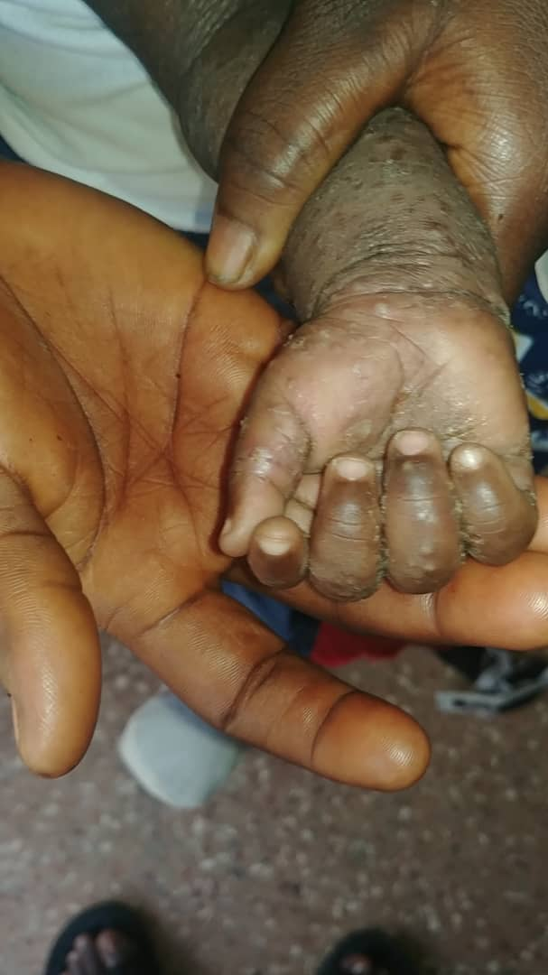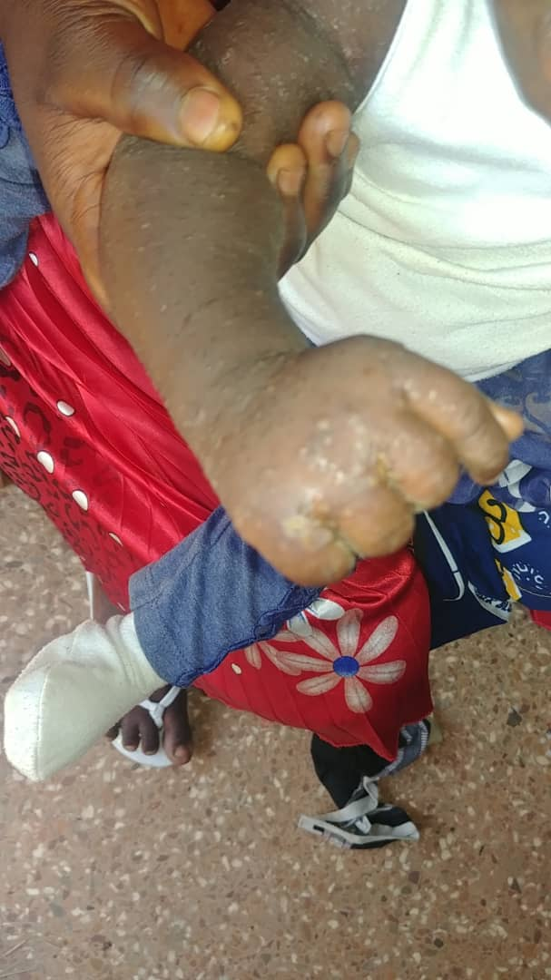
Supplementary Figure 1: Pimple-like Scabies Blisters on a Toddlers Right Hand

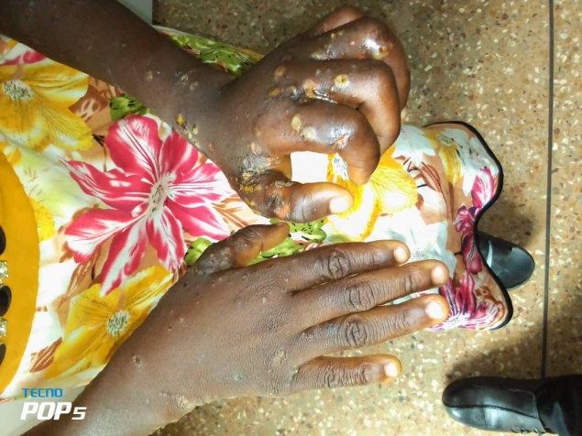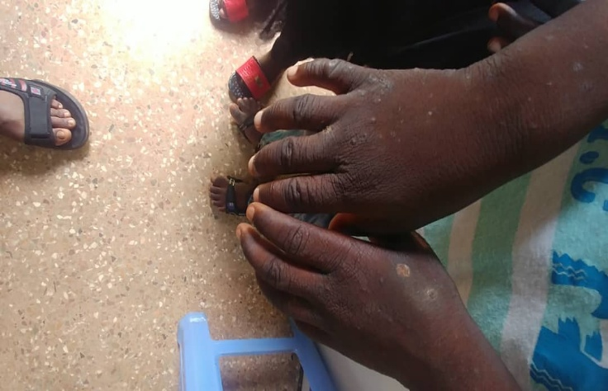
Supplementary Figure 2: Infected Scabies Blisters and Pustules on the Hands and Inter-digital Areas of a Child’s (Left) and Adult’s (Right) Hands

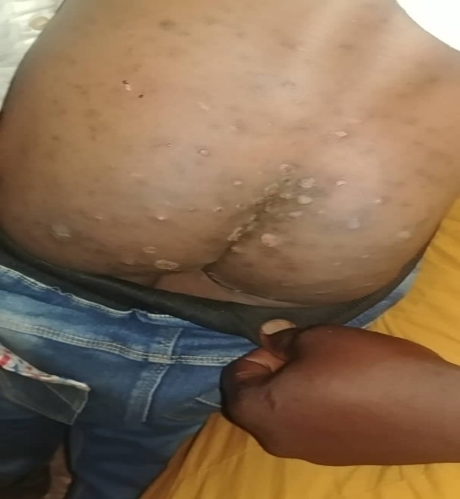
Supplementary Figure 3: Scabies Pustules and Rashes on a Child’s Buttocks (Left)

