Additional file
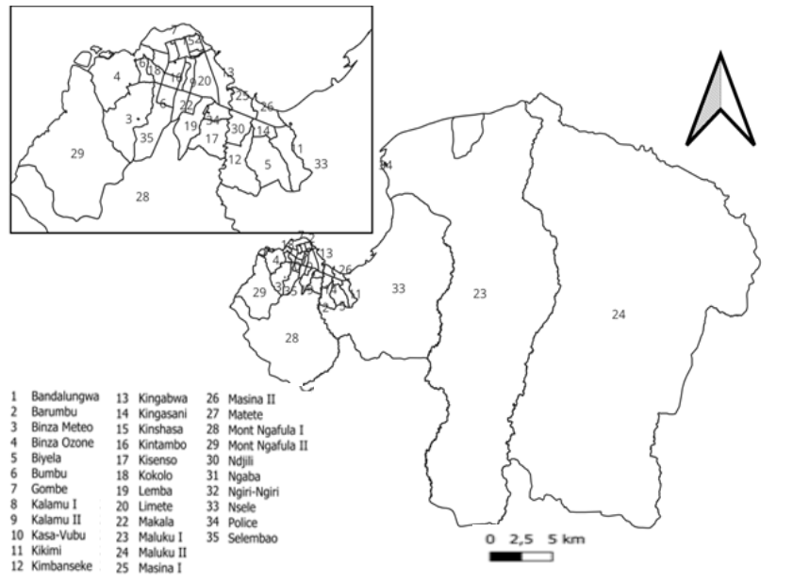
S1. Descriptive map of Kinshasa at the heath zone level
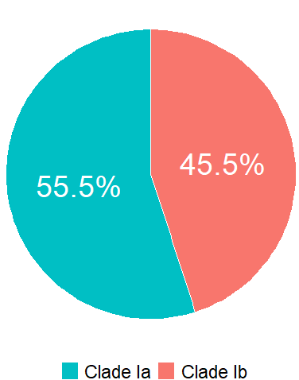
S2. Distribution of clades among PCR-confirmed Mpox cases, Kinshasa, 2024–2025

