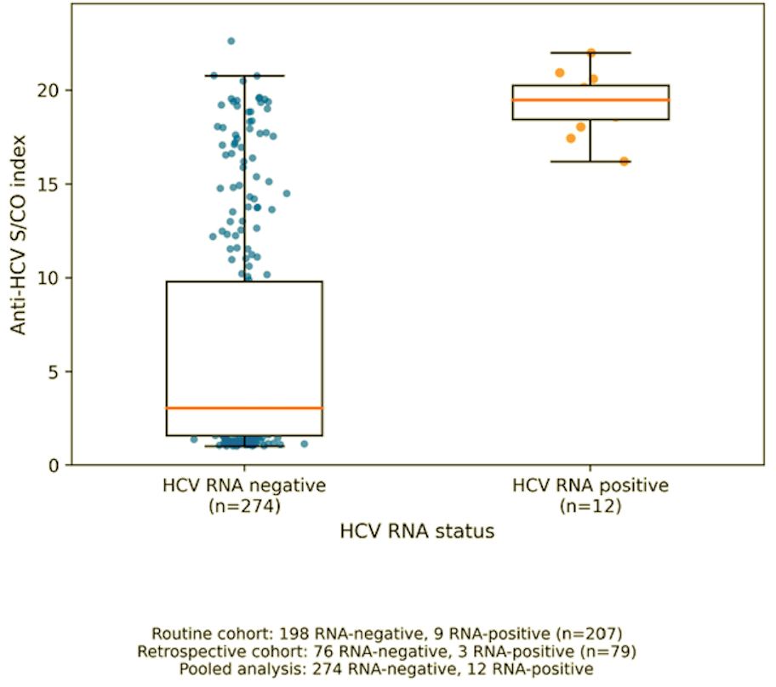

Supplementary Figure S1. Distribution of anti-HCV signal-to-cutoff (S/CO) ratios according to HCV RNA status. Anti-HCV S/CO ratios were compared between HCV RNA-negative and HCV RNA-positive patients. HCV RNA-positive cases included both patients identified through routine confirmatory testing and those identified through retrospective testing without an initial clinician request. Similarly, HCV RNA-negative cases included both routinely tested and retrospectively tested patients in the pooled analysis. The figure illustrates the distribution of anti-HCV S/CO ratios according to HCV RNA status.

