Supplementary Material 1
This file contains supplementary tables S1-S5 and figures S1-S5, including model hyperparameters, the definition of the SeasonalNaive52 baseline comparator, and additional results.

Supplementary Methods
- Data preprocessing and feature engineering

1.1 Data quality control

The data cleaning process comprised three steps: outlier detection and handling, missing-value imputation and data integrity checks. Outliers were identified using the boxplot method (Tukey’s method), with the interquartile range (IQR) as the reference. Values falling outside the range Q1 − 3 × IQR or Q3 + 3 × IQR were flagged as potential outliers. All flagged values were then reviewed manually, drawing on epidemiological expertise to determine whether they represented true extreme events (e.g. peaks during severe epidemic seasons) or data collection errors. Values confirmed as erroneous were replaced using linear interpolation or the mean of the preceding and subsequent time windows, whereas true extreme values were retained.

Missing-value handling was tailored to the pattern of missingness. For data missing completely at random (MCAR) with a missing proportion < 5%, linear interpolation was applied. When the proportion of missing data was between 5% and 10%, a moving average imputation based on neighbouring time windows was used. For weeks with > 10% missing data, the data provider was contacted for verification and a decision was then made on whether to include these observations in the analysis. During data alignment, ISO week codes were used as the primary key to merge influenza surveillance data, web search data, meteorological data and air quality data by timestamp, thereby generating a unified multi-source time-series dataset and ensuring complete temporal correspondence across all variables.

1.2 Aggregation of meteorological variables

Meteorological data were obtained from the China Meteorological Data Service Center (http://data.cma.cn/). The final meteorological dataset used for modelling was organised at the prefecture-level city scale. For each city-day record, daily minimum temperature and daily maximum temperature were extracted, and daily diurnal temperature range (DTR) was calculated as daily maximum temperature minus daily minimum temperature. To align the daily meteorological data with the weekly influenza surveillance data, daily meteorological variables were aggregated within each city and ISO epidemiological week using arithmetic means. Specifically, weekly DTR was calculated as the mean of daily DTR values within the corresponding city-week. Therefore, the weekly DTR represents the average daily within-day temperature fluctuation during that week, rather than the difference between the highest and lowest temperatures observed over the whole week. The resulting city-week meteorological variables were merged with city-level weekly ILI+ records using city name and ISO epidemiological week code.

- Exploratory data analysis and feature combinations

2.1 Construction of the time-series dataset

On the basis of the collected multi-source data, we constructed a unified time-series dataset. All records were aligned using ISO week codes to ensure temporal consistency across data sources. To eliminate the impact of differing measurement scales on model training, all variables were normalised to the [0, 1] range using a MinMaxScaler approach. The resulting time-series dataset covered epidemiological weeks 1/2020 to 52/2024 and comprised four dimensions: influenza surveillance data, web search data, meteorological data and air quality data.

2.2 Lagged time-series association analysis

To account for serial autocorrelation in weekly time-series data, we used prewhitened cross-correlation functions and expanding-window time-series cross-validation to assess lagged associations between candidate predictors and ILI+. Spearman correlation was retained only as descriptive exploratory information, not as the primary basis for predictor selection.

Lagged association results were used to describe temporal relationships and to guide forecast-origin-valid feature construction; simple contemporaneous Spearman coefficients were not used as a standalone predictor-selection rule.

To systematically evaluate the contribution of different data sources to predictive performance, we designed four feature-combination strategies. The first combination used historical ILI+ data alone as the ILI-only feature configuration. The second combined ILI+ with the Baidu Search Index to assess the predictive value of web search behaviour. The third added air quality (AQI) to the previous combination to explore the synergistic role of air quality factors. The fourth included all available variables (ILI+, search indices, meteorological variables and air quality) to construct a full multi-source feature-level integration model. This progressive design followed the logic of moving from surveillance-only predictors to behavioural signals and then to environmental factors, thereby facilitating quantification of the incremental contribution of each data source.
- Prediction models

To comprehensively evaluate the predictive performance of different modelling approaches, we selected five representative machine-learning algorithms and one simple baseline comparator. Gated recurrent unit (GRU) and long short-term memory (LSTM) networks, as variants of recurrent neural networks, are well suited to capturing long-term dependencies in time-series data; random forest (RF) and LightGBM, as ensemble learning methods, perform well in modelling nonlinear relationships and high-order feature interactions; and the stacked autoencoder (SAE) uses deep learning to automatically learn abstract representations of the data. The SeasonalNaive52 baseline comparator was included to assess whether the machine-learning models improved forecasting performance beyond simple annual seasonal recurrence.

3.1 Long short-term memory network (LSTM)

The long short-term memory (LSTM) network, a variant of the recurrent neural network (RNN), introduces a cell state and three gating mechanisms to effectively address the problem of long-term dependencies. In this study, a two-layer stacked LSTM architecture was employed, and regularisation techniques were applied to mitigate overfitting. The core computations of the model are as follows:
$$\begin{aligned}\left\{\begin{matrix}f_{t} & =σ\left(W_{f}[h_{t−1},x_{t}]+b_{f}\right) \\ i_{t} & =σ\left(W_{i}[h_{t−1},x_{t}]+b_{i}\right) \\ {\tilde{C}}_{t} & =\tanh\left(W_{c}[h_{t−1},x_{t}]+b_{c}\right) \\ C_{t} & =f_{t}⊙C_{t−1}+i_{t}⊙{\tilde{C}}_{t} \\ o_{t} & =σ\left(W_{o}[h_{t−1},x_{t}]+b_{o}\right) \\ h_{t} & =o_{t}⊙\tanh{(}C_{t})\end{matrix}\right.\#(2)\end{aligned}$$
where ${\text{x}}_{\text{t}}$ is the input vector at time $\text{t}$, ${\text{h}}_{\text{t}}$ is the hidden state, ${\text{c}}_{\text{t}}$ is the cell state, $\text{σ}$ denotes the sigmoid activation function, $\text{⊙}$ denotes element-wise multiplication, $\text{W}$ represents the weight matrices and $\text{b}$ the bias vectors.

The LSTM model incorporates memory cells and gating mechanisms to capture long-term temporal dependencies in the influenza time series. The core computations are expressed as follows:

Table S1 Hyperparameters and training configuration of the LSTM model.
Category | Hyperparameter | Value | Definition
Model architecture | input_window | 7 | Length of input sequence (weeks)
 | output_window | 3 | Prediction horizon (weeks ahead)
 | hidden_size | 64 | Dimensionality of LSTM hidden layer
 | num_layers | 2 | Number of stacked LSTM layers
 | fc1_dim | 32 | Size of the first fully connected layer
 | output_size | 1 | Output dimension (predicted ILI+)
Regularisation | dropout | 0.2 | Dropout rate
 | weight_decay | 1×10⁻⁴ | L2 regularisation coefficient
 | max_grad_norm | 1.0 | Gradient clipping threshold
Training configuration | batch_size | 16 | Maximum batch size
 | epochs | 500 | Number of training epochs
 | learning_rate | 0.001 | Initial learning rate
 | optimizer | Adam | Optimisation algorithm
 | loss_function | MSE | Loss function
Data split | train_ratio | 0.7 | Proportion of training samples
 | test_ratio | 0.3 | Proportion of test samples
Uncertainty estimation | mc_samples | 100 | Number of Monte Carlo dropout samples
 | confidence_interval | 95% | Prediction confidence interval
The LSTM model also employed MC dropout for uncertainty quantification, with 100 Monte Carlo samples used to estimate the 95% confidence interval.

3.2 Gated recurrent unit (GRU)
The gated recurrent unit (GRU) is a type of recurrent neural network architecture. Compared with LSTM, GRU contains only two gating mechanisms (the update gate and the reset gate) and is therefore more computationally efficient. In this study, we employed a two-layer stacked GRU model with regularisation to prevent overfitting, using the sigmoid function as the activation function.
$$\begin{aligned}\left\{\begin{matrix}z_{t} & =σ\left(W_{z}X_{t}+U_{z}h_{t−1}+b_{z}\right) \\ r_{t} & =σ\left(W_{r}X_{t}+U_{r}h_{t−1}+b_{r}\right) \\ {\tilde{h}}_{t} & =\tanh\left(W_{h}X_{t}+U_{h}\left(r_{t}⊙h_{t−1}\right)+b_{h}\right) \\ h_{t} & =(1−z_{t})⊙h_{t−1}+z_{t}⊙{\tilde{h}}_{t}\end{matrix} \right.\#(3)\end{aligned}$$
where ${\text{x}}_{\text{t}}$ denotes the input vector at time $\text{t}$, ${\text{h}}_{\text{t}}$ the hidden state, $\text{σ}\left(\text{⋅}\right)$ the sigmoid activation function and $\text{⊙}$ element-wise multiplication; $\text{W}$ and $\text{b}$ represent the weight matrices and bias vectors, respectively.

The GRU model captures temporal dependencies in sequential influenza data through its update and reset gating mechanisms, which regulate information flow across time steps. The core computations are defined as follows:

Table S2 Hyperparameters and training configuration of the GRU model.
Category | Hyperparameter | Value | Definition
Model architecture | input_window | 7 | Length of input sequence (weeks)
 | output_window | 3 | Prediction horizon (weeks ahead)
 | hidden_size | 64 | Dimensionality of GRU hidden layer
 | num_layers | 2 | Number of stacked GRU layers
 | fc1_dim | 32 | Size of the first fully connected layer
 | output_size | 1 | Output dimension (predicted ILI+)
Regularisation | dropout | 0.2 | Dropout rate
 | weight_decay | 1×10⁻⁵ | L2 regularisation coefficient
 | max_grad_norm | 1.0 | Gradient clipping threshold
Training configuration | batch_size | 16 | Maximum batch size
 | epochs | 500 | Number of training epochs
 | learning_rate | 0.001 | Initial learning rate
 | optimizer | Adam | Optimisation algorithm
 | loss_function | MSE | Loss function
Data split | train_ratio | 0.7 | Proportion of training samples
 | test_ratio | 0.3 | Proportion of test samples
Uncertainty estimation | mc_samples | 100 | Number of Monte Carlo dropout samples
 | confidence_interval | 95% | Prediction confidence interval

3.3 Stacked autoencoder (SAE)
The stacked autoencoder (SAE) is a deep neural network architecture that first uses unsupervised pretraining to learn low-dimensional representations of the data and then applies supervised fine-tuning for time-series prediction. This approach can automatically extract high-level feature patterns from time-series data. In this study, a two-stage training strategy was adopted: feature learning was performed using the autoencoder in the first stage, followed by supervised training of the prediction layer in the second stage. The core computations of the model are as follows:
$$\begin{aligned}\left\{\begin{matrix}h & =f\left(W_{e}x+b_{e}\right) \\ \hat{x} & =g\left(W_{d}h+b_{d}\right) \\ \hat{y} & =σ\left(W_{p}h+b_{p}\right)\end{matrix}\right.\#(4)\end{aligned}$$
where $\text{x}$ denotes the input features, $\text{h}$ the encoded hidden representation, $\hat{\text{x}}$ the reconstructed output, and $\hat{\text{y}}$ the predicted output; $\text{f}$ and $\text{g}$ is the ReLU activation function, $\text{σ}$ the sigmoid activation function, and ${\text{W}}_{\text{e}}$,${\text{W}}_{\text{d}}$,${\text{W}}_{\text{p}}$ and ${\text{b}}_{\text{e}}$,${\text{b}}_{\text{d}}$,${\text{b}}_{\text{p}}$ denote the weight matrices and bias vectors, respectively.
The stacked autoencoder (SAE) model learns hierarchical latent representations of the influenza time series through layer-wise encoding and decoding, enabling nonlinear feature extraction prior to supervised prediction. The core computations involve transforming the input sequence into a lower-dimensional latent space and reconstructing or predicting outputs through fully connected decoder layers.
Table S3 SAE model architecture and hyperparameters.
Category | Hyperparameter | Value | Definition
Model architecture | input_window | 7 | Length of input sequence (weeks)
 | output_window | 3 | Prediction horizon (weeks ahead)
 | hidden_sizes | [128, 64, 32] | Dimensions of encoder layers
 | output_size | 1 | Output dimension (predicted ILI+)
Regularisation | dropout | 0.3 | Dropout rate applied to fully connected layers
Training configuration | pretrain_epochs | 100 | Number of unsupervised pretraining epochs
 | epochs | 200 | Number of supervised fine-tuning epochs
 | batch_size | 16 | Batch size
 | learning_rate | 0.001 | Learning rate
 | optimizer | Adam | Optimisation algorithm
 | pretrain_loss | MSE | Reconstruction loss during pretraining
 | finetune_loss | MSE | Prediction loss during fine-tuning
Data split | train_ratio | 0.7 | Proportion of training samples
 | test_ratio | 0.3 | Proportion of test samples
Uncertainty estimation | mc_samples | 100 | Number of Monte Carlo dropout samples
 | confidence_interval | 95% | Prediction confidence interval

3.4 Random forest (RF)
Random forest (RF) is an ensemble learning method that constructs multiple decision trees and aggregates their predictions to enhance the model’s generalisation ability and robustness. Compared with a single decision tree, a random forest can effectively reduce the risk of overfitting. In this study, a multi-output regression strategy was adopted, whereby an independent random forest model was trained for each forecasting horizon to capture patterns specific to different prediction time steps. The ensemble prediction of the model is given by:
$$\begin{aligned}\hat{\text{y}}\text{=}\frac{\text{1}}{\text{T}}\sum_{\text{t}\text{=1}}^{\text{T}}{{\text{h}}_{\text{t}}}\left(\text{x}\right)\#(5)\end{aligned}$$
where $\text{T}$ denotes the number of decision trees and${\text{h}}_{\text{t}}\left(\text{x}\right)$ the prediction function of the $\text{t}$-th tree.
The random forest (RF) model is an ensemble learning method that constructs multiple decision trees using bootstrap samples of the training data and aggregates their predictions to improve robustness and generalisation. Each tree is trained on a subset of the data with random feature selection at each split, enabling the model to capture nonlinear relationships and higher-order interactions in the influenza time series.
Table S4 Random forest model hyperparameters.
Category | Hyperparameter | Value | Definition
Model architecture | n_estimators | 100 | Number of decision trees in the ensemble
 | max_depth | 10 | Maximum depth of each tree
 | min_samples_split | 5 | Minimum number of samples required to split an internal node
 | min_samples_leaf | 2 | Minimum number of samples required at a leaf node
 | random_state | 42 | Random seed for reproducibility
 | n_jobs | -1 | Use all CPU cores for parallel training
Data split | train_ratio | 0.7 | Proportion of training samples
 | test_ratio | 0.3 | Proportion of test samples
Uncertainty estimation | bootstrap_samples | 100 | Number of bootstrap replicates for uncertainty quantification
To assess the reliability of the forecasts, we used a bootstrap approach to estimate prediction confidence intervals. For each trained random forest model, 100 bootstrap resamples were generated; in each resample, 50% of the decision trees were randomly selected, and the mean of their predictions was taken as one bootstrap replicate. On the basis of these 100 bootstrap replicates, 95% confidence intervals were then calculated for the model predictions.

3.5 LightGBM-based quantile regression
LightGBM is an efficient algorithm based on gradient boosting decision trees (GBDT) that can be used to quantify predictive uncertainty via quantile regression. In this study, a multi-step, multi-quantile strategy was adopted, whereby an independent model was trained for each forecasting horizon and target quantile, allowing simultaneous multi-step prediction and confidence interval estimation. The quantile loss function of the model is defined as follows:
Lαy,y=i:yi≥yi​αyi−yi+i:yi<yi​1−αyi−yi#(6)
where $\text{τ}$ denotes the target quantile, $\text{y}$ the observed value and $\hat{\text{y}}$ the predicted value. In this study, we used three quantiles to estimate the lower bound, median and upper bound of the predictive distribution.
The LightGBM quantile regression model is a gradient boosting framework that constructs an ensemble of decision trees to estimate conditional quantiles of the influenza time series. By optimising the quantile loss function for multiple quantile levels, the model provides probabilistic forecasts and predictive intervals rather than point estimates. Leaf-wise tree growth and histogram-based splitting enable efficient learning on tabular time-series features. This model was trained separately for the 0.025, 0.5, and 0.975 quantiles to derive the 95% prediction interval.

Table S5 Hyperparameters of the LightGBM quantile regression model.
Category | Hyperparameter | Value | Definition
Model architecture | n_estimators | 200 | Number of boosting iterations
 | learning_rate | 0.05 | Learning rate
 | max_depth | 8 | Maximum depth of each tree
 | num_leaves | 31 | Maximum number of leaves in a tree
 | min_child_samples | 20 | Minimum number of samples in a leaf
 | subsample | 0.8 | Fraction of samples used for training (bagging)
 | colsample_bytree | 0.8 | Fraction of features used at each iteration
 | random_state | 42 | Random seed for reproducibility
Quantile regression | quantiles | [0.025, 0.5, 0.975] | Target quantiles for lower, median, and upper predictions
 | objective | quantile | Loss function for quantile regression
 | early_stopping_rounds | 50 | Number of rounds for early stopping
Data split | train_ratio | 0.7 | Proportion of training samples
 | test_ratio | 0.3 | Proportion of test samples

3.6 Baseline comparator: SeasonalNaive52
A seasonal naive model with a 52-week seasonal period was used as the baseline comparator. This model assumes that influenza activity at a future target week can be approximated by the observed ILI+ value from the same epidemiological week in the previous year. Unlike the machine-learning models, the SeasonalNaive52 baseline contains no fitted parameters and does not use Baidu Search Index, meteorological variables, AQI, or other external predictors.
For region i, forecast origin week t, and forecast horizon h, where h = 1, 2, or 3, the SeasonalNaive52 forecast was defined as:
$$\begin{aligned}{\hat{\text{y}}}_{\text{SN}}\text{(}\text{i}\text{,}\text{t}\text{+h)=}\text{y}\text{(}\text{i}\text{,}\text{t}\text{+h−52), h∈\{1,2,3\}}\#\text{(7)}\end{aligned}$$
where ${\hat{\text{y}}}_{\text{SN}}\text{(}\text{i}\text{,}\text{t}\text{+h)}$ denotes the predicted ILI+ value for region i at target week t + h, and $\text{y}\text{(}\text{i}\text{,}\text{t}\text{+h−52)}$ denotes the observed ILI+ value from the same epidemiological week in the previous year. The value 52 denotes the annual seasonal period in weekly surveillance data.
The seasonal naive baseline was evaluated using the same test period, forecast horizons, and performance metrics as the machine-learning models. It was used only as a transparent benchmark comparator to determine whether machine-learning models provided predictive improvement beyond simple annual seasonal recurrence.

- Performance evaluation

To comprehensively assess model predictive performance, we used a multidimensional evaluation framework covering forecast accuracy, stability, regional applicability and feature contribution. This framework was used to support metric-specific interpretation and practical model comparison.

4.1 Accuracy metrics

(1) Coefficient of determination (R²), which is used to quantify the proportion of variance in the observed data explained by the model:

$$\begin{aligned}{\text{R}}^{\text{2}}\text{=1−}\frac{\text{S}{\text{S}}_{\text{res}}}{\text{S}{\text{S}}_{\text{tot}}}\text{=1−}\frac{\sum_{\text{i}\text{=1}}^{\text{n}}{{\left({\text{y}}_{\text{i}}\text{−}{\hat{\text{y}}}_{\text{i}}\right)}^{\text{2}}}}{\sum_{\text{i}\text{=1}}^{\text{n}}{{\left({\text{y}}_{\text{i}}\text{−}\overset{‾}{\text{y}}\right)}^{\text{2}}}}\#(8)\end{aligned}$$

where$\text{S}{\text{S}}_{\text{res}}\text{=}\sum_{\text{i}\text{=1}}^{\text{n}}{{\left({\text{y}}_{\text{i}}\text{−}{\hat{\text{y}}}_{\text{i}}\right)}^{\text{2}}}$denotes the residual sum of squares, $\text{S}{\text{S}}_{\text{tot}}\text{=}\sum_{\text{i}\text{=1}}^{\text{n}}{{\left({\text{y}}_{\text{i}}\text{−}\overset{‾}{\text{y}}\right)}^{\text{2}}}$ denotes the total sum of squares, and $\overset{‾}{\text{y}}$ is the mean of the observed values.

Root mean squared error (RMSE), which is more sensitive to larger errors and reflects the overall predictive accuracy of the model:

$$\begin{aligned}\text{RMSE}\text{=}\sqrt{\frac{\text{1}}{\text{n}}\sum_{\text{i}\text{=1}}^{\text{n}}{{\left({\text{y}}_{\text{i}}\text{−}{\hat{\text{y}}}_{\text{i}}\right)}^{\text{2}}}}\#(9)\end{aligned}$$

Mean absolute error (MAE), which provides an intuitive measure of the prediction error:

$$\begin{aligned}\text{MAE}\text{=}\frac{\text{1}}{\text{n}}\sum_{\text{i}\text{=1}}^{\text{n}}{\left|{\text{y}}_{\text{i}}\text{−}{\hat{\text{y}}}_{\text{i}}\right|}\#(10)\end{aligned}$$

4.2 Stability metrics

(1) Mean absolute percentage error (MAPE), which reflects the prediction error as a proportion of the true values:
$$\begin{aligned}\text{MAPE}\text{=}\frac{\text{100\%}}{\text{n}}\sum_{\text{i}\text{=1}}^{\text{n}}{\left|\frac{{\text{y}}_{\text{i}}\text{−}{\hat{\text{y}}}_{\text{i}}}{{\text{y}}_{\text{i}}}\right|}\#(11)\end{aligned}$$

Symmetric mean absolute percentage error (SMAPE), which symmetrises the denominator to avoid the numerical instability that may occur with MAPE when the true values approach zero:

$$\begin{aligned}\text{SMAPE}\text{=}\frac{\text{100\%}}{\text{n}}\sum_{\text{i}\text{=1}}^{\text{n}}{\frac{\left|{\text{y}}_{\text{i}}\text{−}{\hat{\text{y}}}_{\text{i}}\right|}{\left(\frac{\left|{\text{y}}_{\text{i}}\right|\text{+}\left|{\hat{\text{y}}}_{\text{i}}\right|}{\text{2}}\right)}}\#(12)\end{aligned}$$
4.3 Standardised scoring scheme
To enable unified comparison of metrics with different scales and interpretations, we developed a standardised scoring scheme that transformed all indicators to a common 0–100 scale.For error-type metrics (RMSE, MAE, MAPE and SMAPE), for which smaller values indicate better performance, the standardisation formula was:
$$\begin{aligned}\text{Scor}{\text{e}}_{\text{error}}\text{=100×}\left(\text{1−}\frac{\text{X}\text{−}{\text{X}}_{\text{min}}}{{\text{X}}_{\text{max}}\text{−}{\text{X}}_{\text{min}}}\right)\#(13)\end{aligned}$$

For the goodness-of-fit metric R², for which larger values indicate better performance, the standardisation formula was:
$$\begin{aligned}\text{Scor}{\text{e}}_{{\text{R}}^{\text{2}}}\text{=100×}\frac{{\text{R}}^{\text{2}}\text{−}{\text{R}}_{\text{min}}^{\text{2}}}{{\text{R}}_{\text{max}}^{\text{2}}\text{−}{\text{R}}_{\text{min}}^{\text{2}}}\#(14)\end{aligned}$$
where $\text{E}$ denotes the raw value of a given error metric, and ${\text{E}}_{\text{min}}$ and ${\text{E}}_{\text{max}}$ represent the minimum and maximum values of that metric across all models and feature combinations, respectively.When a single descriptive visual summary was required, the descriptive composite visual score was calculated as:
$$\begin{aligned}V_{i}=\frac{1}{K}\sum_{j=1}^{K}{S_{ij}}\#(15)\end{aligned}$$
where K denotes the number of standardised metrics included. This value was used only to construct descriptive figures and was not used as a formal weighted objective function or as the sole basis for model selection.The standardised scoring scheme was used only to provide descriptive visual summaries across metrics with different scales. It was not treated as a formal weighted objective function or as the sole basis for model selection. Formal interpretation was based on metric-specific comparisons, with RMSE, MAE and SMAPE used as primary forecast-error metrics and R2 reported as a secondary out-of-sample goodness-of-fit measure.

In this study, predictive models and feature combinations were trained and evaluated separately for each region. Performance was interpreted using metric-specific comparisons on the test set, with RMSE, MAE and SMAPE used as primary forecast-error metrics and R2 reported as a secondary out-of-sample goodness-of-fit measure. The standardised 0-100 scores were used only for descriptive visualisation across metrics with different scales.

Supplementary Figures
Figure S1. LSTM model forecasts of influenza-like illness (ILI+) in 14 prefecture-level cities and Hunan Province, China.

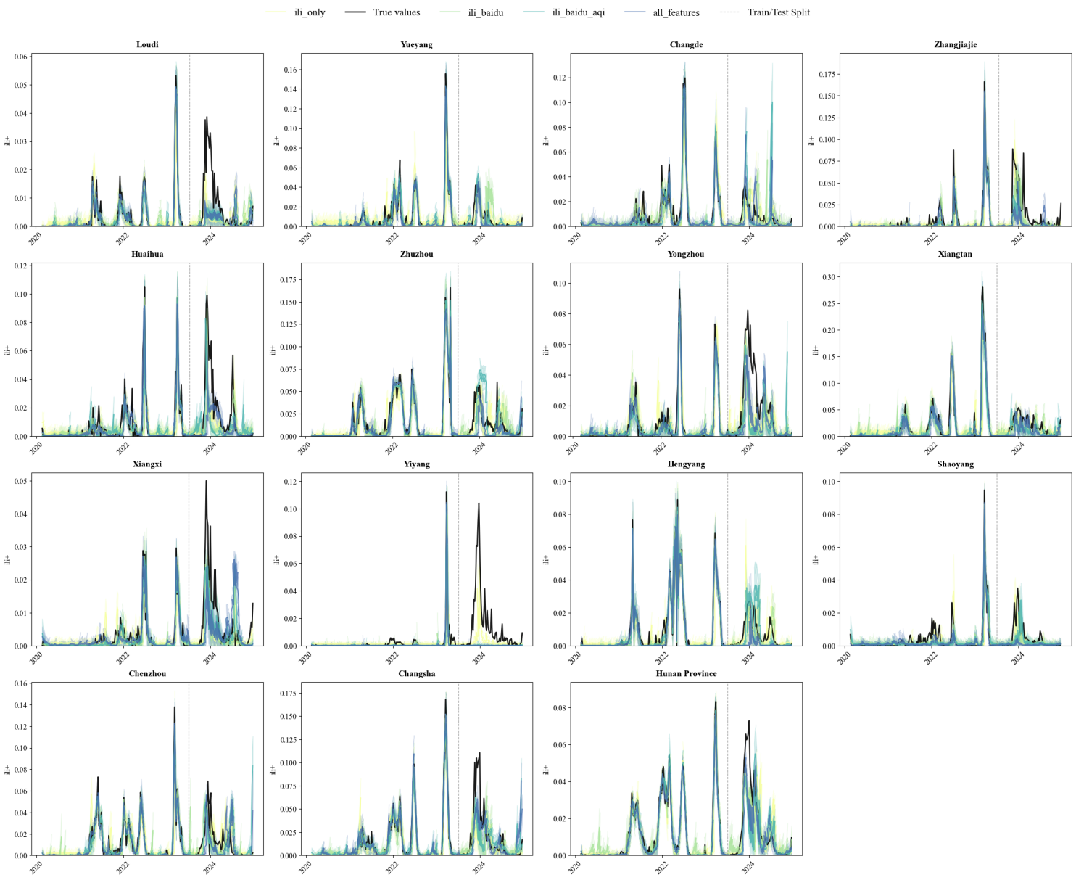
Weekly observed and predicted ILI+ values for 14 prefecture-level cities and the provincial aggregate in Hunan Province based on the long short-term memory (LSTM) model, using four feature configurations. The black line represents the true ILI+ values, coloured lines represent model predictions under different feature combinations, and the vertical dashed line indicates the train/test split.

Figure S2. GRU model forecasts of ILI+ in 14 prefecture-level cities and Hunan Province, China.
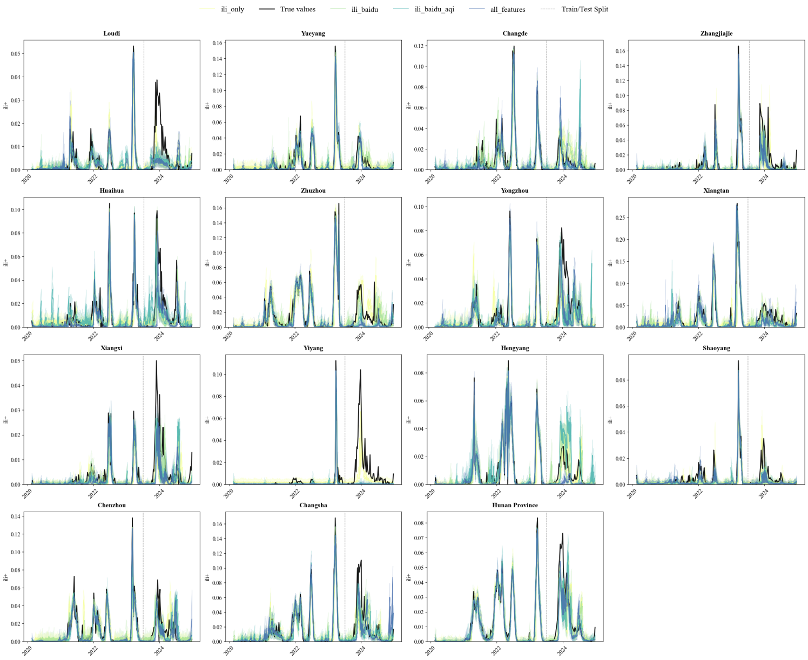
Weekly observed and predicted ILI+ values for 14 prefecture-level cities and the provincial aggregate based on the gated recurrent unit (GRU) model under four feature configurations. The black line denotes observed ILI+ values, coloured lines denote forecasts, and the vertical dashed line marks the train/test split.

Figure S3. SAE model forecasts of ILI+ in 14 prefecture-level cities and Hunan Province, China.
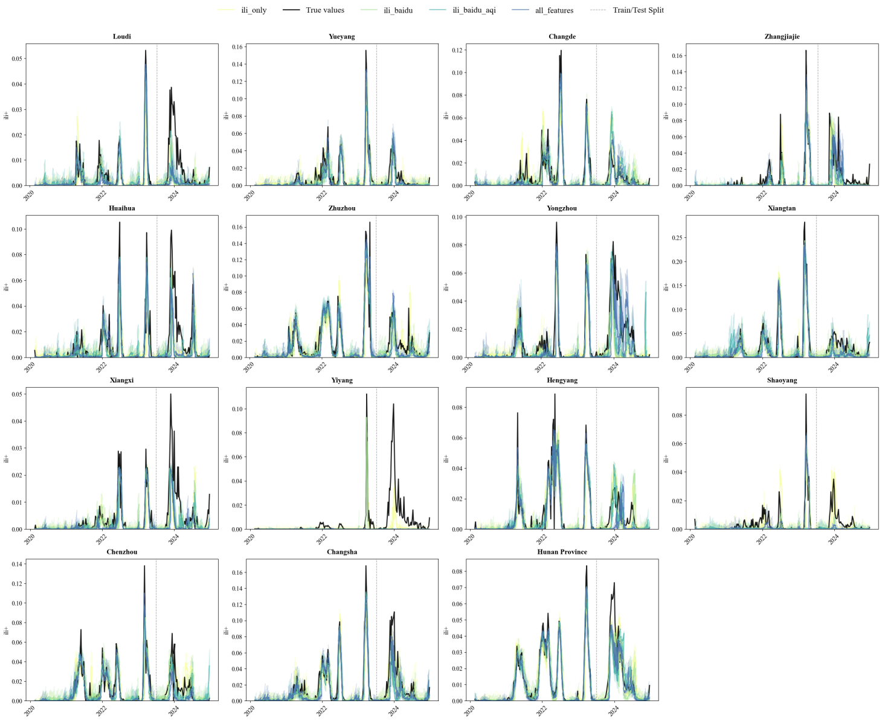
Weekly observed and predicted ILI+ values obtained from the stacked autoencoder (SAE) model for 14 prefecture-level cities and the provincial aggregate.

Figure S4. Random forest model forecasts of ILI+ in 14 prefecture-level cities and Hunan Province, China.
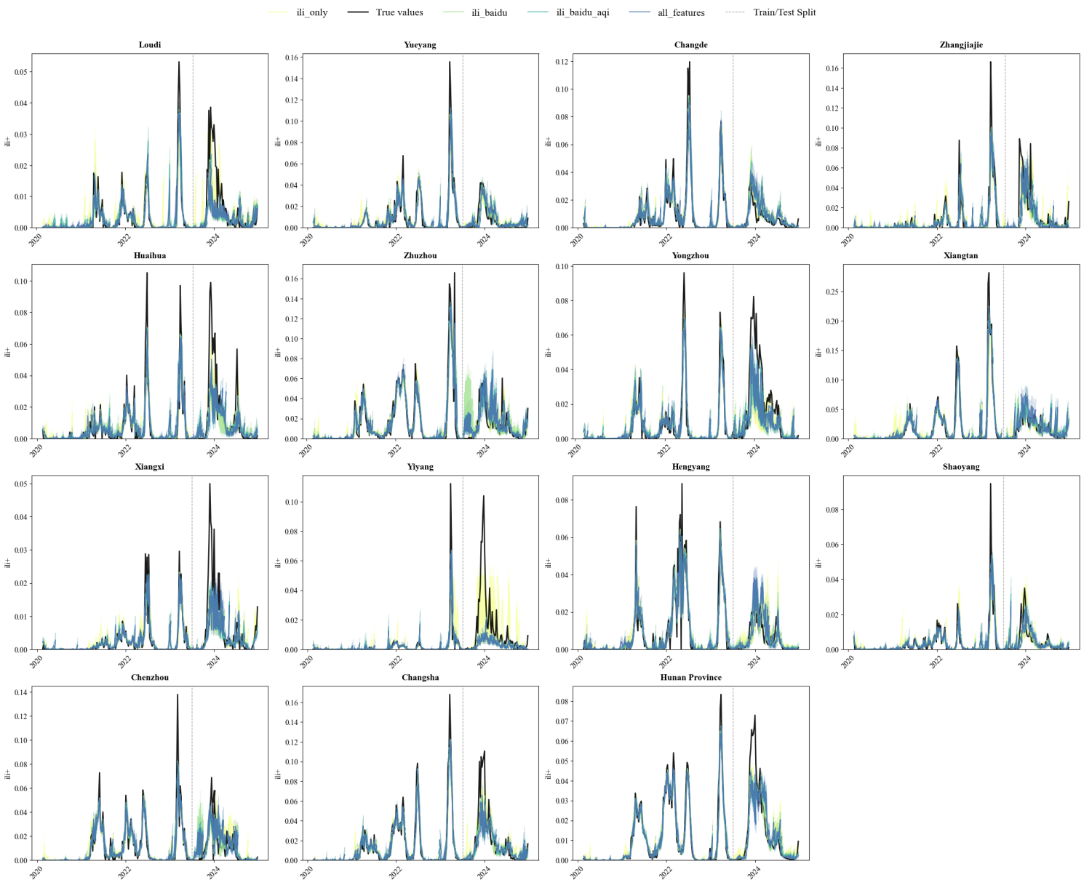
Weekly observed and predicted ILI+ values generated by the random forest model across 14 prefecture-level cities and the provincial aggregate under four feature combinations.

Figure S5. LightGBM model forecasts of ILI+ in 14 prefecture-level cities and Hunan Province, China.
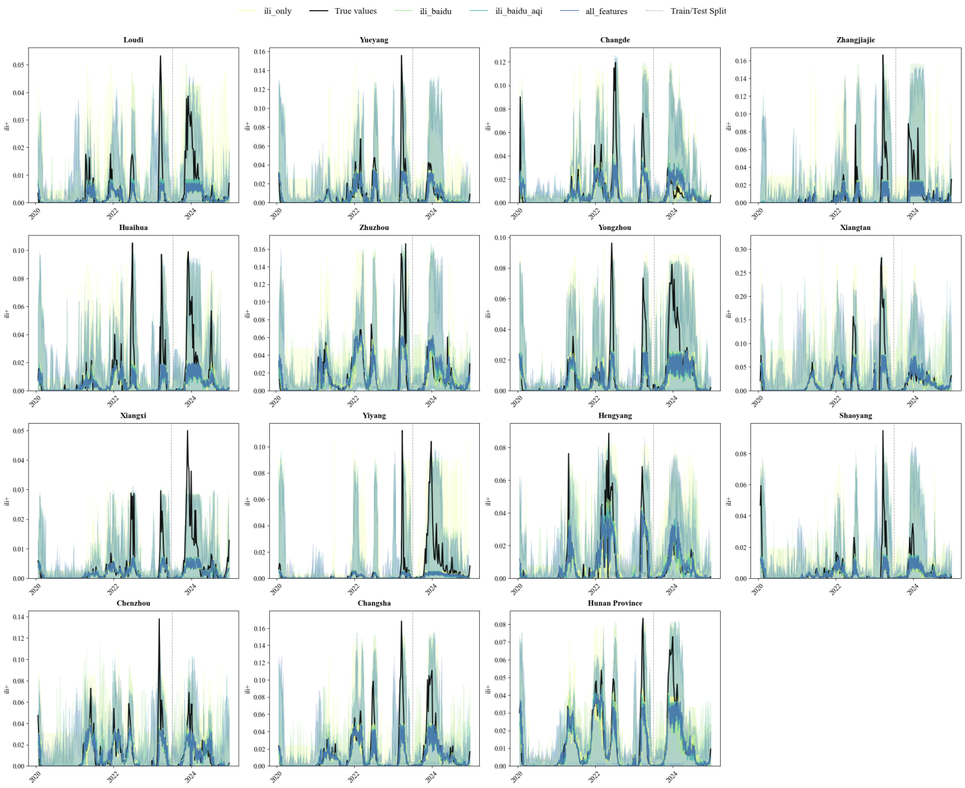
Weekly observed and predicted ILI+ values produced by the LightGBM-based quantile regression models under four feature configurations.

