Appendix 1: Table of diagnostic codes defining the different types of infection

Infection type | Infection | ICD-9 codes | ICD-10 codes
Respiratory | Bronchitis and COPD exacerbation | 466 466.0 466.1 466.9  490 490.9 | J20.1 J20.6 J20.9 J21.9  J40
Respiratory | Otitis media | 381.0 381.4  382.0 382.4 382.9 | H65.0 H65.1 H65.9  H66.0 H66.4 H66.9
Respiratory | Pharyngitis | 034 034.0 034.1  462 462.9  463 463.9 | A38  J02.0 J02.8 J02.9  J03.0 J03.8 J03.9
Respiratory | Pneumonia | 481 481.9  482 482.0 482.1 482.2 482.3 482.4 482.8 482.9  485 485.9  486 486.9 | J13  J14  J15.1 J15.8 J15.9  J18.0 J18.1 J18.8 J18.9
Respiratory | Sinusitis | 461 461.0 461.1 461.2 461.3 461.8 461.9 | J01.0 J01.1 J01.3 J01.4 J01.8 J01.9
Respiratory | URTI | 460 460.9  464 464.0 464.1 464.2 464.3 464.4 464.9  465 465.0 465.8 465.9 | J00  J04.0 J04.1 J04.2  J05.0 J05.1  J06.0 J06.8 J06.9
Urinary | Cystitis | 595 595.0 595.1 595.2 595.3 595.4 595.8 595.9 | N30.0 N30.1 N30.2 N30.3 N30.4 N30.8 N30.9
Urinary | Pyelonephritis | 590 590.1 590.2 590.3 590.8 590.9 | N10  N11.0 N11.1  N13.6

Appendix 2: Summary of the 2016-2017 provincial clinical guidelines

Infection | Age group | Antibiotic 1 | Antibiotic 2 | Minimum total dosage 1 | Maximum total dosage 1 | Minimum total dosage 2 | Maximum total dosage 2
Pneumonia | adult | Clarithromycin |  | 7000 | 7000
Pneumonia | adult | Azithromycin |  | 1500 | 1500
Pneumonia | adult | Doxycycline |  | 1400 | 1400
Pneumonia | adult | Amoxicillin |  | 21000 | 21000
Pneumonia | adult | Amoxicillin | Clarithromycin | 21000 | 21000 | 7000 | 7000
Pneumonia | adult | Amoxicillin | Azithromycin | 21000 | 21000 | 1500 | 1500
Pneumonia | adult | Amoxicillin | Doxycycline | 21000 | 21000 | 1400 | 1400
Pneumonia | adult | Amoxi-clav | Clarithromycin | 14000 | 14000 | 7000 | 7000
Pneumonia | adult | Amoxi-clav | Azithromycin | 14000 | 14000 | 1500 | 1500
Pneumonia | adult | Amoxi-clav | Doxycycline | 14000 | 14000 | 1400 | 1400
Pneumonia | adult | Levofloxacin |  | 3500 | 7500
Pneumonia | adult | Moxifloxacin |  | 2800 | 2800
Pneumonia | adult | Cefuroxime | Clarithromycin | 7000 | 7000 | 7000 | 7000
Pneumonia | adult | Cefuroxime | Azithromycin | 7000 | 7000 | 1500 | 1500
Pneumonia | adult | Cefuroxime | Doxycycline | 7000 | 7000 | 1400 | 1400
Pneumonia | adult | Cefadroxil | Clarithromycin | 7000 | 7000 | 7000 | 7000
Pneumonia | adult | Cefadroxil | Azithromycin | 7000 | 7000 | 1500 | 1500
Pneumonia | adult | Cefadroxil | Doxycycline | 7000 | 7000 | 1400 | 1400
Pneumonia | adult | Cefprozil | Clarithromycin | 7000 | 7000 | 7000 | 7000
Pneumonia | adult | Cefprozil | Azithromycin | 7000 | 7000 | 1500 | 1500
Pneumonia | adult | Cefprozil | Doxycycline | 7000 | 7000 | 1400 | 1400
Sinusitis | adult | Amoxicillin |  | 7500 | 7500
Sinusitis | adult | Amoxi-clav |  | 13125 | 14000
Sinusitis | adult | Cefixime |  | 4000 | 4000
Sinusitis | adult | Cefuroxime |  | 3500 | 3500
Sinusitis | adult | Clarithromycin |  | 7000 | 7000
Sinusitis | adult | Doxycycline |  | 2000 | 2000
Sinusitis | adult | Trimethoprim-sulfamethoxazole |  | 13440 | 13440
Sinusitis | adult | Amoxi-clav |  | 13125 | 14000
Sinusitis | adult | Levofloxacin |  | 5000 | 5000
Sinusitis | adult | Moxifloxacin |  | 2000 | 2000
Sinusitis | child | Amoxicillin |  |  | 56000
Sinusitis | child | Amoxicillin | Amoxi-clav |  | 21000 |  | 21000
Sinusitis | child | Amoxi-clav |  |  | 42000
Sinusitis | child | Cefprozil |  |  | 14000
Sinusitis | child | Cefuroxime |  |  | 14000
Sinusitis | child | Clarithromycin |  |  | 14000
Pharyngitis | child | Phenoxymethylpenicillin |  |  | 12000
Pharyngitis | child | Amoxicillin |  |  | 10000
Pharyngitis | child | Azithromycin |  |  | 2500
Pharyngitis | child | Cefalexin |  |  | 10000
Pharyngitis | child | Clarithromycin |  |  | 5000
Pharyngitis | adult | Phenoxymethylpenicillin |  | 12000 | 12000
Pharyngitis | adult | Amoxicillin |  | 10000 | 10000
Pharyngitis | adult | Azithromycin |  | 1500 | 1500
Pharyngitis | adult | Cefadroxil |  | 10000 | 10000
Pharyngitis | adult | Cefalexin |  | 10000 | 10000
Pharyngitis | adult | Clarithromycin |  | 5000 | 5000
Pharyngitis | adult | Clindamycin |  | 9000 | 9000
Pneumonia | child | Amoxicillin |  |  | 30000
Pneumonia | child | Amoxi-clav |  |  | 30000
Pneumonia | child | Amoxicillin | Amoxi-clav |  | 15000 |  | 15000
Pneumonia | child | Cefuroxime |  |  | 10000
Pneumonia | child | Cefprozil |  |  | 10000
Pneumonia | child | Azithromycin |  |  | 1500
Pneumonia | child | Clarithromycin |  |  | 10000
Otitis | child | Amoxicillin
Otitis | child | Amoxi-clav
Otitis | child | Amoxicill | Amoxi-clav
Otitis | child | Ceftriaxone
Otitis | child | Cefprozil
Otitis | child | Cefuroxime
Otitis | child | Clarithromycin
Otitis | child | Azithromycin
Cystitis in women | adult | Nitrofurantoin |  | 1000 | 2000
Cystitis in women | adult | Fosfomycin |  | 3000 | 9000
Cystitis in women | adult | Trimethoprim-sulfamethoxazole |  | 5280 | 19200
Cystitis in women | adult | Amoxi-clav |  | 10000 | 20000
Cystitis in women | adult | Trimethoprim |  | 600 | 600
Cystitis in women | adult | Cefadroxil |  | 5000 | 10000
Cystitis in women | adult | Cefalexin |  | 14000 | 14000
Cystitis in women | adult | Cefixime |  | 2000 | 4000
Cystitis in women | adult | Ciprofloxacin |  | 1500 | 3500
Cystitis in women | adult | Levofloxacin |  | 750 | 1750
Pyelonephritis or cystitis in men | adult | Ciprofloxacin |  | 7000 | 10000
Pyelonephritis or cystitis in men | adult | Levofloxacin |  | 3500 | 7000
Pyelonephritis or cystitis in men | adult | Ciprofloxacin |  | 10000 | 14000
Pyelonephritis or cystitis in men | adult | Levofloxacin |  | 5000 | 7000
Pyelonephritis or cystitis in men | adult | Trimethoprim-sulfamethoxazole |  | 13440 | 26880
Pyelonephritis or cystitis in men | adult | Amoxi-clav |  | 20000 | 28000
Pyelonephritis or cystitis in men | adult | Cefadroxil |  | 10000 | 14000
Pyelonephritis or cystitis in men | adult | Cefixime |  | 4000 | 5600
Pyelonephritis or cystitis in men | adult | Cefalexin |  | 20000 | 28000
Bronchitis with COPD | adult | Azithromycin |  | 1500 | 1500
Bronchitis with COPD | adult | Clarithromycin |  | 5000 | 7000
Bronchitis with COPD | adult | Doxycycline |  | 1400 | 1400
Bronchitis with COPD | adult | Amoxicillin |  | 15000 | 21000
Bronchitis with COPD | adult | Azithromycin |  | 1500 | 1500
Bronchitis with COPD | adult | Clarithromycin |  | 5000 | 7000
Bronchitis with COPD | adult | Cefuroxime |  | 5000 | 7000
Bronchitis with COPD | adult | Doxycycline |  | 1000 | 1400
Bronchitis with COPD | adult | Trimethoprim-sulfamethoxazole |  | 9600 | 13440
Bronchitis with COPD | adult | Cefprozil |  | 5000 | 7000
Bronchitis with COPD | adult | Amoxi-clav |  | 10000 | 14000
Bronchitis with COPD | adult | Levofloxacin |  | 3750 | 5250
Bronchitis with COPD | adult | Moxifloxacin |  | 2000 | 2000

Appendix 3:

Figure 1: Trends of concordance with guidelines according to the number of comorbidities, in children
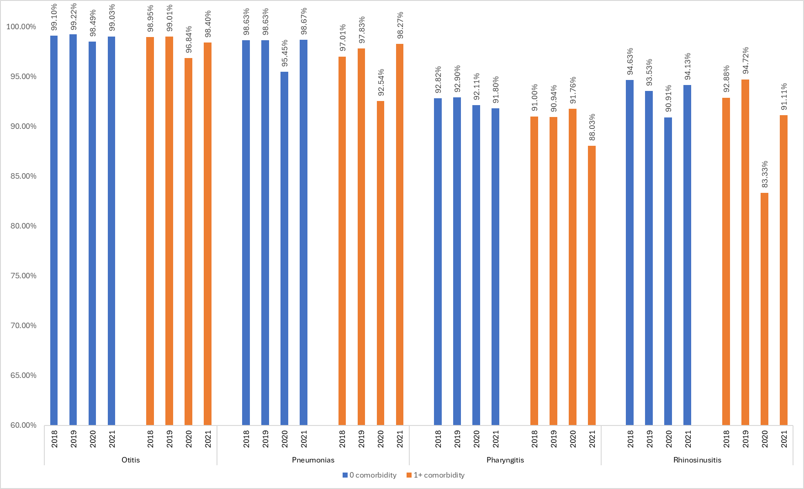
Note: April 2018 to March 2022, provincial guidelines from 2016-2017.

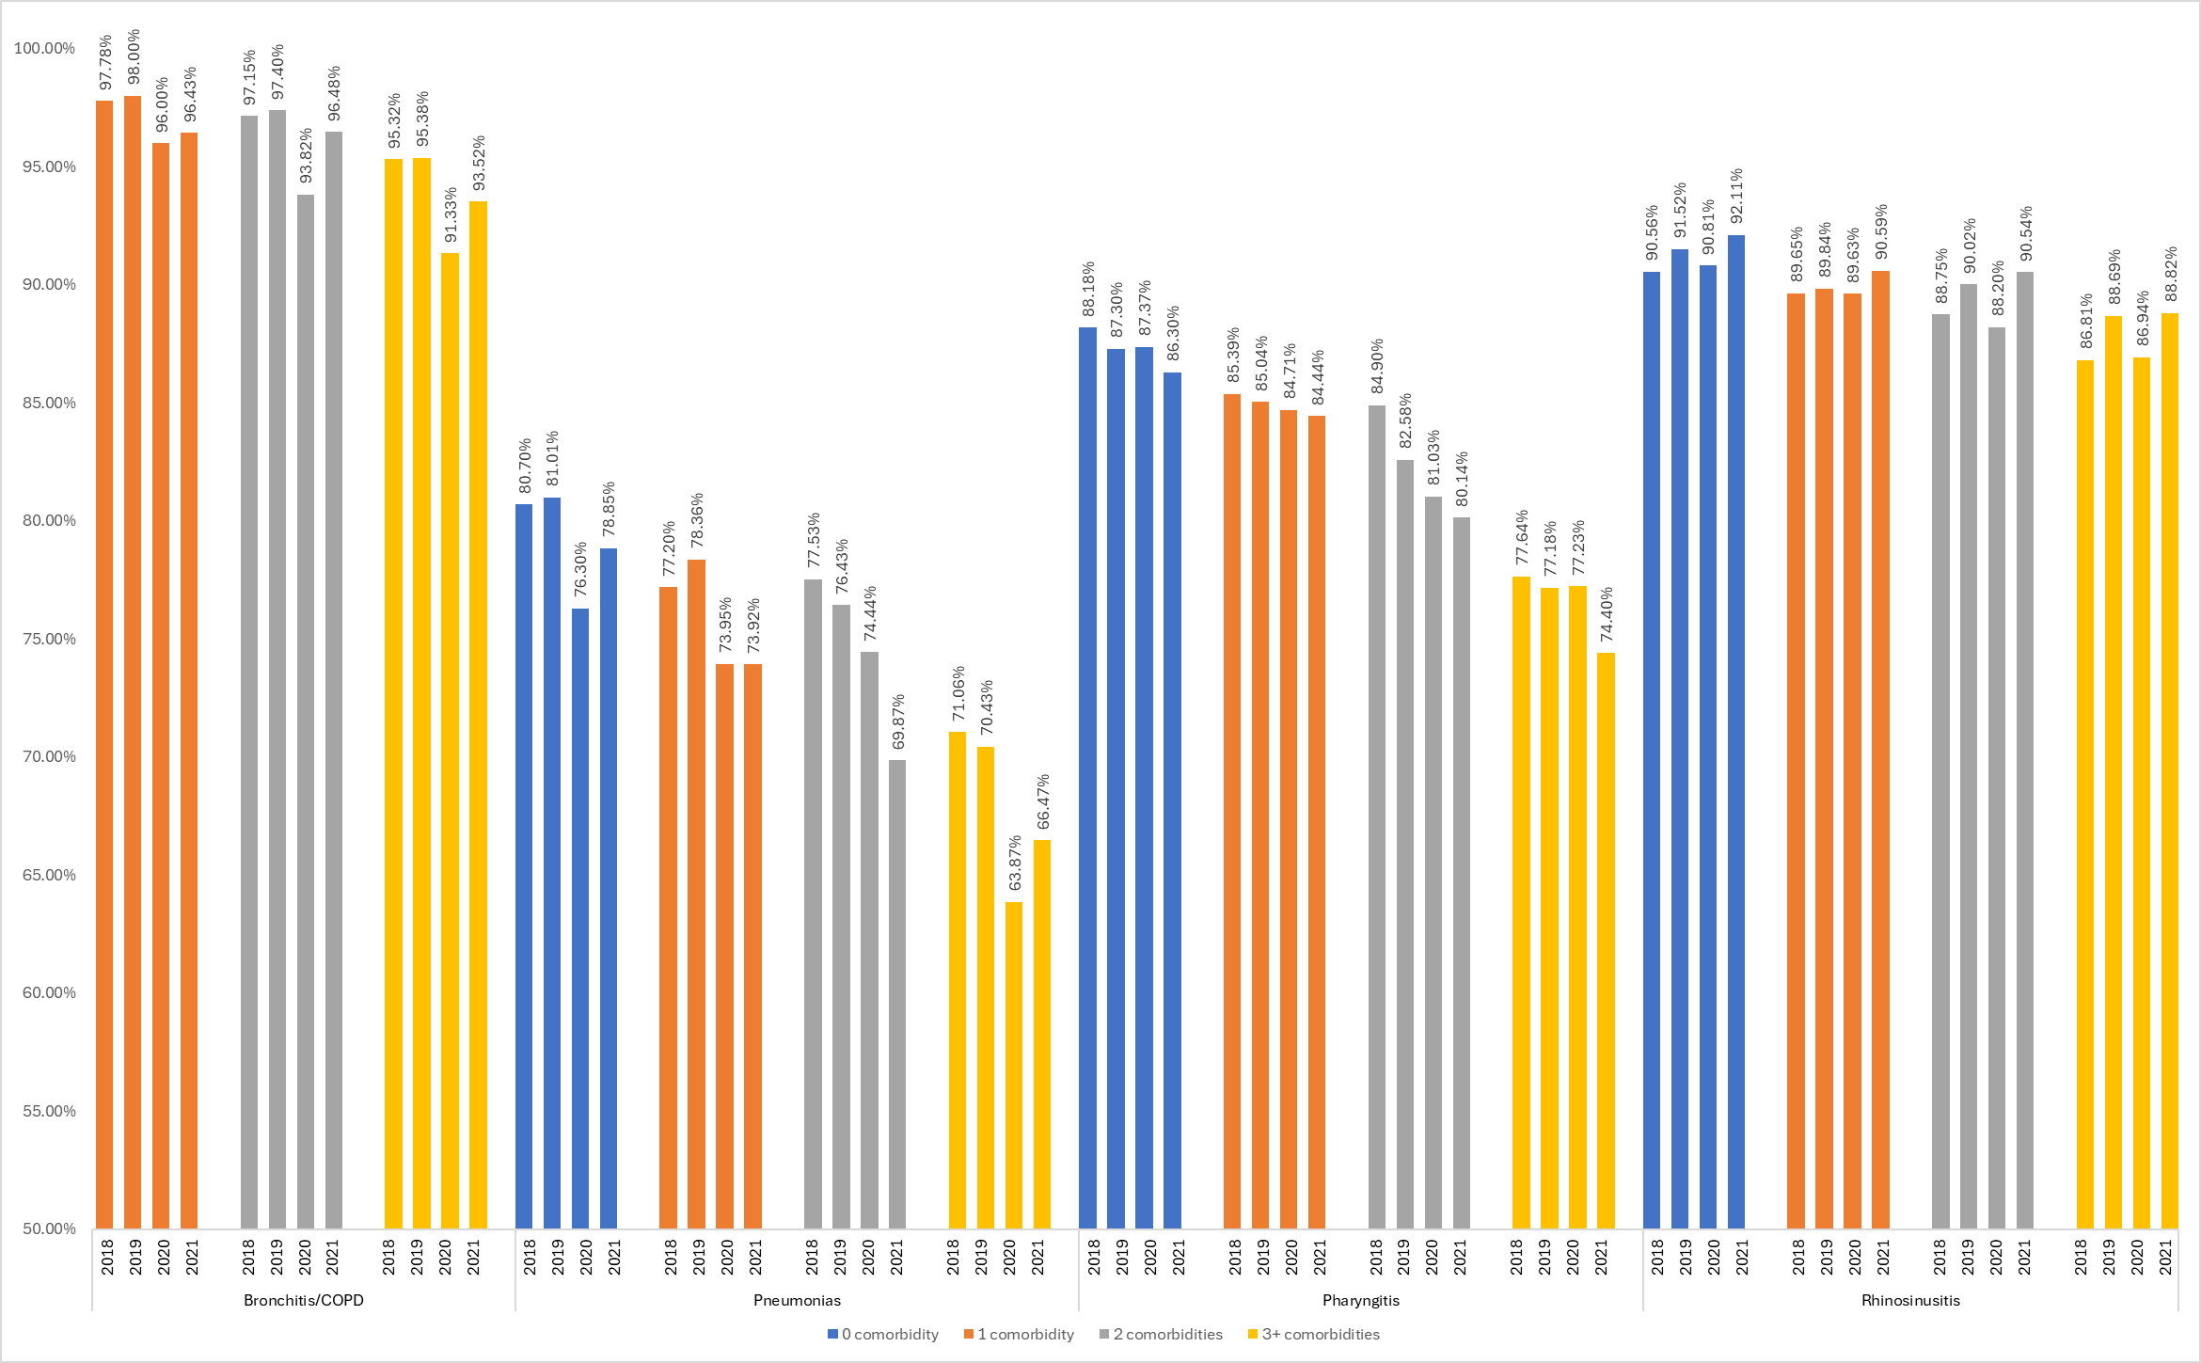
Figure 2: Trends of concordance with guidelines according to number of comorbidities, for respiratory infections, in adults

Note: April 2018 to March 2022, provincial guidelines from 2016-2017. As per the infection definition, bronchitis with COPD does not have a zero-comorbidity category.
Figure 3: Trends of concordance with guidelines according to number of comorbidities, for urinary infections, in adults

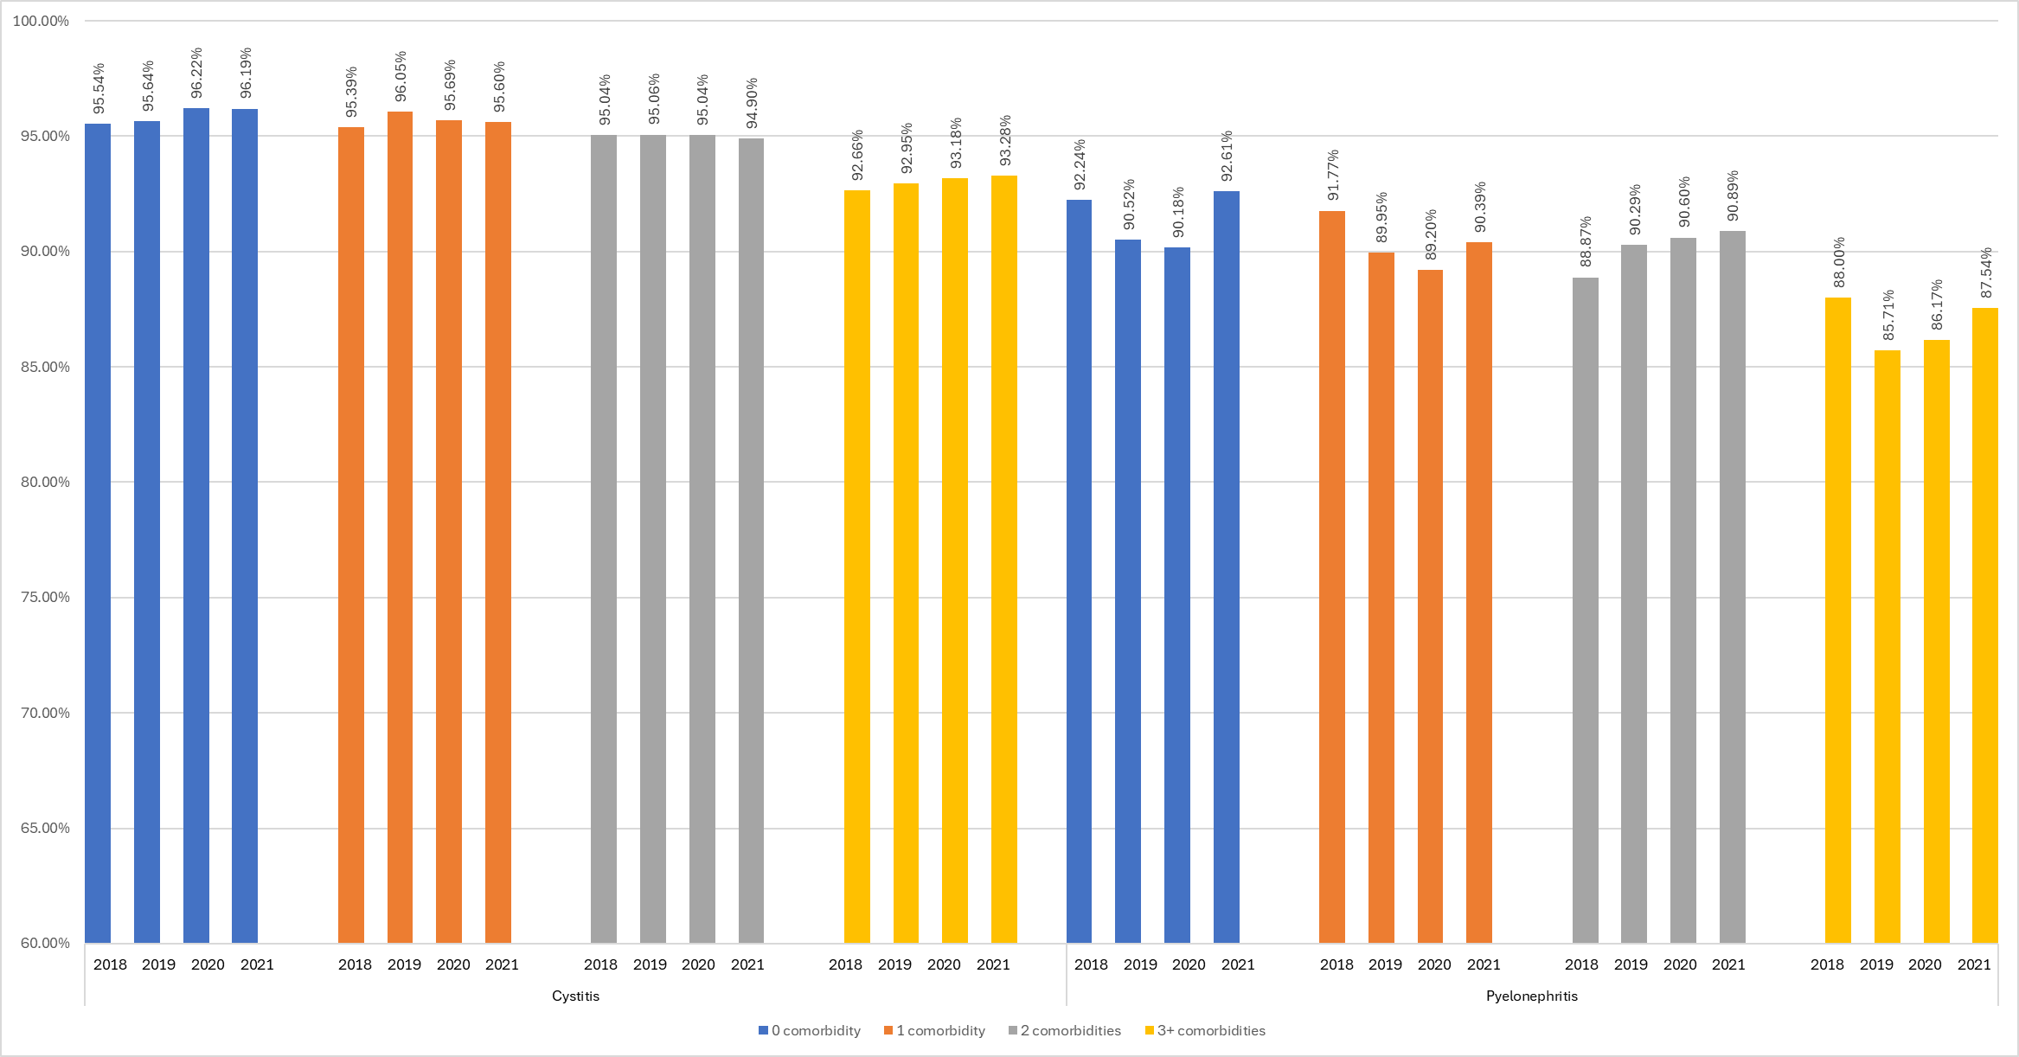
Note: April 2018 to March 2022, provincial guidelines from 2016-2017.

Figure 4: Trends of concordance with guidelines when accounting for dosage according to number of comorbidities, for respiratory infections, in adults
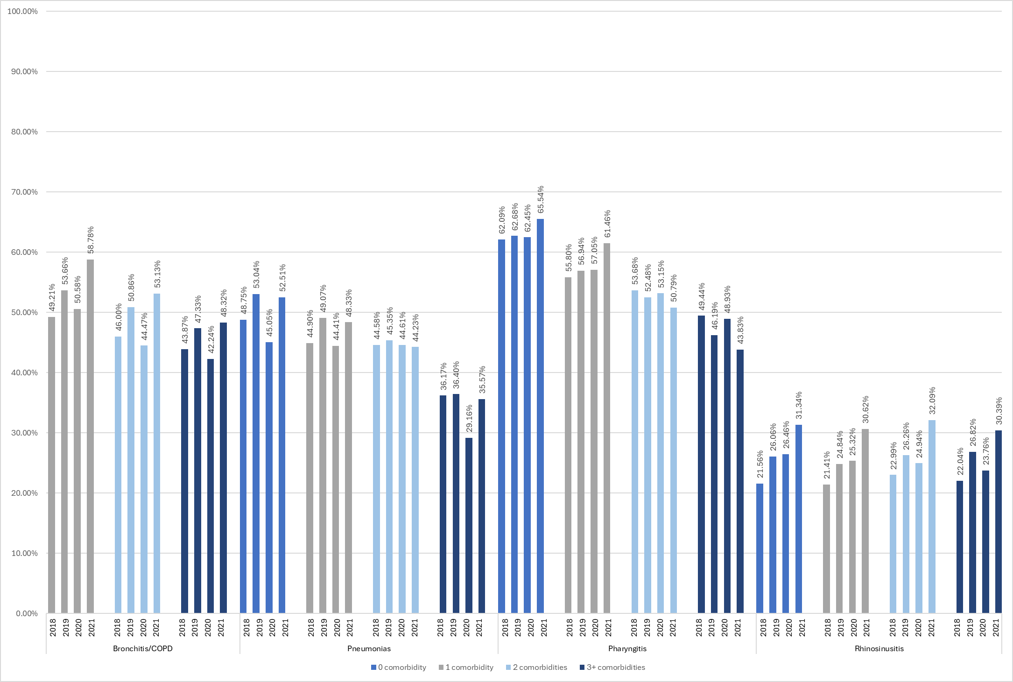

Note: April 2018 to March 2022, provincial guidelines from 2016-2017. This is a descriptive analysis of antibiotic total dosages for respiratory infections in adults.
Figure 5: Trends of concordance with guidelines when accounting for dosage, according to number of comorbidities, for urinary infections, in adults
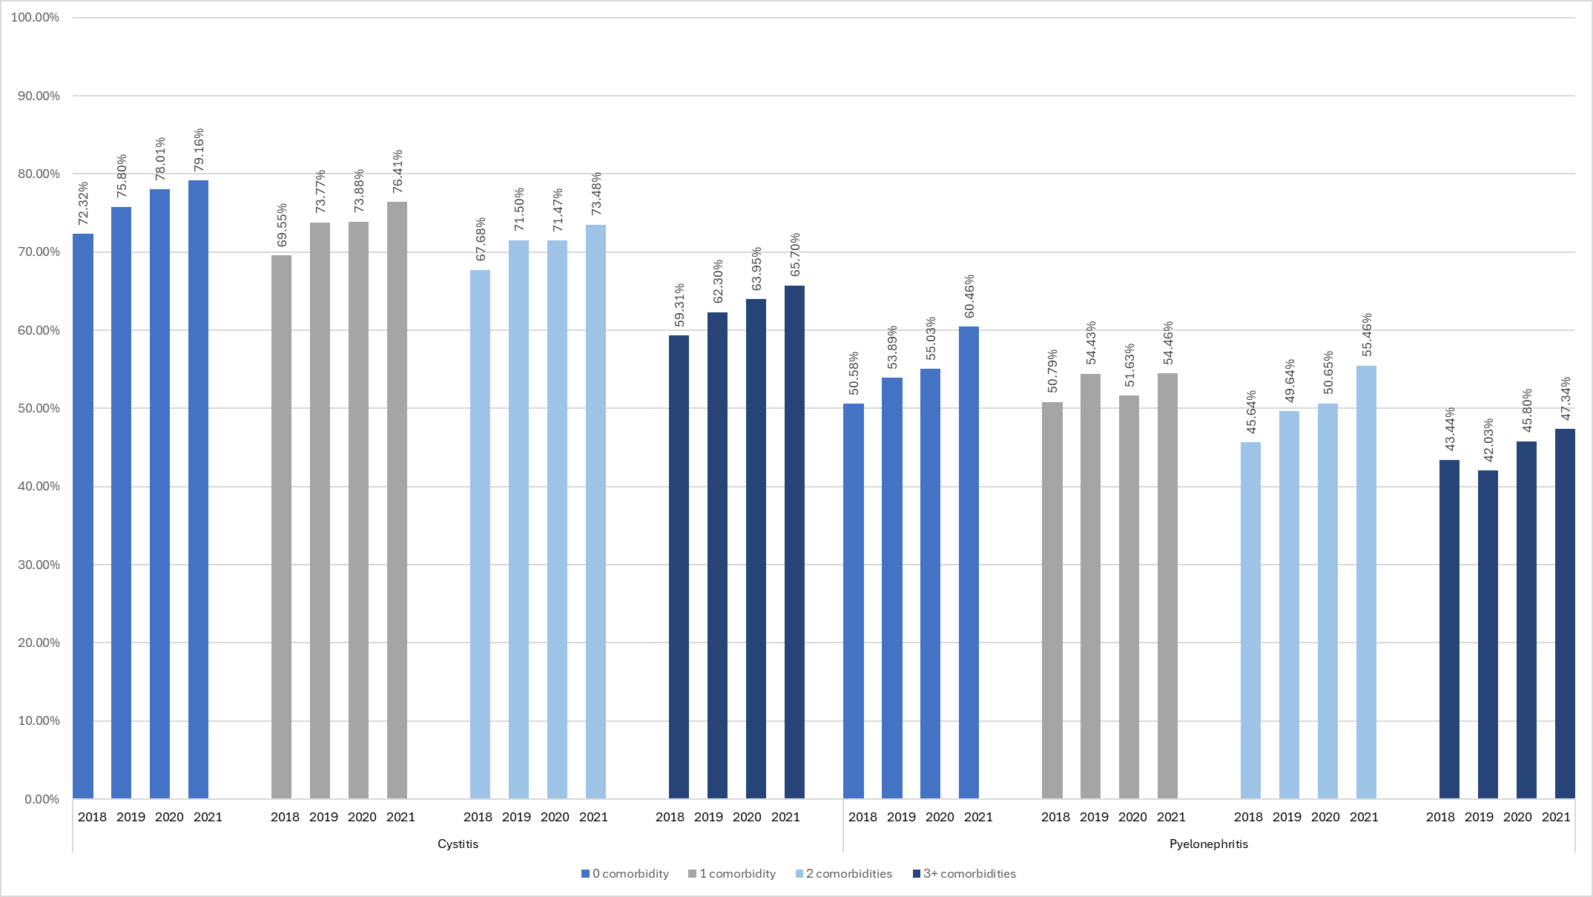
Note: April 2018 to March 2022, provincial guidelines from 2016-2017. This is a descriptive analysis of antibiotic total dosages for urinary tract infections in adults.

Appendix 4:

Children | Pneumonias*** |  | Pharyngitis |  | Rhinosinusitis |  | Otitis
Variable | Crude RR (95% CI) | Adjusted RR**  (95% CI) | Crude RR (95% CI) | Adjusted RR**  (95% CI) | Crude RR (95% CI) | Adjusted RR**  (95% CI) | Crude RR (95% CI) | Adjusted RR**  (95% CI)
Period
Pre-pandemic period  (April 2018 to March 2020) | Ref. | Ref. | Ref. | Ref. | Ref. | Ref. | Ref. | Ref.
Pandemic period  (April 2020 to July 2021) | 0.988  (0.971-1.005) | 0.984  (0.966-1.002) | 1.002  (0.988-1.016) | 1.001  (0.995-1.023) | 0.972  (0.931-1.014) | 0.969  (0.923-1.012) | 0.995  (0.991-0.998) | 0.995  (0.991-0.998)
Post-pandemic period  (August 2021 to March 2022) | 1.001  (0.993-1.010) | 0.997  (0.986-1.006) | 0.978  (0.963-0.994) | 0.982  (0.967-0.998) | 0.994  (0.966-1.023) | 0.992  (0.964-1.021) | 0.998  (0.995-1.000) | 0.998  (0.995-1.000)
Number of comorbidities
0 | Ref. | Ref. | Ref. | Ref. | Ref. | Ref. | Ref. | Ref.
1+ | 0.988  (0.981-0.996) | 0.988  (0.980-0.996) | 0.981  (0.967-0.993) | 0.982  (0.970-0.994) | 0.993  (0.972-1.014) | 0.995  (0.974-1.016) | 0.998  (0.995-1.000) | 0.998  (0.995-1.001)
Table S1: Sensitivity analysis of the impact of comorbidities and pandemic periods on concordance, in children

Note: CI = Confidence interval, RR = Relative risk, Ref = Reference category, April 2018 to March 2022, provincial guidelines from 2016-2017.
* Sensitivity analysis: the "concordant+other" category was included in the "Concordant" category.
**The adjusted models are adjusted for sex, age group, area of residence, social and material deprivation indexes.
*** In order to protect the identity of individuals in cells with small numbers, for pneumonias in children, the model was not adjusted for the social and material deprivation indexes and the 12-17 years old age group was included in the 5-11 years old age group.

Table S2: Sensitivity analysis of the impact of comorbidities and pandemic periods on concordance, in adults

Adults | Pneumonias |  | Pharyngitis |  | Rhinosinusitis |  | Bronchitis and COPD
Variable | Crude RR  (95% CI) | Adjusted RR** (95% CI) | Crude RR  (95% CI) | Adjusted RR** (95% CI) | Crude RR  (95% CI) | Adjusted RR** (95% CI) | Crude RR  (95% CI) | Adjusted RR** (95% CI)
Period
Pre-pandemic period  (April 2018 to March 2020) | Ref. | Ref. | Ref. | Ref. | Ref. | Ref. | Ref. | Ref.
Pandemic period  (April 2020 to July 2021) | 0.93 (0.90-0.96) | 0.93 (0.90-0.96) | 1.01 (0.98-1.03) | 1.01 (0.99-1.04) | 1.10 (1.06-1.15) | 1.10 (1.06-1.15) | 0.99 (0.95-1.02) | 0.98 (0.95-1.01)
Post-pandemic period  (August 2021 to March 2022) | 1.05 (1.02-1.07) | 1.05 (1.02-1.07) | 1.05 (1.02-1.08) | 1.05 (1.02-1.08) | 1.32 (1.28-1.37) | 1.32 (1.28-1.37) | 1.11 (1.08-1.14) | 1.11 (1.08-1.14)
Number of comorbidities
0 | Ref. | Ref. | Ref. | Ref. | Ref. | Ref. | -- | --
1 | 0.94 (0.91-0.96) | 0.94 (0.92-0.97) | 0.91 (0.89-0.93) | 0.95 (0.93-0.97) | 0.97 (0.94-1.00) | 0.97 (0.94-1.00) | Ref. | Ref.
2 | 0.92 (0.89-0.94) | 0.93 (0.91-0.96) | 0.84 (0.82-0.87) | 0.92 (0.89-0.95) | 1.02 (0.98-1.07) | 1.03 (0.98-1.07) | 0.93 (0.90-0.96) | 0.92 (0.90-0.95)
3+ | 0.78 (0.76-0.80) | 0.80 (0.78-0.82) | 0.76 (0.73-0.79) | 0.88 (0.85-0.92) | 1.01 (0.97-1.05) | 1.01 (0.97-1.06) | 0.89 (0.87-0.91) | 0.89 (0.87-0.91)
Note: CI = Confidence interval, COPD = Chronic obstructive pulmonary disease, RR = Relative risk, Ref = Reference category, April 2018 to March 2022, provincial guidelines from 2016-2017. Only respiratory infections.
* Sensitivity analysis: the "concordant+other" category was included in the "Concordant" category.
**The adjusted models are adjusted for sex, age group, area of residence, social and material deprivation indexes.

Table S3: Sensitivity analysis of the impact of comorbidities and pandemic periods on concordance, in adults
Adults | Cystitis |  | Pyelonephritis
Variable | Crude RR (95% CI) | Adjusted RR** (95% CI) | Crude RR (95% CI) | Adjusted RR** (95% CI)
Period
Pre-pandemic period  April 2018 to March 2020) | Ref. | Ref. | Ref. | Ref.
Pandemic period  (April 2020 to July 2021) | 1.05 (1.04-1.06) | 1.05 (1.05-1.06) | 1.06 (1.03-1.10) | 1.06 (1.03-1.09)
Post-pandemic period  (August 2021 to March 2022) | 1.06 (1.05-1.07) | 1.07 (1.06-1.08) | 1.14 (1.09-1.18) | 1.13 (1.09-1.17)
Number of comorbidities
0 | Ref. | Ref. | Ref. | Ref.
1 | 0.96 (0.95-0.97) | 0.99 (0.98-0.99) | 0.97 (0.94-1.01) | 0.98 (0.94-1.01)
2 | 0.93 (0.92-0.94) | 0.97 (0.96-0.98) | 0.91 (0.87-0.95) | 0.90 (0.86-0.94)
3+ | 0.83 (0.82-0.83) | 0.89 (0.88-0.90) | 0.81 (0.79-0.84) | 0.81 (0.78-0.84)

Note: CI = Confidence interval, RR = Relative risk, Ref = Reference category, April 2018 to March 2022, provincial guidelines from 2016-2017. Only respiratory infections. Only urinary tract infections.
* Sensitivity analysis: the "concordant+other" category was included in the "Concordant" category.
**The adjusted models are adjusted for sex, age group, area of residence, social and material deprivation indexes.

