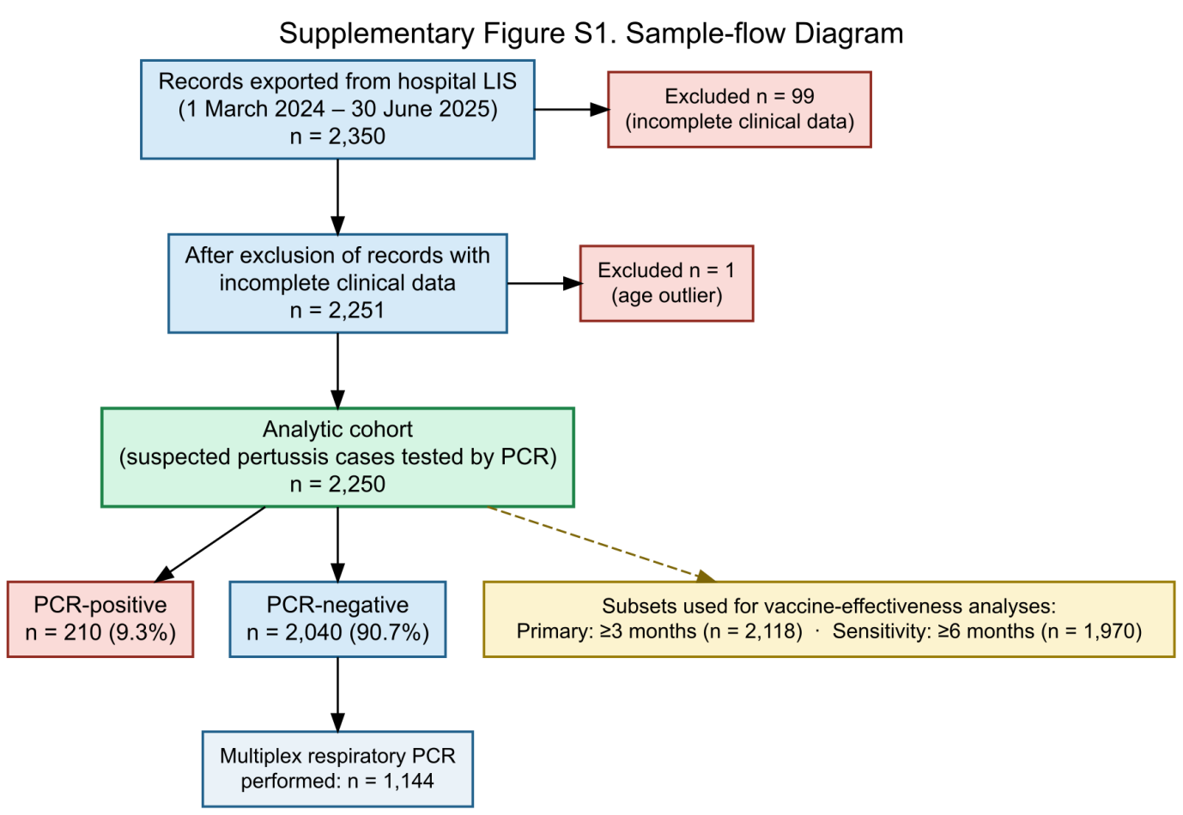
Supplementary Figure S1. Sample flow diagram. Of 2,350 nasopharyngeal swab records identified, 100 were excluded (99 with incomplete clinical data, 1 with an implausible age entry), yielding an analytic cohort of 2,250 children (210 PCR-positive, 2,040 PCR-negative). Subsets for vaccine effectiveness analyses: primary analysis ≥3 months (n = 2,118); sensitivity analysis ≥6 months (n = 1,970).

Supplementary Figure S2. Heatmap of pertussis positivity rates by region and ethnicity. Red indicates high positivity rates, yellow-green indicates low rates, and white cells represent strata with insufficient sample size (n < 5). Rows represent 14 administrative regions in Xinjiang; columns represent ethnic groups.

