Supplementary Table S1. Monthly average numbers of bacterial and viral detections among hospitalized children with CAP from 2018 to 2023
Characteristic | Pre-pandemic  2018-2019 | Pandemic  2020-2022 | Post-pandemic  2023
Duration, months | 24.00 | 36.00 | 12.00
Bacterial testing
Bacterial tests | 201.13 | 97.31 | 106.58
Bacterial positives | 20.00 | 13.58 | 14.58
Viral testing
Viral tests | 308.92 | 143.47 | 189.17
Viral positives | 51.04 | 30.75 | 39.83
Both bacterial and viral testing
Cases tested for both bacteria and viruses | 182.58 | 92.00 | 99.50
Co-infections | 12.58 | 4.72 | 3.00
Data were expressed as monthly average numbers. Monthly mean values were calculated by dividing the cumulative number in each study period by the number of months in that period.

Supplementary Table S2. Multivariable logistic regression analysis of overall bacterial positivity among hospitalized children with CAP
Variable | Category | OR | 95% CI | P value
Period | Pre-pandemic | Reference | — | —
 | Pandemic | 1.506 | 1.313-1.726 | <0.001
 | Post-pandemic | 1.671 | 1.380-2.023 | <0.001
Age group
 | <6 months | Reference | — | —
 | 6 to <12 months | 0.482 | 0.406-0.572 | <0.001
 | 12 to <24 months | 0.336 | 0.262-0.430 | <0.001
 | 24 to ≤60 months | 0.175 | 0.130-0.236 | <0.001
Sex | Female | Reference | — | —
 | Male | 1.070 | 0.940-1.218 | 0.303
Season of admission | Spring | Reference | — | —
 | Summer | 1.176 | 0.974-1.420 | 0.093
 | Autumn | 1.256 | 1.046-1.509 | 0.015
 | Winter | 0.918 | 0.769-1.096 | 0.346
OR, odds ratio; CI, confidence interval; CAP, community-acquired pneumonia. The model included only children who underwent bacteriological testing. Overall bacterial positivity was defined as any positive bacteriological result among children who underwent bacteriological testing. The model was adjusted for period, age group, sex, and season of admission. The season of admission was classified by month: spring (March to May), summer (June to August), autumn (September to November), and winter (December to February).

Supplementary Table S3. Multivariable logistic regression analysis of overall viral positivity among hospitalized children with CAP
Variable | Category | OR | 95% CI | P value
Period | Pre-pandemic | Reference | — | —
 | Pandemic | 1.279 | 1.165-1.403 | <0.001
 | Post-pandemic | 1.802 | 1.592-2.039 | <0.001
Age group
 | <6 months | Reference | — | —
 | 6 to <12 months | 1.126 | 1.001-1.267 | 0.048
 | 12 to <24 months | 0.800 | 0.709-0.902 | <0.001
 | 24 to ≤60 months | 0.499 | 0.446-0.558 | <0.001
Sex | Female | Reference | — | —
 | Male | 1.045 | 0.959-1.139 | 0.318
Season of admission | Spring | Reference | — | —
 | Summer | 0.786 | 0.681-0.907 | 0.001
 | Autumn | 1.248 | 1.097-1.420 | <0.001
 | Winter | 2.539 | 2.258-2.854 | <0.001
OR, odds ratio; CI, confidence interval; CAP, community-acquired pneumonia. The model included only children who underwent virological testing. Overall viral positivity was defined as any positive virological result among children who underwent virological testing. The model was adjusted for period, age group, sex, and season of admission. The season of admission was classified by month: spring (March to May), summer (June to August), autumn (September to November), and winter (December to February).

Supplementary Table S4. Sensitivity analysis restricted to children with pneumonia-specific ICD-10 codes J12–J18
Characteristic | Pre-pandemic  2018-2019  n=14869 | Pandemic  2020-2022  n=8264 | Post-pandemic  2023  n=4899 | P value
Overall bacterial positivity, n/N (%) | 473/4757 (9.94) | 472/3404 (13.87) | 173/1243 (13.92) | <0.001
Overall viral positivity, n/N (%) | 1205/7298 (16.51) | 1053/4956 (21.25) | 454/2178 (20.84) | <0.001
Data were expressed as n/N (%). This sensitivity analysis was restricted to children with pneumonia-specific ICD-10 codes J12–J18. For bacterial positivity, N indicates the number of children who underwent bacterial testing; for viral positivity, N indicates the number of children who underwent viral testing.

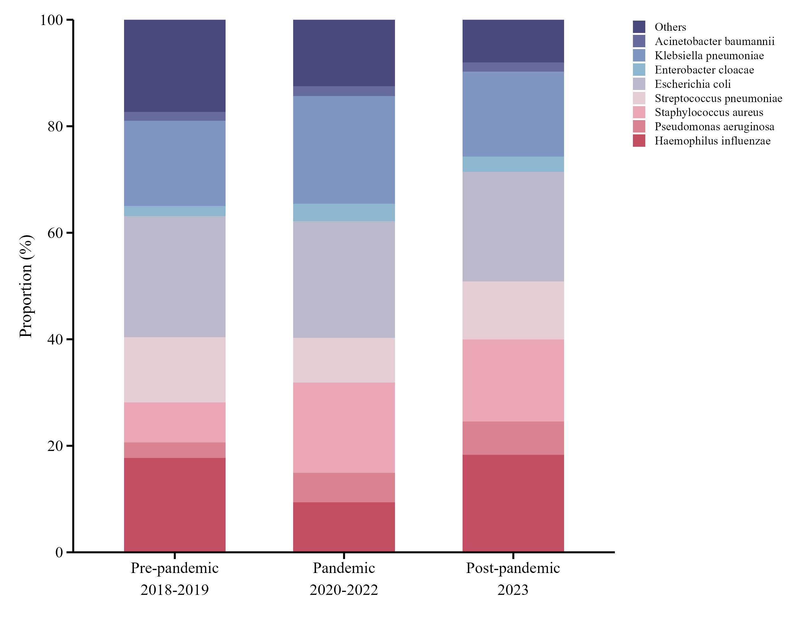 Supplementary Figure S1. Composition of positive bacterial detections among hospitalized children with CAP in Changzhou, China, from 2018 to 2023.

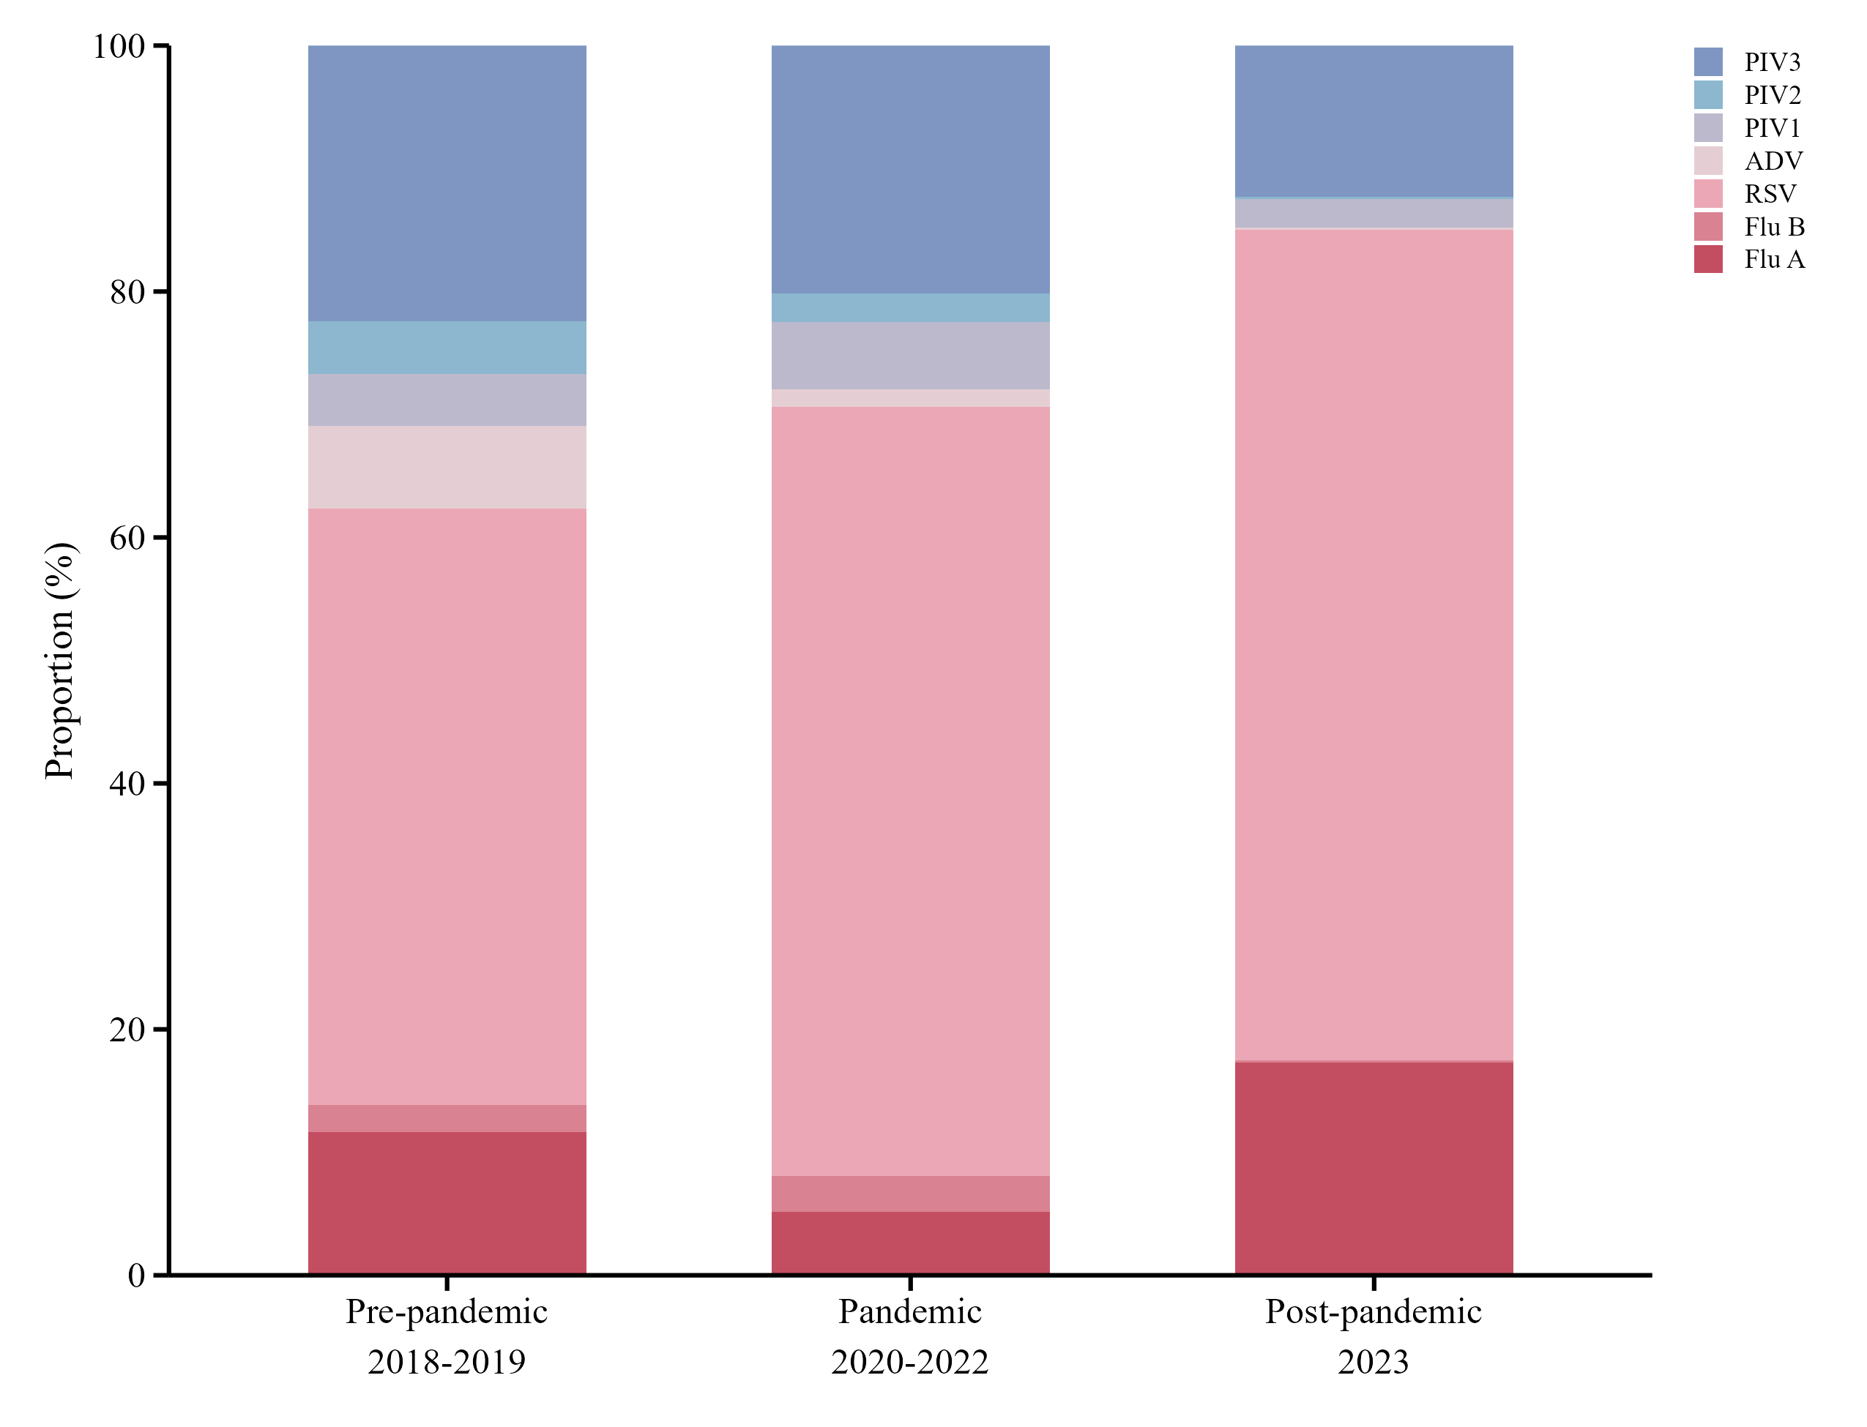 Supplementary Figure S2. Composition of positive viral detections among hospitalized children with CAP in Changzhou, China, from 2018 to 2023.

