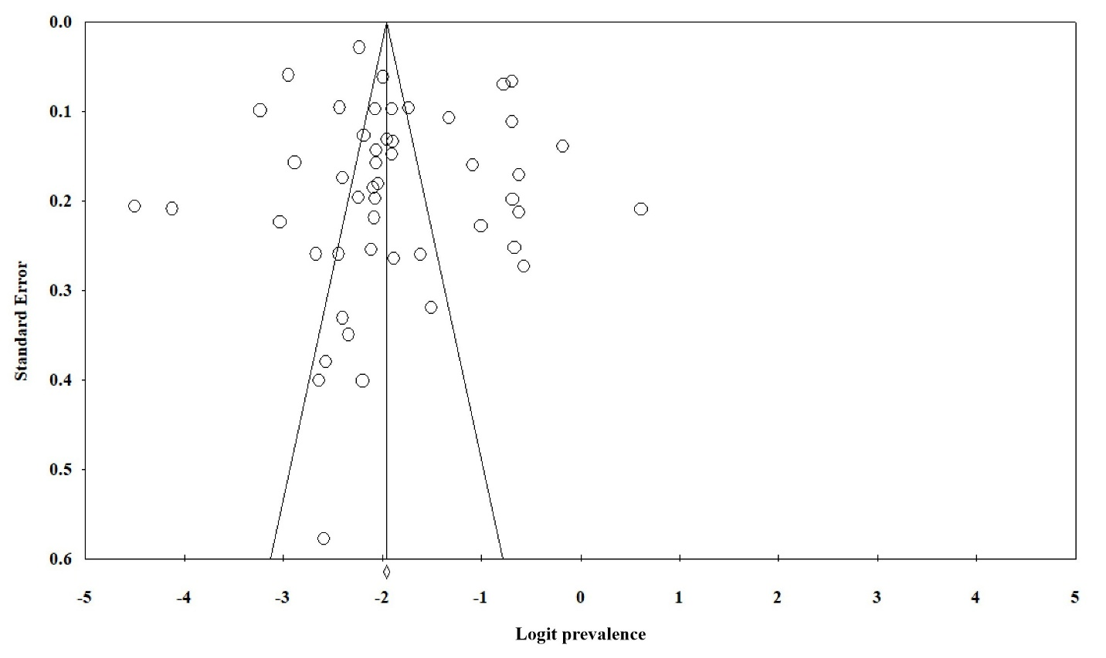
HIV mono-infection
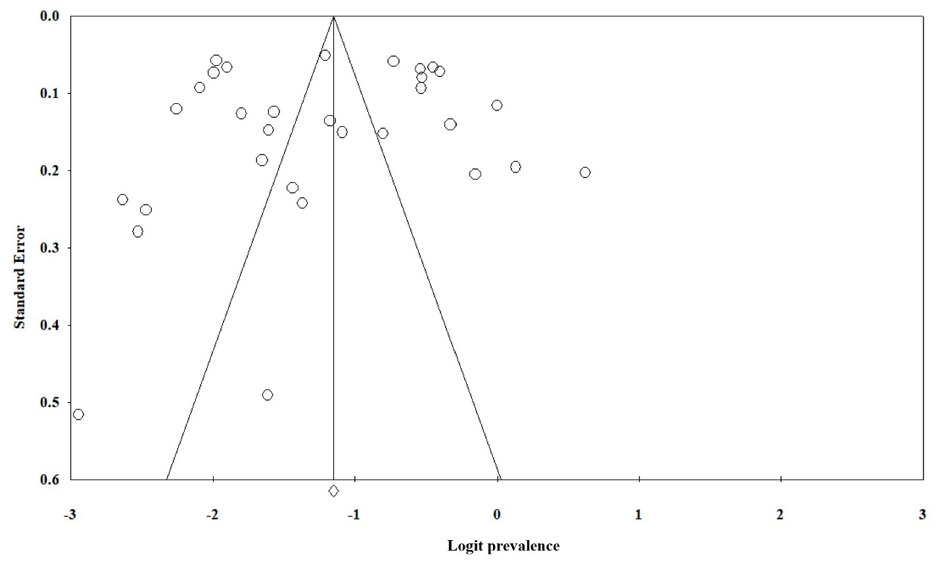
HIV co-infection
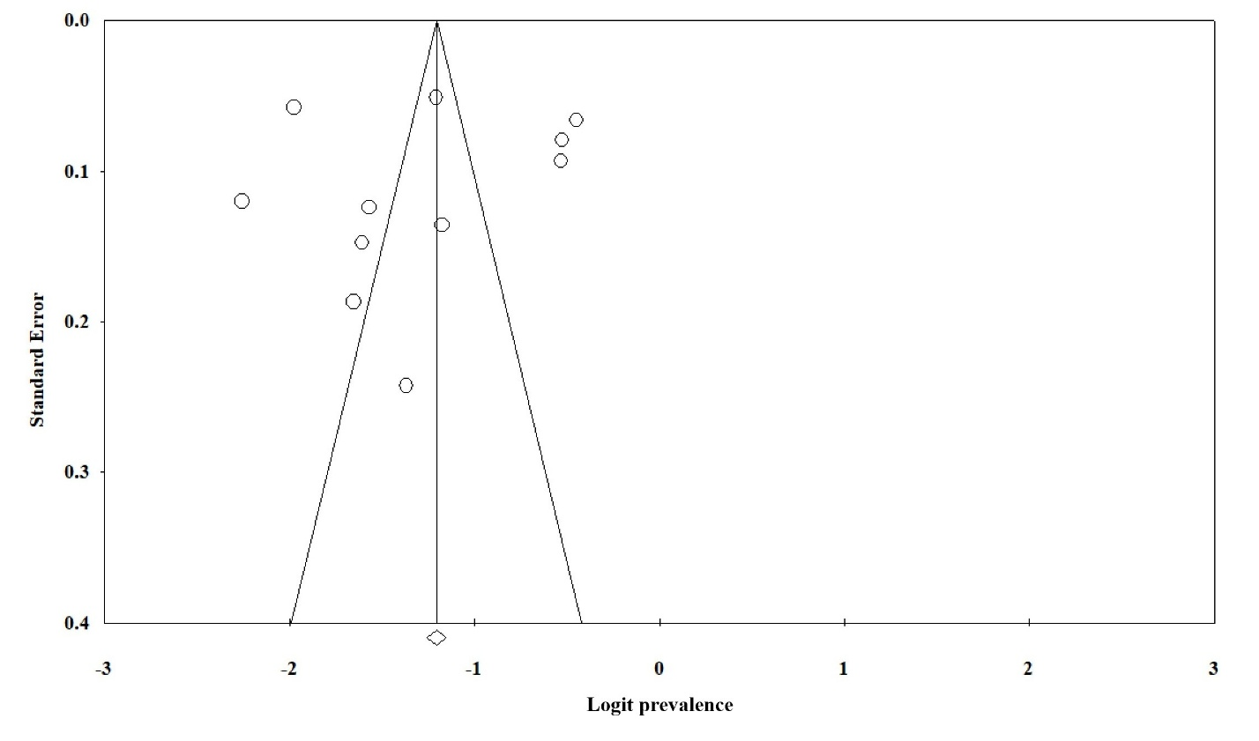
HIV/HBV co-infection
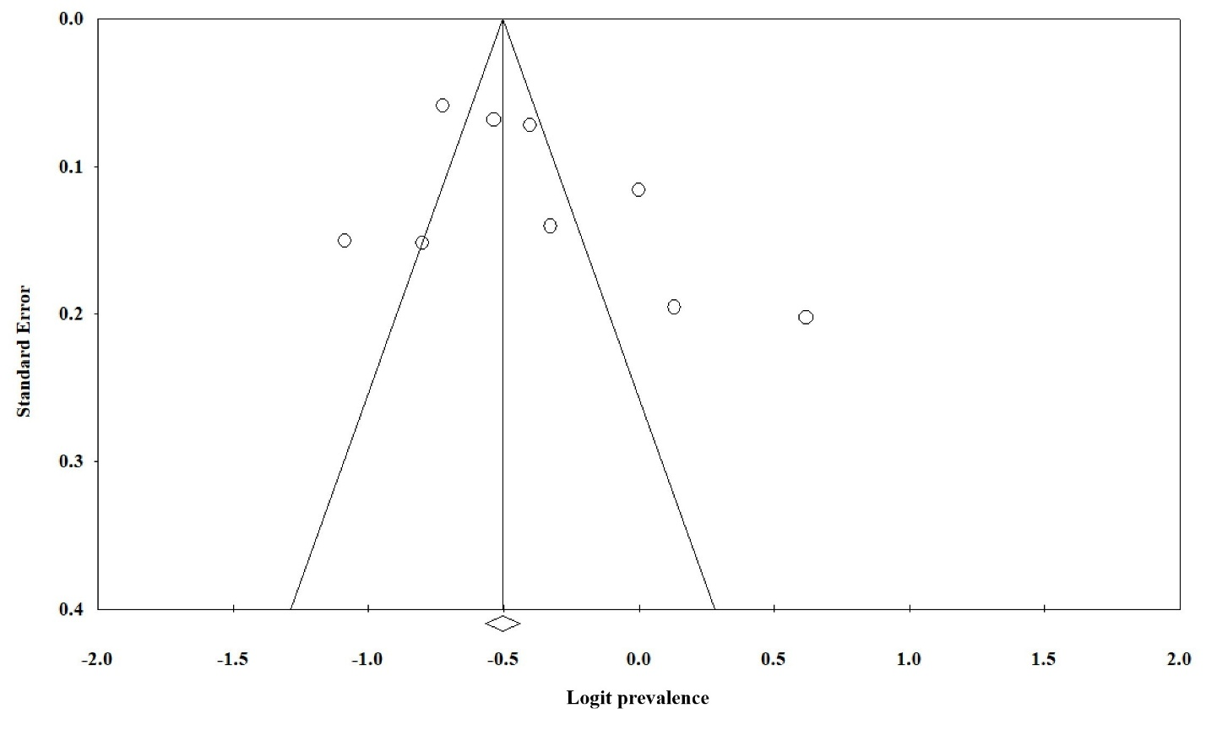
HIV/HCV co-infection
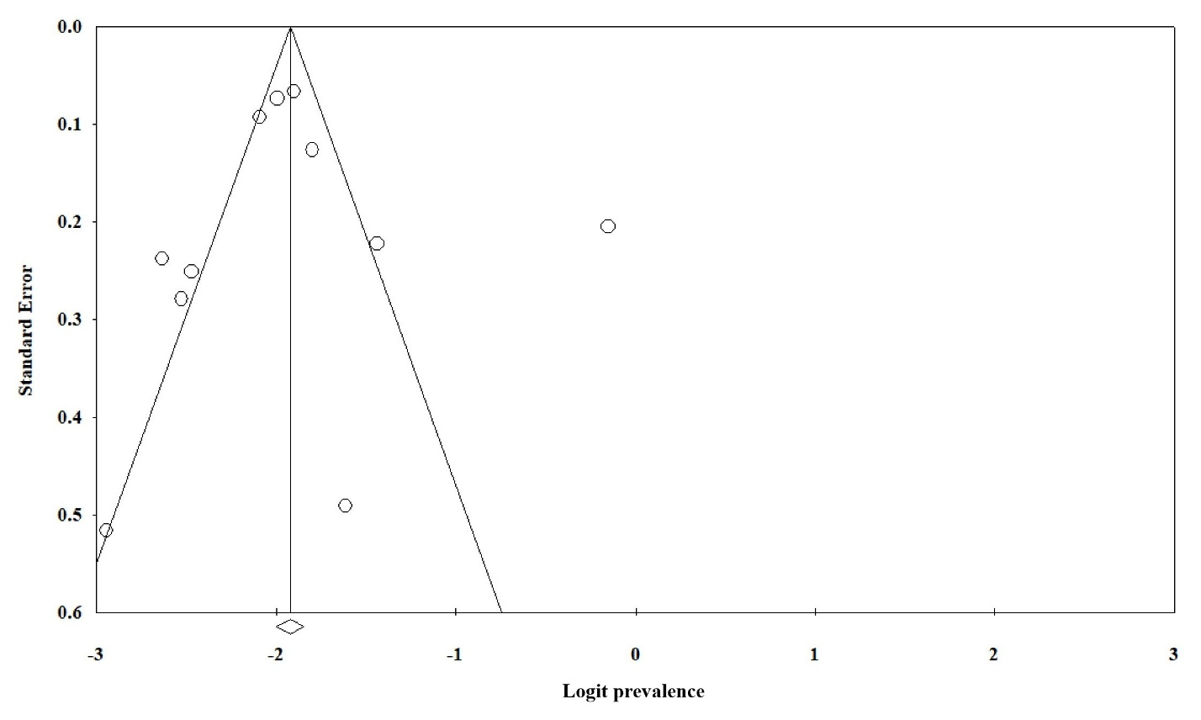
Overall (mono and co-infection)

Figure S1. Funnel plots related to the possibility of publication bias for the prevalence of liver fibrosis among people living with HIV

