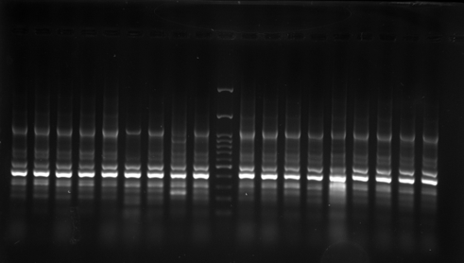
33 34 35 36 37 38 39 40 41 L 42 43 44 45 46 47 48 49 50
Fig 5: Image of the gels obtained from the electrophoresis of the ERIC-PCR product on an agarose gel. From left to right, isolates numbered include 33, 34, 35, 36, 37, 38, 39, 40, 4 1, L (Marker 100 bp), 42, 43, 44, 45, 46, 47, 48, 49 and 50

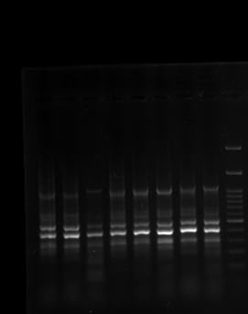
1 2 6 7 8 9 10 11 L
Fig 6: Image of the gels obtained from the electrophoresis of the ERIC-PCR product on an agarose gel. From left to right, isolates numbered include 1, 2, 6, 7, 8, 9, 10, 11, and L (Marker 100 bp)

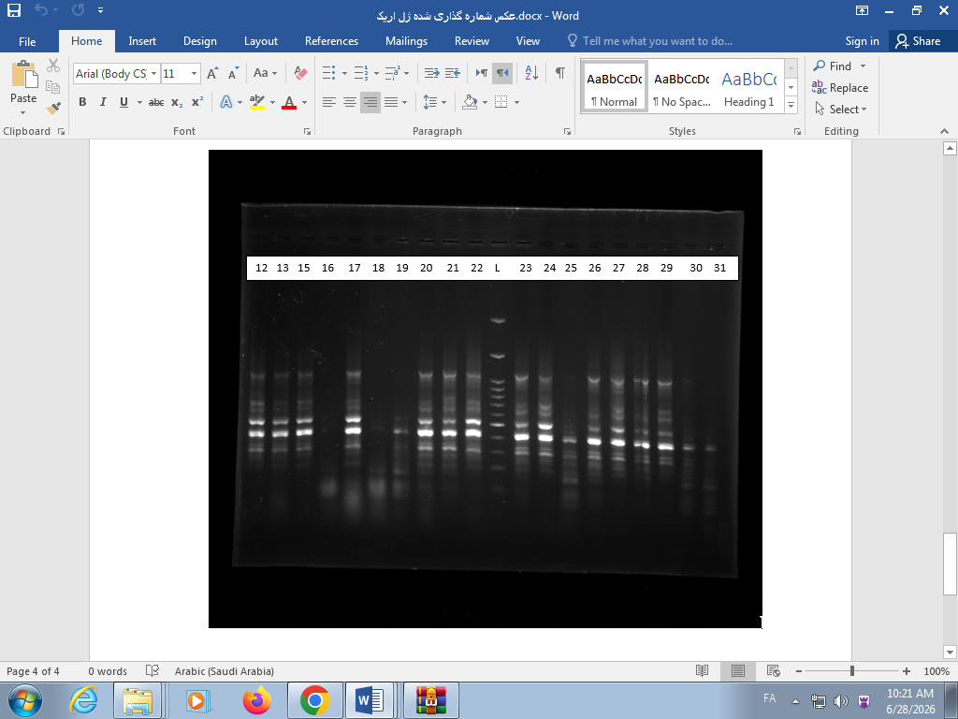
Fig 7: Image of the gels obtained from the electrophoresis of the ERIC-PCR product on an agarose gel. From left to right, isolates numbered include 12, 13, 15, 16, 17, 18, 19, 20, 21, 22, L (Marker 100 bp), 23, 24, 25, 26, 27, 28, 29, 30, and 31

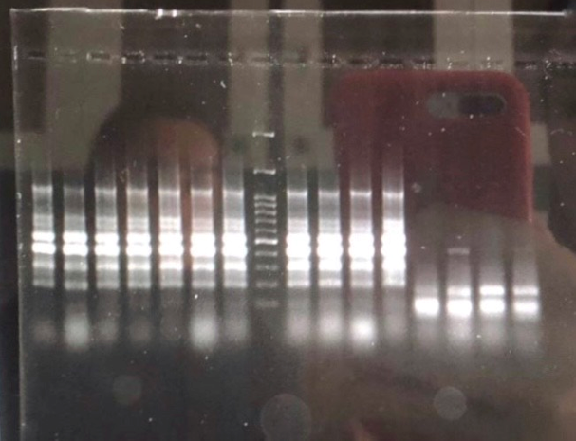
51 52 53 54 55 56 57 L 58 59 60 32 14 3 4 5
Fig 8: Image of the gels obtained from the electrophoresis of the ERIC-PCR product on an agarose gel. From left to right, isolates numbered include 51, 52, 53, 54, 55, 56, 57, L (Marker 100 bp), 58, 59, 60, 32, 14, 3, 4, and 5.

