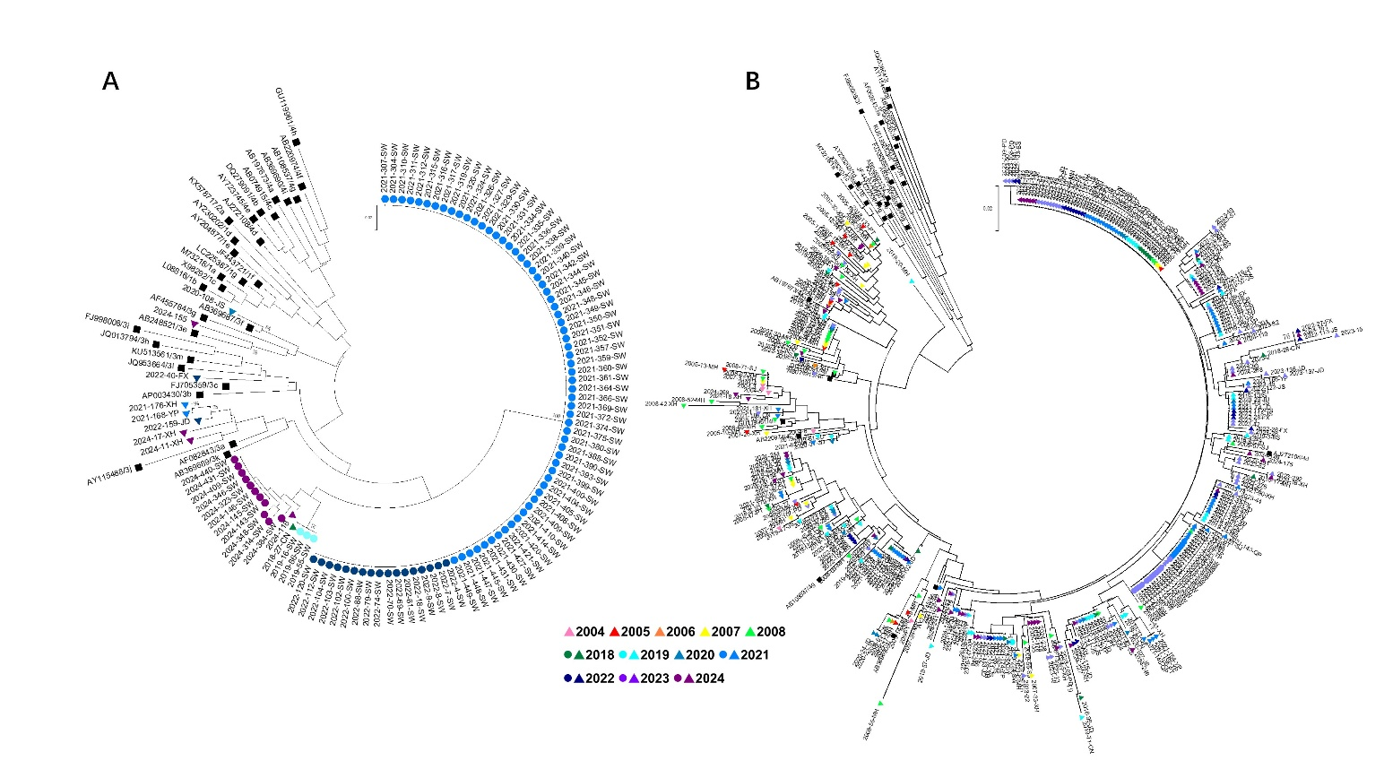
Supplementary Fig Phylogenetic trees reconstructed based on the 150-nt sequence within the HEV ORF2 region, isolated from confirmed hepatitis E cases and swine bile samples in Shanghai, China, 2004–2024. (A) Genotype 3 tree (human sequences, n=10; swine sequences, n=93). (B) Genotype 4 tree (human sequences, n=367; swine sequences, n=21). The trees were reconstructed using the Neighbor-Joining method with MEGA 7.0. The reliability of the inferred phylogenies was assessed using the bootstrap method with 1,000 replications; phylogenetic groupings with bootstrap values greater than 70% were considered sufficiently supported. Circles represent HEV sequences from swine bile samples, triangles represent sequences from human confirmed cases and squares represent reference sequences. Colors indicate the year of isolation as shown in the legend. Bootstrap values ≥70% are shown at key nodes. HEV, hepatitis E virus; ORF, open reading frame.

