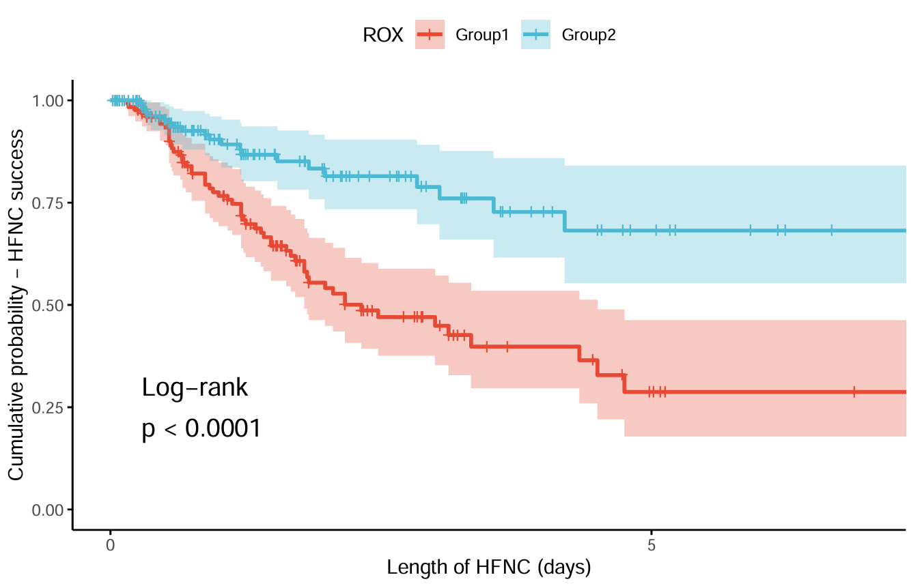
Figure S2 Kaplan-Meier survival curve for HFNC success in sepsis patients stratified by ROX-12h index (Group 1<6.95; Group 2≥6.95). Log-rank P < 0.001.

